Appendix A1. Email Notification from FNS to Regional Offices

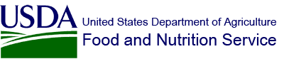 |  | 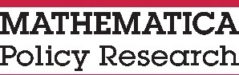

XX/XX/2018
Subject: Study of School Food Authority (SFA) Procurement Practices
Dear [FIRST NAME] [LAST NAME]:
FNS has contracted with 2M Research and its partner, Mathematica Policy Research, to conduct the Study of School Food Authority (SFA) Procurement Practices. The study will describe and assess the decision-making process of SFAs regarding school food procurement practices. Using a nationally representative sample of SFAs, this study is one of the first FNS studies to comprehensively examine SFA procurement practices related to food service management companies, cooperative purchasing agreements, recordkeeping, local purchases, and food purchase specifications for Child Nutrition program meals served in schools.
Please notify your States about the study and encourage their assistance with any study requests from 2M Research and Mathematica Policy Research.
If you have any questions or concerns, please do not hesitate to contact the 2M survey help desk by either calling (toll-free) 1-844-250-1911 or emailing sfaprocurement@2mresearch.com. Someone will be available during normal business hours (9 A.M. to 5 P.M. CST, Monday-Friday) to take your call. If you call outside of this time, please leave a message and they will return your call the following business day. You are also welcome to contact me as needed.
Thank you in advance for your assistance.

Ashley Chaifetz, Ph.D.
Office of Policy Support, Special Nutrition Evaluation Branch

