Appendix H9. 2 CFR 200

A close up of text on a white background

Description generated with very high confidenceA close up of text on a white background

Description generated with high confidenceA close up of text on a white background

Description generated with high confidenceA close up of text on a white background

Description generated with very high confidenceA close up of text on a white background

Description generated with very high confidenceA close up of text on a white background

Description generated with high confidenceA close up of text on a white background

Description generated with very high confidence

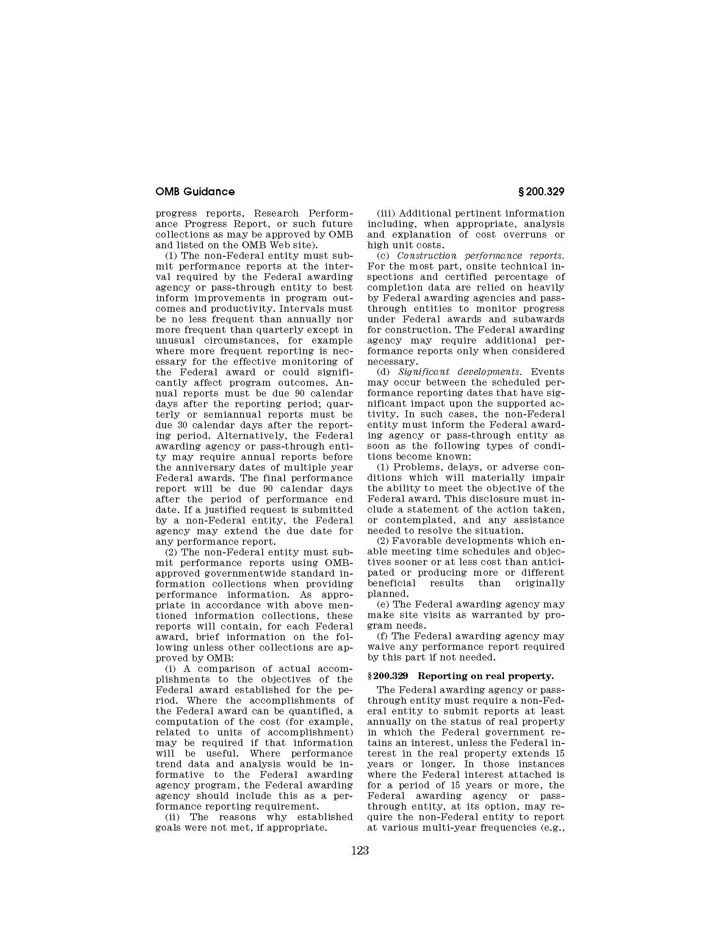

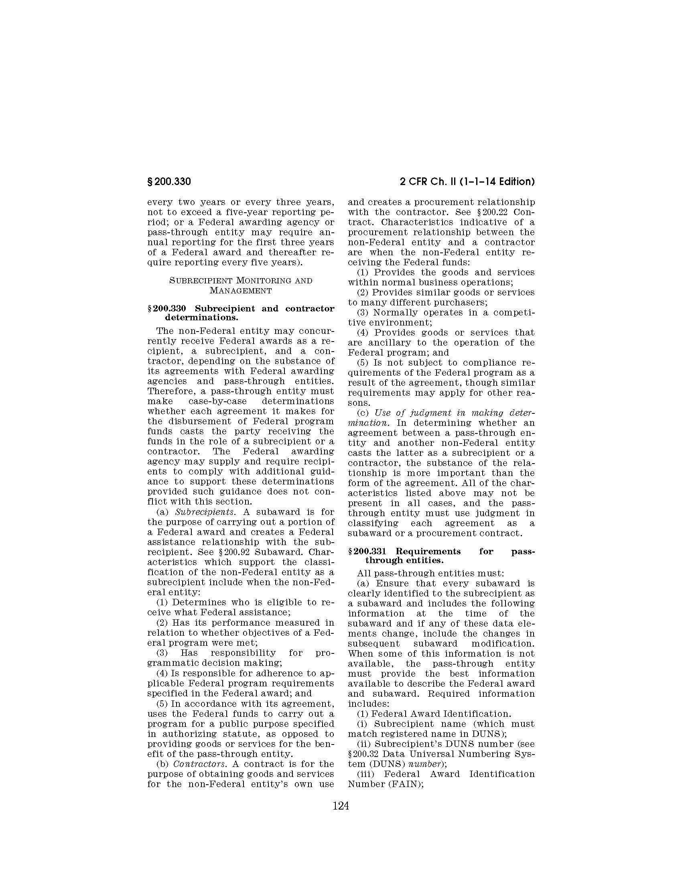

A close up of text on a white background

Description generated with very high confidenceA close up of text on a white background

Description generated with very high confidenceA close up of text on a white background

Description generated with very high confidenceA close up of text on a white background

Description generated with high confidenceA close up of text on a white background

Description generated with very high confidenceA close up of text on a white background

Description generated with very high confidenceA close up of a piece of paper

Description generated with high confidence