Green Mountain National Forest
Visitor Survey
2016

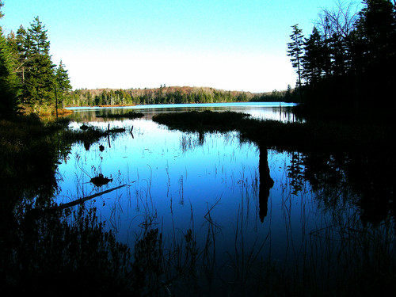

Bourn and Branch Ponds

ID____________ Date __________

Admin.________ Time__________

Destination: □ Bourn Pond □ Branch Pond

Including yourself, how many people are in your personal group on this trip to Bourn or Branch Pond?

Number of people _________

Are there any children under the age of 16 in your personal group on this trip to Bourn or Branch Pond? (Check one box)

□Yes (Number of children) _____

□No

- On this visit, what kind of personal group were you with?

□ Alone
□ Family
□ Friends
□ Family and friends
□ Business associates
□ Other (please specify):_________________________________

- Are you and your group traveling with any larger, organized group (e.g. outfitter, tour, scouts, club, school, etc.)?

□ Yes

□ No

- Have you visited Bourn or Branch Pond before today?

□ Yes

□ No

If YES, about how many times have you visited Bourn or Branch Pond, including this visit?

__________ Number of visits

OR

□ Don’t know/Not sure

- Where did you start your hike for this trip? (Check one box)

□ Bourn/Branch Pond Trailhead
□ Lye Brook Falls Trailhead
□ Stratton Pond
□ Other (please specify):________________________________________
□ Don’t know/Not sure

- At approximately what time did you arrive at the trailhead today? (Enter time)
Approximate arrival time today: ________AM/PM
OR
□ I arrived on a different day (please specify date of arrival: ___________)

- How long do you expect to continue hiking today?
_______________ hours

- Which of the following activities did you/will you do during this trip to Bourn or Branch Pond? Check one box for each item.
 | Did on this Trip | Will do on this Trip | Did/will not do on this Trip
A. Walking/Short hike (less than 1 hour) | ❑ | ❑ | ❑
B. Day hiking (more than 1 hour) | ❑ | ❑ | ❑
C. Backpacking (# of nights): ______ | ❑ | ❑ | ❑
D. Camping at Bourn Pond (# of nights):______ | ❑ | ❑ | ❑
E. Camping at Branch Pond (# of nights):______ | ❑ | ❑ | ❑
F. Camping elsewhere (# of nights):______ | ❑ | ❑ | ❑
G. Picnicking | ❑ | ❑ | ❑
H. Swimming | ❑ | ❑ | ❑
I. Boating (including canoes/kayaks) | ❑ | ❑ | ❑
J. Fishing | ❑ | ❑ | ❑
K. Creative arts (photography/drawing/ painting/writing) | ❑ | ❑ | ❑
L. Other (Please specify):______________________ | ❑ | ❑ | ❑

b) Which of the activities listed in Question 7 is your primary activity on this trip to Bourn or Branch Pond? (Enter Letter of primary box or check the box)

Letter of primary activity: _______

- If you fished at Bourn or Branch Pond today, how many fish of each species did you catch and/or release?
 | Caught | Released
A. Brook trout | _______ | _______
B. Rainbow trout | _______ | _______
C. | _______ | _______
 | _______ | _______
 | _______ | _______
 | _______ | _______
 | _______ | _______

- At approximately what time did you begin fishing at Bourn or Branch Pond today? (enter time)

Approximate time today: ________AM/PM

- For approximately how long did you fish at Bourn or Branch Pond today?

Approximately ________hours

- If you fished at Bourn or Branch Pond last season, how many trips did you make?

Number of trips last season ________

12. Please use the scale below to rate (from 1 to 5) how crowded you felt by people during this visit to Bourn and/or Branch Pond today. Please Circle only one.

Not at all crowded | Slightly crowded | Moderately crowded | Very crowded | Extremely crowded
1 | 2 | 3 | 4 | 5

13. These questions ask for your opinion about management and conditions within the Green Mountain National Forest as a whole. Please indicate the extent to which you agree or disagree with each of the following statements. (Circle one number for each statement.)
 |  | Strongly  Disagree | Disagree | Neither Agree nor Disagree | Agree | Strongly  Agree
a. | The trails are too crowded. | -2 | -1 | 0 | +1 | +2
c. | There are too many large groups hiking on the trails. | -2 | -1 | 0 | +1 | +2
d. | The trails are in good physical condition. | -2 | -1 | 0 | +1 | +2
e. | Signs and way-finding aids on trails should be improved. | -2 | -1 | 0 | +1 | +2
k. | I am very satisfied with my recreation experience on the Green Mountain National Forest. | -2 | -1 | 0 | +1 | +2

14. Do you live in the United States?

□ Yes (What is your zip code? ___________________ )

□ No (In what country do you live? _________________________________ )

15. What year where you born?

Year born: ____________

16. What is your gender? (Please mark one.)

□ Female

□ Male

17. Please indicate the highest level of education you have completed. (Please mark only one.)

□ Less than high school □ High school graduate/GED
□ Vocational or Technical School Certificate □ Associates degree
□ Some college □ Bachelor’s degree
□ Graduate degree or professional degree (MA, MS, PhD, JD, MBA, etc.)

18. Are you Hispanic or Latino?

□ Yes □ No
19. With which racial group(s) do you most closely identify? (Select one or more.)

□ American Indian/Alaska Native □ Asian
□ Black/African American □ Native Hawaiian or other Pacific Islander
□ White □ Refused

Thank you for your help with this survey!
Your responses are anonymous and confidential.

Please return your completed questionnaire to the survey administrator.

