White Mountain National Forest
Visitor Survey
2016

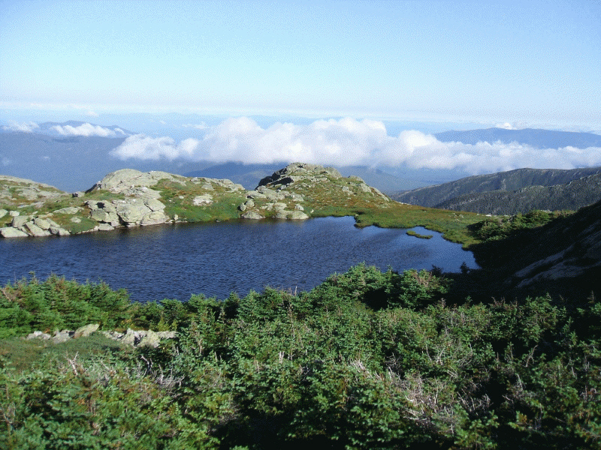

Gulfside Trail

ID____________ Date __________

Admin.________ Time__________

Dir.___________ Version________

Including yourself, how many people are in your personal group on this trip to the Gulfside Trail?

Number of people _________

Are there any children under the age of 16 in your personal group on this trip to the Gulfside Trail? (Check one box)

□Yes (Number of children) _____

□No

- On this visit, what kind of personal group were you with?

□ Alone
□ Family
□ Friends
□ Family and friends
□ Business associates

□ Other (please specify):_________________________________

Are you and your group traveling with any larger, organized group (e.g. tour, scouts, club, school, church, etc.)?

□ Yes

□ No

- Have you visited the Gulfside Trail near Mt. Jefferson’s summit before today?

□ Yes

□ No

If YES, about how many times have you visited the Gulfside Trail, including this visit?

__________ Number of visits

OR

□ Don’t know/Not sure

- Where did you start your hike today? (Check one box)

□ Gulfside Trailhead
□ Other Trailhead
(please specify):_________________________________________________
□ Hut or Camp
(please specify):_________________________________________________
□ Other
(please specify):_________________________________________________
□ Don’t know/Not sure

- At approximately what time did you arrive at the trailhead today? (Enter time)
Approximate arrival time today: ________AM/PM
OR
□ I arrived on a different day (please specify date of arrival: ___________)

- How long do you expect to continue hiking today?
_______________ hours
- For you and your personal group on this visit, please tell us the number and frequency of visits you’ve made to this or similar sites for hikes in the past year. (If you do not know the answer, please leave blank). (Note: number of visits and frequency of visit scale will vary)

Number of visits or Frequency of visits made to [site]
 | First Visit | Less than 1 time/year | Number of times in the past [n] months |  |  |  | Lifetime
 |  |  | 1-11 times | 12-50 times | 51-360 times | Daily
Yourself
Member #2
Member #3
Member #4
Member #5
Member #6
Member #7

- Please tell us how many times during the past 12 months you have participated in the following activities?
 | 11+ | 5-10 | 2-4 | 1 | 0
Hiking | □ | □ | □ | □ | □
Backpacking | □ | □ | □ | □ | □
Camping | □ | □ | □ | □ | □
Rock or ice climbing | □ | □ | □ | □ | □
Hunting | □ | □ | □ | □ | □
Fishing | □ | □ | □ | □ | □
Cycling | □ | □ | □ | □ | □
Wildlife viewing | □ | □ | □ | □ | □
Scenic driving | □ | □ | □ | □ | □
Picnicking | □ | □ | □ | □ | □
Trail running | □ | □ | □ | □ | □
Cross country or  backcountry skiing | □ | □ | □ | □ | □

Encounters with other hikers

The following section of this survey asks questions about encounters with other hikers on the Gulfside Trail near Mt. Jefferson’s summit. An encounter with another hiker occurs when:
- You pass another hiker who is not part of your personal group
- Another hiker who is not part of your personal group passes you

- We would like to know how acceptable you would find various numbers of encounters per hour while hiking the Gulfside Trail. To help judge this, imagine you’re you are hiking the Gulfside Trail. Please rate how acceptable the following numbers of other hikers per hour on the Gulfside Trail near Mt. Jefferson’s summit? A rating of -4 means the number of encounters per hour would be very unacceptable, and a rating of +4 means it would be very acceptable. (Circle one number for each rate of encounters.)

 | Very  Unacceptable | Very  Acceptable
0 ^{encounters}/_{hour} | -4 -3 -2 -1 0 +1 +2 +3 +4
10 ^{encounters}/_{hour} | -4 -3 -2 -1 0 +1 +2 +3 +4
25 ^{encounters}/_{hour} | -4 -3 -2 -1 0 +1 +2 +3 +4
50 ^{encounters}/_{hour} | -4 -3 -2 -1 0 +1 +2 +3 +4
100 or more ^{encounters}/_{hour} | -4 -3 -2 -1 0 +1 +2 +3 +4

- About how many other hikers did you encounter during your last hour of hiking?

I encountered about __________ other hikers over the past hour
or
□ I have not been hiking for an hour.
or
□ Don’t know/Not sure.

- About how many other hikers did you expect to encounter over the past hour?

I expected to encounter _________ other hikers over the past hour.
or
□ I had no expectations about the number of encounters I would experience.

- About how many other hikers would you have preferred to encounter over the past hour?

I would have preferred to encounter ________ other hikers over the past hour.

- What is the maximum number of encounters per hour you think the U.S. Forest Service should allow on the Gulfside Trail near Mt. Jefferson’s summit? In other words, at what point should the number of visitors hiking the Gulfside Trail be limited?

The U.S. Forest Service should allow no more than _________ encounters per hour.

or

□ There should be no limit to the number of encounters per hours the U.S. Forest Service allows.

- What is the maximum number of encounters per hour you could experience on Gulfside Trail near Mt. Jefferson’s summit before you would not hike here again?

If I experienced as many as _________ encounters per hour I would not hike here again.
or
□ I would hike the Gulfside Trail near the Mt. Jefferson summit again regardless of the number of encounters per hour I experienced.
- During your visit to the Gulfside Trail near the Mt. Jefferson summit did you encounter any congestion on the trail that interfered with your ability to hike at the pace you desired?

□ No
□ Yes [IF YES] How did you respond to congestion on the trail?
□ I traveled slower than I desired
□ I traveled faster than I desired

- Did congestion from the number of other hikers on the Gulfside Trail near the Mt. Jefferson summit interfere with your freedom to move and/or stop as you wished?

□ Yes, frequently
□ Yes, occasionally
□ No, never

Hikers in view on the trail

The following section of this survey asks questions about the number of hikers you could see along a section of the Gulfside Trail near Mt. Jefferson’s summit.

Please notify the survey administrator that you are ready to view the photographs.

- We would like to know how acceptable you would find various numbers of hikers on the Gulfside Trail near Mt. Jefferson’s summit? To help judge this, imagine that you are hiking on the Gulfside Trail, and rate how acceptable the level of use depicted in each of the photographs would be. A rating of -4 means seeing the number of hikers depicted would be very unacceptable, and a rating of +4 means it would be very acceptable. (Circle one number for each photograph.)

 | Very  Unacceptable |  | Very  Acceptable
Photo 1 |  | -4 -3 -2 -1 0 +1 +2 +3 +4
Photo 2 |  | -4 -3 -2 -1 0 +1 +2 +3 +4
Photo 3 |  | -4 -3 -2 -1 0 +1 +2 +3 +4
Photo 4 |  | -4 -3 -2 -1 0 +1 +2 +3 +4
Photo 5 |  | -4 -3 -2 -1 0 +1 +2 +3 +4
Photo 6 |  | -4 -3 -2 -1 0 +1 +2 +3 +4

- Which photograph looks most like the conditions you typically saw today on the Gulfside Trail near Mt. Jefferson’s summit while hiking today?

Photograph # ___________
or
□ Don’t know/Not sure

- Which photograph shows the number of hikers at one time you expected to see on the Gulfside Trail near Mt. Jefferson’s summit?

Photograph # ___________
or
□ I had no expectations about the number of hikers I would see at one time.
- Which photograph shows the number of hikers at one time you would prefer to see on the Gulfside Trail near Mt. Jefferson’s summit?

Photograph # ___________

21. Which photograph shows the maximum number of hikers at one time you think the U.S. Forest Service should allow on the Gulfside Trail near Mt. Jefferson’s summit? In other words, at what point should the number of hikers on the Gulfside Trail be limited?

Photograph # ___________

or

□ None of the photographs show a high enough number of hikers to limit the number of hikers on the Gulfside Trail.

or

□ The number of hikers hiking on the Gulfside Trail should not be limited.

22. Which photograph shows the maximum number of hikers at one time on Gulfside Trail near Mt. Jefferson’s summit you could see before you would not hike here again?

Photograph # ___________

or

□ I would hike the Gulfside Trail near Mt. Jefferson’s summit again regardless of the number of hikers I saw.

23. Please use the scale below to rate (from 1 to 5) how crowded you felt by people during this visit to the Gulfside Trail today. Please Circle only one.

Not at Extremely
all crowded Crowded Crowded
1 2 3 4 5

24. These questions ask for your opinion about management and conditions within the White Mountain National Forest as a whole. Please indicate the extent to which you agree or disagree with each of the following statements. (Circle one number for each statement.)
 |  | Strongly  Disagree | Disagree | No  Opinion | Agree | Strongly  Agree | Not Applicable /Don’t know
a. | The trails are too crowded. | -2 | -1 | 0 | +1 | +2 | □
b. | There should be no limit on the number of people allowed to use the trails. | -2 | -1 | 0 | +1 | +2 | □
c. | There are too many large groups hiking on the trails. | -2 | -1 | 0 | +1 | +2 | □
d. | The trails are in good physical condition. | -2 | -1 | 0 | +1 | +2 | □
e. | Signs and way-finding aids on should be improved. | -2 | -1 | 0 | +1 | +2 | □
f. | Optional shuttle service connecting gateway communities, trailheads and facilities in the region should be expanded | -2 | -1 | 0 | +1 | +2 | □
g. | Road and traffic conditions in the region create safety hazards. | -2 | -1 | 0 | +1 | +2 | □
h. | Road and traffic conditions in the region cause environmental damage. | -2 | -1 | 0 | +1 | +2 | □
i. | Road and traffic conditions disturb my enjoyment of nature. | -2 | -1 | 0 | +1 | +2 | □
j. | U.S. Forest Service facilities in the White Mountain National Forest are in poor condition. | -2 | -1 | 0 | +1 | +2 | □
k. | I am very satisfied with my recreation experience on the White Mountain National Forest. | -2 | -1 | 0 | +1 | +2 | □

25. Do you live in the United States?

□ Yes (What is your zip code? ___________________ )

□ No (In what country do you live? _________________________________ )

26. What year where you born?

Year born: ____________

27. What is your gender? (Please mark one.)

□ Female

□ Male

28. Please indicate the highest level of education you have completed. (Please mark only one.)

□ Less than high school □ High school graduate/GED
□ Vocational or Technical School Certificate □ Associates degree
□ Some college □ Bachelor’s degree
□ Graduate degree or professional degree (MA, MS, PhD, JD, MBA, etc.)

29. Are you Hispanic or Latino?

□ Yes □ No
30. With which racial group(s) do you most closely identify? (Select one or more.)

□ American Indian/Alaska Native □ Asian
□ Black/African American □ Native Hawaiian or other Pacific Islander
□ White □ Refused

Thank you for your help with this survey!
Your responses are anonymous and confidential.

Please return your completed questionnaire to the survey administrator.

