OMB Control #: 0596-0236 Expiration Date: 11/30/2020
Raystown Lake is located on the Juniata River in south-central Pennsylvania. The U.S. Army Corps of Engineers (Corps) is the steward of the lands and waters around Raystown Lake and is responsible for providing the public with quality outdoor recreation experiences.
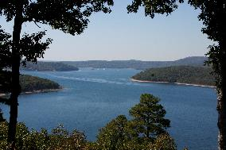
We would like your feedback to better understand your experiences and preferences regarding Raystown Lake! This survey will provide insight for the Raystown Lake Master Plan Revision which will guide management of the project into the future.
The survey is brief and will take approximately 12 minutes to complete. Please complete this paper survey and return in the paid envelope provided (or you may drop the completed survey off at the Raystown Visitor Center). Responses will be accepted [date] to [date], so we kindly ask that you complete the survey at your earliest convenience.
If you would like to complete this survey online, please use the following website with this onetime access code
[web URL] Access Code:
If you have questions or would like more information, please contact the Raystown Lake Operations Project Manager at (814) 658-6803.

THANK YOU FOR HELPING WITH THIS IMPORTANT EFFORT TO UNDERSTAND PEOPLE’S EXPERIENCES AND PREFERENCES FOR BOATING AT RAYSTOWN LAKE
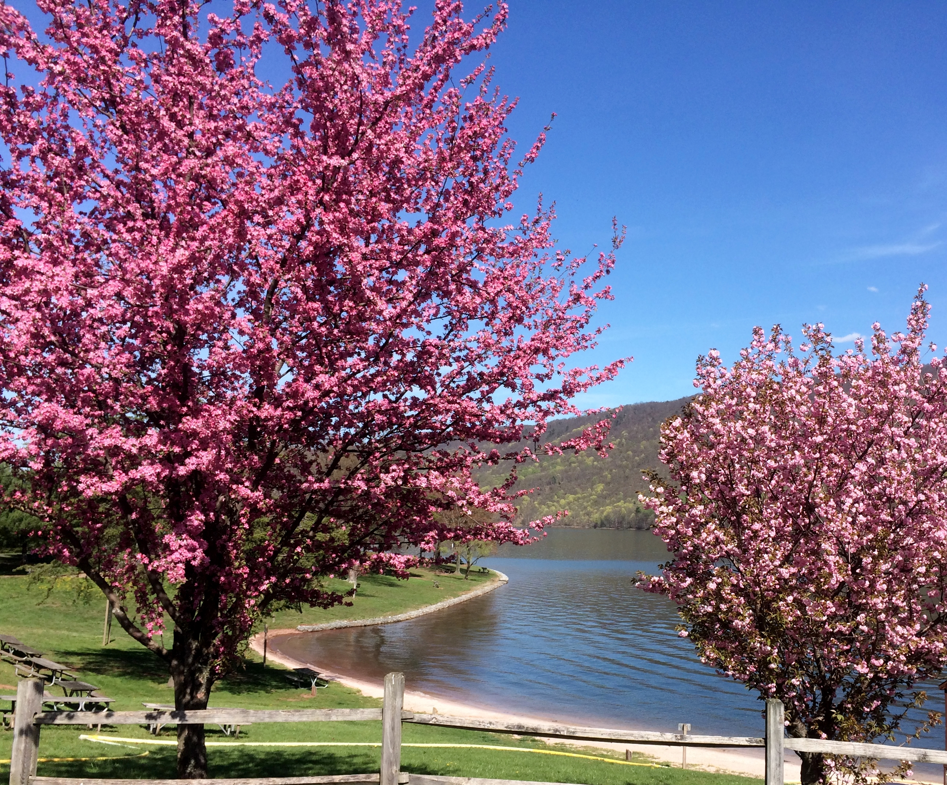
Agency Disclosure Statement
The public reporting burden for this collection of information, 0596-0236, is estimated to average 10 minutes per response, including the time for reviewing instructions, searching existing data sources, gathering and maintaining the data needed, and completing and reviewing the collection of information. Send comments regarding the burden estimate or burden reduction suggestions to the Department of Defense, Washington Headquarters Services, at whs.mc-alex.esd.mbx.dd-dod-information-collections@mail.mil. Respondents should be aware that notwithstanding any other provision of law, no person shall be subject to any penalty for failing to comply with a collection of information if it does not display a currently valid OMB control number.
PLEASE DO NOT RESPOND TO THE ABOVE ADDRESS
Responses should be directed to:
[address]

Privacy Act Statement
Authority: The Flood Control Act of 1944, as amended; 33 U.S.C. 652, Engineer Regulations 1130-2-550 Recreation Operations and Maintenance Policies and 1130-2-540 Environmental Stewardship Operations and Maintenance Policies
Principal Purpose: The information you provide will be combined with other visitor's information to understand opinions and preferences related to boating at Raystown Lake as part of a larger master planning effort.
Routine Use: No PII is collected as part of this survey. For more information on DOD routine uses, visit http://dpcld.defense.gov/Privacy/SORNsIndex/Blanket-Routine-Uses/
Disclosure: Participation in this survey is voluntary and there are no penalties for refusing to provide any information. If you do not provide a response, it may affect the completeness and accuracy of the statistical results

Please continue to the next page

Please reference this map when answering Questions 7-9 and 12-14.
Raystown Lake Boater Survey

A. User Characteristics
1. Where do you live? (provide information for your primary residence)
____________________________ _____ __________ ___________________
City State Zip Code Country (if not US)

2a. Which of the following activities have you participated in during your trip(s) to Raystown Lake? (Check one box for each item)
 | Participate In | Do Not Participate In
A. Boating
B. Walking/Short hike (less than 1 hour)
C. Day hiking (more than 1 hour)
D. Backpacking (# of nights): ______
E. Camping
F. Picnicking
G. Swimming
H. Shoreline Fishing
I. Mountain biking
J. Creative arts (photography/drawing/ painting/writing)
K. Other (Please specify): __________________________________

2b) Which of the activities listed in Question 2a is generally your primary activity at Raystown Lake?

Letter of primary activity: _________ (from list above)

For Boating (row A, question 2a above), if you selected:
“Participate in” - please continue to question 3 on the next page.
“Do Not Participate in” - please skip to Questions 27-29 on page 9.

The yellow numbered circles are Mile Markers. Add north south, add zone label

A. Boating Questions
3. How many years have you been boating? (Round up) _____ Years
4. How many years have you been boating on Raystown Lake? (Round up) _____ Years
5. How often do you engage in boating activities on Raystown Lake? (Mark one)
First time
Less than once per year
1-5 times per year
6-10 times per year
11-15 times per year
16-20 times per year
21 times or more per year

6. How experienced are you in the operation of a boat? (Mark only one)
Very inexperienced | Inexperienced | Experienced | Very experienced

7. During a typical boating trip on Raystown Lake, please indicate the primary area where you (and your group) do most of your recreation activities. Use the map included with this survey as a reference. (Mark only one zone)
Zone 1  (Mile Markers 1-4) | Zone 2  (Mile Markers 4-12) | Zone 3  (Mile Markers 12-16) | Zone 4  (Mile Markers 16-25) | Zone 5  (Mile Markers 25-28) | No primary location

8. Generally, where do you (and your group) enter Raystown Lake for boating? Use the map included with this survey as a reference. (Mark only one zone)

Zone 1  (Mile Markers 1-4) | Zone 2  (Mile Markers 4-12) | Zone 3  (Mile Markers 12-16) | Zone 4  (Mile Markers 16-25) | Zone 5  (Mile Markers 25-28) | No primary location

9. What is the farthest mile marker you reach in both directions on a typical boating trip? Use the map included with this survey as a reference. Mile markers are the yellow circles. Please enter the value next to the circle that represents the:

_____ Northern-most Mile Marker you reach _____ Southern-most Mile Marker you reach

Please continue to the next page
10. Please provide the type and size of the primary boat used by you and other persons in your party at Raystown Lake and whether this boat was trailered to the lake or kept at a marina on the lake.
Boat Type  (Mark one) | Boat Size  (Mark one) | Was this boat transported (e.g., trailered or car/truck roof) to the lake? (Mark one)
  - I don't know
  - Runabout/Speedboat
  - Ski or Wake Boat
  - Fishing boat/bass boat
  - Pontoon boat
  - House boat
  - Cabin cruiser
  - Sailboat/Sailboard
  - Personal Watercraft (e.g. Jet Ski)
  - Rowboat/Kayak/Canoe
  - Other ___________________
  - less than 16'
  - 16 - 20'
  - 21 - 28'
  - 29'+
  - Trailered/transported to the lake
  - Kept at a marina on the lake
  Slip #________________
Do you own, rent or borrow your boat?
(Mark one)
- Own

- Rent

- Borrow
 |  | Where do you store your boat? (Mark one)
- Marina

- Private Parking Lot/Storage Facility

- Private Residence

11. On a typical visit, what percent of your time do you spend on the following activities while boating on Raystown Lake? (Consider time spent getting to or moving between fishing locations as "Fishing")
Fishing _______ %
Cruising _______ %
Swimming _______ %
Water Skiing _______ %
Relaxing/Sunning _______ %
in boat (stationary)
Other activities _______ % ...please describe_______________________
(BE SURE THE TOTAL = 100%)

Please continue to the next page
12. Do you have a favorite location to go on this lake? No Yes

If Yes, describe below:

Name of favorite location: _________________________________________

Why is that your favorite location: __________________________________

________________________________________________________________

Mile Marker: ______ (Use the map as a reference, mail markers are yellow numbered circles)

13. Are there any locations on this lake that you deliberately avoid? No Yes

If Yes, describe below:

Name of location to avoid: _________________________________________

Why do you avoid that/those locations: _______________________________

________________________________________________________________

Mile Marker: ______ ((Use the map as a reference, mail markers are yellow numbered circles)

14. Are there any locations on this lake where you feel unsafe? No Yes
If Yes, describe below:

Name of location is unsafe: _________________________________________

Why do you feel unsafe at that/those locations: ________________________

________________________________________________________________

Mile Marker: ______ (Use the map as a reference, mail markers are yellow numbered circles)

15. On a scale of 1 to 10 (with 10 being the perfect trip), how would you generally rate the quality of your boating experience? ____________

Please continue on next page

B. Management Questions
16. How much of a problem is there from too many boats on the lake? (Check one)
Not a problem at all | Small Problem | Moderate Problem | Big Problem

17. How safe do you generally feel while boating or launching your boat at the following locations? (Circle number that reflects your opinion)
Location | Not at all safe | Somewhat safe | Moderately safe | Extremely safe | Not Applicable
At the boat ramp | 1 | 2 | 3 | 4 | NA
On the water | 1 | 2 | 3 | 4 | NA
Marina | 1 | 2 | 3 | 4 | NA

18. How crowded do you generally feel at the following locations? (Circle number that reflects your opinion)
Location | Not at all crowded | Somewhat crowded | Moderately crowded | Extremely crowded | Not Applicable
At the boat ramp | 1 | 2 | 3 | 4 | NA
On the water | 1 | 2 | 3 | 4 | NA
Marina | 1 | 2 | 3 | 4 | NA

19. How much, if at all, has the noise from other boats reduced your enjoyment of Raystown Lake? (Mark one)
Not at All | Slightly | Somewhat | Quite a Bit | Extremely

20. How likely is it that the presence of too many boats would cause you to avoid your favorite parts of Raystown Lake? (Mark one)
Not at All Likely | Slightly Likely | Somewhat Likely | Quite Likely | Extremely Likely

Please continue on next page

21. For each of the following, please indicate if you feel that at Raystown Lake there are too few, adequate, too many, or don’t know. (Mark one in each row)

Boat Ramps | Too few | Adequate | Too many | Don’t know
Parking Areas | Too few | Adequate | Too many | Don’t know
Waterways Conservation Officers | Too few | Adequate | Too many | Don’t know
Park Rangers | Too few | Adequate | Too many | Don’t know
Marinas | Too few | Adequate | Too many | Don’t know

22. Have you noticed any positive or negative changes at this lake in the last five years?
If you have, please describe the changes below

Positive: ________________________________________________________

Negative: _______________________________________________________

If you have noticed changes, have these changes affected your enjoyment or use of Raystown Lake?

Positive: ________________________________________________________

Negative: _______________________________________________________

23. Which of these statements best describes your expectation for the number of boats on Raystown Lake? Please refer to your last outing on the lake when answering this question.
(Mark one)
I saw FEWER boats than I expected to see that day
I saw ABOUT AS MANY boats as I expected to see that day
I saw MORE boats than I expected to see that day
23b. Please indicate the date of your last outing:
______________(month) ______________(day) _____________(year)
Please continue on next page
24. Which of these statements best describes your preference for the number of boats on the lake? Please refer to your last outing on the lake when answering this question. (Mark only one)
I saw ABOUT AS MANY boats than I wanted to see that day
I saw FEWER boats as I wanted to see that day
I saw MORE boats than I wanted to see that day
25. To what extent do you agree or disagree with each of the following statements? (Circle number that reflects your level of agreement for each statement)
Statement | Strongly Disagree | Disagree | Neutral | Agree | Strongly Agree
a) I generally stay off the lake during parts of the day/week because there are too many boats on the lake. | 1 | 2 | 3 | 4 | 5
b) My boating trips are generally not as enjoyable as I expect them to be. | 1 | 2 | 3 | 4 | 5
c) There are generally an unsafe number of boats on the water. | 1 | 2 | 3 | 4 | 5
d) Other boats generally come closer to my boat than I like. | 1 | 2 | 3 | 4 | 5
e) My boat trip(s) are generally well worth the money I spend to take them. | 1 | 2 | 3 | 4 | 5
f) The behavior of other boaters generally interfered with the quality of my boating experience. | 1 | 2 | 3 | 4 | 5
g) I generally do not like the amount of time I have to wait to get on the water. | 1 | 2 | 3 | 4 | 5
h) Boating conditions on the lake are generally safe. | 1 | 2 | 3 | 4 | 5
i) All boaters should be required to wear a Personal Floatation Device (PFD) while boating. | 1 | 2 | 3 | 4 | 5
j) I generally do not participate in some boating activities because of crowded conditions at the lake. | 1 | 2 | 3 | 4 | 5
k) The size of the boats that I generally see on Raystown Lake is acceptable in terms of my experience. | 1 | 2 | 3 | 4 | 5
l) The speed used by other boaters is generally safe. | 1 | 2 | 3 | 4 | 5
Please continue to the next page
26. Which photo shows the maximum number of boats you could see at one time on Raystown Lake WITHOUT thinking it was crowded? (Circle one)
A | B | C | D | E | I don’t think it looks crowded in any of the photos

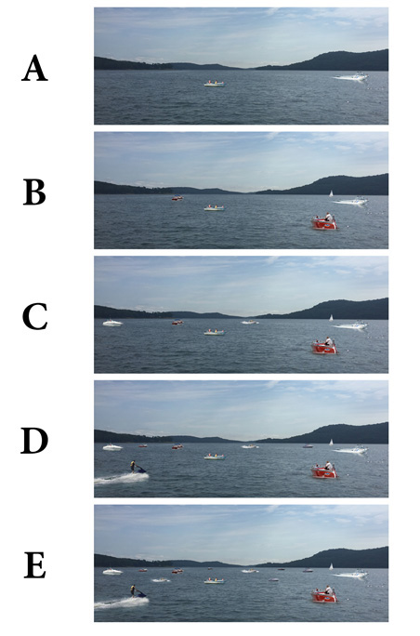

Please continue to the next page
C. Basic Demographics
27. What is your gender? (Mark one) Female Male Other

28. What is your age? (Mark one)
Under 18
18 – 24
25 – 44
45 – 54
55 – 64
65+

29. Please indicate the highest level of education you have completed? (Mark one)
Less than high school
High school graduate/GED
Vocational or Technical School certificate
Associates Degree
Some college
Bachelor’s degree
Graduate degree or professional degree (MA, MS, PhD, JD, MBA etc.)

Thank you for taking the time to complete this survey.
Your responses are important and will help inform the
future management of Raystown Lake.

Please return your completed survey in the
postage paid envelope provided.

