OMB CONTROL NUMBER: XXXX-XXXX

OMB EXPIRATION DATE: XX/XX/XXXX

**AGENCY DISCLOSURE NOTICE**

The public reporting burden for this collection of information, 0702-XXXX, is estimated to average 60 minutes per response, including the time for reviewing instructions, searching existing data sources, gathering and maintaining the data needed, and completing and reviewing the collection of information. Send comments regarding the burden estimate or burden reduction suggestions to the Department of Defense, Washington Headquarters Services, at whs.mc-alex.esd.mbx.dd-dod-information-collections@mail.mil. Respondents should be aware that notwithstanding any other provision of law, no person shall be subject to any penalty for failing to comply with a collection of information if it does not display a currently valid OMB control number.

**PLEASE DO NOT RETURN YOUR RESPONSE TO THE ABOVE ADDRESS.**

Responses should be sent to US Army Public Health Center, ATTN: Dr. Coleen Baird, 5158 Blackhawk Road, Aberdeen Proving Ground, Maryland 21010-5403.

**Post Deployment Health Survey**

**You may also complete this questionnaire online at htpps://aphc.secure.survey.mil**

|  |  |  |  |  |  |
| --- | --- | --- | --- | --- | --- |
| **Instructions**   * Use BLUE or BLACK ink. * Shade circles like this: ● * Cross out mistakes with an “X”.   *This question is modeled from question 15 of the Milco Survey* • Print in CAPITAL LETTERS.   * Avoid contact with the edge of the box, like this:  |  |  |  |  |  | | --- | --- | --- | --- | --- | | **H** | **E** | **L** | **L** | **O** | |

**M M / D D / Y Y Y Y**

1. What is today’s date?
2. **Has your doctor or other health professional ever told you that you have any of the following conditions?**

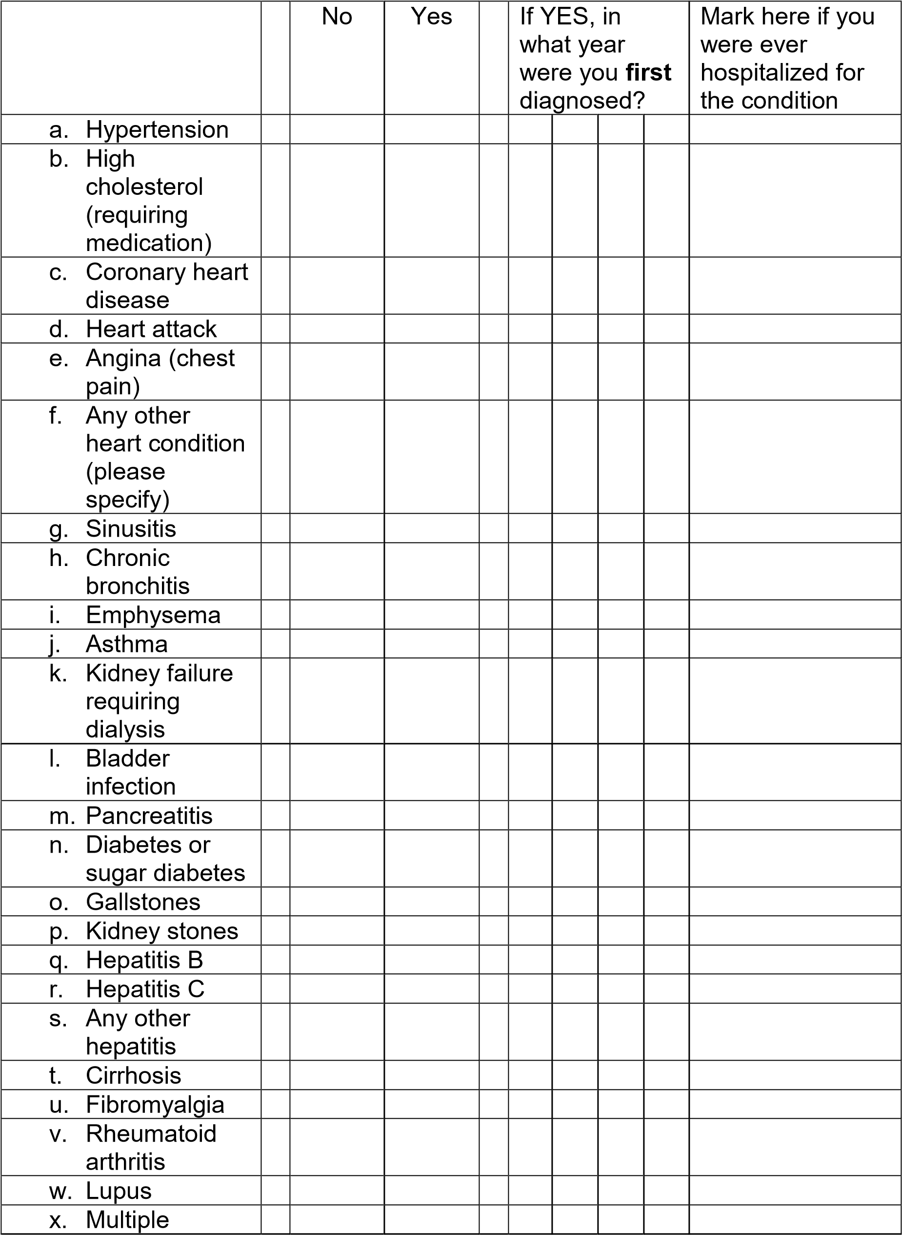

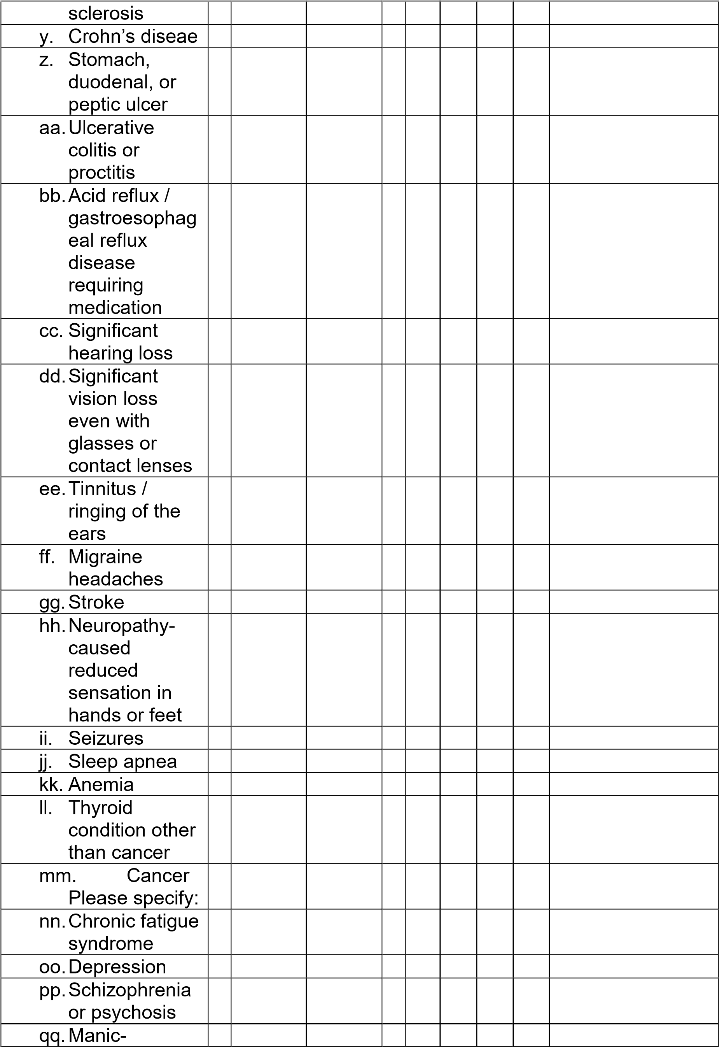

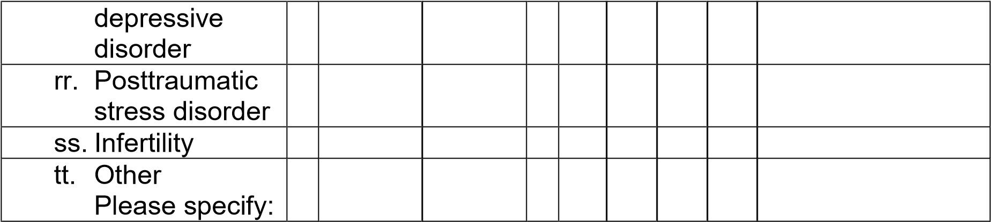

1. **During the last 12 months, have you had persistent or recurring problems with any of the following?**

|  |  |  |  |  |  |
| --- | --- | --- | --- | --- | --- |
|  | No | Yes |  | No | Yes |
| a. Severe headache |  |  | k. Night sweats |  |  |
| b. Diarrhea |  |  | l. Chest pain |  |  |
| c. Rash or skin ulcer |  |  | m. Unusual muscle pains |  |  |
| d. Sore throat |  |  | n. Shortness of breath |  |  |
| e. Frequent bladder infections |  |  | o. Trouble sleeping |  |  |
| f. Cough |  |  | p. Unusual fatigue |  |  |
| g. Fever |  |  | q. Forgetfulness |  |  |
| h. Sudden unexplained hair loss |  |  | r. Confusion |  |  |
| i. Earlobe pain |  |  | s. Other  Please specify: |  |  |
| j. Sleepy all the time |  |  |  |  |  |