Gonococcal Isolate Surveillance Project
OMB 0920-0307
Sancta St. Cyr, Project Officer
Attachment 4
Screenshots of GISP Web Application

Screenshot of GISP web application Main Menu:
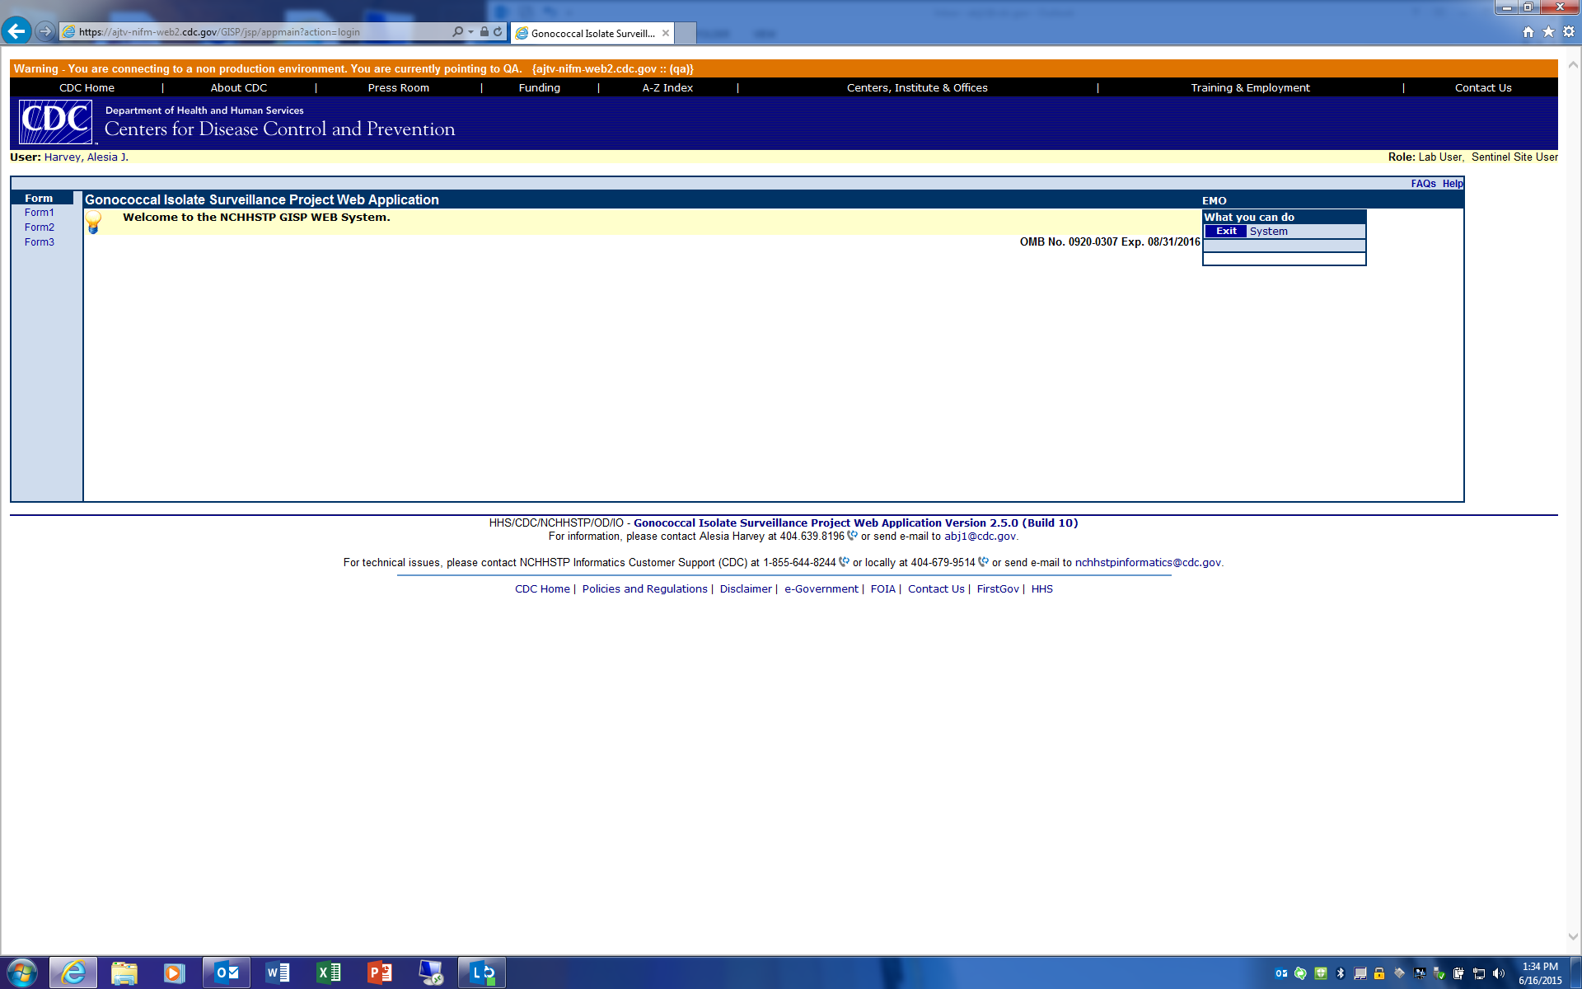

Screenshot of Demographic/Clinical Data Entry for clinics conducting core activities
