Request for Non-substantive Change
Blood Lead Surveillance System (BLSS)
OMB Control No. 0920-0931
Expiration date 05/31/2021

Justification for Non-substantive change:
The National Institute for Occupational Safety and Health (NIOSH) is requesting a change request in response to the following Terms of Clearance included in the Notice of Action (NOA) for 0920-0931:
TERMS OF CLEARANCE: Within two months of the approval of this ICR, CDC will submit a non-substantive change request confirming updates to the public-facing website reflecting the new language as indicated in the supplementary document associated with this package. Approved consistent with CDC’s commitment to always communicate that these data do not provide for nationally representative prevalence estimates, due to the fact that not all states participate in CBLS and ABLS, as well as differences in jurisdictional screening practices and
laboratory reporting requirements among state and local jurisdictions. However, use of the consistent case definition allows for estimating needs at the Federal, state, and local level which is important for establishing national program goals and objectives. In addition, CDC commits to working with CMS to better capture Medicaid-required test results and decrease duplicative requirements on States.

NIOSH would like to confirm that the ABLES content is finalized on the website. We also put an emphasis on occupational lead exposure and linked it back to HP2020 goal. In addition, we added a webpage detailing ABLES standardized variables, format, and instruction for data submission. Below are the websites and screenshots with the updated information. NIOSH would like to request that the NOA be updated to reflect the finalized website.

- ABLES main page : https://www.cdc.gov/niosh/topics/ables/default.html
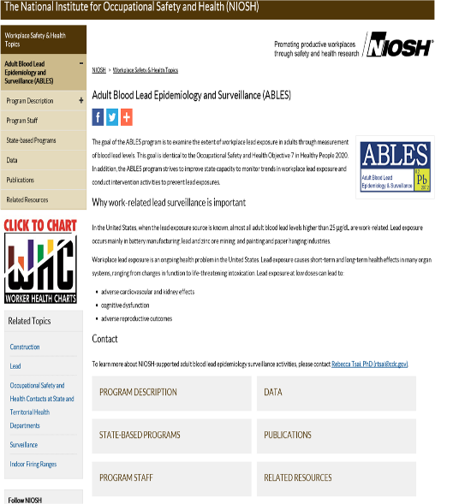

- ABLES program description page: https://www.cdc.gov/niosh/topics/ables/description.html
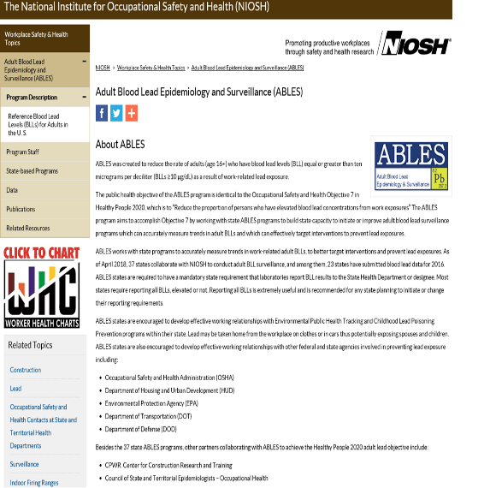

3) ABLES standardized variable, format page: https://www.cdc.gov/niosh/topics/ables/statesub.html
