1. How did you learn about this event today? (Please check all that apply and describe)
- Direct mail  - Flyer  - Publication: __________ |  |  |  |  |  | - Friends/family  - Internet  - News: ______________ |  |  |  |  |  | - Radio: ______________  - WHB Staff: __________  - Other: ______________ |  |  |  |  | - TV Interview: _________  - Social Media: _________
2. Why did you come today? Was it to …(Please check all that apply)
- Adopt an animal  - Purchase an animal  - Learn about program |  |  |  | - Meet past adopters/talk to trainers  - Pick up animal (from Internet adoption)  - See the animals |  |  |  |  |  |  |  |  |  | - See other events (not adoption related)  - Other: ___________________________
3. IF YOU DID NOT ADOPT/PURCHASE AN ANIMAL TODAY: Why not? (Please check all that apply)
- Did not come to buy or adopt
- Too expensive
- Did not see what I wanted; I wanted a |  |  |  |  |  |  |  |  | - Sale horse |  |  |  |  | Different colored horse
 |  |  |  |  |  |  |  |  | - Trained horse |  |  |  |  | Younger horse
 |  |  |  |  |  |  |  |  | - Burro |  |  |  |  | Smaller horse or pony
 |  |  |  |  |  |  |  |  | - Bigger horse |  |  |  |  | Other: ____________________________
4. Have you adopted or purchased a wild horse or burro before?
- Yes Was it Adopted Purchased |  |  |  |  |  |  |  |  |  | - No Have you owned a domestic horse or burro? Yes No
5. How far are you willing to travel to attend an event like this? ___________ Miles or ___________ Hours
6. When is it convenient for you to attend? M Tu We Th Fri Sa Su Morning Afternoon Evening
7. Are you in your: |  | Teens |  |  | 20s |  |  | 30s |  |  | 40s |  | 50s |  | 60s and older |  |  | 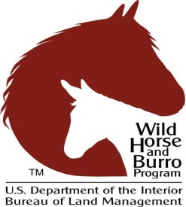
8. Are you: | - Male |  | - Female |  |  |  | Zip Code: ___________________________ |  |  |  |  |  |  |  |  | 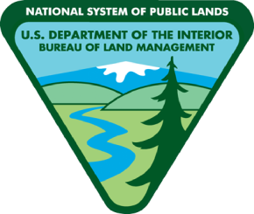
Bureau of Land Management- Wild Horse and Burro Program Please tell us a little about yourself…
Event Code
FORM APPROVED OMB NO. 1090-0011 (Expires: 10/31/2021)

Expires

Paperwork Reduction Act and Privacy Act Statement
The purpose of this survey is to provide information to the Bureau of Land Management for evaluating and improving the wild horse and burro program. Response to this survey is voluntary. Your response to this request is voluntary and anonymous. Your name will never be associated with your answers, and all contact information will be destroyed when the information collection is concluded. No action may be taken against you for refusing to supply the information requested. The reporting burden for this form is estimated to average 1 minute, which includes the time for reviewing instructions and completing and reviewing the form. An agency may not conduct or sponsor, and a person is not required to respond to, a collection of information unless it displays a currently valid Office of Management and Budget (OMB) control number. Please direct comments regarding the burden estimate or any other aspect of this form to: U.S. Department of the Interior, Bureau of Land Management (1090-0011), Bureau Information Collection Clearance Officer (WO-630), 1849 C Street, N.W., Room 2134LM, Washington, D.C. 20240.

