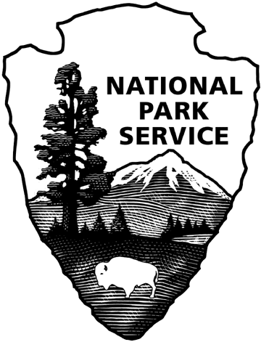 OMB Number: 1090-0011
Expires 10/31/2021

Carter G. Woodson Home National Historic Site
Visitor Questionnaire

PAPERWORK REDUCTION and PRIVACY ACT STATEMENT: The Paperwork Reduction Act requires us to tell you why we are collecting this information, how we will use it, and whether or not you have to respond. We are authorized by the National Park Service Protection Interpretation and research in System (54 USC §100702) to collect this information. The routine uses of this information will be for the benefit of NPS Managers and Planning Specialists of the Carter G. Woodson Home National Historic Site in future initiatives related to the site rehabilitation and exhibit planning. The data collected will be summarized to evaluate visitor uses and expectations. Your responses to this collection are completely voluntary and will remain anonymous. You can end the process at any time and will not be penalized in any way for choosing to do so. All paper versions of the information collected will be destroyed at the end of the collection period and no personal identifiable records will be maintained or stored for any purposes. Data collected will only be reported in aggregates and no individually identifiable responses will be reported. A Federal agency may not conduct or sponsor, and you are not required to respond to, a collection of information unless it displays a currently valid OMB Control Number (1090-0011). We estimate that it will take about 5 minutes to complete this questionnaire. You may send comments concerning any aspect of this information collection to: Phadrea Ponds, NPS Information Collection Coordinator, Fort Collins, CO 80525, pponds@nps.gov (email).

(Name of Site)

The National Park Service (NPS) and the Association for the Study of African American Life and History, Inc. (ASALH) have been working cooperatively to restore the circa 1870's home of Dr. Carter G. Woodson. Known as the “father of black history,” Dr. Woodson established the academic study of African American life and history. The completed site will provide a unique opportunity for visitors to experience the very place where Dr. Woodson lived and worked as he and ASALH brought African American history to life.

The purpose of this brief survey is to assist NPS and the design team with determining the requirements and approach to the new exhibit design at the Carter G. Woodson Home and its adjacent buildings.
Your responses will help guide the design of the building and interpretive exhibits. Thank you for your time!

1. What is your age? __

These questions will only be asked at CAWO
2. Please select the choice below that best describes your traveling party. (Please select only one)
Individual
Family only
Friends only
Family plus friends
Tour or other group

3. When deciding to visit a historical home or landmark, how important is the ability to park near the site?
Not important
Slightly important
Moderately important
Very important
Extremely important

4. How knowledgeable are you on the topic of Carter G. Woodson?
Not knowledgeable at all
Somewhat knowledgeable
Extremely knowledgeable

5. Would you consider visiting the Carter G. Woodson Home again?
Yes, likely
No, unlikely
Not sure
Why or why not? __ [visitor response]

These questions will only be asked at FRDO, MALU and AACWM

6. Would you consider visiting the Carter G. Woodson Home?
Yes, likely
No, unlikely
Not sure
Why or why not? __ [visitor response]

7. How much time would you be willing to spend learning more about Carter Woodson and his work?
Less than 30 minutes
Between 30 – 60 minutes
More than 60 minutes

8. If you were to visit the Carter G. Woodson Home, which of the following additional facilities would you like to have available? Please select all that apply:
Bookshop / Giftshop
Library / Research Room
Meeting Room
Classroom or community room

9. If you were to visit in the future, how would you prefer to learn about the history of Carter Woodson, his home, and his work? Please select all that apply:
Not interested in learning about any of these topics
Films
Audio (headphones)
Photographs, posters and other graphics
Original artifacts and furnishings
Guided tours
Digital media (like touch-screen interactives, animated maps, kiosks, etc)
Content you access using your smartphone
Hands-on, participatory activities
Other, please specify:__ [visitor response]

This question will only be asked at CAWO

10. Which of the following forms of transportation did you use to reach the location you’re visiting today?
Please select one:
Personal vehicle/rental car
Taxi or commercial ride service (Uber, Lyft)
Tour bus or van
Bicycle
Walk
Public transportation (Metro bus, train or shuttle)

