Request for Approval under the “DOI Generic Clearance for the Collection of Qualitative Feedback on Agency Service Delivery”
OMB Control Number: 1090-0011 (Expires 10/31/2021)
TITLE OF INFORMATION COLLECTION: Feedback from Phone Customers

ATTACHMENT 1 -- CUSTOMER SERVICE FEEDBACK FLOW CHART

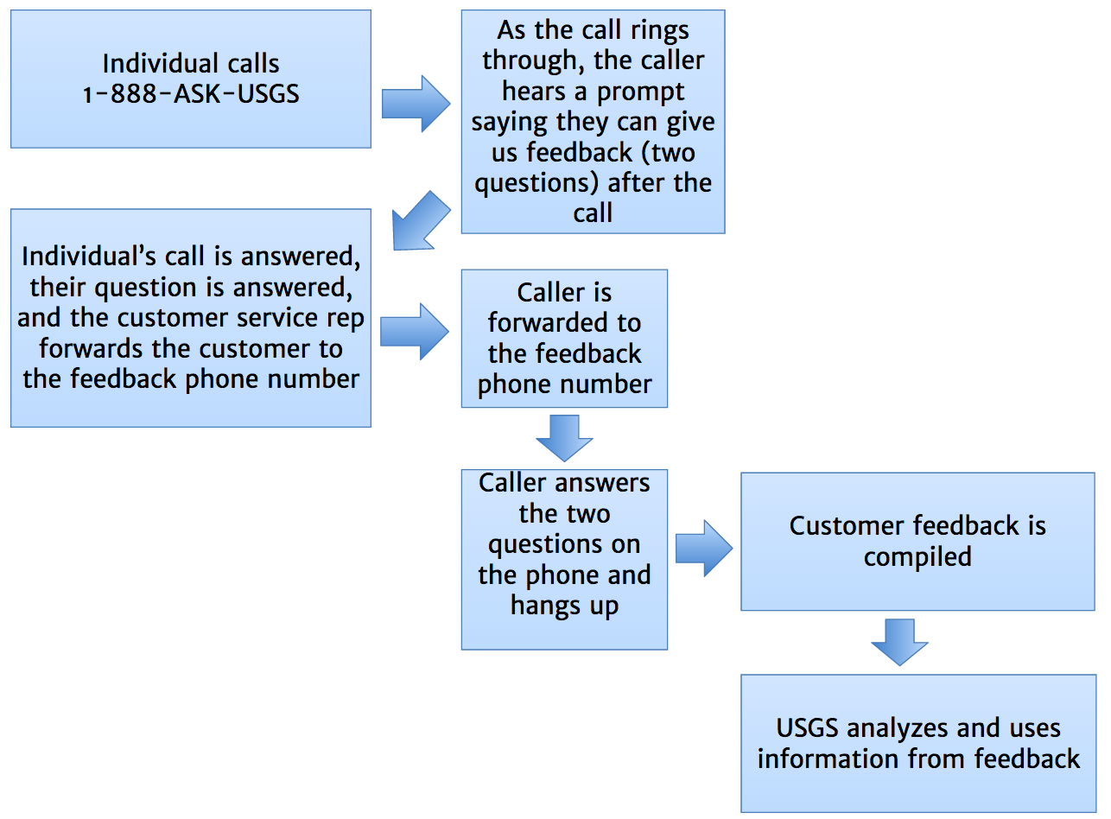

ATTACHMENT 2 -- PHONE FEEDBACK PROCESS OVERVIEW

This is a brief description of the proposed process in which USGS will enable customers who phone USGS with science questions to rate their service and provide ideas for improved phone service. Note that this process is low-cost and easy to implement. USGS will benefit by having an aggregate “score” to measure how well we are doing with phone customer service and open-ended suggestions for improvements from real customers.

1. An individual contacts the USGS by phone to ask a question about USGS science. (The USGS currently receives about 15,000 customer service phone calls each year.)

2. When the call is being placed, the caller is informed they will have an opportunity to give feedback after the call is over: “You are invited to answer two short questions about our service today. At the end of this call our agent will forward you to the audio survey.”

3. The call is answered by the Science Information Services (SIS) staff and the caller’s question is answered.

4. Before hanging up, the customer service agent forwards the call; the caller stays on the line to answer the questions.

5. The caller is greeted and then hears, “On a scale of 1 to 5, where 1 indicates “very poorly,” 2 indicates “poorly,” 3 indicates “average,” 4 indicates “well,” and 5 indicates “very well,” how well did our USGS customer service representative answer your question or resolve your problem?”
[Customer presses a number on the keypad or says 1, 2, 3, 4, or 5.]

6. The caller then hears, “In your own words, what would you suggest to help USGS improve our phone customer service? Press # when you are done speaking. ”
[Customer speaks the response]

7. The caller presses # when done, and they hear, “Thank you for your feedback and for calling the U.S. Geological Survey today. Good-bye.”

8. Data from all the respondents are compiled in Survey Monkey, which provides USGS analysts with the rating and sound files an transcribed text of the open-ended feedback for evaluation and prioritization.

