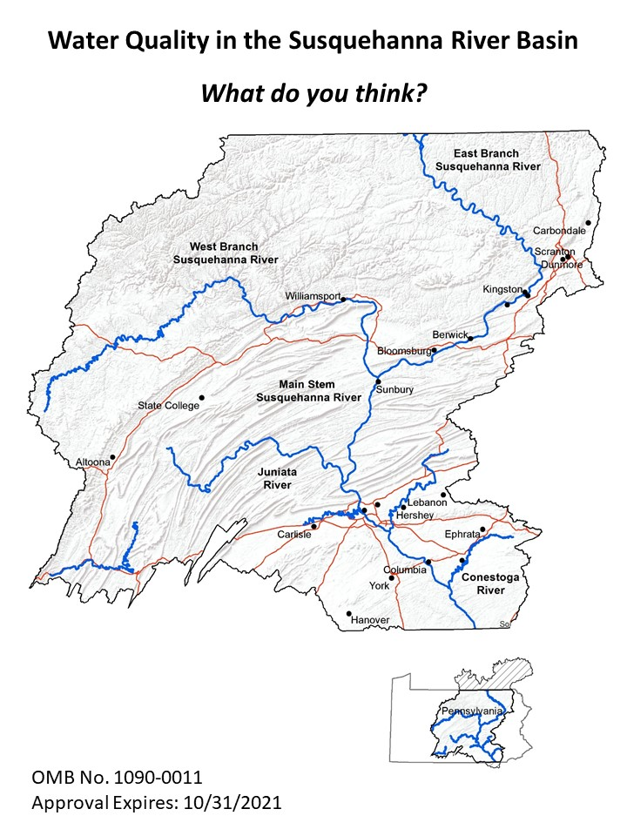

**The Susquehanna River**

* The Susquehanna River, with its streams and tributaries, is the largest river system lying entirely within the United States that drains into the Atlantic Ocean.
* The Susquehanna River flows from New York through Pennsylvania to Maryland, and is the largest river flowing into the Chesapeake Bay.
* The Susquehanna River watershed covers 27,510 square miles, ¾ of which are in Pennsylvania.

**This survey focuses only on the portion of the Susquehanna River within the state of Pennsylvania.**

* The Susquehanna River supplies nearly 750,000 Pennsylvanians with tap water for drinking.
* The Susquehanna River provides water for manufacturing, agriculture, and power plants that generate electricity.
* The Susquehanna River contains a network of dams that are used for power generation and flood control.
* The Susquehanna River and the other waterways in the river system are popular with locals and tourists for recreation such as fishing, kayaking, canoeing, and motor-boating.
* The Susquehanna River provides habitat for fish, eels, and freshwater mussels.

**Water quality problems in the Susquehanna River**

Historic and current uses within portions of the Susquehanna River have resulted in several types of contamination:

* Sediment and excess nutrients that run off from farm fields (crops and livestock), lawns, and poorly treated sewage, pollute about 4,200 stream miles—nearly 1 of every 10 miles of the Susquehanna River and its tributaries.
* Stormwater runoff from residential streets, driveways, businesses and development such as construction, mining, and industry contains contaminants such as fertilizer, pesticides, herbicides, excess nutrients, sediment and other pollutants that pollute about 1,200 stream miles of waterways.
* Other sources of contaminated (usually acidic) water from old mining operations.

**This survey focuses on excess nutrients (e.g., nitrogen and phosphorus) and sediment (e.g., sand and soil).**

**Excess nutrients** and **sediment** result in poor water quality, the consequences of which are:

* Increased **Algae Blooms –** Algae reproduce rapidly, a situation called an algae bloom, which can lead to low levels of oxygen in the water (which adversely affects some fish species such as trout). Some of these blooms are harmless, but some blooms can contain toxins, other harmful chemicals, or pathogens.
* Changes in **Fish Species –** Cool or cold water fish species (e.g., trout, chub) are replaced by other fish species (e.g., carp, largemouth bass, channel catfish) that can tolerate low levels of oxygen.
* Reduced **Biodiversity –** Fewer plant and animal species are found in the water, and some species that are normally present are missing.
* Degraded **Aesthetics** – The water turns green, limiting the depth to which one might see. The water may also have a strong and unpleasant odor.
* Lower quality **Recreation** – The quality of swimming, fishing or boating experiences will diminish. On rare occasions, people may experience a skin rash after coming into contact with the water.
* Degraded **Drinking Water Aesthetics** – Increased chance of municipal drinking water having an earthy or musty taste and/or smell, despite being treated to the standards of the Safe Drinking Water Act.

**Improving Water Quality in the Susquehanna River in Pennsylvania**

**Is it important to you?**

When you think about the potential to improve water quality in the streams and waterways that feed into the Susquehanna River and the Susquehanna River itself, please tell us, how much, if at all, improving water quality is important to you for each of the reasons below.

|  |  |  |  |  |
| --- | --- | --- | --- | --- |
|  | **Not at all important** | **Somewhat important** | **Important** | **Very important** |
| 1. To provide clean drinking water for current and future generations | 🞏 | 🞏 | 🞏 | 🞏 |
| 1. To provide clean water for industry | 🞏 | 🞏 | 🞏 | 🞏 |
| 1. To provide habitat for eels, mussels and fish | 🞏 | 🞏 | 🞏 | 🞏 |
| 1. To improve recreation opportunities for me and my family | 🞏 | 🞏 | 🞏 | 🞏 |
| 1. To ensure that future generations have recreation opportunities | 🞏 | 🞏 | 🞏 | 🞏 |
| 1. To ensure that all streams in the Susquehanna River system (even those not frequently used by people) are clean | 🞏 | 🞏 | 🞏 | 🞏 |
| 1. To provide clean water for agriculture | 🞏 | 🞏 | 🞏 | 🞏 |
| 1. Other (please describe in the space below) | 🞏 | 🞏 | 🞏 | 🞏 |
|  |  |  |  |  |
|  |  |  |  |  |

**Your Personal Experience with Water Quality in the Susquehanna River**

|  |  |  |  |
| --- | --- | --- | --- |
|  | **Yes** | **No** | **Don’t know** |
| 1. Do you regularly buy bottled water for drinking because of the taste or color of your tap water? | 🞏 | 🞏 | 🞏 |
| 1. Have you caught fish in the Susquehanna River or any of its tributaries that were deformed or had unusual coloring or other defects? | 🞏 | 🞏 | 🞏 |
| 1. Do you avoid visiting any areas along the Susquehanna River or any tributaries because the water is unpleasant looking due to algae? | 🞏 | 🞏 | 🞏 |
| 1. Other (please explain below) |  |  |  |
|  |  |  |  |
|  |  |  |  |

**Susquehanna River Water Quality Improvement Program**

The State of Pennsylvania is considering a Susquehanna River Water Quality Improvement Program. This program would focus on efforts to reduce pollution from stormwater run-off as well as sediment and nutrients from farms and lawns. Other programs will focus on additional water quality issues such as acid mine drainage. This survey focuses only on a potential program to address sediment and excess nutrient pollution.

**The goal of the Susquehanna River Water Quality Improvement Program would be to reduce sediment and excess nutrient pollution by 20%.**

**This would be done by:**

* Installing stormwater treatment systems that intercept stormwater and clean it before it goes into streams on 1,200 stream miles of waterways currently polluted by stormwater runoff.
* Building wetland detention ponds and increasing streamside vegetation buffers to intercept sediment and excess nutrients from farms and lawns to prevent them from flowing into 4,200 miles of streams and waterways currently polluted by sediment and excess nutrients.
* A multi-vegetation stream buffer approach that combines initial planting of grass (that would be effective immediately) and tree buffers would be planted to cut in half the algae producing nutrients (nitrates, phosphorous) and sediment from entering the stream along segments where planted. The tree buffers would be effective at reducing nutrients and sediment for 40-120 years.

**The result would be to:**

* Improve the aesthetics (smell and visual appearance) of 5,400 stream miles in the Susquehanna River Basin used for recreational boating, fishing, and swimming.
* Reduce the frequency of algae blooms by 20%, which would increase oxygen and habitat for eels, mussels and fish in 5,400 miles of streams.
* Improve water quality for industrial and agricultural users.
* Improve the clarity of drinking water.

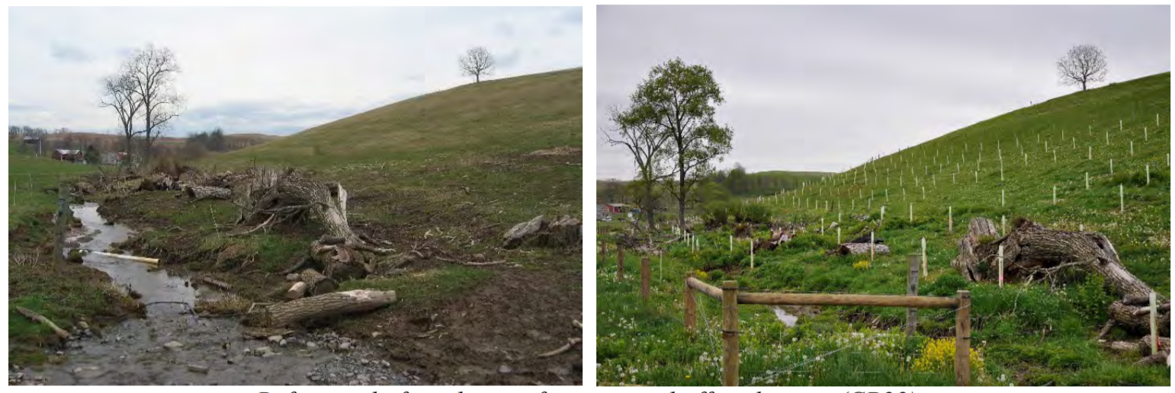

Before riparian buffer planting

After riparian buffer planting

**Paying for the Susquehanna River Water Quality Improvement Program**

Currently, there is insufficient public funding available to improve water quality in the Susquehanna River and streams to the level described in the proposed Susquehanna Water Quality Improvement Program.

To provide the necessary funding, the costs of the proposed Susquehanna River Water Quality Improvement Program would be shared proportionally between households, businesses, agriculture, and industry based on the amount that each type of polluter emits to the river and streams feeding into the Susquehanna River.

If the program is approved, the money raised will be deposited into a dedicated Susquehanna River Water Quality Improvement Fund, which could only be used to improve water quality in the Susquehanna River and streams in Pennsylvania as described in the Susquehanna Water Improvement Program.

A citizen advisory panel would monitor expenditures from the Fund to ensure that they are spent on actions that will result in improved water quality in the Susquehanna River.

If the Susquehanna River Water Quality Improvement Program is implemented in the State of Pennsylvania, your household share of the cost of the program would be paid through an increase in the State of Pennsylvania income tax. The cost to your household would be $X per year.

* Your answers will be used to help the Pennsylvania state government decide whether to implement the Susquehanna River Water Quality Improvement Program.
* The answers you give could affect whether water quality in the Susquehanna River will be improved and the amount of taxes you would pay.
* In responding to this question, please take into account your household’s annual income, whether you can afford to make the payment shown, and whether improvements to water quality in the Susquehanna River are worth that much to you.
* Consider everything else you could buy with the money and whether there are other government programs that you would prefer to see money spent on.

**Your Chance to Vote on the Susquehanna River Water Quality Improvement Program**

|  |  |  |  |
| --- | --- | --- | --- |
| 1. If the cost to your household would be $X per year, would you vote in favor (Yes) or against (No) the Susquehanna River Water Quality Improvement Program? (check one box) | | | |
| Yes | 🞏 | No | 🞏 |

|  |  |  |  |  |  |  |  |  |  |  |  |
| --- | --- | --- | --- | --- | --- | --- | --- | --- | --- | --- | --- |
| 1. On a scale from 1 to 10, where 1 is “very uncertain” and 10 is “very certain,” please circle the number that best describes how certain you are that you would actually vote in a real election the way that you indicated above. | | | | | | | | | | | |
| **Very uncertain** | **1** | **2** | **3** | **4** | **5** | **6** | **7** | **8** | **9** | **10** | **Very certain** |

If you selected “Yes” to Question 1 on the previous page, go to Question 4.

1. If you selected “No” to Question 1 , please tell us why

(check the **single** most important reason):

|  |  |
| --- | --- |
| 🞏 | Improving water quality in the Susquehanna River is not worth that much to me. |
| 🞏 | I can’t afford to pay that much. |
| 🞏 | We need to cut all government spending. |
| 🞏 | Taxes are too high already. |
| 🞏 | I do not believe I pollute the Susquehanna River very much, so the amount that I am being asked to pay is too high. |
| 🞏 | Water quality improvement programs should be paid for with existing tax dollars. |
| 🞏 | I don’t think that water quality is a problem in the Susquehanna River. |
| 🞏 | The proposed improvement program won’t solve the Susquehanna River’s water quality problem. |
| 🞏 | Other (please describe):  ___________________________________________________________________________________________  ___________________________________________________________________________________________ |
|  |  |

|  |  |  |  |  |  |  |  |  |  |  |  |
| --- | --- | --- | --- | --- | --- | --- | --- | --- | --- | --- | --- |
| 1. How certain are you that your vote will actually be used by the State of Pennsylvania in deciding whether to implement the water quality improvement programs for the Susquehanna River? | | | | | | | | | | | |
| **Very uncertain** | **1** | **2** | **3** | **4** | **5** | **6** | **7** | **8** | **9** | **10** | **Very certain** |
| 1. How certain are you that you’ll actually have to pay the State of Pennsylvania tax increase to fund the water quality improvement program? | | | | | | | | | | | |
| **Very uncertain** | **1** | **2** | **3** | **4** | **5** | **6** | **7** | **8** | **9** | **10** | **Very certain** |

**Next, we would like to know about you and your recreational activities.**

Your answers to these questions will only be used to see how well our survey sample represents the state of Pennsylvania. Your answers are confidential. You will not be identified in any way.

1. In the last 12 months, have you participated in any outdoor recreation activities related to the Susquehanna River, its streams, tributaries, or reservoirs?

|  |  |  |  |
| --- | --- | --- | --- |
| 🞏 | Yes🡪 go to question 2 | 🞏 | No 🡪 go to question 4 |

1. Which outdoor recreation activities have you participated in while visiting the Susquehanna River, its streams, tributaries, reservoirs, lakes, or ponds over the last 12 months? (Check **all** that apply.)

|  |  |  |  |
| --- | --- | --- | --- |
| 🞏 | Visited a stream, river or a reservoir | 🞏 | Gone motor-boating |
| 🞏 | Watched birds or other wildlife | 🞏 | Gone camping |
| 🞏 | Gone rafting, canoeing, kayaking or other non-motorized boating | 🞏 | Gone swimming outdoors |
| 🞏 | Gone fishing |
| 🞏 | Other outdoor activities (please describe) ______________________________________________________ | | |

1. In total, how often did you do all the activities you checked above in the Susquehanna River or its streams and tributaries in the last year?

|  |  |  |  |  |  |  |  |  |  |
| --- | --- | --- | --- | --- | --- | --- | --- | --- | --- |
| 🞏 | 1 to 2 times | 🞏 | 3 to 5 times | 🞏 | 6 to 9 times | 🞏 | 10 to 19 times | 🞏 | 20 or more times |

1. Do you belong to any local, state, or national non-governmental organizations whose purpose is to protect water quality, environmental quality, and/or wildlife?

|  |  |  |  |  |
| --- | --- | --- | --- | --- |
| 🞏 | Yes | 🞏 | No | |
| 1. What is your zip code? | | | | | __________________________ | |

|  |  |  |  |  |
| --- | --- | --- | --- | --- |
| 1. Are you: | 🞏 | Male | 🞏 | Female |

|  |  |
| --- | --- |
| 1. In what year were you born? | ________________________ |

|  |  |  |  |  |
| --- | --- | --- | --- | --- |
| 1. Are you retired? | 🞏 | Yes | 🞏 | No |

|  |  |  |  |
| --- | --- | --- | --- |
| 1. What is the highest level of schooling you have completed? | | | |
| 🞏 | Some high school | 🞏 | High school graduate or equivalent |
| 🞏 | Some college or technical school (but no degree) | 🞏 | Associate’s degree (including occupational or academic degrees) |
| 🞏 | Bachelor’s degree (BA, BS, AB, etc.) | 🞏 | Master’s degree (MA, MS, MENG, MSW, etc.) |
| 🞏 | Doctoral degree (PhD, EdD, etc.) | 🞏 | Professional school degree (MD, DDC, JD, etc.) |

|  |  |  |  |  |  |
| --- | --- | --- | --- | --- | --- |
| 1. Here is a list of racial categories. Please select one or more which best describes your race (check **all** that apply): | | | | | |
| 🞏 | American Indian or Alaska Native | 🞏 | Native Hawaiian or other Pacific Islander | 🞏 | Asian |
| 🞏 | Black or African American | 🞏 | White | 🞏 | Other _______________________ |

|  |  |  |  |  |
| --- | --- | --- | --- | --- |
| 1. Are you Hispanic or Latino? | 🞏 | Yes | 🞏 | No |

|  |  |  |  |  |  |
| --- | --- | --- | --- | --- | --- |
| Next we’d like to ask you about your household income. Your answer will be kept strictly confidential and only used for comparing groups of people. | | | | | |
| 1. Which of the following income categories best describes your household’s total income last year before taxes? | | | | | |
| 🞏 | Less than $15,000 | 🞏 | $15,000 up to $24,999 | 🞏 | $25,000 up to $34,999 |
| 🞏 | $35,000 up to $49,999 | 🞏 | $50,000 up to $74,999 | 🞏 | $75,000 up to $99,999 |
| 🞏 | $100,000 up to $149,999 | 🞏 | $150,000 up to $199,999 | 🞏 | $200,000 or more |

1. How many people contributed to this household income amount to listed above?? __________ (number)
2. How many people of currently live in your household? __________________________ (number)
3. How many children under the age of 18 currently live in your household? __________________________ (number)

Thank you taking the time to complete this survey. Use the postage paid return envelope to return the survey.

If you have any additional comments, please use the space below.



Department of Agriculture and Resource Economics

Colorado State University

Fort Collins, CO 80525

This information collection is authorized by the Clean Water Act and the Clean Drinking Water Act. Your response is voluntary.

**Paperwork Reduction Act Statement:** We are collecting this information subject to the Paperwork Reduction Act (44 U.S.C. 3501) to assess your preferences for water quality in the Susquehanna River. Your response is voluntary and results we will not share them publicly. We may not conduct or sponsor, and you are not required to respond to a collection of information, unless it displays a currently valid OMB Control Number. OMB has reviewed and approved this survey and assigned OMB Control Number 1090-0011, which expires 9/30/2021.

**Estimated Burden Statement:** We estimate this focus group will take you 120 minutes to complete, including time to read instructions, gather information, and complete and submit your responses. You may submit comments on any aspect of this information collection to the Information Collection Clearance Officer, James Sayer, jsayer@usgs.gov.