Group A Stories (Firearms, Archery and Communicators)
Long Feature – Archery Ranges
River Metroparks opens new archery range at Crystal Lake in Brown Township
River Metroparks has added yet another amenity to its park system.
Beginning Aug. 15, two weeks before bow-hunting season begins in Montana, a new archery range will open to the public at Crystal Lake in Brown Township.
The unstaffed range, patrolled by park rangers, will be available for general target shooting from dawn to dusk, seven days a week for no cost, River Metroparks confirmed during a Aug. 14 opening ceremony.
The new range features eight ground-level shooting lanes and 4-foot by 4-foot targets ranging from 10 to 50 yards, and a raised shooting platform that accommodates three archers.
In a separate adjacent area, archers can use a shorter range, up to 20 yards, which will allow people of all ages and skill levels to enjoy the sport.
According to the River Metroparks, the new range offers archers in and around River County the opportunity to practice on their own. Bows and arrows are not provided unless archers attend a scheduled program.
Only targets provided by the park are permitted for use. Archers must use field points only; broadheads are prohibited. Participants younger than the age of 18 must be accompanied by an adult.
River Metroparks Executive Director Mark Peters said “extremely popular” archery programs run out of the system’s Environmental Learning Center in Concord Township precipitated the range’s construction.
“A lot of people expressed their love for the sport but detailed how they had nowhere to shoot after the programs concluded,” he said. “We looked at some of the archery ranges in the region and found that there really wasn’t a great full-service range in River County.
“We looked at ranges across the state for about a year, went and visited them and talked to the people who ran them and designed them, and tried to come up with the best practices for this one.”
River Metroparks secured a $20,000 Cooperative Shooting Range grant from the Montana Fish, Wildlife, and Parks, U.S. Fish and Wildlife Service, and Wildlife and Sport Fish Restoration Program to support construction of the range. The overall cost of the range was $35,000.
River Metroparks Commissioner Gretchen Brachs believes the new range is a wonderful resource for the community.
“Given the increased interest in archery, we’re so happy we were able to partner with Montana on this opportunity.”
Crystal Lake is located at 7024 Kniffen Road.
For additional information and directions, visit www.rivermetroparks.com/crystallake.

Paperwork Reduction Act Statement: We are collecting this information subject to the Paperwork Reduction Act (44 U.S.C. 3501) to seek comments from key industry partners to achieve greater awareness and understanding of WSFR and to validate messages and strategies in the WSFR communication plan. Your response is voluntary and we will not share your response publicly. We may not conduct or sponsor and you are not required to respond to a collection of information unless it displays a currently valid OMB Control Number. OMB has reviewed and approved this survey and assigned OMB Control Number 1090-0011.

Estimated Burden Statement: We estimate it will take 20 minutes per respondent (per each of 5 focus group sessions) to participate in this focus group, including time to read instructions and gather information. You may submit comments on any aspect of this information collection to the Information Collection Clearance Officer, Madonna L. Baucum. U.S. Fish and Wildlife Service (BPHC-PPM), 5275 Leesburg Pike, MS: BPHC Falls Church, VA 22041-3803.
Conservation and outdoor recreation connect people with nature, improve quality of life, are beneficial to personal mental and physical health, and sustaining natural resources. WSFR grants fund state fish and wildlife agencies, tribes and non-profits in the maintenance and management of more than 900 shooting and archery ranges across America.
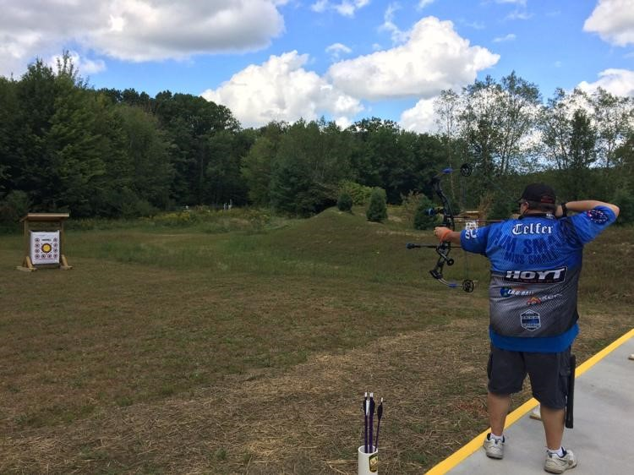

Bill Kirk at Crystal Lake’s new archery range in Brown Township on Aug. 14.

Medium – Archery Ranges
River Metroparks opens new archery range at Crystal Lake
Beginning Aug. 15, a new archery range will open to the public at Crystal Lake in Brown Township.
The unstaffed range, patrolled by park rangers, will be available for general target shooting from dawn to dusk, seven days a week for no cost, River Metroparks confirmed during a Aug. 14 opening ceremony.
The new range features eight ground-level shooting lanes and 4-foot by 4-foot targets ranging from 10 to 50 yards, and a raised shooting platform that accommodates three archers.
In a separate adjacent area, archers can use a shorter range, up to 20 yards, which will allow people of all ages and skill levels to enjoy the sport.
River Metroparks secured a $20,000 Cooperative Shooting Range grant from the Montana Fish, Wildlife, and Parks, U.S. Fish and Wildlife Service, and Wildlife and Sport Fish Restoration Program to support construction of the range.
The overall cost of the range was $35,000.
Crystal Lake is located at 7024 Kniffen Road.
For additional information and directions, visit www.rivermetroparks.com/crystallake.
Conservation and outdoor recreation connect people with nature, improve quality of life, are beneficial to personal mental and physical health, and sustaining natural resources. WSFR grants fund state fish and wildlife agencies, tribes and non-profits in the maintenance and management of more than 900 shooting and archery ranges across America.

Bill Kirk at Crystal Lake’s new archery range in Brown Township on Aug. 14.

Brief – Archery Ranges
Conservation and outdoor recreation connect people with nature, improve quality of life, are beneficial to personal mental and physical health, and sustaining natural resources. WSFR grants fund state fish and wildlife agencies, tribes and non-profits in the maintenance and management of more than 900 shooting and archery ranges across America.

Hunting Access – Long Feature Story
Service work supports public access on both federal and state lands
We at the U.S. Fish and Wildlife Service are excited to celebrate the opening of new public lands – whether federal, state or local. One way we support access to public lands for hunting and fishing is through the Wildlife and Sport Fish Restoration Program. State land acquisition grants are used to acquire and manage wildlife management areas, which are open to the public and managed for wildlife. The below example from Indiana highlights a project we recently funded which expands public access to a unique natural area and provides multiple recreation opportunities. This story is reprinted with permission from Indiana Department of Natural Resources.
Hunters enjoy diverse experiences at Madison County Wildlife Area
East Peru, Indiana - Holly Jobs arrived for a tour of a potential new wildlife area and was immediately struck by the uniqueness of the parcel’s size, lack of internal roads and its location less than an hour from Des Moines.
Jobs, the senior land conservation director with Indiana Natural Heritage Foundation (INHF), saw the potential in the nearly 400 acres of rolling hills, timber and prairie in southern Madison County and began a six month negotiation to purchase the private hunting retreat. The deal was finalized in early fall 2016.
In the late summer of 2017, the Indiana Department of Natural Resources (DNR) purchased the land from INHF and Victory Valley Wildlife Area became the second largest state managed public area in the county. And word got out quickly.
“Hunters found it pretty early last fall,” said Bob Heck, supervisor for the Indiana DNR’s southeast wildlife district. And why wouldn’t they. Victory Valley has an oak hickory timber, food plots, reconstructed prairie, mature field in the Conservation Reserve Program and small prairie streams.
“There’s something here for everyone, whether you’re a nature lover or a hunter. It’s a neat landscape,” he said.
The landscape will support hunters looking for a hike-in hunting experience, to bird watchers and nature lovers. It’s a place for everything – grassland birds, deer hunting, hiking, photography and pheasant and quail hunting. Along the west edge of the reconstructed prairie, a covey of 20 quail could be still no longer and flushed.
“This is kind of an exciting thing going on,” said Sarah Panini, fish and wildlife biologist with U.S. Fish and Wildlife Service out of Bloomington, IN., who is responsible for regional grants for land acquisition and access. “We hope to see the neighbors’ kids shoot their first deer here or pheasant off this area.”
And while the area is already in excellent condition, there is some work to do.
This past spring, Heck’s staff burned about 300 acres of the upland and timber that took out a number of cedar trees off the hillsides and helped kick start the prairie reconstruction. The timber resource will be managed under a forest stewardship plan.
“We will be filling in abandoned ditches and removing undesirable trees, open up the grasslands, take trees off the remnant prairie. It will just take a little time,” said Harvey Van Braun, wildlife technician with the Indiana DNR who will be managing the area. “Looking six years out, it will look a lot different.”

Hunters help fund Victory Valley purchase
The Victory Valley project was possible in part because of the federal taxes paid on hunting related equipment.
A federal excise tax on sporting arms and ammunition is used as a way to help fund wildlife related research, hunter education, shooting range development, land acquisition and access at the state level. The funds are distributed to states based on a formula that includes the number of hunting and fishing licenses sold.
Victory Valley funding was part of the Indiana DNR’s 2016-2019 Statewide Wildlife Restoration Land Acquisition Program Grant funded with Wildlife and Sport Fish Restoration program funds.
Victory Valley home to threatened species
Part of the acquisition process included conducting bat surveys and surveyors found federally endangered Indiana bats and federally threatened northern long-eared bats on the area. Henslow’s sparrows, a threatened species in Indiana, have been heard here.
As work continues on the habitat improvement, Victory Valley may become home to other species of concern that have been found nearby, including regal fritillary – a prairie butterfly, and Edwards hairstreak – an oak woodland butterfly, as well as bull snakes.

WSFR grants fund state fish and wildlife agencies, tribes and non-profits in the maintenance and management of wildlife conservation on more than 464 million acres of land and more 167 million acres of lakes, reservoirs, and wetlands across America.
OR
WSFR grants fund state fish and wildlife agencies, tribes and non-profits in the maintenance and management of wildlife conservation on more than 153 parcels of land and 500 lakes, reservoirs, and wetlands across America.
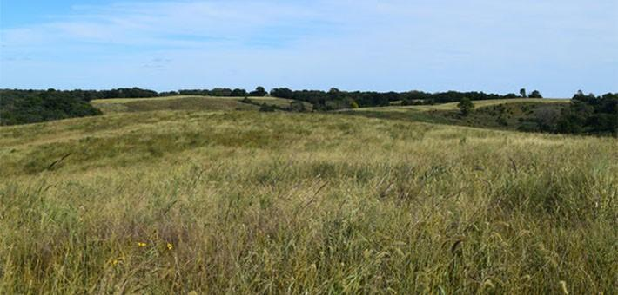

Rolling hills of prairie and oak savanna at Victory Valley Wildlife Management Area, Indiana. Photo courtesy of Indiana Department of Natural Resources.

Hunting Access – Medium Story
400 Acres near East Peru Indiana become the Victory Valley Wildlife Area

East Peru, Indiana – In the late summer of 2017, the Indiana Department of Natural Resources (DNR) purchased 400 acres and the Victory Valley Wildlife Area became the second largest state managed public area in the county. The land is a former private hunting retreat featuring in southern Madison County featuring rolling hills, timber and prairie.
The land was first acquired by the Indiana Natural Heritage Foundation (INHF) and resold to the DNR to form Victory Valley.
Brain Heck, supervisor for the Indiana DNR’s southeast wildlife district said “There’s something here for everyone, whether you’re a nature lover or a hunter. It’s a neat landscape,”
The landscape will support hunters looking for a hike-in hunting experience, to bird watchers and nature lovers. It’s a place for everything – grassland birds, deer hunting, hiking, photography and pheasant and quail hunting. And while the area is already in excellent condition, there is some work to do.
This past spring, Heck’s staff burned about 300 acres of the upland and timber that took out a number of cedar trees off the hillsides and helped kick start the prairie reconstruction. The timber resource will be managed under a forest stewardship plan.
“We will be filling in abandoned ditches and removing undesirable trees, open up the grasslands, take trees off the remnant prairie. It will just take a little time,” said Harvey Van Braun, wildlife technician with the Indiana DNR who will be managing the area. “Looking six years out, it will look a lot different.”
WSFR grants fund state fish and wildlife agencies, tribes and non-profits in the maintenance and management of wildlife conservation on more than 464 million acres of land and more 167 million acres of lakes, reservoirs, and wetlands across America.
OR
WSFR grants fund state fish and wildlife agencies, tribes and non-profits in the maintenance and management of wildlife conservation on more than 153 parcels of land and 500 lakes, reservoirs, and wetlands across America.

Rolling hills of prairie and oak savanna at Victory Valley Wildlife Management Area, Indiana. Photo courtesy of Indiana Department of Natural Resources.

Hunting Access – Brief
WSFR grants fund state fish and wildlife agencies, tribes and non-profits in the maintenance and management of wildlife conservation on more than 464 million acres of land and more 167 million acres of lakes, reservoirs, and wetlands across America.
OR
WSFR grants fund state fish and wildlife agencies, tribes and non-profits in the maintenance and management of wildlife conservation on more than 153 parcels of land and 500 lakes, reservoirs, and wetlands across America.

R3 - FEATURE STORY
MENTORING NEW HUNTERS IN VERMONT
Today guest blogger Wendy Rice shares her story of how mentoring one new hunter can influence many new conservationists in return.
A few years ago, a worried colleague approached me, expressing concern around her son’s intense interest in hunting. Being self-described left-leaning hippies, she and her husband could not understand what was driving their son, Andy’, interest to take up hunting. I recommended a week of Conservation Camp for Andy where he would participate in Hunters Education followed by finding Andy a mentor.
Eventually, I became Andy’s mentor. Am I a duck hunter? Not really, but you bet I scouted ducks that fall and in the early morning hours of duck season, I dragged a kayak loaded with decoys through a cornfield to be a mentor, guide and retriever to Andy. His mom would drop him off early in the morning, we would hunt ducks for a couple of hours and then she would deliver him to his private school, complete with camo paint on his face. As a family, Andy and his parents prepared the game he brought home and they grew to understand the importance of conservation through hunting. Andy’s parents eventually took my Hunters Ed Course themselves.
As it turned out, one of his classmate’s father happened to be a chef, restaurant owner and more importantly, landowner on Lake Champlain. “Not a duck hunter”, Andy explained to me, but he would take Andy hunting. Very quickly, the “non-hunting, lake-front owning, chef” took up duck hunting, which makes perfect sense, really, and wild duck was on the menu for the next staff dinner. Remarkably, this very French restaurant now hosts an annual game dinner, attended by hunters and non-hunters alike. In this case, mentoring just one person introduced many people to hunting as a means of conservation. It also allowed a new hunter to bring at least one more hunter into the field.
When youth turkey season rolled around the next spring, I took Andy to my very best hunting spot. The place I prefer to hunt myself. I plan for the highest success rate possible for every brand new hunter I work with. Andy was not the first new hunter to take advantage of my favorite turkey hunting location, nor was he the last. Georgette Rhodes contacted me for turkey hunting tips and I invited her to join me on a hunt.
She bagged her first turkey that morning and one or two springs later, I had an excited email from her, describing an exciting hunt where she had been the mentor for a college student friend.
I teach Hunters Education at a local college for students, faculty, staff and adults from the community, who, like Andy and Georgette, are interested in becoming hunters. The challenge for these new hunters without the benefit of growing up in a hunting tradition is where exactly to begin after their certification. My point in this is to say, in times when hunting license sales are declining and food culture is changing, we as a hunting community must invest our time in mentoring new hunters. Mentoring truly is not a sacrifice, it is an investment and maybe, even more thrilling than hunting for myself. At least its close!
In 2017, WSFR grants funded and state fish and wildlife agencies, tribes and non-profits held 527 hunter and angler education events and 27 studies to aid in better understanding of hunter and angler motivations to increase the recruitment, retention and reactivation of hunters and anglers.

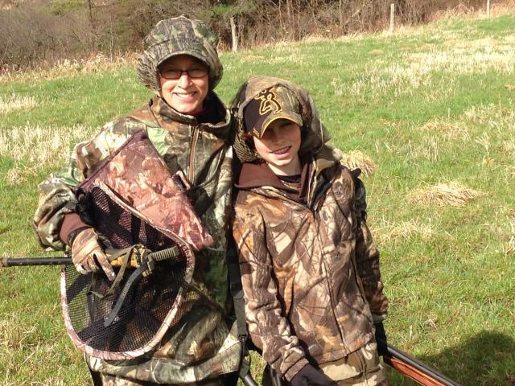
Andy and his mom ready for a day in the field.

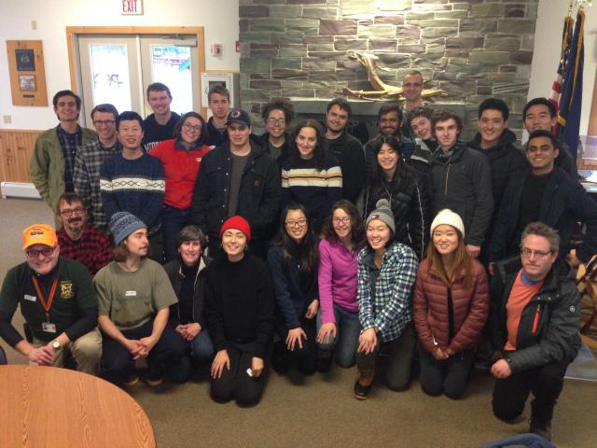
Hunter Education, 2018
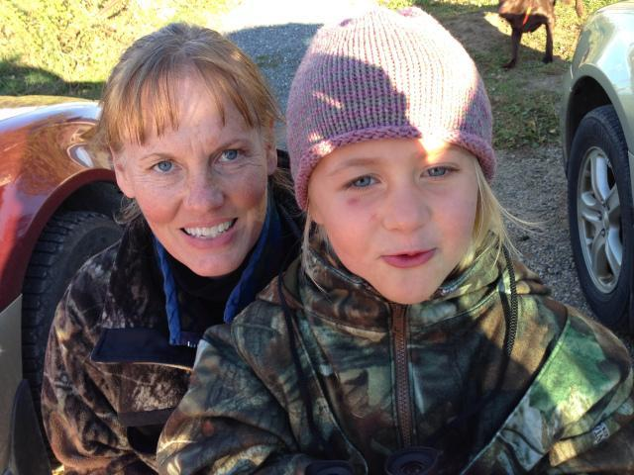
Georgette Rhodes and Granddaughter Emily

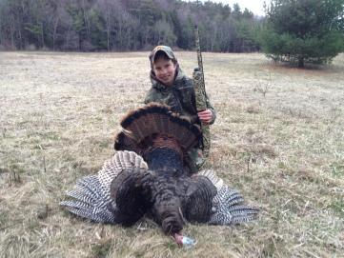

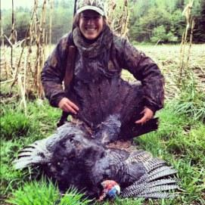

R3 - MEDIUM STORY
Mentored Hunt Brings 67 Individuals into Hunting
(Maple City , Vermont) – The Maple City Chapter of the National Wild Turkey Federation (NWTF) and the Vermont DNR teamed up to host a group of 67 individuals for an introduction to wildlife conservation and hunter education at Maple Farms Wildlife Area.
The group of event attendees ranging from 11 to 17 participated in a variety of activities that included pattering a gun, hunter safety, wildlife and habitat conservation. They also got to hunt for Wild Turkey.
Volunteers from the Maple City Chapter coordinated activities that were fun, educational and most importantly, safe. They also worked with local landowners to make sure they had access to land that would provide a good first hunting experience.
“To ensure the future of hunting and outdoor sports, we need to educate future generations about what it means to be a hunter and a conservationist,” said Carl Fryman NWTF Hunting Heritage program coordinator. “We are so thankful for the support of our volunteers acting as hunt mentors, the opportunity for hunts through donations from landowners and the recruitment of new sportsman by our local chapters.”
To learn more about volunteering as a hunting mentor or contact Carl Fryman at Carl@MapleCityGoblers.com
In 2017, WSFR grants funded and state fish and wildlife agencies, tribes and non-profits held 527 hunter and angler education events and 27 studies to aid in better understanding of hunter and angler motivations to increase the recruitment, retention and reactivation of hunters and anglers.

Just a few of the 67 new hunters attending the Maple Farms Mentored Hunt.

R3 - BRIEF
In 2017, WSFR grants funded and state fish and wildlife agencies, tribes and non-profits held 527 hunter and angler education events and 27 studies to aid in better understanding of hunter and angler motivations to increase the recruitment, retention and reactivation of hunters and anglers.

Mule Deer – Long Feature Story
Path to Safety: Man-made wildlife crossings cut animal-vehicle collisions nearly 80 percent
cebookTwitterEmailGmailPinterestMore20
Each year, thousands of animals are killed by motorists on interstate highways and roads that intersect critical wildlife habitats, greatly increasing the risk to human safety.
Looking to address this issue, the Nevada Department of Wildlife (NDOW), with grant funding from the U.S. Fish and Wildlife Service (FWS) and in collaboration with the Nevada Department of Transportation (DOT) have recently built and monitored the effectiveness of the first-ever wildlife overpass project in Nevada along Highway 93, in Elko County.
The project started in 2008 with research on where multiple wildlife safety crossing structures would be placed with a goal of improving public safety and reducing the number of animals killed by 90 percent. This involved researching where wildlife typically crossed using GPS collars on mule deer and where collisions took place.
“Before the crossing structures, you just hated to see the carnage that was happening on the roadways,” said Karl Huebly, game biologist with NDOW who manages the mule deer herd that uses the overpasses and underpasses. Besides being designed for primarily mule deer, other species that use the crossing structures include: elk, coyotes, bobcats, badgers, mountain lions, black-tailed jackrabbits and pronghorn which are using an overpass in North America for the first time.
“We were pretty nervous about the project, but there was a spot on Highway 93 that lent itself perfectly with a cut in the road for the overpass,” Huebner said. “When deer walk uphill and all they see is sky it minimizes their fear and the next thing they know they are on the other side. Now the deer know exactly where that crossing is and they don’t miss a beat.”
The crossing structures included three underpasses and two overpasses with three to four miles of roughly eight-foot fencing on both sides. The underpass is a giant culvert with fencing modifications to funnel the deer. The overpass, filled in with dirt and vegetation is wide enough where the animal cannot see underneath to eliminate fear when crossing the busy highway. Prior to this project, the only known successful overpass in North America was in Banff National Park, Canada primarily for black bears.
In a recent five year span, there were nearly 2,500 reported wildlife-vehicle collisions across Nevada, including about 1,300 deer. Also there were 300 specific deer deaths alone in the area on Highway 93 and a location on Interstate-80 along the Pequop Mountains. Also, research estimates indicate that more than 50 percent of collisions went unreported, pointing to an even higher potential number of such incidents.
The installation of crossing structures has shown to decrease the number of wildlife-vehicle collisions up to 80 percent, according to Jessica Simons, from the University of Nevada Reno (UNR), who was a graduate student at the time but now works for the Department of Transportation. Simon's research also showed that during the first four years (Fall 2010-Spring 2014) after safety crossings were installed, 35,369 mule deer crossings were kept off the road, avoiding potential collisions with vehicles.
“People I spoke to in the area were very doubtful that these structures would be effective,” Simpson said. “Once I was able to explain how many animals have been kept off the roadway it is eye-opening. When you say 35,000 in four years, they are shocked by that.”
Simpson added that on this section of Highway 93, now there is only one or less reported collision for each mule deer migration season.
“This has been not only a win-win for building partnerships with multiple agencies, but it is a win-win for wildlife and the public at large,” said Cody Sisk, wildlife staff specialist with NDOW. “Not only are we creating a passageway for wildlife to safely cross, but we’re also minimizing human fatalities and accidents, saving money on auto repairs.”
Huebner agreed. “It took all of us working together to make it a success,” she said. “There were some who thought this was a waste of money at first – just a silly idea. They didn’t think the deer would use it. I had one guy call me and apologize because he was traveling north on 93 one day and a group of 200 deer went over his head as he drove underneath the overpass. He didn’t realize how much safer our roadways would be.
“The human safety impact is just phenomenal. From a biologist standpoint it is essential the deer make it to winter range, so to watch them get there free and easy was a relief. It has been everything we hoped it would be.”
Migrating more than 100 miles, the mule deer cross two highways (Highway 93 and I-80), so NDOW has subsequently used a second FWS Wildlife Restoration Grant to pursue similar collaborative efforts in building wildlife overpasses along the Pequop Mountain range on Interstate 80 which will be finalized in Fall 2017 and around State Route 160 near Las Vegas, Nevada.
“This is why I got into this profession,” said Justin Lumber, grants management specialist with the U. S. Fish and Wildlife Service. “To see this project from our Wildlife Sport Fish Restoration Program come to fruition is very rewarding.
“The goal of the Wildlife Restoration Act is to meet Congress’ purpose to implement projects through grants to benefit wildlife, people and in this case support highway infrastructure,” he said.
Wildlife and Sport Fish Restoration Programs funded grants support conservation efforts utilizing the latest technology to track, observe and record fish and wildlife to provide greater understanding of their needs, behaviors and habitats to advance wildlife and fisheries science. In 2017, 42 projects totaling 67 million dollars benefitting mule deer and related species were funded by WSFR grants and implemented by state fish and wildlife agencies, tribes and non-profits. It is estimated that the mule deer herd has increased from XXXXX in 1925 to YYYYYY in 2017.

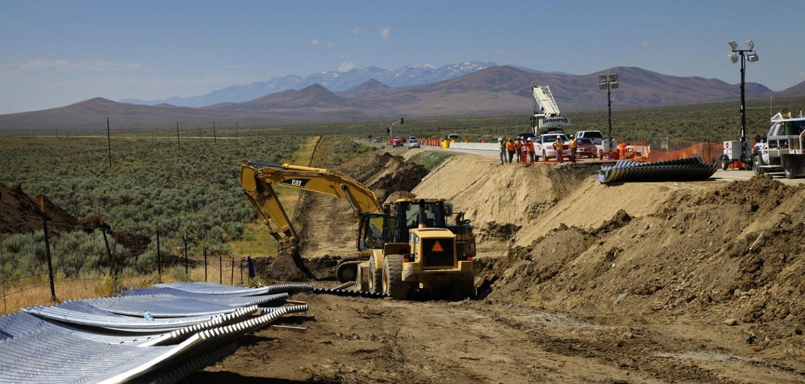
Thousands of motorists are involved in collisions involving animals each year. Looking to address the problem, federal and state wildlife and transportation partners recently built and monitored the effectiveness of Nevada's first wildlife overpass project (shown above) along Highway 93, in Elko County.
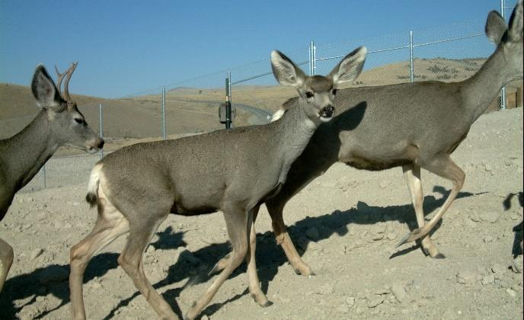
Mule deer use the recently constructed overpass along Highway 93, in Elko County. More than 35,000 mule deer crossed the overpass between Fall 2010 and Spring 2014, avoiding potential collisions with vehicles.
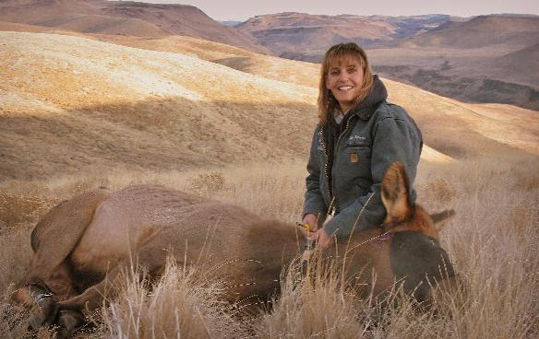
“When deer walk uphill and all they see is sky, it minimizes their fear and the next thing they know they are on the other side," said Kali Huebly, with Nevada Department of Wildlife.
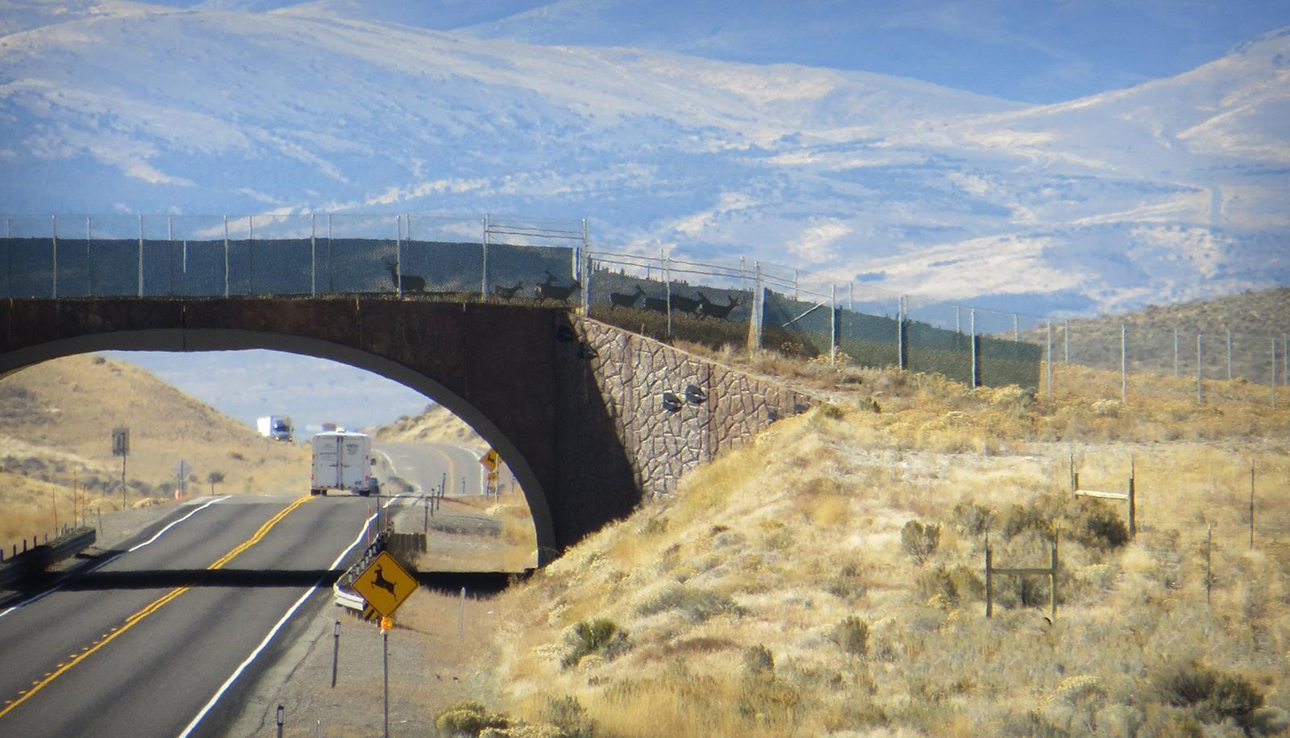
SUCCESS: Eight mule deer cross the overpass along Highway 93, Elko County, Nevada, in this Oct. 14, 2014 photo.

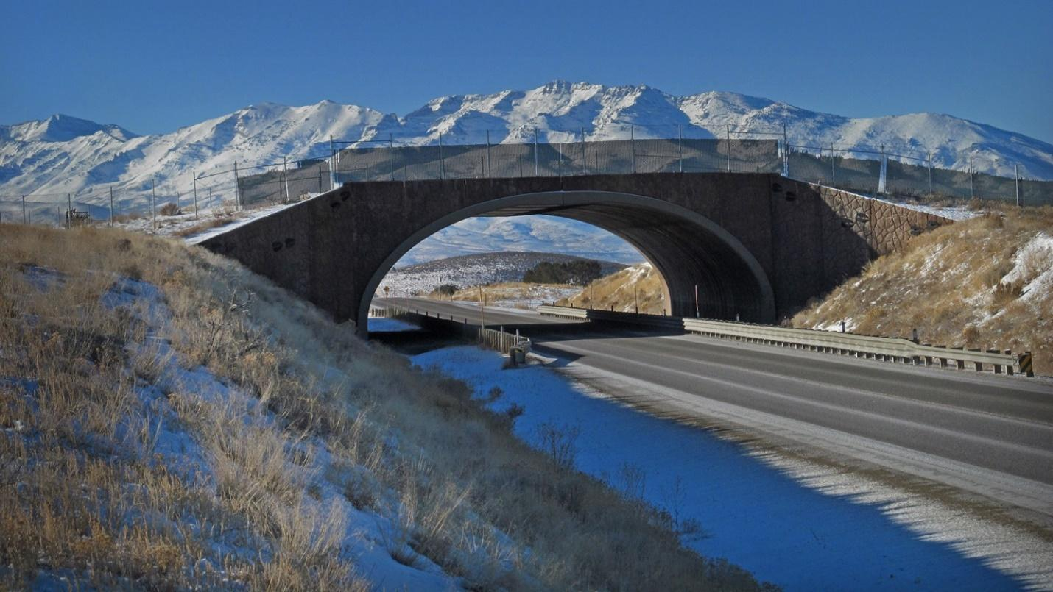
State and federal partners, through the Wildlife Sport Fish Restoration Program, have built and are now monitoring the effectiveness of the wildlife overpass project seen here along Highway 93, in Elko County, Nevada.

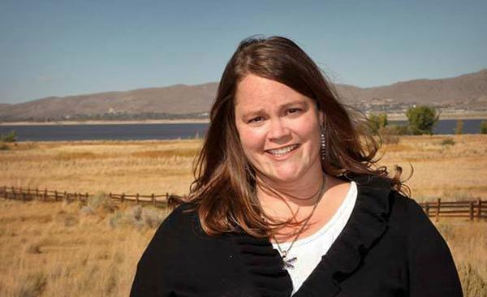
As a graduate student at the University of Nevada-Reno, Jessica Simons produced much of the research showing that crossing structures decreases wildlife-vehicle collisions up to 80 percent. When explaining it to the public, "it is eye-opening. When you say 35,000 in four years, they are shocked by that," she says.
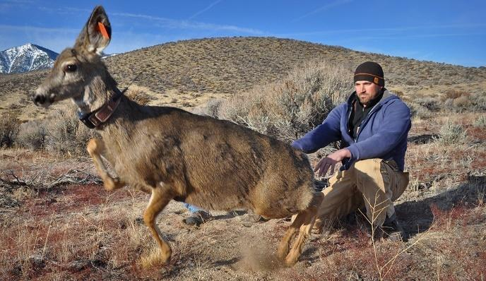
“Not only are we creating a passageway for wildlife to safely cross, but we’re also minimizing human fatalities and accidents," says Cody Sisk, wildlife specialist with NDOW.
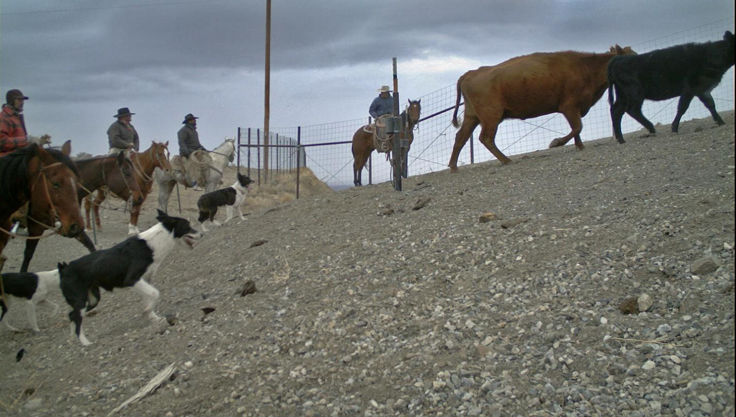
In addition to the primary users – mule deer, ranchers and other wildlife use the overpass.

Mule Deer – Medium Story
Man-made wildlife bridges cut animal-vehicle collisions nearly 80 percent
In a recent five year span, there were nearly 2,500 reported wildlife-vehicle collisions across Nevada, including about 1,300 deer. Also there were 300 specific deer deaths alone in the area on Highway 93 and a location on Interstate-80 along the Pequop Mountains. Also, research estimates indicate that more than 50 percent of collisions went unreported, pointing to an even higher potential number of such incidents.
To address this issue, the Nevada Department of Wildlife (NDOW), with grant funding from the U.S. Fish and Wildlife Service (FWS) and in collaboration with the Nevada Department of Transportation (DOT) have recently built and monitored the effectiveness of the first-ever wildlife overpass project in Nevada along Highway 93, in Elko County.
The project started in 2008 with research on where multiple wildlife safety crossing structures would be placed with a goal of improving public safety and reducing the number of animals killed by 90 percent. This involved researching where wildlife typically crossed using GPS collars on mule deer and where collisions took place.
The crossing structures included three underpasses and two overpasses with three to four miles of roughly eight-foot fencing on both sides. The underpass is a giant culvert with fencing modifications to funnel the deer. The overpass, filled in with dirt and vegetation is wide enough where the animal cannot see underneath to eliminate fear when crossing the busy highway. Prior to this project, the only known successful overpass in North America was in Banff National Park, Canada primarily for black bears.
The installation of crossing structures has shown to decrease the number of wildlife-vehicle collisions up to 80 percent, according to Jessica Simons, from the University of Nevada Reno (UNR), who was a graduate student at the time but now works for the Department of Transportation. Simon's research also showed that during the first four years (Fall 2010-Spring 2014) after safety crossings were installed, 35,369 mule deer crossings were kept off the road, avoiding potential collisions with vehicles.
Migrating more than 100 miles, the mule deer cross two highways (Highway 93 and I-80), so NDOW has subsequently used a second FWS Wildlife Restoration Grant to pursue similar collaborative efforts in building wildlife overpasses along the Pequop Mountain range on Interstate 80 which will be finalized in Fall 2017 and around State Route 160 near Las Vegas, Nevada.
Wildlife and Sport Fish Restoration Programs funded grants support conservation efforts utilizing the latest technology to track, observe and record fish and wildlife to provide greater understanding of their needs, behaviors and habitats to advance wildlife and fisheries science. In 2017, 42 projects totaling 67 million dollars benefitting mule deer and related species were funded by WSFR grants and implemented by state fish and wildlife agencies, tribes and non-profits. It is estimated that the mule deer herd has increased from XXXXX in 1925 to YYYYYY in 2017.

State and federal partners, through the Wildlife Sport Fish Restoration Program, have built and are now monitoring the effectiveness of the wildlife overpass project seen here along Highway 93, in Elko County, Nevada.

Mule Deer – Brief
Wildlife and Sport Fish Restoration Programs funded grants support conservation efforts utilizing the latest technology to track, observe and record fish and wildlife to provide greater understanding of their needs, behaviors and habitats to advance wildlife and fisheries science. In 2017, 42 projects totaling 67 million dollars benefitting mule deer and related species were funded by WSFR grants and implemented by state fish and wildlife agencies, tribes and non-profits. It is estimated that the mule deer herd has increased from XXXXX in 1925 to YYYYYY in 2017.

Group B Stories (Boating, Fishing, and Communicators)
Long/Feature Story – Boating Access
Oregon: Improved Boater/Angler Access on Miracle River
NORTHPORT, OR. – Boaters and anglers have improved access to the Miracle River in Northport, now that the Riverstone boat ramp is complete. Anticipating more than 15,000 users each year, a new boat ramp at Riverstone will provide improved access for boaters, paddlers and anglers.
“The ramp at Riverstone Park is a popular spot for locals and tourists alike and I’m thrilled we’ve been able to open the ramp this June,” said Olga Tanner, Tourism Director. “The park is one of the best places to view our Fourth of July fireworks show, but locals know the best spot is out on the water. This ramp is going to see a lot of use over the next month!”
The ramp is located at Riverstone Park, an almost 4-acre county memorial park accessible to the public 24 hours a day, seven days a week. This facility includes a 24-foot wide concrete boat ramp, with 6-foot wide canoe/kayak steps. This project was needed as the previous facility had not had major improvements since the early ‘90s. As part of this project, a new piece of land was purchased and an old building removed, and the parking lot was expanded. The bigger boat launch improves navigability and congestion. The upgrade also added new ADA restrooms and updated walkways. Anglers can find a new fish cleaning station and boat wash-down station across the street next to the gravel overflow parking lot.
According to Jonny West, City Manager of Northport, "Each boat, each trailer that you see here - many of them have purchased gas here, purchased materials and have gone to a restaurant or two during their stay here. All those things serve to benefit the local economy.
This project improves access to waterways, helping facilitate fishing participation and other recreation uses, like kayaking and canoeing. This area is the gateway for one of the states’ most popular tourist attractions – Stoney Beach Seashore. In addition to this famous park, Northport also offers access to the Lonely Island Recreation Area. Visitors are drawn to the natural beauty of the area, which is best viewed by boat, resulting in high demand for access. “We serve as the west gateway to Stoney Beach and have seen a large increase in visitors in the past decade,” said Tanner. According to ODFW Biologist Evan Alexander, this site provides improved boating access to a great angling opportunity for fall Chinook, coho, perch and sturgeon, all within a mile or two from the ramp.
Cost of the project was approximately $2M, which was paid by several partners, including the Oregon Department of Fish and Wildlife (ODFW) through a U.S. Fish and Wildlife Service Sport Fish Restoration grant, The Northport Chamber of Commerce, USDA, Northport Urban Renewal District and City of Northport.
WSFR grants fund state fish and wildlife agencies, tribes and non-profits in the maintenance and management 632 of recreational boating facilities 307 of which are boat ramps.
For more information about boating access and boating regulations, visit www.boatoregon.com.

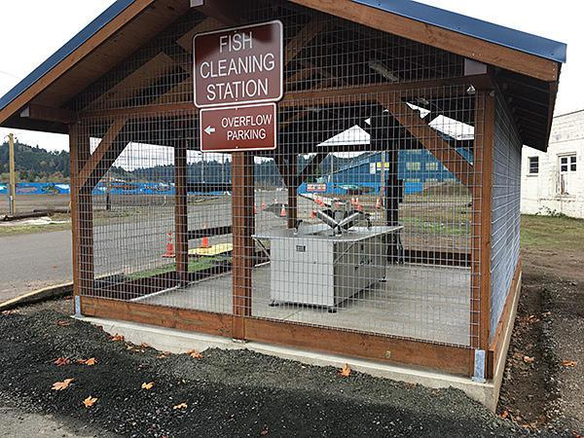

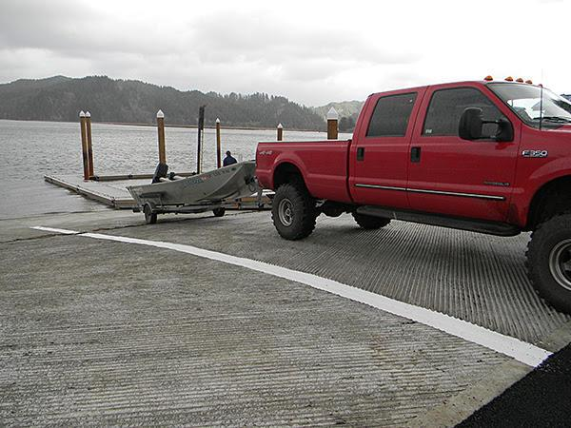

Medium/Release – Boating Access
Oregon: New Boat Ramp on the Miracle River
NORTHPORT, OR. – Boaters and anglers now have improved access to the Miracle River in Northport, now that the Riverstone boat ramp is complete. The current Riverstone ramp is a popular and heavily used boat launch facility with an estimated 10,000 boat launches per year.
The ramp is located at Riverstone Park, an almost 4-acre county memorial park accessible to the public 24 hours a day, seven days a week. This facility includes a 24-foot wide concrete boat ramp, with 6-foot wide canoe/kayak steps. This project was needed as the previous facility had not had major improvements since the early ‘90s. As part of this project, a new piece of land was purchased and an old building removed, and the parking lot was expanded The bigger boat launch improves navigability and congestion. The project also added new ADA restrooms and updated walkways. Anglers can find a new fish cleaning station and boat wash-down station across the street next to the gravel overflow parking lot.
The installation of boat ramps gives improved access to waterways, helping facilitate fishing participation in the state’s exceptional fishing resources. Additionally, the availability of ramps in a community brings people through those areas, with the potential for economic increase.
Cost of the project was approximately $2M, which was paid by several partners, including the Oregon Department of Fish and Wildlife (ODFW) thru a U.S. Fish and Wildlife Service Sport Fish Restoration grant, The Northport Chamber of Commerce, USDA, Northport Urban Renewal District and City of Northport.

WSFR grants fund state fish and wildlife agencies, tribes and non-profits in the maintenance and management 632 of recreational boating facilities 307 of which are boat ramps.
For more information about boating access and boating regulations, visit www.boatoregon.com.

Brief – Boating Access

WSFR grants fund state fish and wildlife agencies, tribes and non-profits in the maintenance and management 632 of recreational boating facilities 307 of which are boat ramps.

Long/Feature Story – Boating Access
Munising marina increases access to top Michigan attractions
On June 4, 2018 the Bayshore Marina in Munising, Michigan opened 24 new slips for recreational boaters traveling through Lake Superior. The Bayshore Marina received a Boating Infrastructure Grant through our Wildlife and Sport Fish Restoration program to increase access while preserving the northern experience.
“We get to live and work with one of the greatest natural wonders in the midwest right out our back door,“ said Devin Olson, Munising’s city manager. “Our marina expansion gives us the ability to share these wonders with boaters who previously may not have been able to access our area.”
Munising is the gateway community for one of Michigan’s most popular tourist attractions - Pictured Rocks National Lakeshore. In addition to this famous park, Munising also offers access to the Grand Island National Recreation Area and the Alger Underwater Preserve. Visitors are drawn to the natural beauty of Lake Superior’s southern shores and enjoy beaches, dunes, waterfalls, cliffs and forests. Many of these attractions are best viewed by boat, resulting in high demand for transient boat slips in Munising.
“We serve as the west gateway to pictured Pictured Rocks National Lakeshore and have seen a large increase in visitors in the past decade,” said Olson. “A portion of this demand was comprised of recreational boaters who made Munising a destination rather than a stop.”
This expansion meets the needs of this popular boating destination by adding 12 50-foot floating slips and 12 additional 40-foot floating slips to the marina. With these additions, the marina will be open to boats larger than 30 feet for the first time. Prior to the expansion, transient slips were completely occupied 75 percent of the time during boating season and recreational boaters were turned away.
Additionally, the expansion was designed with the goal of preserving the Lake Superior experience. The Upper Peninsula of Michigan offers the best location for viewing the northern lights in the lower 48 because of dark skies and high latitude. The southern shore of Lake Superior allows for northern views all the way down to the horizon, offering an unobstructed view of the night sky. To help preserve this unique viewing opportunity, the walkway portion of the expansion is lit with glow stones - pebbles that glow in the dark without the use of electricity.
We are excited to support the City of Munising and the Michigan Department of Natural Resources in providing increased access for outdoor recreation in northern Michigan.
WSFR grants fund state fish and wildlife agencies, tribes and non-profits in the maintenance and management 632 of recreational boating facilities 212 of which are marinas.
Learn more about the Bayshore Marina and start planning your visit.
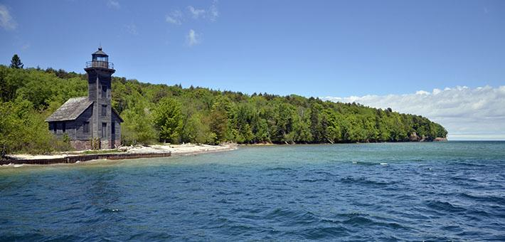
Grand Island East Channel Light.
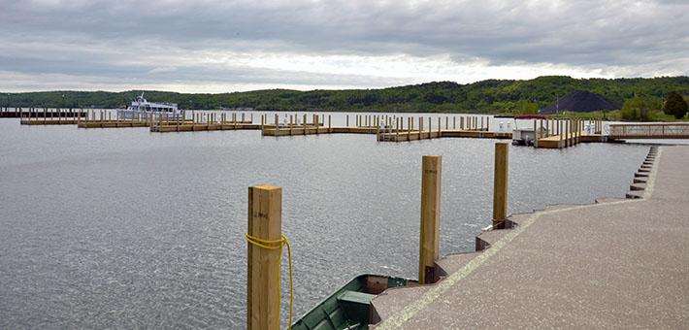
Floating slips featuring low-light pollution glow stones.

Medium/Release – Boating Access
Munising marina increases access to top Michigan attractions
On June 4, 2018 the Bayshore Marina in Munising, Michigan opened 24 new slips for recreational boaters traveling through Lake Superior. The Bayshore Marina received a Boating Infrastructure Grant through our Wildlife and Sport Fish Restoration program to increase access while preserving the northern experience.
Munising is the gateway community for one of Michigan’s most popular tourist attractions - Pictured Rocks National Lakeshore. In addition to this famous park, Munising also offers access to the Grand Island National Recreation Area and the Alger Underwater Preserve. Visitors are drawn to the natural beauty of Lake Superior’s southern shores and enjoy beaches, dunes, waterfalls, cliffs and forests. Many of these attractions are best viewed by boat, resulting in high demand for transient boat slips in Munising.
This expansion meets the needs of this popular boating destination by adding 12 50-foot floating slips and 12 additional 40-foot floating slips to the marina. With these additions, the marina will be open to boats larger than 30 feet for the first time. Prior to the expansion, transient slips were completely occupied 75 percent of the time during boating season and recreational boaters were turned away.
Additionally, the expansion was designed with the goal of preserving the Lake Superior experience. The Upper Peninsula of Michigan offers the best location for viewing the northern lights in the lower 48 because of dark skies and high latitude. The southern shore of Lake Superior allows for northern views all the way down to the horizon, offering an unobstructed view of the night sky. To help preserve this unique viewing opportunity, the walkway portion of the expansion is lit with glow stones - pebbles that glow in the dark without the use of electricity.
WSFR grants fund state fish and wildlife agencies, tribes and non-profits in the maintenance and management 632 of recreational boating facilities 212 of which are marinas.
Floating slips featuring low-light pollution glow stones.
Brief – Boating Access
WSFR grants fund state fish and wildlife agencies, tribes and non-profits in the maintenance and management 632 of recreational boating facilities 212 of which are marinas.

Long/Feature Story – R3
Fishing Gear Loaned From Libraries Generates Reel Interest
FOSTORIA, Md. — Library patrons might expect to see Dr. Seuss' "One Fish, Two Fish, Red Fish, Blue Fish" at the Hillside Road Community Library — but not necessarily the instruments to catch 'em.
Yet the Fostroria library is one of two in Urdel County where people can check out fishing rods and gear — just as they would a book — through a partnership with the Maryland Department of Natural Resources.
John Franklin, Hillside Road's branch manager, said the library has eight fishing rods and reels on hand, as well as a supply of tackle equipment. The branch also stocks books on fishing — both nonfiction help and some fish-inspired fiction. While the library rents out poles and tackle, it doesn't offer fishing licenses — those are available at a fishing supply store across the street.
Franklin said the program has hooked people who wouldn't ordinarily try fishing to get into the sport, and away from their television sets.
"It's also encouraged families to spend more time outdoors together," he said.
The branch, at 4730 Hillside Road, started the pilot program last year, and it was such a hit that the DNR is expanding it this season. The Turkey Neck Branch Library, at 269 Seaside Dr., Annapolis, now has six fishing rods to lend, and the department is also setting up fishing gear loaner programs in select branches in Harford, Carroll and Frederick counties.
"By engaging the next generation of anglers, we can foster a passion for outdoor recreation and sports, and cultivate an appreciation and love of nature that will last a lifetime," said Mark Mendon, DNR secretary, in a statement.
The department's Aquatic Resources Education Program provided the libraries with rods and reels, tackle and some fishing books, specifically geared toward children. DNR said the U.S. Fish and Wildlife Service Sport Fish Restoration Program helped fund the program.
Patrons can borrow a pole for up to two weeks. There is a $1 fee for every day it is late and a $15 fee if the pole is lost. At Hillside Road, library associate Nathan McDaniel’s has created a display near the front door that details the program and suggests some fishing-related reading.
Volunteers from the nearby Fostoria Sportfishing Group regularly service the equipment, should the poles need repair or "come back kind of icky," Franklin said.
Doug Vander, a member of the group, praised the loaner program, saying it's a convenient and cost-effective way to introduce youngsters to the pleasures of fishing.
"Loaning the rods out, the kids are learning to fish a little without the parents having to spend a lot of money to try it out," he said.
Vander said the library approached the club last year about helping with the program, and members thought it would be a perfect fit. Fostoria Sportfishing Group already hosts youth fishing derbies twice a year, as well as other outreach efforts to introduce people of all ages to the sport.
He said Hillside Road is a good spot for the program because it is close to the Mahogany River and good fishing spots on Crook Island.
Vander should know. The 72-year-old said he's lived on the Mahogany his whole life, and started fishing at age 6. He said he hopes the library loaner program can hook others on fishing the same way it hooked him.
"I've been very lucky to live near a body of water and have enjoyed fishing all my life," he said.
In 2017, WSFR grants funded and state fish and wildlife agencies, tribes and non-profits held 352 of aquatic ed events 247 of which taught fishing skills. They also funded 27 studies to aid in better understanding of hunter and angler motivations to increase the recruitment, retention and reactivation of hunters and anglers.
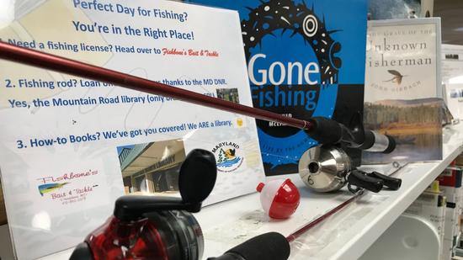

The Hillside Road Library is one of two in Urdel that has fishing rods and gear to loan as part of a partnership program with the Maryland Department of Natural Resources.

Medium/Release Story – R3
Library Loans Fishing Gear
Fostroria library is one of two in Urdel County where people can check out fishing rods and gear through a partnership with the Maryland Department of Natural Resources.
The library has eight fishing rods and reels on hand, as well as a supply of tackle. The branch also stocks books on fishing — both nonfiction help and some fish-inspired fiction. While the library rents out poles and tackle, it doesn't offer fishing licenses — those are available at a fishing supply store across the street.
The branch, at 4730 Hillside Road, started the pilot program last year, and it was such a hit that the DNR is expanding it this season. The Turkey Neck Branch Library, at 269 Seaside Dr., Annapolis, now has six fishing rods to lend, and the department is also setting up fishing gear loaner programs in select branches in Harford, Carroll and Frederick counties.
The department's Aquatic Resources Education Program provided the libraries with rods and reels, tackle and some fishing books, specifically geared toward children. DNR said the U.S. Fish and Wildlife Service Sport Fish Restoration Program helped fund the program.
Patrons can borrow a pole for up to two weeks. There is a $1 fee for every day it is late and a $15 fee if the pole is lost. At Hillside Road, library associate Nathan McDaniel’s has created a display near the front door that details the program and suggests some fishing-related reading.
In 2017, WSFR grants funded and state fish and wildlife agencies, tribes and non-profits held 352 of aquatic ed events 247 of which taught fishing skills. They also funded 27 studies to aid in better understanding of hunter and angler motivations to increase the recruitment, retention and reactivation of hunters and anglers.

The Hillside Road Library is one of two in Urdel that has fishing rods and gear to loan as part of a partnership program with the Maryland Department of Natural Resources.

Brief – R3
In 2017, WSFR grants funded and state fish and wildlife agencies, tribes and non-profits held 352 of aquatic ed events 247 of which taught fishing skills. They also funded 27 studies to aid in better understanding of hunter and angler motivations to increase the recruitment, retention and reactivation of hunters and anglers.

Long/Feature – Species Projects
Radios Reveal Wandering Habits of Smallmouth Bass in Oklahoma: Angler-funded research lends greater understanding of one of America’s greatest sport fish
About the time that redbuds flash their pretty pinkish blooms on eastern Oklahoma’s hillsides and gray streamside sycamores unfurl their fresh leaves the color akin to a wet lime, there’s something curious going on.
And it goes mostly sight unseen.
Smallmouth bass are on the move with the singular purpose of procreation. As Planet Earth wobbles back to the vernal position the daylight lengthens, shadows shorten and the creeks warm. These cues signal to what is arguably America’s top freshwater sport fish that it’s time to spawn.
The fish that ardent anglers call “bronzeback,” hold a renowned reputation as energized packets of fish flesh. Twitch a floating stickbait on slick water over a dark pool at dusk or drag a crayfish-colored club-tailed jig over a gravelly run, and then hang on. The fight of this fish is always outsized. And expect a few leaps out of the water before you feel on your thumb its raspy lip at release. A plucky flip of the tail fin, a splash, and off it goes.
Smallmouth bass are an angler’s favorite—have been for years since well before former U.S. Fish and Wildlife Service scientist and medical doctor, James Henshall, branded the species the “gamest fish that swims” in his 1881 tome, Book of the Black Bass. It’s still in print, by the way.
If you’ve caught one, you’re not hearing anything new. You know the “arrowy rush” that Henshall spoke of. And if you’re a licensed angler, take heart in knowing that you are helping pay for leading-edge research into the whereabouts of smallmouth bass in select Oklahoma streams, that in the end can improve a strain of bronzeback unique to the area—and make fishing all the better.
Dr. Shannon Brewer, an Associate Professor at Oklahoma State University, leads ongoing research into how the bass behaves through the year. Brewer and graduate student Andrew Miller monitor a strain of bronzebacks found only in the spring-fed streams in the Ozark highlands near where Oklahoma, Missouri and Arkansas converge. The fish is known as Neosho smallmouth bass—and it has an affinity for flowing water.
This habitat and behavior research on smallmouth bass that swim in Oklahoma’s Elk River and tributaries is paid for through the U.S. Fish and Wildlife Service’s Wildlife and Sport Fish Restoration Program, collected through taxes paid by fishing tackle manufacturers on fishing gear, passed on to the angler. When an angler hears the ding of a cash register and coin drop in the till, they are paying for conservation. Brewer and Miller conduct the work expressly for the Oklahoma Department of Wildlife Conservation (ODWC), which, in the end expects to use research findings to inform fishery management decisions.
How they get the work done is nearly as interesting as what they are learning. Brewer and Miller surgically implanted 100 Neosho smallmouth bass with radios, as early as 2015. The fish were caught by electrofishing, anesthetized, and the radios placed inside the body cavity and then stitched up. The bass were returned to the same streams in which they were caught after they recovered from surgery. A few radioed bass have been lost to otters and to anglers, but through the course of the study, at least 30 bass have remained tagged in each of three streams.
The radios emit a signal whereby the researchers relocated the fish many times, some for nearly three years before the batteries exhausted. In the warm months of March to October, the fish were relocated at least once weekly; in the colder months, only once per month. Though the research is still underway the professor and student have been able to gather a fair amount of information, revealing when and where these bass go through the year. Where the males take up housekeeping in the spring is of particular interest.
Brewer and Miller relocated the bass by walking streamside or kayaking, intent on hearing the distinct radio signals on a receiver they carried. Tracking through the winter months revealed very little movement, according to Brewer.
“Their favorite habitats in winter seemed to be deep pools,” said Brewer. “They would hold between rocks in slow water—and sometimes in quite shallow rocky areas—stationary. I’m an angler and naturally curious and snorkeled in January for a closer look. Smallmouth bass shoved themselves between rocks, in cavities, and in piles of woody debris – fish of all sizes. Some were wedged sideways in cavities, protected from swifter water. ”
As winter turned to spring, the two researchers found much variation among the many individual fish that carried radios. “Females were first to move,” said Brewer. “Come April, they were headed upstream to spawning sites. Some moved nearly five miles to find spawning habitat.”
Male smallmouth bass typically build nests over gravel in shallow water and court females to spawn. Males aggressively guard the nests during construction, through hatching and for a short spell as fry hover above the nest and the guarding male before disbursing to nursery habitat. The researchers noted that bass in their study seemed to concentrate in select areas which may speak to there being limited spawning habitat. As to what happened to the females, post-spawn, Brewer said they didn’t travel far, typically staying near the closest deep pools until around September when there seemed to be a downstream movement, particularly by the older and larger bass.
The three streams that harbored the radioed smallmouth bass all lead into Grand Lake O’ the Cherokees. Curiously, none of the bass to date have been located in the reservoir – they have all stayed in the streams. Moreover, the bass stayed in the streams in which they were tagged, save for one female that moved seasonally between to streams.
And that speaks to their uniqueness, says ODWC biologist, Kurt Kuklinski, who oversees the research for the agency. He works at the Fisheries Research Lab in Norman. “Neosho smallmouth bass are a stream fish,” says Kuklinski. “They have a liking for cool, spring-fed flowing waters. They’re native to the eastern third of Oklahoma—and their reliance on Ozark streams makes them different than lake-dwelling smallmouth bass.”
The preliminary results are surely fascinating, but Kuklinski says the full picture is not yet in view. The two researchers have more work to do and a great amount of data to analyze. As bass behavior and habitat selection in northeastern Oklahoma streams come into better focus, it should be good for fishery managers and for anglers, ultimately.
In 2017, 52 projects totaling 55 million dollars benefitting the many species of bass and related species were funded by WSFR grants and implemented by state fish and wildlife agencies, tribes and non-profits.
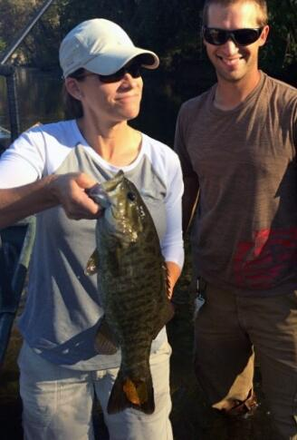
Dr. Shannon Brewer with Oklahoma State University Ph.D. candidate Andrew Miller. She holds a radio-tagged Neosho smallmouth bass. Credit OSU

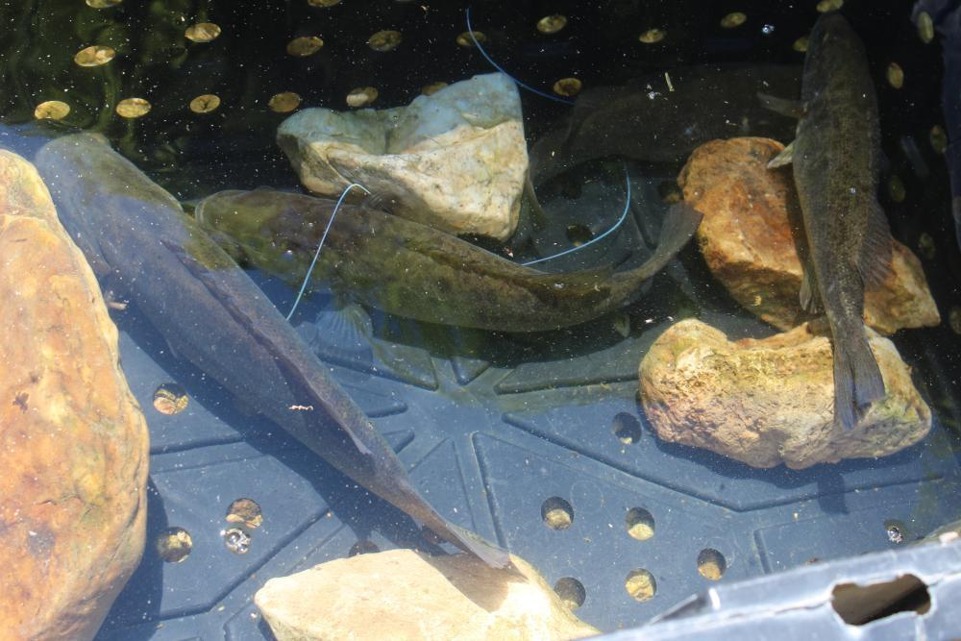
After ensuring their recovery from sedated surgery these Neosho smallmouth bass were planted back into to the streams where they were caught. Research was funded by Wildlife and Sport Fish Restoration. Photo Shannon Brewer OSU

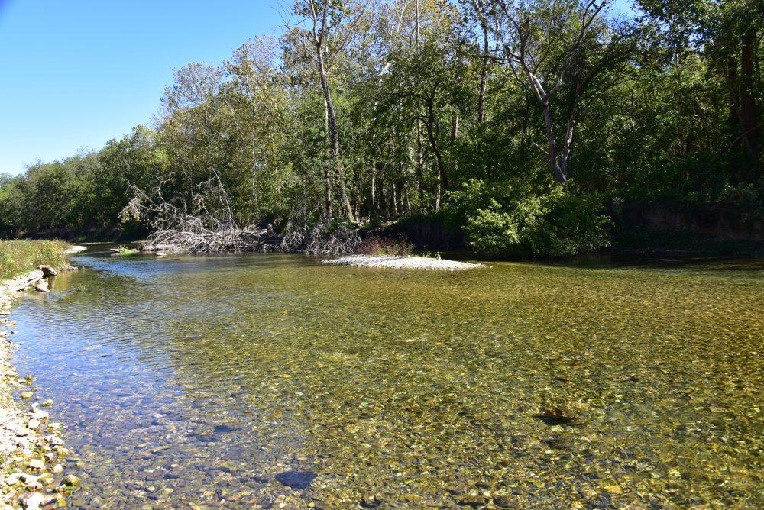
Large masses of woody debris yields habitiat for Neosho smallmouth bass habitat northeast Oklahoma. Research was funded by the Wildlife and Sport Fish Restoration Program. Photo credit Shannon Brewer OSU

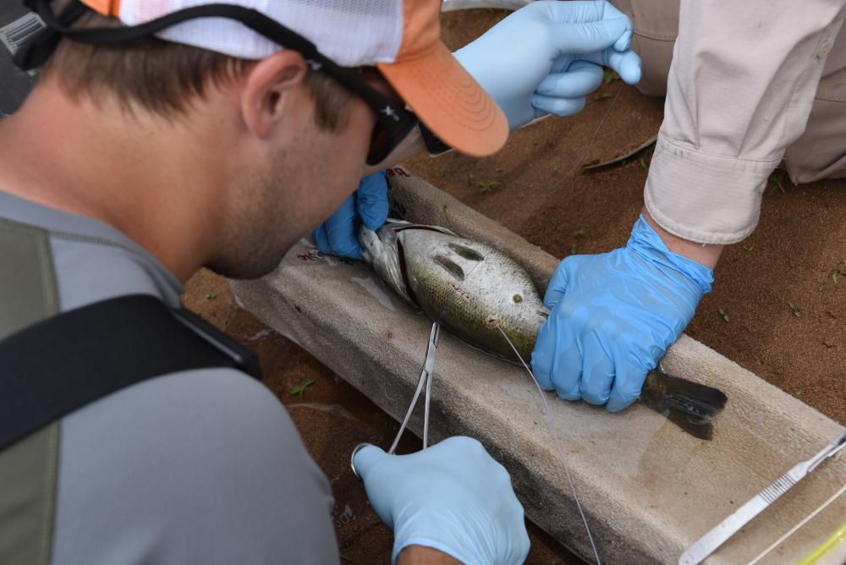
Andrew Miller sutures a sedated Neosho smallmouth after implanting a radio transmitter. Note the trailing white antenna. Research was funded by the Wildlife and Sport Fish Restoration. Shannon Brewer OSU

Medium/Release – Species Projects
Radios Reveal Wandering Habits of Smallmouth Bass in Oklahoma: Angler-funded research lends greater understanding of one of America’s greatest sport fish
Smallmouth bass are an angler’s favorite—have been for years since well before former U.S. Fish and Wildlife Service scientist and medical doctor, James Henshall, branded the species the “gamest fish that swims” in his 1881 tome, Book of the Black Bass.
Dr. Shannon Brewer, an Associate Professor at Oklahoma State University, leads ongoing research into how the bass behaves through the year. Brewer and graduate student Andrew Miller monitor a strain of bronzebacks found only in the spring-fed streams in the Ozark highlands near where Oklahoma, Missouri and Arkansas converge. The fish is known as Neosho smallmouth bass—and it has an affinity for flowing water.
This habitat and behavior research on smallmouth bass that swim in Oklahoma’s Elk River and tributaries is paid for through the U.S. Fish and Wildlife Service’s Wildlife and Sport Fish Restoration Program.
How they get the work done is nearly as interesting as what they are learning. Brewer and Miller surgically implanted 100 Neosho smallmouth bass with radios, as early as 2015. The fish were caught by electrofishing, anesthetized, and the radios placed inside the body cavity and then stitched up. The bass were returned to the same streams in which they were caught after they recovered from surgery. A few radioed bass have been lost to otters and to anglers, but through the course of the study, at least 30 bass have remained tagged in each of three streams.
Though the research is still underway the professor and student have been able to gather a fair amount of information, revealing when and where these bass go through the year. Where the males take up housekeeping in the spring is of particular interest.Male smallmouth bass typically build nests over gravel in shallow water and court females to spawn. Males aggressively guard the nests during construction, through hatching and for a short spell as fry hover above the nest and the guarding male before disbursing to nursery habitat. The researchers noted that bass in their study seemed to concentrate in select areas which may speak to there being limited spawning habitat. As to what happened to the females, post-spawn, Brewer said they didn’t travel far, typically staying near the closest deep pools until around September when there seemed to be a downstream movement, particularly by the older and larger bass.
The three streams that harbored the radioed smallmouth bass all lead into Grand Lake O’ the Cherokees. Curiously, none of the bass to date have been located in the reservoir – they have all stayed in the streams. Moreover, the bass stayed in the streams in which they were tagged, save for one female that moved seasonally between to streams.
In 2017, 52 projects totaling 55 million dollars benefitting the many species of bass and related species were funded by WSFR grants and implemented by state fish and wildlife agencies, tribes and non-profits.

Andrew Miller sutures a sedated Neosho smallmouth after implanting a radio transmitter. Note the trailing white antenna. Research was funded by the Wildlife and Sport Fish Restoration. Shannon Brewer OSU

Medium/Release – Species Projects
In 2017, 52 projects totaling 55 million dollars benefitting the many species of bass and related species were funded by WSFR grants and implemented by state fish and wildlife agencies, tribes and non-profits.

Long/Feature 2 – Boating Access

Something in the water
I wouldn’t normally drive 50 miles out of my way to see a dock. I had reason to believe the new day docks on the Delaware River in Bristol Borough, Penn., were worth the detour.
“I have gone there on a beautiful summer weekend, and thought, ‘Where am I, Miami?’’, Stacey Mulholland told me the day before when explaining her connection to the project. “The boats that are coming in are amazing.”
Now a public a airs specialist for the Delaware River Basin
Commission, Mulholland was deputy chief of sta for Pennsylvania Congressman Michael Fitzpatrick in 2013 when Bristol submitted an application for a boating infrastructure grant from the U.S. Fish and Wildlife Service to build a new pier and day docks. She helped shepherd the application through the process.
“I used to like to say I was the ambassador to Bristol Borough,” Mulholland said. “It’s just such a special place, and this project has been transformative for them.”
When I visited Bristol, it was a drizzly Wednesday morning in early fall, and the waterfront was quiet. But in the way that a stage is quiet before a big performance.
On the south side of the pier, which was completed in July 2017, two gangways lead down to docks extending into the Delaware River like floating red carpets. At the foot of the pier, a large pavilion with “Bristol” painted in ornate lettering beckons visitors to cross the threshold into the downtown, just steps away. Along the riverfront path, benches welcome spectators to take in the view.
Bristol appears poised for great things to happen. And they are.
The day that I was in Bristol, Bill Perry was in Duluth, Minn., accepting an award for the day dock project on behalf of the town at the States Organization for Boating Access Conference. Perry is a grant specialist for the Service’s Wildlife and Sport Fish Restoration Program, which administers the boating infrastructure grant funding.
“The waterfront docks in Bristol Borough are a great example of how these projects can bene t both boaters and local communities,” said Perry, who nominated the town for the SOBA award. “They have provided a beautiful gateway for boaters on the Delaware River to access the historic downtown.”
That’s exactly what the project planners envisioned. “Our town has always enjoyed having a waterfront, but there was never a way for visitors to get to the town from the water,” said Borough Council President Ralph DiGuiseppe. “We thought: We have this beautiful river; we need to use it to bring people into our community.”
That vision has become a reality. DiGuiseppe explained that the town holds a number of annual events — including an Italian Day, Celtic Heritage Day, a Puerto Rican Festival, an African-American Day, and a Doo Wop concert — and the docks have expanded capacity for, and interest in, these events. The Doo Wop concert attracts about 15,000 people, most of whom are shuttled in on buses from a parking lot on the outskirts of town. But during this year’s show, DiGuiseppe said every boat slip was taken, and people were anchored o of other boats.
But boaters don’t need special events to lure them to town. They just need nice weather. The next nearest public docks that are within walking distance of downtown restaurants and shops are 14 nautical miles north at Trenton, N.J., and 19 nautical miles south at Penn’s Landing in Philadelphia. Bristol serves as an ideal midway destination for the many transient boaters that travel this section of the tidal Delaware, and DiGuiseppe said business owners have reported an increase in sales that they attribute to foot traffic from boaters looking to stretch their legs or grab a meal.
“The docks were full over Columbus Day weekend, and one local restaurant owner told me that he tripled his typical Sunday business,” he said.
Although the day docks are helping to generate more public interest in Bristol Borough, the town already had a good reputation for its focus on community revitalization. In 2017, just days before the project was complete, Bristol Borough was named the №1 Small Town in America by the Deluxe Corporation.
That community spirit made it possible to execute what Scott Bollinger, Statewide Public Access Program Manager for Pennsylvania Fish and Boat Commission, called, “The project that wasn’t meant to be, but got done anyway.”
He explained that the town ran into a number of issues with the day dock project, ranging from concerns about lighting on the pier interfering with shipping lanes on the Delaware, to delays in construction to accommodate the spawning season for shad. When the original grant project was in jeopardy because of the unforeseen challenges, Pennsylvania Fish and Boat Commission worked with the Bristol Borough officials and the Service to secure a different boating infrastructure grant to cover additional costs.
“They did a phenomenal job,” Bollinger said, adding, “One of our engineers went out to inspect the project after completion, and his words were: It’s the premier boating facility in the state.”
That’s good for the larger watershed community as well. “Since we have been running the grant program, there have been very few proposals for projects along the Delaware River,” Bollinger said. “The Delaware is a big system, and the more public access the better.”
Bristol has set the stage, and the bar.
WSFR grants fund state fish and wildlife agencies, tribes and non-profits in the maintenance and management 632 of recreational boating facilities 212 of which are marinas.

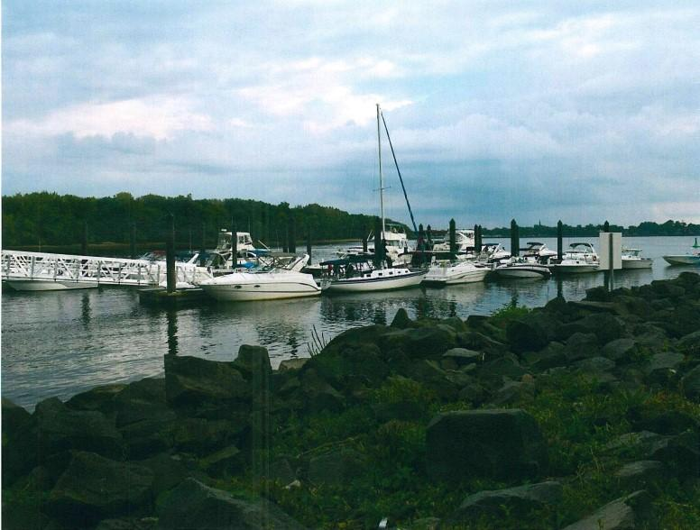
Boaters have docked to the new day docks on the Delaware River in Bristol Borough, Penn. — the only public docks between Philadelphia and Trenton, N.J., that are walking distance to a downtown. (Ralph DiGuiseppe)

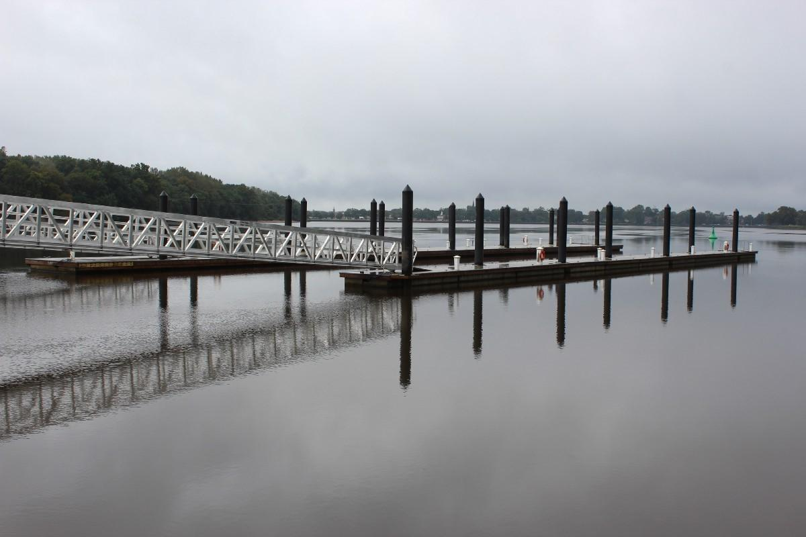
An atypical view: The new day docks on the Delaware River in Bristol Borough, Penn., without any boats. (Bridget Macdonald)
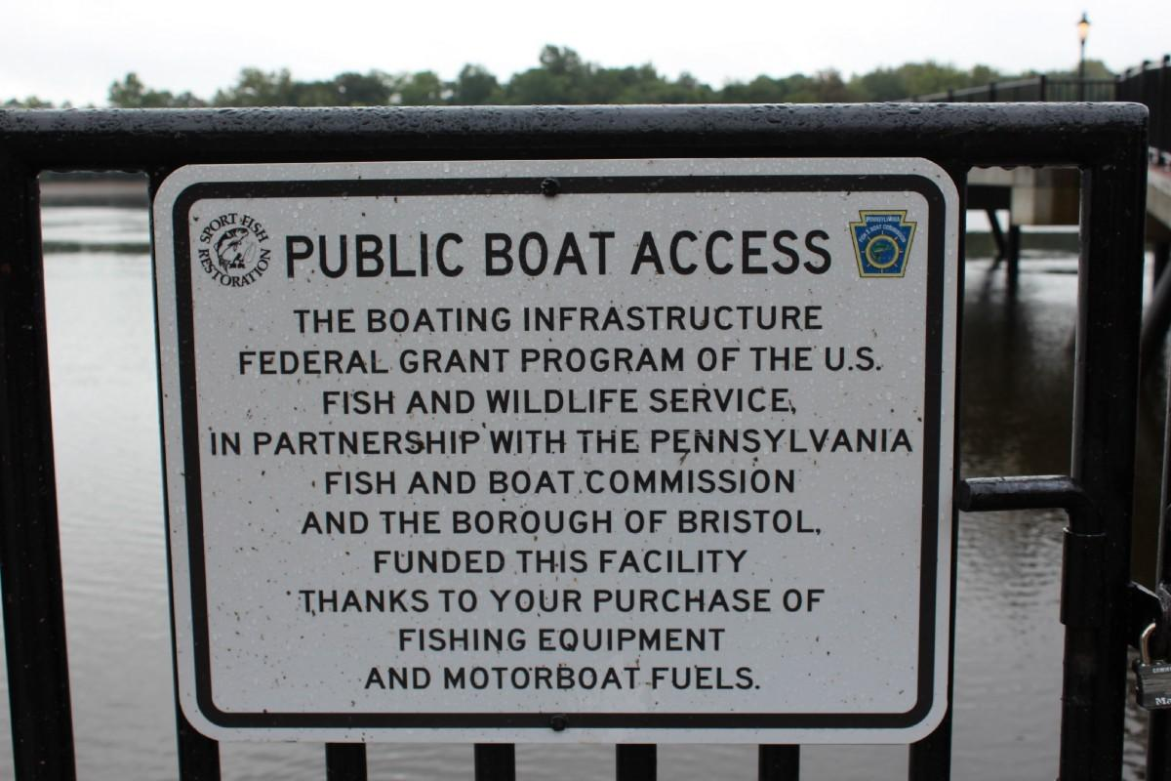
The dock project leveraged funding from multiple sources to provide better public access to the
Delaware River. (Bridget Macdonald)
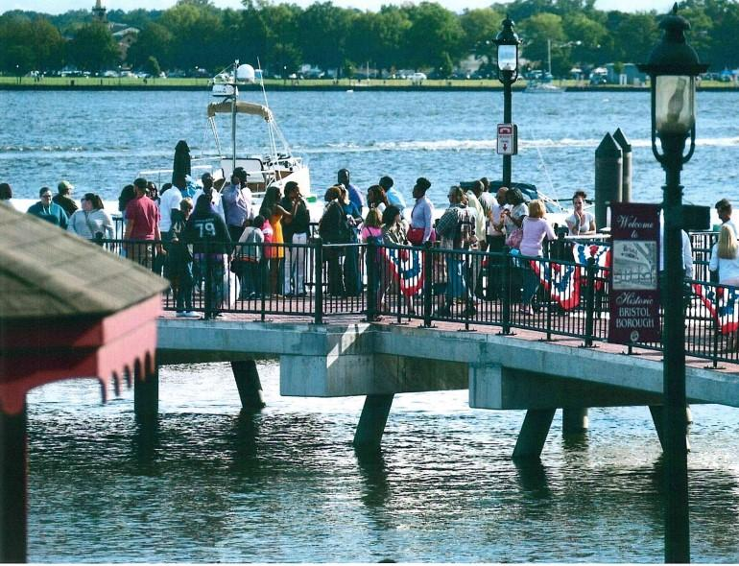
The new pier is an attraction for visitors from the water and the land. (Ralph DiGuiseppe)
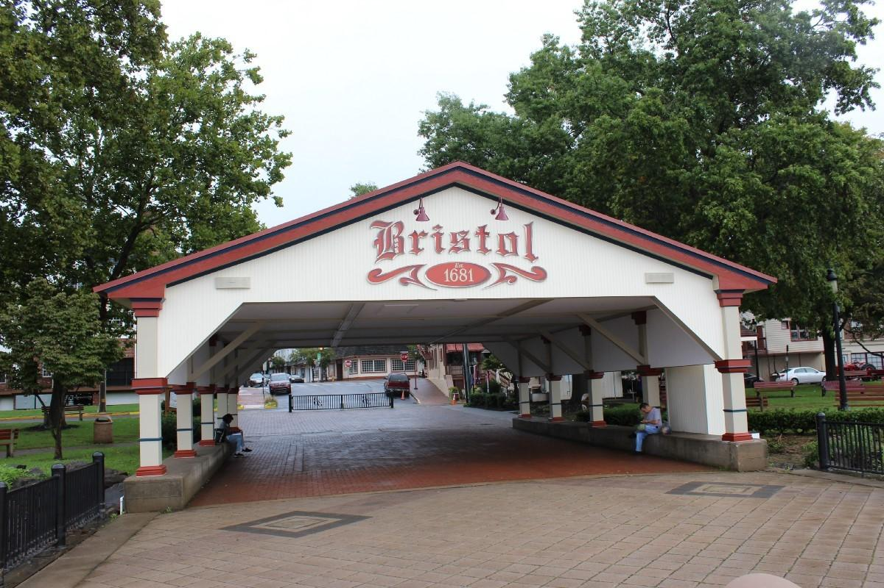
The pavilion at the foot of the pier provides a gateway into downtown Bristol — just steps away. (Bridget Macdonald)

Medium/Release 2– Boating Access

Something in the water
Bristol received a boating infrastructure grant from the U.S. Fish and Wildlife Service to build a new pier and day docks. On the south side of the pier two gangways lead down to docks extending into the Delaware River. At the foot of the pier, a large pavilion attracts to cross the street from downtown. Along the riverfront path, benches welcome spectators to take in the view.
Bristol appears poised for great things to happen. And they are.
“The waterfront docks in Bristol Borough are a great example of how these projects can bene t both boaters and local communities,” said Perry, who nominated the town for the SOBA award. “They have provided a beautiful gateway for boaters on the Delaware River to access the historic downtown.”
That’s exactly what the project planners envisioned. “Our town has always enjoyed having a waterfront, but there was never a way for visitors to get to the town from the water,” said Borough Council President Ralph DiGuiseppe. “We thought: We have this beautiful river; we need to use it to bring people into our community.”
The next nearest public docks that are within walking distance of downtown restaurants and shops are 14 nautical miles north at Trenton, N.J., and 19 nautical miles south at Penn’s Landing in Philadelphia. Bristol serves as an ideal midway destination for the many transient boaters that travel this section of the tidal Delaware, and DiGuiseppe said business owners have reported an increase in sales that they attribute to foot traffic from boaters looking to stretch their legs or grab a meal.
WSFR grants fund state fish and wildlife agencies, tribes and non-profits in the maintenance and management 632 of recreational boating facilities 212 of which are marinas.

An atypical view: The new day docks on the Delaware River in Bristol Borough, Penn., without any boats. (Bridget Macdonald)

The new pier is an attraction for visitors from the water and the land. (Ralph DiGuiseppe)

Brief 2 – Boating Access
WSFR grants fund state fish and wildlife agencies, tribes and non-profits in the maintenance and management 632 of recreational boating facilities 212 of which are marinas.

Group C (Communicators Only)
Story Pitch Email
Subject: Black bear conservation story

Good morning Jim,
You know firearms industry manufactures have generated more than $12 billion dollars for conservation since 1930s. You’ve read about how the state wildlife agencies use this funding. Now you have a chance to see it for yourself while assisting the Connecticut Department of Energy and Environmental Protection with fieldwork researching black bear biology.
Prior to the site visit, I can provide background information about northeast black bear populations, the research site, and how the data collected will benefit black bear conservation. You’ll have a chance to get to know our biologists on the way to the den site, and once there you can capture visuals for your story. Once the biologists have completed their work, you’ll have an additional opportunity to interview them.
Please let me know if you’re interested in this firsthand experience and don’t hesitate to reach out if you need more information. Black bear stories are some of our most popular content. This research project has generated a lot of clicks and a lot of data for conservation!
Kind regards,
NAME

A pitch like this resulted in this video: https://youtu.be/GAehJPaqPHU

Story Pitch Email
Subject: Lake sturgeon conservation story

Good morning Jim,
You know sportfish industry manufacturers have generated more than $9 billion dollars for conservation since 1950s. You’ve read about how the state wildlife agencies use this funding. Now you have a chance to see it for yourself while assisting the Wisconsin Department of Natural Resources with fieldwork researching lake sturgeon biology.
Prior to the site visit, I can provide background information about lake sturgeon populations, the research site, and how the data collected will benefit sturgeon conservation. You’ll have a chance to get to know our biologists on the way to the collection site, and once there you can capture visuals for your story. Once the biologists have completed their work, you’ll have an additional opportunity to interview them.
Please let me know if you’re interested in this firsthand experience and don’t hesitate to reach out if you need more information. Sturgeon stories are some of our most popular content. This research project has generated a lot of clicks and a lot of data for conservation!
Kind regards,
NAME

