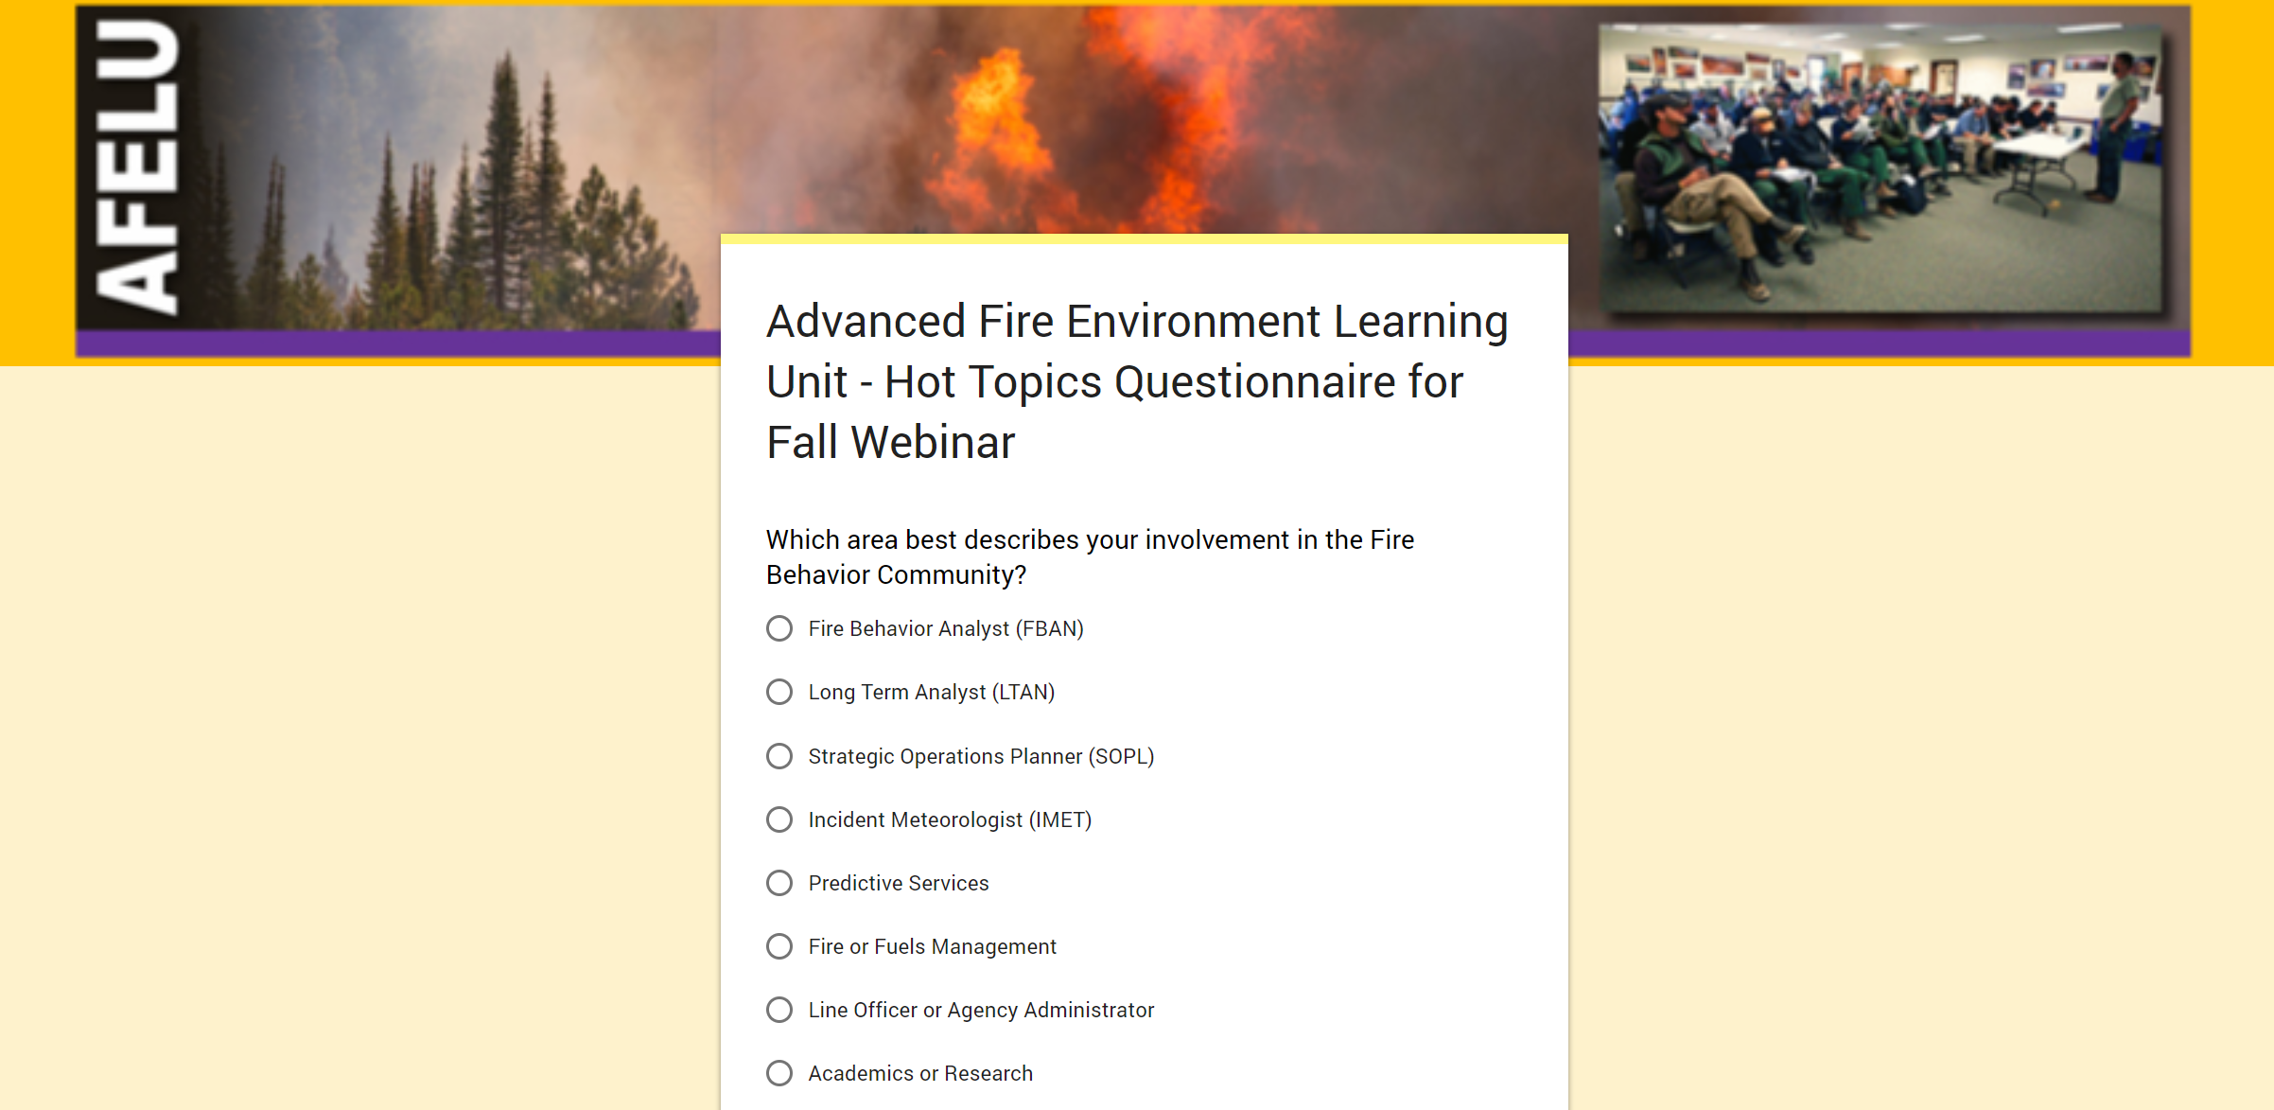
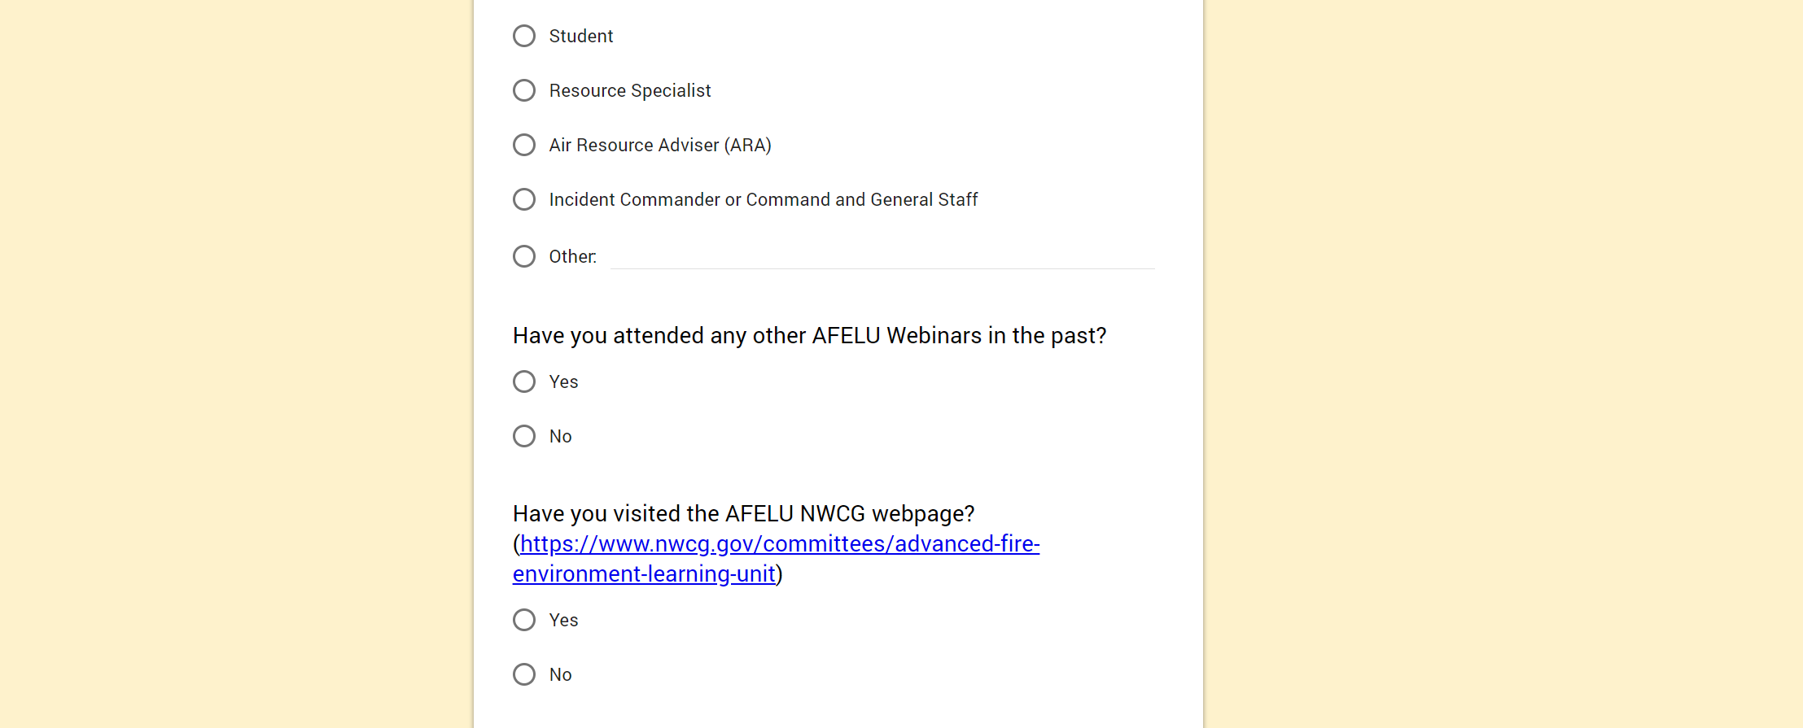
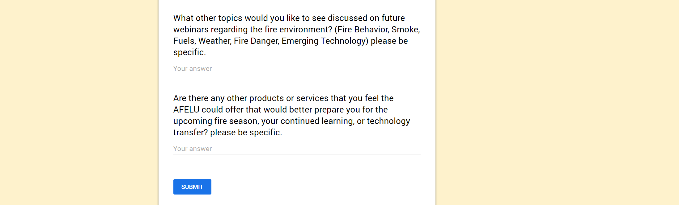
Paperwork Reduction Act Statement: We are collecting this information subject to the Paperwork Reduction Act (44 U.S.C. 3501) to solicit suggestions for specific topics to be included in the 2019 webinar and future webinar. Your response is voluntary and we will not share your response publicly. We may not conduct or sponsor and you are not required to respond to a collection of information unless it displays a currently valid OMB Control Number. OMB has reviewed and approved this focus group and assigned OMB Control Number 1090-0011.

Estimated Burden Statement: We estimate it will take 5 minutes to complete this survey, including time to read instructions and gather information. You may submit comments on any aspect of this information collection to the Departmental Information Collection Clearance Officer, U.S. Department of the Interior, Office of the Secretary, Office of the Chief Information Officer, Planning and Performance Management Division, 1849 C Street, NW, Washington, DC 20240.

