

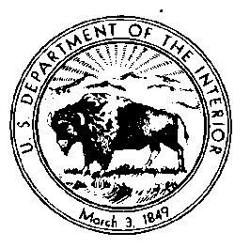

2019 Data Management Workshop Follow-up Survey

PAPERWORK REDUCTION ACT STATEMENT: A Federal agency may not conduct or sponsor, and a person is not required to respond to a collection of information unless it displays a currently valid OMB control Number. Public burden for the collection of this information is estimated to average 20 minutes per response. Comments regarding this collection of information should be directed to the Bureau Clearance Officer, U.S. Geological Survey, [gs-info_collections@usgs.gov](mailto:gs-info_collections@usgs.gov).

OMB NO. TBD Expiration Date: TBD

**Workshop Feedback:**

Was the workshop duration:

* Too short
* Too long
* About right

Was the mix of presentations and activities adequate to keep you engaged?

* Yes, great mixture
* No, needs improvement; here is how:____________________________________

Which presented content did you find of high interest and usefulness for your preservation tasks?

___________________________________

About which projects or state geological surveys would you like to hear updates or additional information?

___________________________________

What do you think is the most effective way to learn about best practices in data preservation?

* Webinars
* In-person workshops
* Website posts
* Social media / LinkedIn, etc
* Other:____________________________________________

Do you find it useful to tour repositories during the workshop?

* Yes
* No

What suggestions do you have to improve future data preservation workshops?

___________________________________

**Webinar Feedback**

How frequent should webinars be conducted?

* Monthly
* Bi-Monthly
* Quarterly
* As needed/ad-hoc
* Not needed

Which topics would you like to see further discussed and presented at webinars?

___________________________________

How can we best advertise data preservation webinars?

* Direct email
* Website posts
* Social media / LinkedIn , etc
* Other: _______________________________________

**NGGDP and National Digital Catalog Feedback**

Do you have additional suggestions for how the NGGDPP can better serve state geological surveys?

_____________________________

What do you think is the most effective way for you to contribute standards-based content to the National Digital Catalog?

_____________________________

What suggestions do you have to improve the National Digital Catalog for end-users?

_____________________________

What other suggestions do you have for the National Digital Catalog?

_____________________________