NHD stewards are a known community to the NHD program, and many/most have signed MOU agreements with the USGS The NHD Update the tool training will be outreached via email to them. Up to 15 participants will be registered per training session. After the training is complete, we would like to email course participants a customer satisfaction survey to collect feedback on the effectiveness of the training.

Due to ArcGIS Online permissions, the survey will become public facing. However, you won’t be able to view it unless you are given a link or you have a USGS ArcGIS Online account. Below are screenshots of the survey as it appears in Survey123.

This is the beginning of the survey. It tells the participants what the survey is and provides the Paperwork Reduction Act Statement and the Estimated Burden Statement for them to read. The first question asks for course feedback in relation to course objectives. This is a required question.

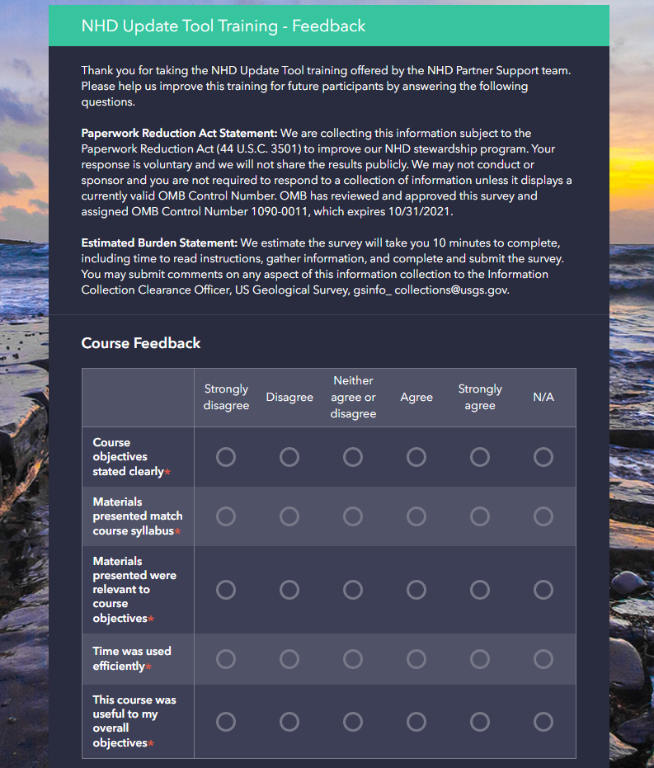
The second question asks if participants have taken the NHD Basics training, which is a prerequisite for the NHD Update tool training. This is a required question.
The third question asks participants what they intend to use the training for; whether they intent to edit the NHD or perform geoconflation, which is another service we offer. This is a required question.

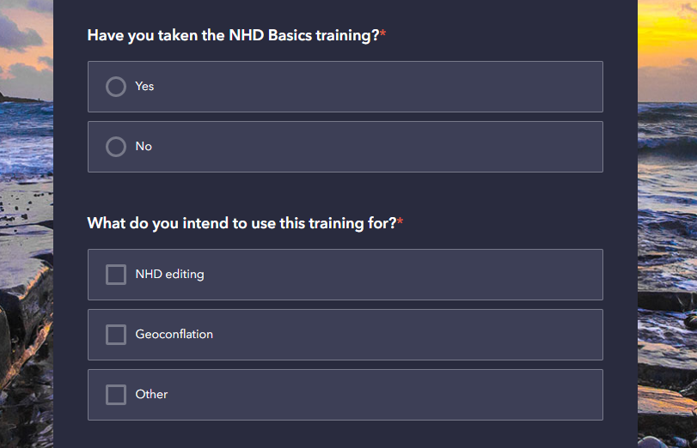

The fourth question asks the participants more detailed information about why they are taking the training – we would like to know how many people are taking the training but don’t intend to use it to edit the NHD. This is a required question.
The fifth question asks about the participant’s level of GIS experience prior to taking the course. This is a required question.

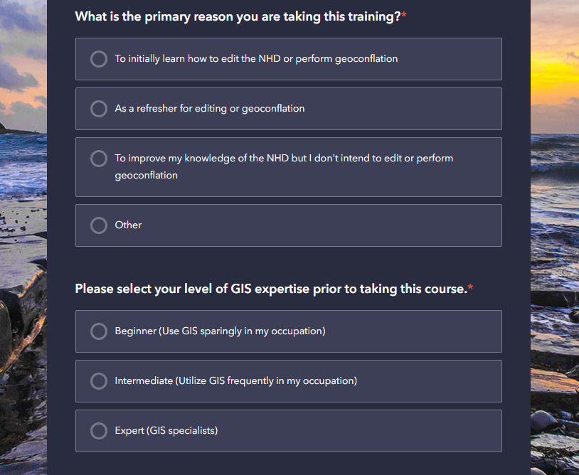

The sixth question asks participants how many times they have taken the course previously. This will help us determine if we need to offer a refresher course in an addition to a full training. This is a required question.
The seventh question is an open ended and allows participants to type in the most valuable aspect of the training and any changes they might suggest. This is not a required question.

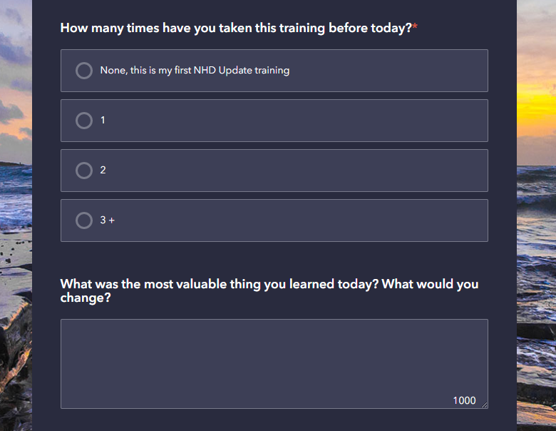

The last question (question 8) asks the user to ‘drop a point’ on their current location. This can be any location of their choosing. It is not a required question.

