MonitoringResources.org has five components, a user can use one, some or all of these components. Within each component there is a short list of necessary fields to complete the documentation, but users can fill in additional fields to improve their metadata documentation. Below are the components in MonitoringResouces.org:

- Study Design Tool helps define project objectives and an overall monitoring plan.
- Method Builder and Library supports documentation of the step-by-step processes for collecting and analyzing data.
- Protocol Builder and Library allows users to combine multiple methods into a protocol to define the suite of information collected and analyzed, including use of previously published methods from the method library.
- Master Sample Library stores, displays, and documents master samples—a master sample consists of a set of potential sample locations from which monitoring sites can be selected. Use of master samples allows data from multiple monitoring programs to be more easily shared, integrated, and used for other applications.
- User Sample File leads users through the process of uploading planned sampling sites to MonitoringResources.org.
- Sample Designer Tool helps users Create and document multiple types of sample designs;
  - Use a master sample to select and document spatially balanced, random sample sites and define the temporal plan for sampling; the selection process uses the Generalized Random Tessellation Stratified (GRTS) algorithm commonly used by agencies, monitoring organizations, and scientists;
  - Track site evaluation status before and during sampling; and
  - Share sampling dates, times, and implementation details with others.

Here is the landing (home page) for www.MonitoringResources.org
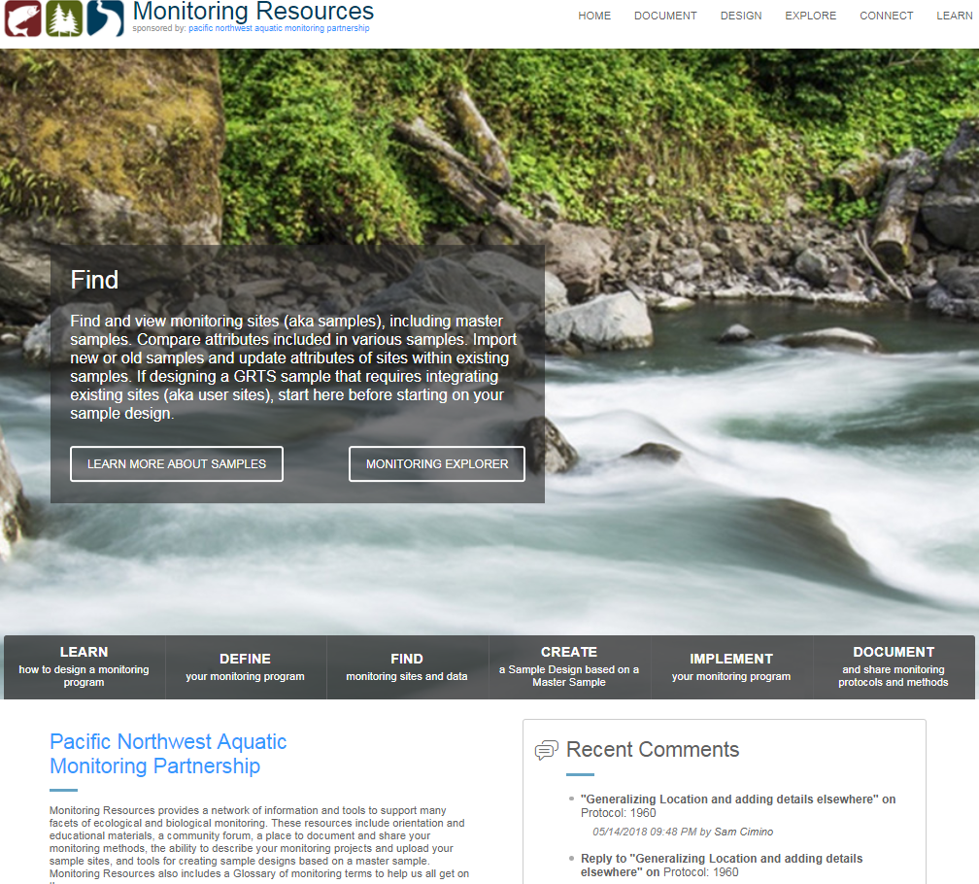

Below are screenshots from each component.

Study Design
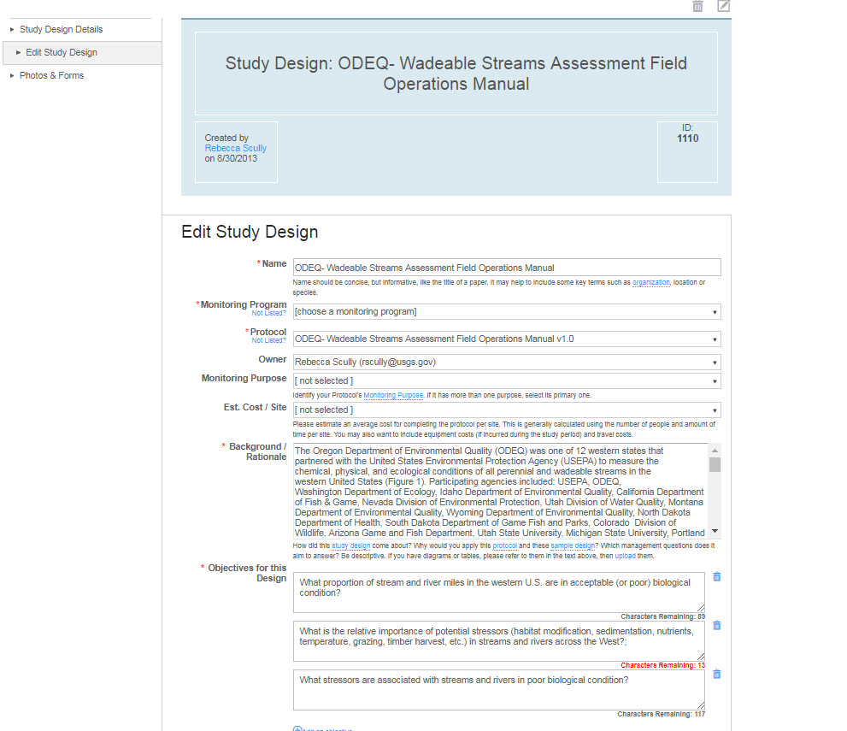

Method Builder
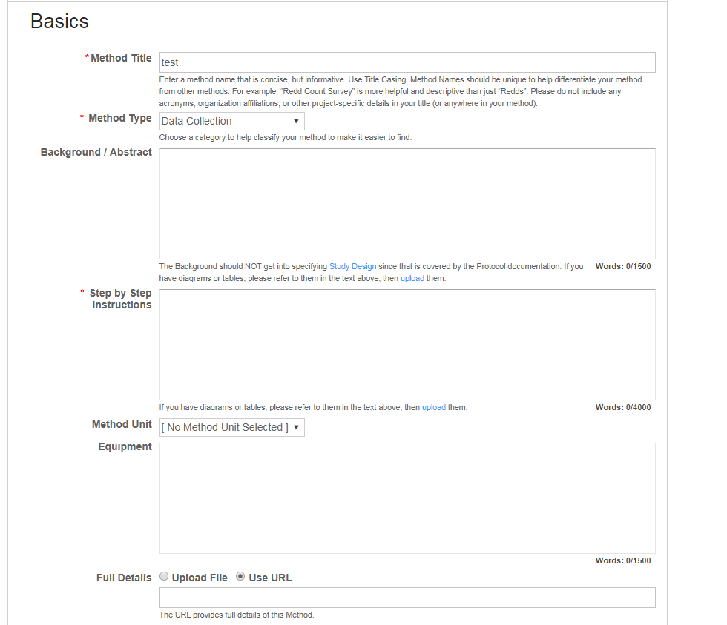

Protocol Builder 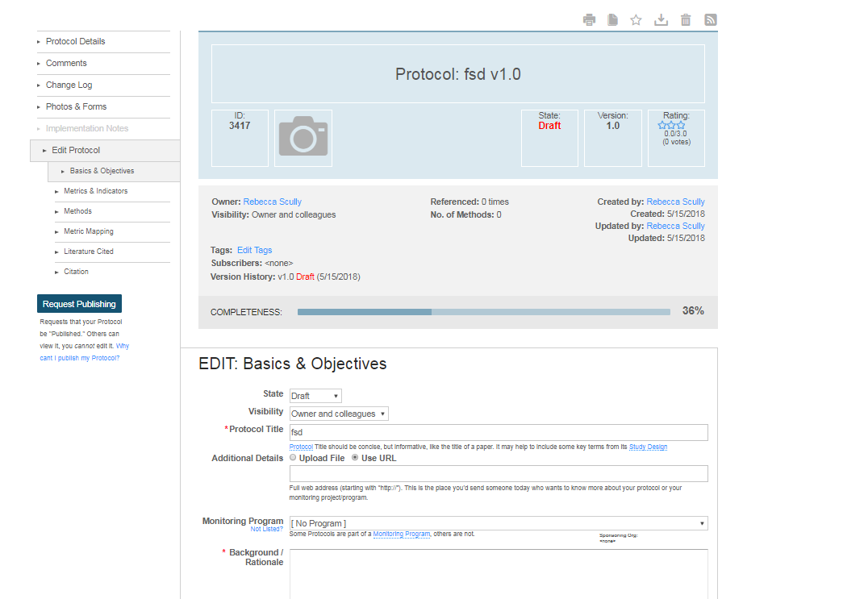

User Sample
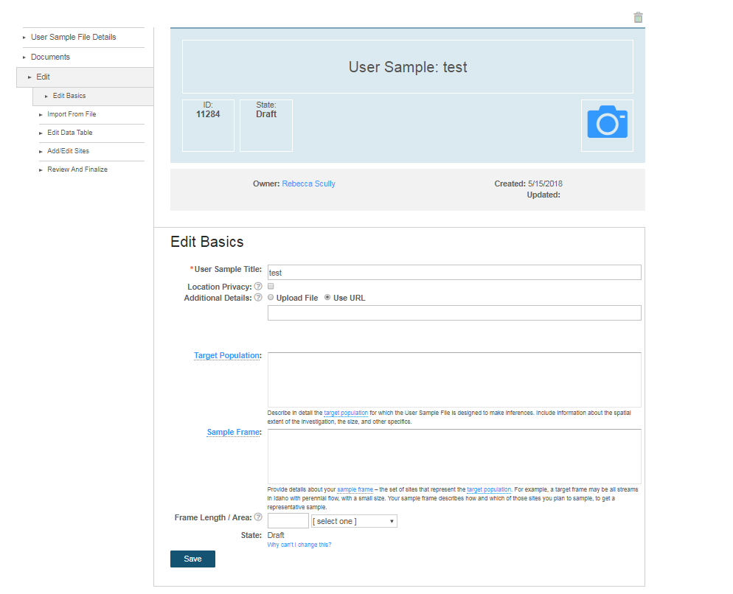

Sample Design
