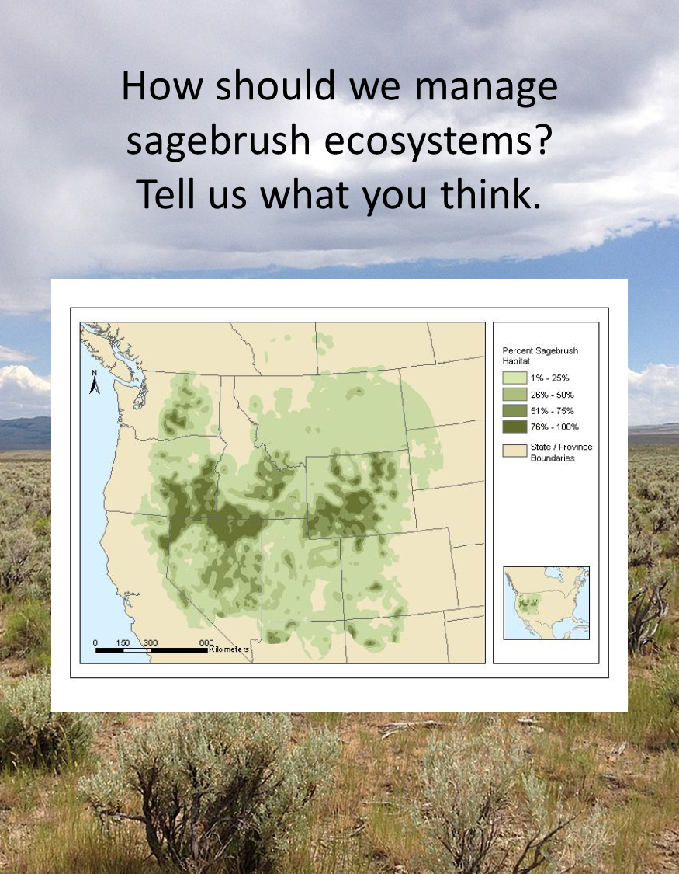
OMB No. 1090-0011
Approval Expires: 10/31/2021
Sagebrush ecosystems
Sagebrush ecosystems, like the one shown on the front of this survey, are communities of plants and animals where several species of sagebrush shrubs are the dominant plants. They also contain many species of grasses, other shrubs, and cactus.
Sagebrush ecosystems cover approximately 72 million acres of public lands, managed for the benefit of all citizens in the western U.S. They provide habitat for hundreds of species of birds and animals, some that are found nowhere else. Important sagebrush species include sage grouse, mule deer, pronghorn, Brewer’s sparrow, and pygmy rabbits. Sage grouse are entirely dependent on sagebrush ecosystems throughout their lifecycle. Pronghorn also depend on sagebrush for most of their lifecycle.
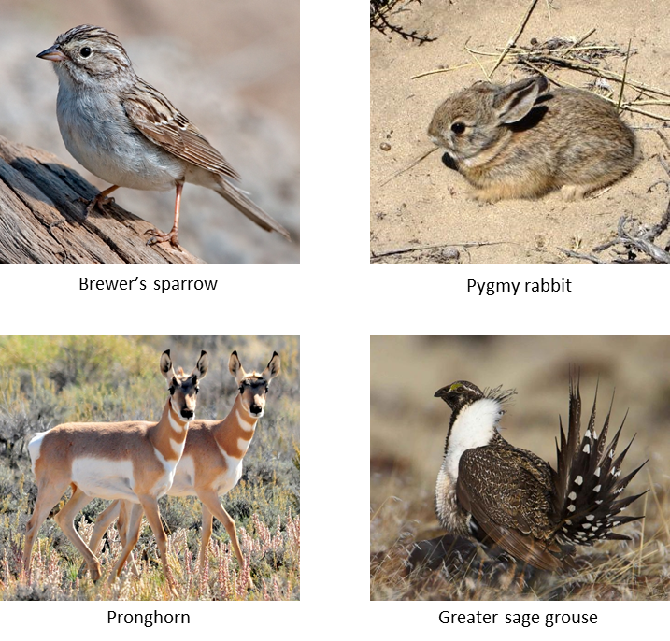
Condition of sagebrush ecosystems
- Sagebrush ecosystems are in decline for several reasons, including the spread of non-native plants like cheatgrass and pinyon-juniper woodlands.
- Recent decades have seen a general increase in the area burned across the full range of sagebrush ecosystems.
- While fire can be a natural part of sagebrush ecosystems, recent wildfires tend to kill most vegetation, and it often takes decades to return to pre-fire conditions.
- Without management after a wildfire, sagebrush ecosystems can be taken over by non-native grasses, such as cheatgrass, or experience other changes that can have negative effects on the species that depend on sagebrush.
- Many of the non-native plants are not edible for wildlife or livestock.
- Some are also especially fire-prone which can result in a cycle of repeated damaging wildfires.

What do sagebrush ecosystems mean to you?
We would like to know more about your experience with sagebrush ecosystems and your preferences for their management. For each of the statements below please indicate how strongly you agree or disagree.

 | Strongly agree | Agree | Neither agree nor disagree | Disagree | Strongly disagree
- Sagebrush ecosystems should be managed to support big game wildlife species.

- I am familiar with sagebrush ecosystems.
- It is important to prevent soil erosion on public lands.
- It is important to me to know that sage grouse will continue to exist in North America even if I never see one.
- It is more important to manage sagebrush areas for plants that produce good livestock forage than to focus on native plant species.
- My livelihood depends on sagebrush ecosystems.
- It is important to preserve ranching heritage on public lands the West.
- It is important to produce energy from public lands even if it impacts wildlife.
- It is important to me that sagebrush ecosystems are maintained for future generations.

Restoration of sagebrush ecosystems after wildfire
Each year approximately 2 million acres of sagebrush in the western US is burned in wildfires (example in photo A).
If no post-fire restoration occurs, then sagebrush areas become dominated by non-native cheatgrass (example in photo B) which provides little habitat for big game, sage grouse and other wildlife and is poor livestock forage.
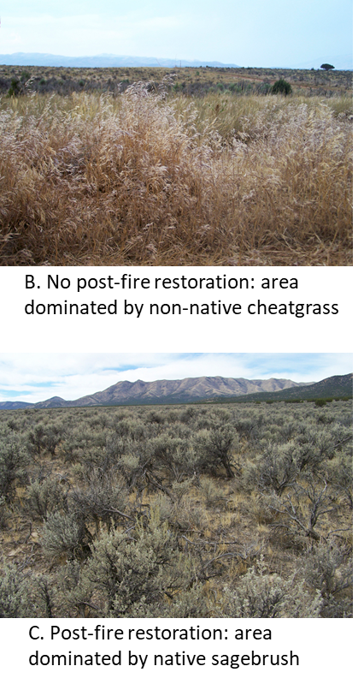
If post-fire restoration is carried out, sagebrush ecosystems can be restored to more healthy conditions (example in photo C). This would result in increased diversity of plants and animals, reduction of trees that encroach on the open shrublands, reducing or eliminating non-native, invasive plant species like cheatgrass, increasing native grasses and flowers, fewer damaging wildfires and less soil erosion.
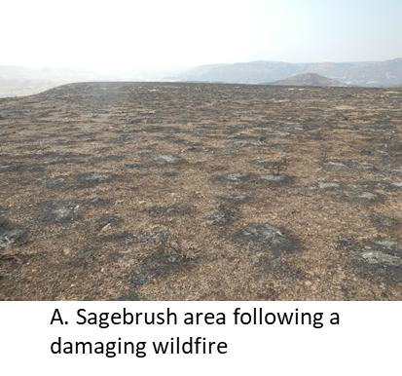
Possible restoration actions:
- Replanting sagebrush after wildfires
- Replanting native flowering plants and grasses after wildfires
- Controlling invasive species
- Reducing the spread of trees into sagebrush areas
- Adding fire breaks to reduce the spread of wildfires across the landscape

Possible outcomes of restoration:
- Restored landscapes that provide habitat for sage grouse
- Increased habitat for big game such as mule deer, pronghorn, and elk
- Perennial grasses that produce better livestock forage
Restoration following fires can be achieved through several management actions, and different actions could lead to different outcomes. The restoration option chosen will also affect how much the plan costs.
The purpose of this survey is to determine your preferences for the different possible options for restoration and the outcomes that would be achieved.
Restoration after fires can create healthy, native plant communities by treating the burned areas to bring back conditions that support livestock, native plant species, native animal and bird species, and reduce soil erosion.
One proposal to fund restoration of sagebrush ecosystems after fires is to set up a special fund dedicated to this restoration effort.
Since 60% of sagebrush ecosystems are on federal land, the dedicated fund would be paid for by an increase in the federal income tax.
- The increase would be paid annually and would last for 10 years.
- All U.S. households would pay the tax.
On the next page you will be asked to decide whether you would choose to raise taxes to restore sagebrush ecosystems.
- Your answers will be used to help the federal government compare the cost of sagebrush restoration with the benefits to American households. The answers you give could affect the amount of sagebrush ecosystems available for livestock and wildlife in the future and the amount of taxes you pay.
- In making this decision, please take into account your household income, whether you can afford to make the payment shown, and whether sagebrush restoration programs are worth that much to you.
- Consider everything else you could buy with the money and whether there are other government programs that you might rather see money spent on.
Options for sagebrush ecosystem restoration
The table below shows three possible restoration options.
Option 1 does not provide any post-fire restoration and there would be no cost to your household.
Options 2 and 3 are two different post-fire restoration programs that produce different levels of wildlife habitat and/or livestock forage.
The option chosen by a majority of households will be carried out, and all households will pay the amount specified. There is no right or wrong answer, please choose the option that is best for you.
At the bottom of this table, please check the boxes to indicate your most preferred option and your least preferred option:
 | Option 1  No post-fire restoration | Option 2  Post-fire restoration | Option 3  Post-fire restoration
Big game habitat: Acres restored with conditions the specifically support big game such as pronghorn, mule deer and elk. | 0 | 250,000 acres | 750,000 acres
Sage grouse habitat: Acres restored with conditions that specifically support sage grouse. | 0 | 200,000 acres | 750,000 acres
Livestock forage: Acres restored with conditions that specifically support livestock such as cattle, sheep, domestic bison. | 0 | 600,000 acres | 500,000 acres
Acres with no post fire restoration | 2,000,000 | 950,000 acres | 0
 | 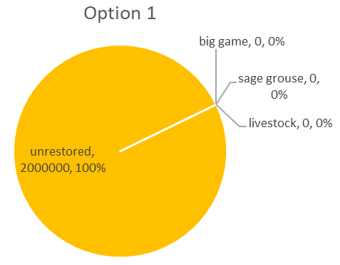 | 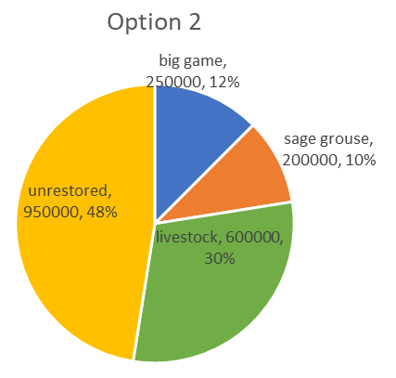 | 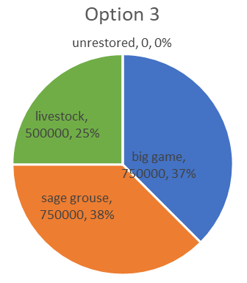
Your household’s annual cost for each of the next 10 years: | for No post-fire restoration:  $0 | Post-fire restoration Option B:  $50 | Post-fire restoration Option C:  $150
- Select Your Single Most Preferred Option: | Option 1 | Option 2 | Option 3
- Select Your Single Least Preferred Option: | Option 1 | Option 2 | Option 3

- If you selected Option B or C as your most preferred option for question 1 (on page 5) go to Question 5 (below. If you selected Option A as your most preferred option, please tell us why (check the single most important reason).
 |  | Restoring sagebrush ecosystems is not worth that much to me.
 |  | I can’t afford to pay that much.
 |  | We need to cut all government spending.
 |  | Taxes are too high already.
 |  | Sagebrush restoration programs should be paid for with existing tax dollars.
 |  | I don’t think that restoration of sagebrush is necessary.
 |  | The proposed management (or restoration) program won’t solve the problem of declining sagebrush ecosystems.
Other (please describe):
_______________________________________________________________________________________

_______________________________________________________________________________________
- How certain are you that your answers would be used to determine which sagebrush restoration programs will be implemented?
 | Very certain |  |  | Certain |  | Neither certain nor uncertain |  | Uncertain |  | Very uncertain
- How certain are you that you would actually have to pay the tax increase to provide restoration of sagebrush ecosystems?
 | Very certain |  |  | Certain |  | Neither certain nor uncertain |  | Uncertain |  | Very uncertain

Next, we would like to know about you and your recreational activities.
Your answers to these questions will only be used to see how well our survey sample represents the American public as a whole. Your answers are confidential. You will not be identified in any way.
- In the last 12 months, have you participated in any outdoor recreation activities in sagebrush ecosystems?
 |  | Yes go to question 2 |  |  |  |  |  |  |  |  |  |  |  |  |  |  |  |  |  | No go to question 4
- Which outdoor recreation activities have you participated in while visiting sagebrush ecosystems during the last 12 months? (Check all that apply.)
 |  | Hunting upland game birds |  |  |  |  |  |  |  |  |  |  |  |  |  |  |  |  |  |  |  |  |  |  |  |  |  |  |  | Hunting big game (deer, elk, pronghorn)
 |  | Watching birds or other wildlife |  |  |  |  |  |  |  |  |  |  |  |  |  |  |  |  |  |  |  |  |  |  |  |  |  |  |  | Camping or backpacking
 |  | Hiking or walking |  |  |  |  |  |  |  |  |  |  |  |  |  |  |  |  |  |  |  |  |  |  |  |  |  |  |  | Biking
 |  | Off-highway vehicle use |  |  |  |  |  |  |  |  |  |  |  |  |  |  |  |  |  |  |  |  |  |  |  |  |  |  |  | Scenic driving
 |  | Other outdoor activities (please describe) ______________________________________________________
- In total, how often did you do all the activities you checked above in sagebrush ecosystems in the last year?
 |  |  | 1 to 2 times |  |  |  |  |  |  |  | 3 to 5 times |  |  |  |  |  |  |  |  |  |  |  |  |  |  | 6 to 9 times |  |  |  |  |  |  |  | 10 to 19 times |  |  |  |  |  |  |  |  | 20 or more times
- Do you belong to any local, state, or national non-governmental organizations whose purpose is to protect environmental quality, wildlife habitat, and/or wildlife?
 |  | Yes |  |  |  |  |  |  |  | No
- What is your zip code? _______________________________________________________
- Are you: |  |  |  | Male |  |  |  |  |  |  |  |  |  |  |  |  |  |  |  |  | Female
- What is your age? |  |  |  |  |  |  |  |  |  |  |  | 18-24 |  |  |  |  |  |  |  |  |  |  |  |  | 25-34 |  |  |  |  |  |  | 35-44 |  |  |  |  |  | 45-64 |  |  |  |  |  | 65 or older
- Are you retired? |  |  |  |  |  |  |  |  | Yes |  |  |  |  |  |  |  |  |  |  |  |  | No
- What is the highest level of schooling you have completed?
 | Some high school |  |  |  |  |  |  |  |  |  |  |  |  |  |  |  |  |  |  |  |  |  |  |  |  |  |  |  |  |  | High school graduate or equivalent
 | Some college or technical school (but no degree) |  |  |  |  |  |  |  |  |  |  |  |  |  |  |  |  |  |  |  |  |  |  |  |  |  |  |  |  |  | Associate’s degree (including occupational or academic degrees)
 | Bachelor’s degree (BA, BS, AB, etc.) |  |  |  |  |  |  |  |  |  |  |  |  |  |  |  |  |  |  |  |  |  |  |  |  |  |  |  |  |  | Master’s degree (MA, MS, MENG, MSW, etc.)
 | Doctoral degree (PhD, EdD, etc.) |  |  |  |  |  |  |  |  |  |  |  |  |  |  |  |  |  |  |  |  |  |  |  |  |  |  |  |  |  | Professional school degree (MD, DDC, JD, etc.)
- Here is a list of racial categories. Please select one or more which best describes your race (check all that apply):
 | American Indian or Alaska Native |  |  |  |  |  |  |  |  |  |  |  |  |  |  |  |  |  |  |  |  | Native Hawaiian or other Pacific Islander |  |  |  |  |  |  |  |  |  |  |  |  |  |  |  |  | Asian
 | Black or African American |  |  |  |  |  |  |  |  |  |  |  |  |  |  |  |  |  |  |  |  | White |  |  |  |  |  |  |  |  |  |  |  |  |  |  |  |  | Other _______________________
- Are you Hispanic or Latino? |  |  |  |  |  |  |  |  |  |  |  |  |  |  |  |  | Yes |  |  |  |  |  |  |  |  |  |  | No
- Which of the following income categories best describes your household’s total income last year before taxes? Your answer will be kept strictly confidential and only used for comparing groups of people.
 | Less than $15,000 |  |  |  |  |  |  |  |  |  |  |  |  |  |  |  |  |  |  |  |  |  | $15,000 up to $24,999 |  |  |  |  |  |  |  |  |  |  |  |  |  |  |  |  | $25,000 up to $34,999
 | $35,000 up to $49,999 |  |  |  |  |  |  |  |  |  |  |  |  |  |  |  |  |  |  |  |  |  | $50,000 up to $74,999 |  |  |  |  |  |  |  |  |  |  |  |  |  |  |  |  | $75,000 up to $99,999
 | $100,000 up to $149,999 |  |  |  |  |  |  |  |  |  |  |  |  |  |  |  |  |  |  |  |  |  | $150,000 up to $199,999 |  |  |  |  |  |  |  |  |  |  |  |  |  |  |  |  | $200,000 or more
- How many people contributed to this household income amount to listed above? ___________________ (number)
- How many people of currently live in your household? __________________________________________ (number)
- How many children under the age of 18 currently live in your household? ___________________________ (number)

Thank you taking the time to complete this survey. Use the postage paid return envelope to return the survey.
If you have any additional comments, please use the space below.



Department of Agriculture and Resource Economics
Colorado State University
Fort Collins, CO 80525

Paperwork Reduction Act Statement: We are collecting this information subject to the Paperwork Reduction Act (44 U.S.C. 3501) to assess your preferences for sagebrush restoration at wildfires. Your response is voluntary and results we will not share them publicly. We may not conduct or sponsor, and you are not required to respond to a collection of information, unless it displays a currently valid OMB Control Number. OMB has reviewed and approved this survey and assigned OMB Control Number 1090-0011, which expires 10/31/2021.

Estimated Burden Statement: We estimate this focus group will take you 120 minutes to complete, including time to read instructions, gather information, and complete and submit your responses. You may submit comments on any aspect of this information collection to the Information Collection Clearance Officer, James Sayer, jsayer@usgs.gov.

