## NWS 2018 Quarterly Pop-up Customer Satisfaction Survey_Q2 FY18

## Final (12/19/17)

### Introduction

Note: Section headers will not be included in online survey. Items in **BOLD AND CAPS** are programmer instructions. Response options will be randomized, except when sequential. All rated questions will include a “Don’t Know” and/or “NA” option. When a “RANDOMIZE” instruction is provided, any “Other,” “Don’t Know,” “NA,” or “None” style of response will be forced to the bottom of the response set.

**Introduction**

The National Oceanic and Atmospheric Administration’s (NOAA) National Weather Service (NWS) is committed to serving the needs of all of its users. The NWS is undertaking research on how satisfied users are and would appreciate your feedback. The purpose of this research, conducted in partnership with the federal government as part of the American Customer Satisfaction Index, is to help the NWS improve its services for you and others like you.

Your answers are voluntary, but your opinions are very important for this research. Your responses will be kept completely confidential, and you will never be identified by name. CFI Group, a third-party research and consulting firm, is administering this survey via a secure server. The time required to complete this survey will depend on how certain questions are answered, but will likely take about 10 minutes. This survey is authorized by Office of Management and Budget Control No. 1090-0007, which expires May 31, 2018.

Please click on the “Next” button below to begin the survey.

### Screeners

Q1. What is your age?

|  |  |  |
| --- | --- | --- |
| Under 15 | 1 | **[THANK AND TERMINATE]** |
| 15-24 | 2 |  |
| 25-34 | 3 |  |
| 35-44 | 4 |  |
| 45-54 | 5 |  |
| 55-64 | 6 |  |
| 65+ | 7 |  |

Q2. Are you familiar with the watches and warnings issued by the NWS as they relate to winter weather, including extreme cold/wind chill events?

|  |  |  |
| --- | --- | --- |
| Yes, both winter weather and extreme cold/wind chill | 1 |  |
| Winter weather only | 2 | **[SKIP TO WINTER WEATHER SECTION]** |
| Extreme cold/wind chill only | 3 | **[I[SKIP TO EXTREME COLD/WIND CHILLSECTION]** |
| Neither winter weather nor extreme cold/wind chill | 4 | **[THANK AND TERMINATE]** |

### Sources of Weather Information

Q3. What is your **preferred** method to check the weather?

|  |  |
| --- | --- |
| My personal computer (i.e., laptop, desktop) | 1 |
| Television | 2 |
| NOAA Weather Radio/All Hazards | 3 |
| Commercial Radio Broadcast | 4 |
| My smartphone | 5 |
| My tablet | 6 |

### NWS Information for Winter Weather

Q4. Please think about the information you receive from the NWS during this season regarding winter weather (e.g., snow, sleet, freezing rain). Using a scale from 1 to 10 where 1 is “Poor,” and 10 is “Excellent,” please rate **NWS** on the following:

(Select one for each row)

|  |  |  |  |  |  |  |  |  |  |  |  |
| --- | --- | --- | --- | --- | --- | --- | --- | --- | --- | --- | --- |
|  | Poor 1 | 2 | 3 | 4 | 5 | 6 | 7 | 8 | 9 | Excellent 10 | Don’t Know/NA |
| Ease of finding winter weather, forecast information specific to your geographic area of interest |  |  |  |  |  |  |  |  |  |  |  |
| Accuracy of winter weather forecasts |  |  |  |  |  |  |  |  |  |  |  |
| Explaining the threat and expected impacts of winter weather |  |  |  |  |  |  |  |  |  |  |  |
| Providing information to help you make decisions relative to winter weather events (e.g., stay home, go to supermarket, drive versus taking public transportation) |  |  |  |  |  |  |  |  |  |  |  |

Q4.1 **[If any response within Q4 is <6]** Please comment on the aspects of NWS winter weather forecasts that you find particularly unsatisfactory (**open end**)

### Contribution to Understanding of Winter Weather

Q5.How would you rate your **current knowledge of** winter weather using a 10-point scale in which 1 means “Not at all knowledgeable” and 10 means “Very knowledgeable”?

Q6.Now please rate the extent to which the information provided by the NWS has contributed to your understanding of the dangers of winter weather, using a 10-point scale in which 1 means “Not at all” and 10 means “Significantly.”

### NWS Information for Extreme Cold/Wind Chill

Q7.Now consider the information you receive from the NWS regarding extreme cold/wind chill. Using a scale from 1 to 10 where 1 is “Poor,” and 10 is “Excellent,” please rate **NWS** on the following:

(Select one for each row)

|  |  |  |  |  |  |  |  |  |  |  |  |
| --- | --- | --- | --- | --- | --- | --- | --- | --- | --- | --- | --- |
|  | Poor 1 | 2 | 3 | 4 | 5 | 6 | 7 | 8 | 9 | Excellent 10 | Don’t Know/NA |
| Ease of finding extreme cold/wind chill information specific to your geographic area of interest |  |  |  |  |  |  |  |  |  |  |  |
| Accuracy of information for extreme cold/wind chill events |  |  |  |  |  |  |  |  |  |  |  |
| Explaining the threat and expected impacts of extreme cold/wind chill events |  |  |  |  |  |  |  |  |  |  |  |
| Providing information to help you make decisions relative to extreme cold/wind chill (e.g., remain indoors, insulate exposed pipes, made sure vehicle is winterized, found shelter for pets/livestock) |  |  |  |  |  |  |  |  |  |  |  |

### Contribution to Understanding of Extreme Cold/Wind Chill

Q8.How would you rate your **current knowledge of** extreme cold/wind chill using a 10-point scale in which 1 means “Not at all knowledgeable” and 10 means “Very knowledgeable”?

Q9.Now please rate the extent to which the information provided by the NWS has **contributed to your understanding of the dangers of extreme cold/wind chill,** using a 10-point scale in which 1 means “Not at all” and 10 means “Significantly.”

**Probabilistic Snow Forecasts**

The Probabilistic Snow Forecasts contain probabilities that represent the percent chance of receiving the amount of snow shown on the map. The purpose of these probabilistic snowfall products is to provide a range of snowfall possibilities to better communicate forecast uncertainties during winter weather events. For example, the left-most slide of the diagram lists "10th percentile" on the bottom and "9 in 10 chance (90%)" on the top. They mean the same thing.  
  
Q10. How would you rate your current knowledge of the following probabilistic snow total forecasts to help you make decisions concerning heavy snow on a scale of 1 to 10, where 1 means “very low knowledge” and 10 means “very high knowledge” (i.e., an expert)?

Q11. Using a 10-point scale where 1 means “not at all satisfied” and 10 means “very satisfied,” please rate your level of satisfaction with the following probabilistic snow total forecasts in helping you make decisions concerning heavy snow.

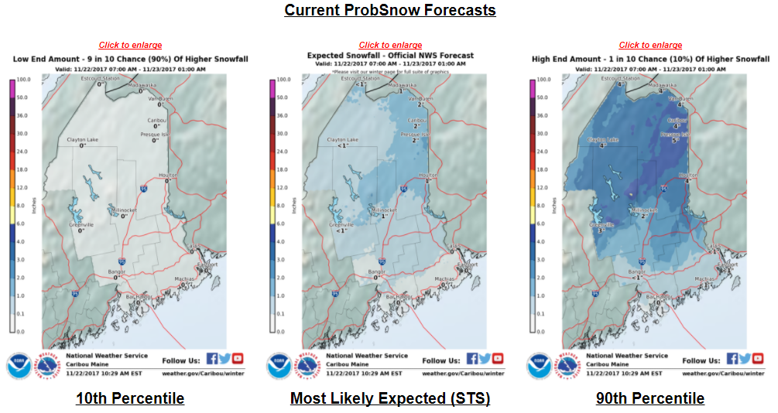

Q12 [If Q11 <6]  
Please indicate what the NWS should change to improve your satisfaction with probabilistic snow total forecasts in helping you make decisions concerning heavy snow? **(Open End)**

### **Weather Hazard Preparedness**

Q13. Do you have a safety plan and/or a safety kit for coping with any of the following hazard types? Select all that apply

|  |  |  |
| --- | --- | --- |
|  | **Safety Plan (e.g., evacuation, shelter, communication)** | **Emergency Preparedness/Safety/ Disaster Supply Kit** |
| Hazardous Flooding |  |  |
| Tornadoes |  |  |
| Tropical Storms/Hurricanes |  |  |
| Tsunamis |  |  |
| Wildland Fires |  |  |
| Hazardous Winter Weather |  |  |

### Social Media/Websites

Q14. People rely on various sources for information during winter weather-related events. Please indicate how the following sources influenced your decisions before and during ongoing winter weather-related events,using a 1 to 10 scale, where 1 means “Did Not influence your decisions at all” and 10 means***,*** “Greatly influenced your decisions”:

* National Weather Service Social Media Accounts (Facebook, Twitter, Instagram).
* Other Social Media Accounts (e.g., The Weather Channel, Facebook/ Twitter/Instagram, Weather Underground Facebook/Twitter/Instagram).
* Websites (e.g., Weather.com, Weather.gov)
* Mobile applications
* Other (please specify) **(CAPTURE)**

### Customer Satisfaction Index (CSI)

Q15. Now, please consider all your experiences with the **NWS**. Using a 10-point scale where 1 means “Very Dissatisfied” and 10 means “Very Satisfied,” how satisfied are you with the **NWS**?

|  |  |  |  |  |  |  |  |  |  |  |
| --- | --- | --- | --- | --- | --- | --- | --- | --- | --- | --- |
|  | Very Dissatisfied 1 | 2 | 3 | 4 | 5 | 6 | 7 | 8 | 9 | Very Satisfied 10 |
| Overall Satisfaction with the NWS |  |  |  |  |  |  |  |  |  |  |

Q17. Using a 10-point scale where 1 now means “Falls Short of your Expectations” and 10 means “Exceeds Your Expectations,” to what extent has the **NWS** fallen short of or exceeded your expectations?

|  |  |  |  |  |  |  |  |  |  |  |
| --- | --- | --- | --- | --- | --- | --- | --- | --- | --- | --- |
|  | Falls Short Of Your Expectations 1 | 2 | 3 | 4 | 5 | 6 | 7 | 8 | 9 | Exceeds Your Expectations 10 |
| How well the NWS has met your expectations |  |  |  |  |  |  |  |  |  |  |

Q18. Now, imagine what an ideal organization providing weather information would be like. Using a 10-point scale where 1 means “Not Very Close to the Ideal,” and 10 means “Very Close to the Ideal,” how well do you think the **NWS** compares with that ideal weather information provider?

|  |  |  |  |  |  |  |  |  |  |  |
| --- | --- | --- | --- | --- | --- | --- | --- | --- | --- | --- |
|  | Not Very Close to the Ideal  1 | 2 | 3 | 4 | 5 | 6 | 7 | 8 | 9 | Very Close to the Ideal  10 |
| NWS compared to an ideal weather information provider |  |  |  |  |  |  |  |  |  |  |

### Desired Outcomes

Q19. Using a scale from 1 to 10 where 1 means “Not at All Likely” and 10 means “Very Likely,” please indicate how likely you are to:

|  |  |  |  |  |  |  |  |  |  |  |  |
| --- | --- | --- | --- | --- | --- | --- | --- | --- | --- | --- | --- |
|  | Not at All Likely 1 | 2 | 3 | 4 | 5 | 6 | 7 | 8 | 9 | Very Likely  10 | Don’t Know |
| Take action based on the information you receive from the NWS? |  |  |  |  |  |  |  |  |  |  |  |
| Use the NWS as a source of weather information in the future |  |  |  |  |  |  |  |  |  |  |  |
| Recommend the NWS to a colleague or a friend |  |  |  |  |  |  |  |  |  |  |  |

Q20.Please share with us any final thoughts about your experience with NWS, including how we can improve our services to you and what you value most about our services. **(Open End)**

### Demographics and Additional Background

We’re almost done! We would like to ask you just a few more questions:

Q21. Please enter your zip code **(Text Box)**

Q22. What is your gender?

|  |  |
| --- | --- |
| Male | 1 |
| Female | 2 |
| Prefer not to answer | 3 |

Q23. What is your race or origin?

|  |  |
| --- | --- |
| White/Caucasian | 1 |
| Black/African American | 2 |
| Hispanic or Latino | 3 |
| Native Hawaiian or Other Pacific Islander | 4 |
| Asian | 5 |
| American Indian or Alaska Native | 6 |
| Other (please specify) | 7 |
| Prefer not to answer | 8 |

Q24. What is the highest degree or level of education that you have completed?

|  |  |
| --- | --- |
| 12th grade or less (no diploma) | 1 |
| High school diploma or GED | 2 |
| Some college, no degree | 3 |
| Associate or technical degree | 4 |
| Bachelor’s degree | 5 |
| Graduate/Professional degree | 6 |
| Don’t know | 7 |
| Prefer not to answer | 8 |

Q25. What was your household income last year?

|  |  |
| --- | --- |
| Less than $20,000 | 1 |
| Between $20,000 and $29,999 | 2 |
| Between $30,000 and $39,999 | 3 |
| Between $40,000 and $49,999 | 4 |
| Between $50,000 and $59,999 | 5 |
| Between $60,000 and $79,999 | 6 |
| Between $80,000 and $99,999 | 7 |
| $100,000 or more | 8 |
| Don’t know | 9 |
| Prefer not to answer | 10 |

### Close

Those are all the questions we have. Please click “Submit” below to finalize your responses. Thank you for your participation!