**UNITED STATES ENVIRONMENTAL PROTECTION AGENCY**



NATIONAL VEHICLE AND FUEL EMISSIONS LABORATORY

2565 PLYMOUTH ROAD

ANN ARBOR, MICHIGAN 48105-2498

OFFICE OF

AIR AND RADIATION

Dear Vehicle Owner:

The Environmental Protection Agency is conducting an important, voluntary program to help control air pollution which involves analyzing vehicle emissions of privately owned cars and trucks to determine the effectiveness of emissions control systems. You may be able to contribute significantly toward this program and be compensated for allowing us to test your vehicle. If your vehicle qualifies, we will offer you the following incentives to participate. Participation is necessary to receive these incentives:

1. The use of a fully insured loaner car with a full tank of fuel, and $20.00 per day.
2. If you do not wish to use a loaner vehicle, you will receive $50.00 per day.
3. If you do not wish to provide your social security number, you have the option to cap your total incentive at $599.
4. Your vehicle will be returned to you after testing with a full tank of fuel.

Testing will be conducted in EPA's National Vehicle and Fuel Emissions Laboratory in Ann Arbor. Your vehicle will probably accumulate less than 300 miles under simulated driving conditions. No unusual operations will be performed on your vehicle and it will be fully insured for the entire test period which will take approximately one to four weeks. EPA will want to continue testing your vehicle until all tests are complete.

Jacobs, a contractor to the EPA, is working with EPA to procure vehicles for this program. Please complete and return the enclosed reply form in the prepaid envelope to Jacobs as soon as possible even if you choose not to participate. If you are willing to participate, a representative of Jacobs may be in touch with you to ask questions about your vehicle. The information that you provide to EPA in the reply form and your answers to our questions will indicate your willingness to participate and whether your vehicle is eligible to participate. The amount of time to answer the questions, which includes reviewing instructions, locating records, and reviewing the information, is estimated to be up to 60 minutes with an average of about 30 minutes per response. (Questions about the time estimate may be sent to Chief, Information Policy Branch, PM-223, USEPA, 401 M St. SW, Washington, DC 20460. This information is collected under Information Collection Request OMB# 2060-0086.)

The EPA will keep the personal information that you provide (name, contact information and, if collected, social security number) confidential. However, EPA must submit your social security number to the IRS if your incentive is $600 or more. Your vehicle’s VIN will be shared with the vehicle manufacturer because the vehicle manufacturer needs the VIN in order to provide information to EPA that is necessary for testing your vehicle’s emissions systems.

On rare occasions the manufacturer may ask for your contact information so that they may contact you with questions about your vehicle or to test your vehicle as well. We ask for your permission to share your contact information with the manufacturer.

(over)

The enclosed information sheet answers some questions people often ask about this program. If you want to participate in this program or have any additional questions, please feel free to call Jacobs toll free at **(855) 665-1228**. Someone is available between 8 AM and 4 PM or you may leave a message for a return call. You may also call me at (734) 214-4851. I will be happy to answer any questions you may have related to this program. We look forward to receiving your reply form or a telephone call very soon.

Sincerely,

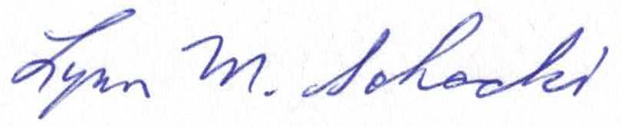

Lynn Sohacki

Environmental Engineer

Compliance Division

Environmental Protection Agency

2565 Plymouth Road

Ann Arbor, MI 48105