Appendix H. Process Mapping Protocol
OMB No. 0584-[NEW]
Assessment of Mandatory E&T Programs
Month XX, 2018
Project Officer: Jordan Younes
Office of Policy Support
Food and Nutrition Service
U.S. Department of Agriculture
3101 Park Center Drive
Alexandria, VA 22303
703-305-2935
Jordan.younes@fns.usda.gov

Assessment of Mandatory E&T Programs: Process Mapping Protocol
My name is [name], and I’m a researcher at [Insight Policy Research/Mathematica Policy Research, working with Insight]. As you may know, we’re conducting a study of Mandatory E&T Programs for the Food and Nutrition Service (FNS) of the U.S. Department of Agriculture. This study examines how mandatory State SNAP E&T programs are administered and how the programs help SNAP clients move toward economic self-sufficiency. We are interested in better understanding the rates of participation, sanction, and employment among mandatory E&T clients. We also want to explore reasons why mandatory E&T clients are most often sanctioned and when sanctions happen, such as at initial referral, intake and assessment, or service referral. This study also seeks to understand how well mandatory programs help SNAP clients gain skills, certificates and credentials, and stable employment.
My colleagues and I are currently visiting local SNAP offices and E&T providers here and in five other States to collect information from a wide range of stakeholders involved in operating a mandatory SNAP E&T program. I want to start by thanking you for taking time to speak with us today. Your perspective and insights on these issues will be very helpful to the study.
I want to let you know that your participation in this process mapping exercise is voluntary, and your responses will be kept private to the extent provided by law. We will not share the information you provide with anyone outside the study team. You may refuse to answer any question, and you may stop the discussion at any time. There will no penalties if you refuse to participate in part or at all.
We will take notes over the course of the exercise and would like to record the conversation so we can remember the information we collect. We will use this information in our reports to FNS, describing the SNAP E&T process in your State. The reports might list the names of States that contributed information, but we will not quote you or anyone by name or title. However, because of the relatively small number of SNAP offices participating in the study, there is a possibility a response could be correctly attributed to you.
I expect our discussion will take about 90 minutes. First, do you have any questions for me about the project in general or what we will be discussing today?
Do I have your permission to record our discussion? [Confirm permission before recording starts.]
Note to moderator: Some of the questions in this protocol can be addressed through information available in States’ E&T plans. These questions should still be asked to ensure the information in the plan is accurate and to obtain more detail.
Several of the questions and probes in this protocol can also be found in the Local Office Eligibility Worker and Local Office Director protocols. The general answers to these questions should be provided during this process mapping exercise. The questions may be asked again during the eligibility worker and local office director interviews, should further probing, or a more in-depth conversation, be required.
According to the Paperwork Reduction Act of 1995, an agency may not conduct or sponsor, and a person is not required to respond to, a collection of information unless it displays a valid OMB control number. The valid OMB control number for this information collection is 0584-xxxx. The time required to complete this information collection is estimated to average 90 minutes per response, including the time for reviewing instructions, searching existing data sources, gathering and maintaining the data needed, and completing and reviewing the collection of information. Send comments regarding this burden estimate or any other aspect of this collection of information, including suggestions for reducing this burden, to: U.S. Department of Agriculture, Food and Nutrition Services, Office of Policy Support, 3101 Park Center Drive, Room 1014, Alexandria, VA 22302, ATTN: PRA (0584-xxxx*). Do not return the completed form to this address.
- Abstracted SNAP E&T Process
Note to moderator: Include a flow chart of the basic SNAP E&T process, on a large poster board, showing details abstracted from the E&T State plan. After showing the flow chart to the group, make sure to confirm whether all applicable agencies and providers are included in the flow chart.
Figure 1. Example flow chart
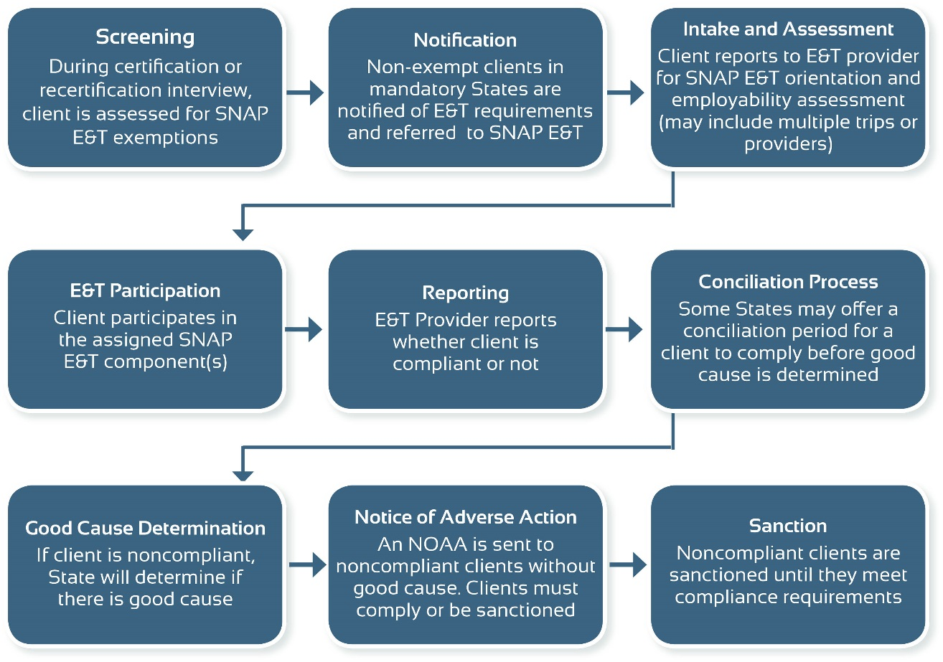
- Screening
First I want to discuss the screening process.
- Can you tell me how your office screens new SNAP applicants for participation in the mandatory SNAP E&T program? Please walk me through this process.
  - [Probe] When, during the intake process, are SNAP applicants screened for E&T?
  - [Probe] Who conducts the screening?
i. Do they use a guide or desk aid to conduct the screening interview? [Collect guide if available.]
  - [Probe] How does the screening occur – is it done in person? By phone? Online?

  - [Probe] How do you identify possible exemptions from E&T? Do you walk through the list of possible exemptions with the client or do you ask clients to identify any barriers that might exempt them?
i. Are there specific documents clients need to present to demonstrate they meet one or more exemption criteria?
  - [Probe] Do you use your computer or MIS to screen clients?
i. Do any of the answers to questions require your judgment? Please elaborate.
  - [Probe] What information is provided to the participant at the time of the screening?
  - [Probe] Who makes the final determination regarding work registrant status? Is it made during the screening or is there a delay?
- How do you screen SNAP participants for E&T during recertification?
  - [Probe] How does the screening process differ from new SNAP applicants?
  - [Probe] What information is provided to the participant?
  - How frequently do you reassess eligibility for E&T?
- How do you screen ABAWDs?
  - [Probe] How does the screening process differ from new SNAP applicants?
  - [Probe] What information is provided to ABAWDs?
- Notification
I want to move on to the notification process.
- Can you describe how a SNAP participant is notified that they must participate in E&T?
  - [Probe] Is there any lag time between screening and notification? If so, what is the latest you can notify a client?
  - [Probe] What additional information do you provide to the client at that time, aside from letting them know they must participate in E&T services? Do you direct them to a particular office, give them a phone number to call, or a list of E&T providers? Do mandatory participants receive any hard copy or electronic instructions?
  - [Probe] How is the notification sent to the participant? Via phone? Mail? Do you discuss it in person?
  - [Probe] What information is included in the notification?
  - How does the notification process differ for new applicants versus those recertifying for SNAP? What information is included in the notification for those recertifying?
  - How does the notification process differ for ABAWDs vs. non-ABAWDs?
- What can a client do if they are referred to E&T but believe themselves to be exempt?

- Does the State or client select the appropriate E&T provider?
  - [Probe if State selects provider] How do you determine what E&T provider to refer a client to? Does this differ for ABAWDs?
i. [Probe] How does the E&T provider receive notification of a new mandatory client?
ii. [Probe] What system, if any, is used to notify the E&T provider? Is this information manually entered? Is it an automatic process?
iii. What are the next steps for the E&T provider?
  - [Probe if client selects provider] What information is given to clients about available providers?
- How long does a client have to report to a provider? What happens if they do not report?
  - [Probe] How does this differ for ABAWDs? For those recertifying?
- Once a client learns they are required to participate in E&T, what happens next?
- Intake and Assessment
Let’s discuss the next step after a client is referred to E&T.
- Can you walk me through the intake process?
  - [Probe] What activities or assessments must a client complete? How does this differ for clients recertifying for SNAP? How does it differ for ABAWDs?
  - [Probe] How does the client learn of the intake process? Do clients recertifying their SNAP benefits learn about their next step differently? How about ABAWDs?
  - [Probe] How much time does a client have to complete intake?
  - [Probe] How is the intake appointment scheduled? Can the client change the appointment day/time? What happens if the client does not show up to the appointment?
  - [Probe] Who does the client interact with during the intake and assessment process?
  - [Probe] Is there a process in place if a provider thinks someone should be exempt? How do you learn about incorrect referrals?
  - [Probe] Does your office or a provider offer a SNAP E&T orientation? If so, please describe.
i. [Probe] Where does the orientation happen (local office, provider’s site, online)? What information is provided?
ii. [Probe] Is the orientation mandatory? If so, who must attend? Do recertifying clients need to attend?
iii. [Probe] How is the orientation scheduled? When is it typically offered?
iv. [Probe if orientation is mandatory] How much time does a client have to attend the orientation after being notified that they must participate? What happens if a client cannot attend or needs to reschedule?
- How do clients learn about the supportive services that are available?
  - How do clients learn about participant reimbursements?
  - What is the process for obtaining supportive services and reimbursements?
- How are mandatory clients assigned to an E&T component?
  - [Probe] Can they choose among various E&T components or do they get placed or assigned to a particular one?
  - [Probe] What factors or considerations go into deciding which component to assign someone to?
  - Do clients who have recertified stay with the same provider?
  - Do ABAWDs have the same provider selections as non-ABAWDs?
- What is the next step after a client completes intake and assessment?
  - [Probe] How is the client notified of next steps?
- E&T Participation and Reporting
The next step in our process is participation in the E&T components. Let’s discuss how E&T providers report information to the local SNAP office.
- How long does a client have to participate in E&T after completing intake? Does this differ for individuals recertifying for SNAP? For ABAWDs?
- What are the processes in place at the local office to track E&T participation? How do you track whether clients are meeting their E&T requirements?
  - How do you know if a client reported to a provider? Engaged in an E&T component for the requisite hours? [Note to moderator: probe as needed to determine how tracking occurs at each step of the intake process]
- How do these processes differ, if at all, for tracking ABAWDs?
  - [Probe] How do you track ABAWDs over a 3-year continuous period? How do you assess that they work and/or participate in E&T for 80 hours/month?
- How do you communicate with E&T providers about a client’s status with regards to participation in E&T and compliance with requirements?
- What information do providers report to your office?
- [Note this could include: What component the client is enrolled in? If they complete the program? Receive a credential or certificate? Enroll in another component? Get a job?]
  - [Probe] How often are the data sent? By whom?
  - [Probe] Are the data sent manually or is it automated? What systems are used?
  - [Probe] How are the data processed and used? Does the system manually or automatically identify clients who are noncompliant? How are you alerted of a client’s noncompliant status?
- To your knowledge, how does the E&T provider track and log participation?
- What are the participation requirements for clients in order to remain compliant?
  - [Probe] How many days or hours are they required to participate? What steps are they required to take?
  - [Probe] How do participant requirements differ for ABAWDs versus non-ABAWDs?
- How is non-participation defined, logged, and reported? What is the timeframe for reporting noncompliance? [Note to moderator: According to FNS policy, the E&T provider has 10 days to report noncompliance to the State.]
  - [Probe] Does this vary depending on the component or E&T provider?
- Noncompliance and Good Cause Determination
Next, I want to discuss noncompliance and good cause determination. [Note to moderator: According to FNS policy, the State must determine good cause “as soon” as it learns of noncompliance.]
- What happens next after you learn about noncompliance?
  - [Probe] How do you notify the client of their noncompliance?
  - [Probe] How soon do you have to notify them?
  - [Probe] What is your process for making the “good cause” determination?
  - [Probe] What questions do you ask the client? What information do you ask them to provide?
  - [Probe] What happens if the client provides good cause?
  - [Probe] What happens if the client does not provide good cause?
  - [Probe] What happens if the client does not respond to any notices of noncompliance?
- Who makes the decision regarding the good cause determination?
  - Do they assess good cause based on their own observations, or is it incumbent upon the client to show that he or she has good cause?
  - Are there specific criteria or guidelines they use for determining good cause?
[Moderator: collect any guidelines]
  - Do they ever use information from providers when determining good cause? From employers? Please describe.
- How long does it take to make a good cause determination after you learn of noncompliance?
- How is the decision logged in the State MIS system?

- Conciliation Process (if applicable)
Note to moderator: Only ask questions in this section for States that have implemented a conciliation process.
- Next, let’s discuss the conciliation process. Can you describe the conciliation process for noncompliant clients?
  - [Probe] How and when is the process started? How long is the conciliation period?
  - [Probe] Who sends notice of the conciliation process to the client and how? When is the notice sent? Is there a deadline to send the notice after you learn of noncompliance?
  - [Probe] How much time does the client have to respond?
  - [Probe] How is the client supposed to respond to the notice? Is an appointment scheduled? Can the appointment be rescheduled?
i. What happens if the client does not come to the appointment?
- How do you determine whether a client comes into compliance? What information do you use?
  - [If applicable, ask] If the E&T provider conducts the conciliation process, how does the local agency receive data regarding instances of compliance versus noncompliance?
- Does the conciliation process differ at all for ABAWDs?
- Notice of Adverse Action (NOAA)
The next step in the E&T process is the Notice of Adverse Action. [Note to Moderator: The State has 10 days to issue an NOAA if the noncompliance was without good cause (can be longer if State has a conciliation process).]
- Can you walk me through the process of issuing an NOAA?
  - [Probe] When is the NOAA sent? Who sends the NOAA? How is it issued?
  - [Probe] Is the NOAA sent manually or is it an automated process? If automated, what is entered in the system to prompt the action?
  - [Probe] How long does the client have to respond to the NOAA?
  - [Probe] Who does the work registrant interact with during this step in the process?
- Sanction
Lastly, I would like to discuss sanctioning a mandatory client. [Note to Moderator: The participant has 10 days to comply or demonstrate good cause before being sanctioned.]
- What needs to take place for a SNAP E&T client to be sanctioned?
  - [Probe] How long after the NOAA is sent is the disqualification decision made? By whom? Is it an automated process? How is this decision logged in the State SNAP MIS system?
  - [Probe] How is the client notified of the sanction?
- How does your office track and report sanctions to the State?
- How does a client appeal a decision?
  - [Probe] What information must they provide?
  - [Probe] How frequently are decisions successfully appealed? What commonly leads to a successful appeal?
  - [Probe] Does this process differ at all for ABAWDs? If so, how?
- Wrap-Up
Lastly, while we are here in a group, I wanted to learn each of your thoughts regarding the SNAP E&T process in your State.
- At what step in the process do sanctions most often occur (e.g., between screening and intake, between intake and participation in activities, during participation in activities)? Why?
- Can you think of anything that could be done to reduce the likelihood of noncompliance at these points?
- Is there anything else you would like to share with us?
- Is there anything we did not ask about that you think is important for us to know?
That completes our questions for the process mapping exercise. Thank you very much for speaking with us.

