Appendix M.1. FTP Site Instructions for Submitting Administrative Data

OMB No. 0584-[NEW]

*Assessment of Mandatory E&T Programs*

Month XX, 2018

**Project Officer: Jordan Younes**

Office of Policy Support

Food and Nutrition Service

U.S. Department of Agriculture

3101 Park Center Drive

Alexandria, VA 22303

703-305-2935

Jordan.younes@fns.usda.gov

Email With FTP Site Address and User Name

Dear [State or E&T Provider DATABASE ADMINISTRATOR],

Thank you for your continued cooperation with the Assessment of Mandatory SNAP E&T project. Please submit your data files using the Mandatory SNAP E&T FTP site.

Mandatory SNAP E&T FTP site link: <http://snap.insightpolicyresearch.com>   
Your username is: [USERNAME]  
Your password will be sent to you in a separate email.

For detailed submission instructions, please see the Administrative Data Submission Instructions and Variable List.

If you are unable to submit data files via the FTP site, please contact [PROJECT MANAGER NAME] at [PHONE NUMBER] or [EMAIL ADDRESS].

Sincerely,

[PROJECT MANAGER NAME]

Mandatory SNAP E&T Project Manager

Screenshot of website homepage:

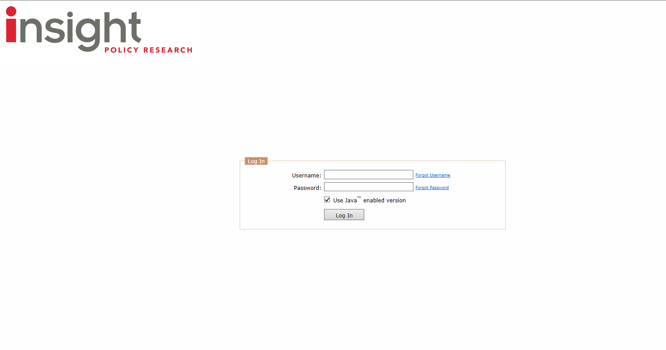

*According to the Paperwork Reduction Act of 1995, an agency may not conduct or sponsor, and a person is not required to respond to, a collection of information unless it displays a valid OMB control number. The valid OMB control number for this information collection is 0584-xxxx. The time required to complete this information collection is estimated to average 30 minutes per response, including the time for reviewing instructions, searching existing data sources, gathering and maintaining the data needed, and completing and reviewing the collection of information. Send comments regarding this burden estimate or any other aspect of this collection of information, including suggestions for reducing this burden, to: U.S. Department of Agriculture, Food and Nutrition Services, Office of Policy Support, 3101 Park Center Drive, Room 1014, Alexandria, VA 22302, ATTN: PRA (0584-xxxx*). Do not return the completed form to this address.*