**Recreational Angler Survey of Sea Turtle Interactions**

**Survey Instructions**

**Introduction:** All sea turtles in United States waters are listed as threatened or endangered under the Endangered Species Act (ESA). When sea turtle distribution overlaps with commercial and recreational fishing effort, sea turtles may be accidentally captured in the fishing gear. For commercial fisheries, observers are often placed on vessels to better understand these interactions. These observations provide insight into how and why these interactions occur and the impact of the interactions on sea turtle populations. In contrast, recreational fishing often occurs from shore, piers, and private vessels making traditional observer coverage challenging. Therefore, alternative data collection methods must be considered. NOAA Fisheries will use this survey to gain similar insights into recreational fishing interactions and impacts. Pier is used as a general term, and the survey can be conducted on any fixed fishing structure (e.g., jetty, pier). While the survey packet consists of several documents, the survey itself should only take about 10 minutes for an individual angler to complete.

**Forms included in survey packet:** The survey packet consists of a “quick reference” guide to complement these instructions, a cover sheet designed to capture the fishing location and environmental characteristics (e.g., number of anglers on pier, wave height), and the angler questionnaire. Each of these forms will be described below.

**Related forms:** While not directly applicable to the recreational survey, there are two related forms – Fishing Site Characterization and Sea Turtle Hook and Line Incidental Capture Intake - that may help in assessing recreational fishing interactions. The relationship of these forms to the angler survey are also described here and may be considered when designing a comprehensive assessment of shore-based sea turtle and recreational fishing interactions.

**Quick Reference Guide**: This guide provides the user with a “cheat sheet” of hook type, sea state, fishing time estimates, and pier codes. Each of these is described fully below, but the guide provides a quick reference for use on the pier.

**Survey Cover Sheet**: The interviewer should complete the cover sheet when first arriving at the pier. This form summarizes overall information on the pier and environmental conditions.

*Date*: Enter the date in MM/DD/YYYY format.

*Survey ID #*: The survey ID is the concatenation of the date (YYYYMMDD) and pier abbreviation. Ex. 20180512-PB

*Location*:List the location/pier name, town, and state. For jetties or other locations also include street name.

*Start time*/*End time*: All times should be entered in 24 hour time.

*Weekday*: Circle the day of the week survey conducted.

*Environmental Conditions*: Circle the term that most closely describes the wave height (ft), cloud cover and amount of precipitation at the start of the survey. In weather changes greatly during survey, please note changes in the Comments section.

*Interviewer/Team Leader:* Each pier survey should have a designated team leader. Their full name (first and last) should be listed first followed by the full name of any additional interviewers.

*Number of anglers*: At the start of the survey, place a tick mark for each angler on the pier. An angler is anyone who is actively fishing. If additional anglers arrive while the survey is being conducted, note this with the appropriate tick marks. When the survey is completed, tally the tick marks and enter the result in the *Final Count*.

*Number of lines in the water*: Similar to the number of anglers, place a tick mark for each line in the water, adding additional ticks if new anglers arrive or more lines are deployed. When the survey is completed, tally the tick marks and enter the result in the *Final Count.*

*Number of surveys completed*: At the end of the survey, count the number of interviews completed and enter this in the *Final Count.*

*Total number of anglers not participating:* When an angler declines to participate, enter a tick mark. Ask the angler if they are willing to tell you their zip code and record that on the line. The data will be used to determine a nonresponse rate. At the end of the survey, tally the total number of anglers that declined to participate.

*Number of anglers who have already taken the survey:* Enter a tick mark for each angler who was not surveyed because they had already taken the survey within the last 3 months AND they had not had any changes to their previous answers. If answers to sea turtle related questions have changed, the angler may be interviewed again. At the end of the survey, tally the total number of anglers who had already been surveyed.

*Completed surveying entire location?*  A completed survey is one in which the interview(s) were able complete all required interviews at the survey site. The goal is always to complete a site but sometimes time constraints or weather may cause the interviews to end early. Circle yes or no, as appropriate.

*Completed angler count & line count?*  Circle whether the angler and line counts were completed. If a survey is ended early, please try and count the number of anglers and lines in the water at the location.

**Angler questionnaire:** This form includes the questions to be asked of individual anglers. If several anglers are fishing together only complete one survey for that group of anglers. Anglers should not be interviewed if they have completed a survey in the last 3 months, unless they have had an interaction with a sea turtle since the last interview. The number of anglers who have previously participated should be recorded on the cover sheet. If there are some members of an angler group who have not previously completed a survey, one of those anglers can be interviewed.

The questionnaire should take approximately five minutes to complete. If the angler gets a bite while being interviewed, the interviewer should stop the interview and either wait or come back later to complete the interview.

*Date*: Enter the date in MM/DD/YYYY format.

*Time*: Enter the time the interview is started. All times should be entered in 24 hour time.

*Survey ID*: The survey ID is the concatenation of the date (YYYYMMDD) and location name or code. Ex. 20150512-PB

*Survey #*: Sequentially number each survey completed at a single location each day.

*Location Name*:List the location or pier name.

*Data Collector*: Enter the full (first and last) name of the data collector.

*Residential state:* Enter the state of residence of angler being interviewed.

*Residential zip code:* Enter the zip code of angler being interviewed.

*# of people*: Record the number of people fishing with the angler being interviewed.

*# of lines in the water*: Enter the total lines the angler being interviewed has in the water when the interview begins.

*Where was angler fishing?*  Circle location on pier or site where angler was fishing.

*Is the angler:* Either ask the angler or watch how the angler is fishing and determine if they are active fishing (i.e. moving the pole or reeling to make the bait move) or inactive fishing and not moving the rod and reel.

Angler Interview Questions

Questions 1 – 4 ask the angler about time, month and frequency of fishing at that specific location only. If the angler fishes in more than one season, record the amount of effort at that location for each season fished.

Questions 5 – 15 ask the angler about what they are fishing for and the type of gear they are currently using at that specific location. Circle or record the given response.

* *What are you fishing for today?*  The top local species will be listed. Circle up to two species the angler is targeting. If the angler lists three or more species, circle anything. If the species is not listed, write the species name under other.
* If the angler is using multiple poles and they are rigged the same way (i.e. all have the same hook, tackle and bait) circle their response and also circle “e) same on all poles”.
* If the angler is using multiple poles and they are NOT rigged the same way (i.e. different hooks, tackle and/or bait) record answers to questions 10 – 16 for each pole.
* *Hook type:* Ask the angler if you can see the hook or similar hook (do NOT make them reel in their line either ask to see a similar hook or wait until they check their bait.) Many anglers do not know what type of hook they are using. Verify hook type ID, and circle the corresponding size. If hook is a circle hook, select if it is offset or non-offset.
* *Hook size:* Using a ruler, measure the total length from the top of the eye to the bottom of the hook, as below. If it is a circle hook, also measure gape size.

*Popular hooks used*: Identify type of hook used based on examples and descriptions below.

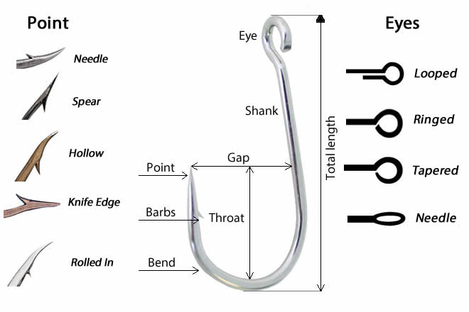

Shaft/Shank

* **J-hook:** the shaft is straight and resembles the letter “J” and the point and barb do not point toward the shaft.
* **Circle hook:** sharply curved back in a circular shape with the point is pointed toward the shaft. Circle hooks may be offset or non-offset. The degree of offset can vary. Gape is measured as the tip of the point to the inside of the shaft, as shown above.
* 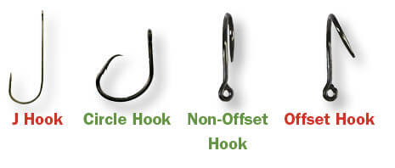**Kahle hook:** curved back in an oval shape with the hook point is pointed toward the hook eye; distance between the point and the shaft is much greater than on a circle hook.
* **Jig hook:** bent on the shank before the eye about 60-90°, often used with artificial lures.
* **Treble hook:** consists of three hooks with a single eye, often used with artificial lures.

Questions 16 – 18 ask the angler about bait and fish cleaning. Circle the most appropriate answer.

Questions 19 – 23 are sea turtle specific questions pertaining to what the angler has observed in the last 6 months while fishing at this location only. Circle the most appropriate answers.

If the angler has NOT caught a sea turtle at that location within the last 6 months, thank the angler and end the interview or ask additional protected species questions if provided. If the angler caught a sea turtle within the last 6 months ask questions 24 – 34.

Questions 24 – 34 pertain to the most recently captured sea turtle within the last 6 months. It would be helpful to have outreach materials with the stranding networks’ contact information to provide if the angler asks where captures should be reported. This could be in the form of tackle box stickers, business cards, etc.

**Related forms**

There are two forms that are related to the survey. The first is a Fishing Site Characterization Form. This form, while not part of this survey, can be helpful in designing recreational surveys, implementing outreach activities, etc. The form is designed to characterize a particular fishing pier. In aggregate, these characterizations can provide an inventory of piers in a particular location. This information can be then used when designing a recreational fishing survey.

The second related form is the Sea Turtle Hook and Line Incidental Capture Intake Form. This form complements the pier survey. When a sea turtle that has interacted with hook-and-line gear is evaluated by the network, it is used to document information similar to that collected during the survey. Information such as bait, hook type, and interaction details are documented. When used together with the survey, this form can help inform our understanding of interactions. For example, the intake data may show that the hook type, bait, etc. for admitted turtles is different than what would be expected from the pier survey. This information can then be used to target management to be more effective, helping to promote sea turtle recovery.