Concept Testing: HCP Screener
OMB No. 0920-0572
Expiration Date 08/31/2021

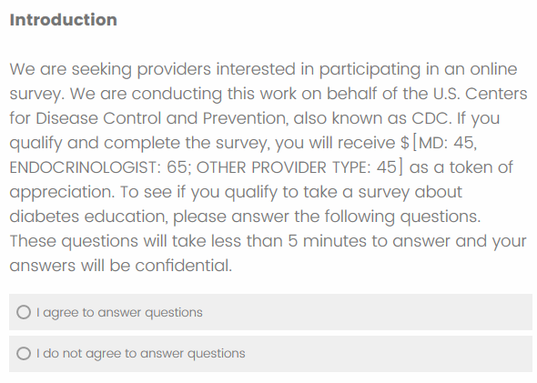
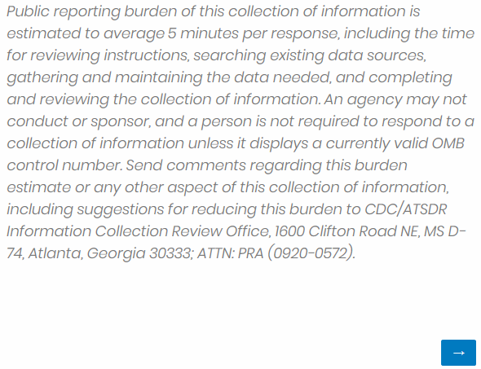
OMB No. 0920-0572
Expiration Date 08/31/2021
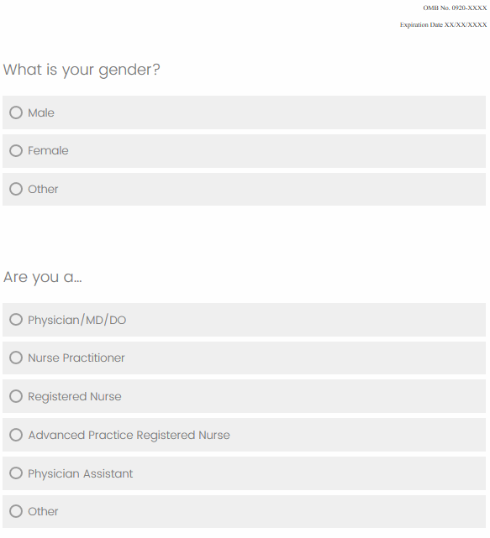

OMB No. 0920-0572
Expiration Date 08/31/2021
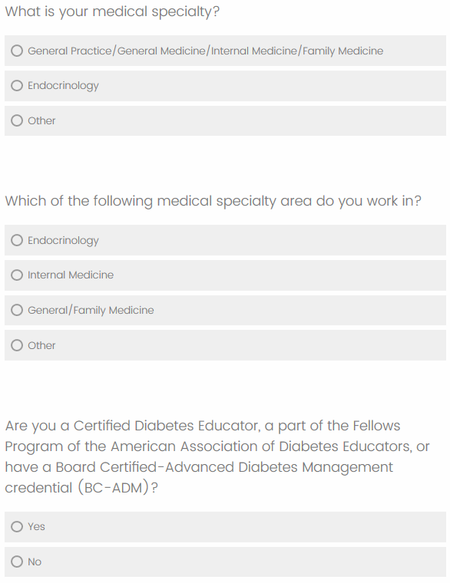

OMB No. 0920-0572
Expiration Date 08/31/2021
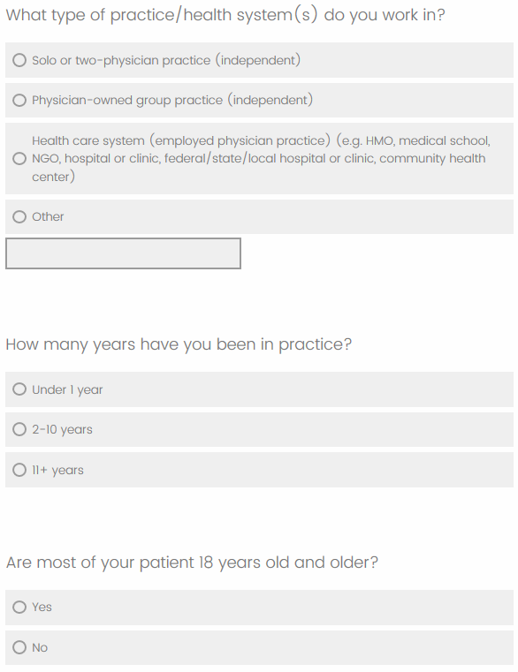

OMB No. 0920-0572
Expiration Date 08/31/2021
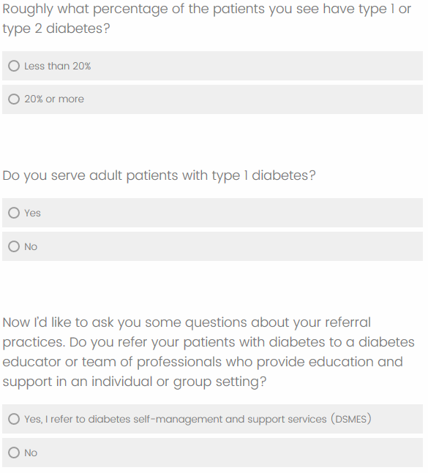

OMB No. 0920-0572
Expiration Date 08/31/2021

OMB No. 0920-0572
Expiration Date 08/31/2021

OMB No. 0920-0572
Expiration Date 08/31/2021
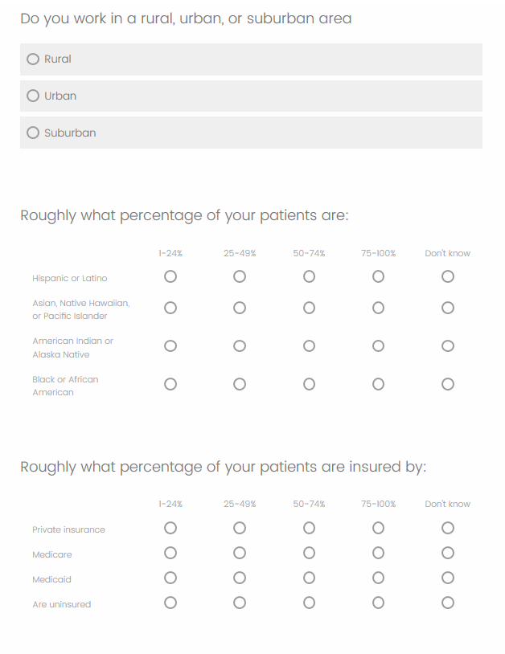

OMB No. 0920-0572
Expiration Date 08/31/2021

Concept Testing: HCP Consent Form
OMB No. 0920-0572
Expiration Date 08/31/2021

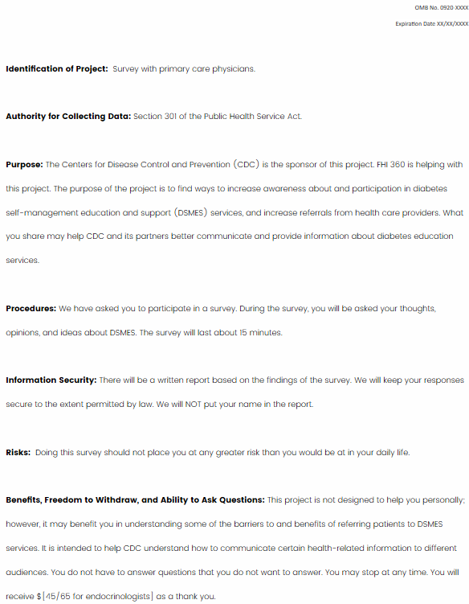

Concept Testing: HCP Survey
OMB No. 0920-0572
Expiration Date 08/31/2021
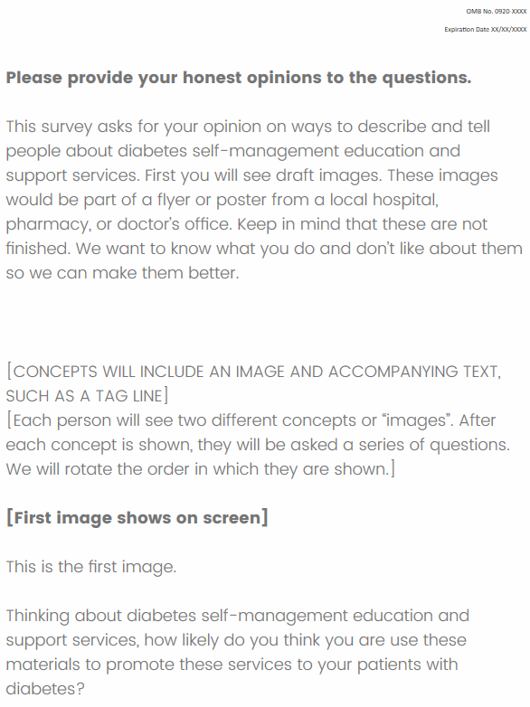
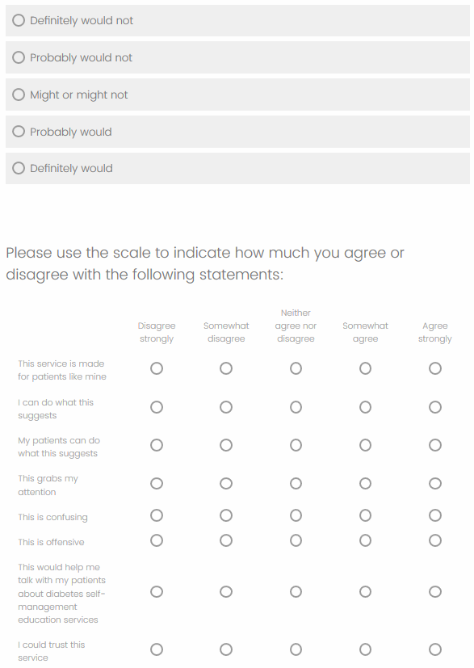
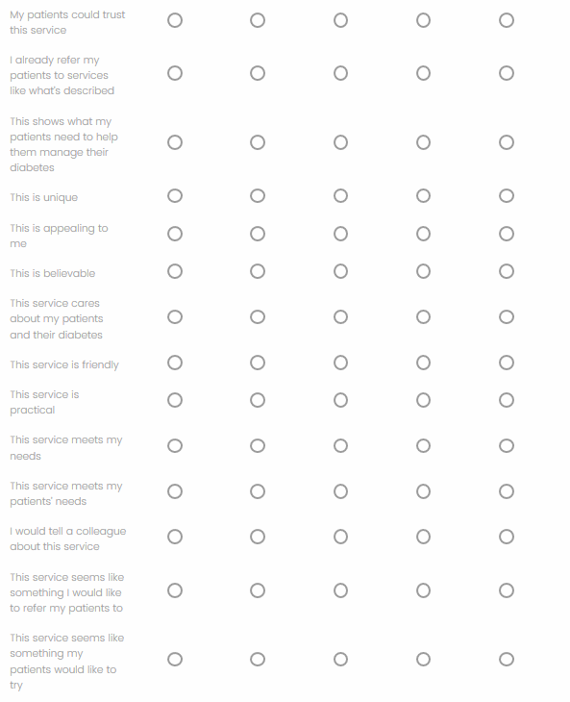
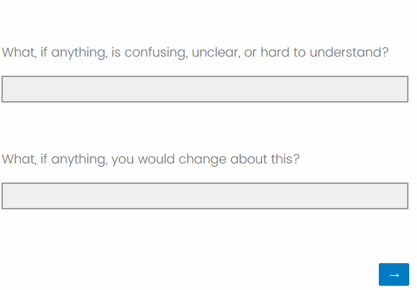

OMB No. 0920-0572
Expiration Date 08/31/2021
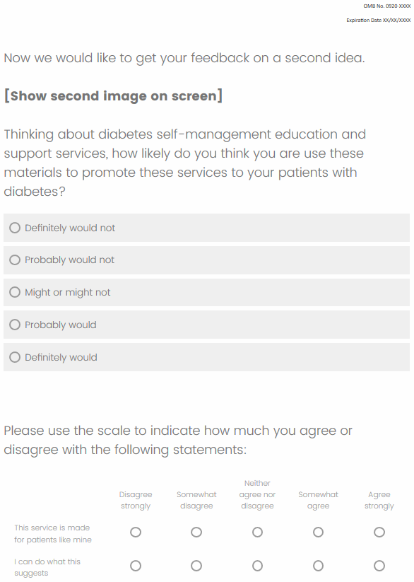
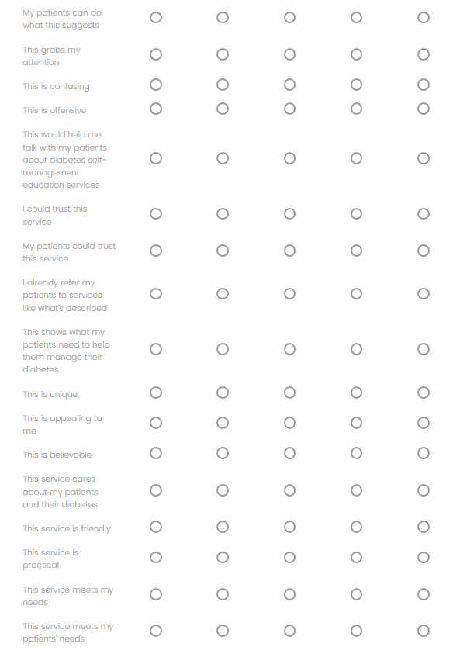
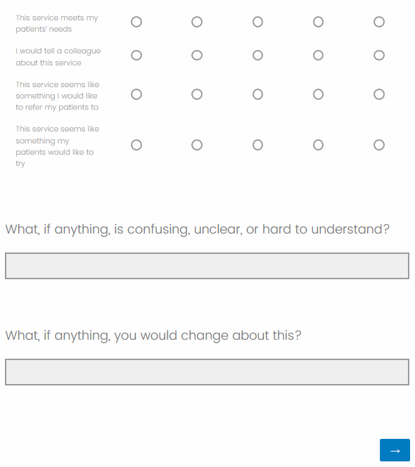

OMB No. 0920-0572
Expiration Date 08/31/2021
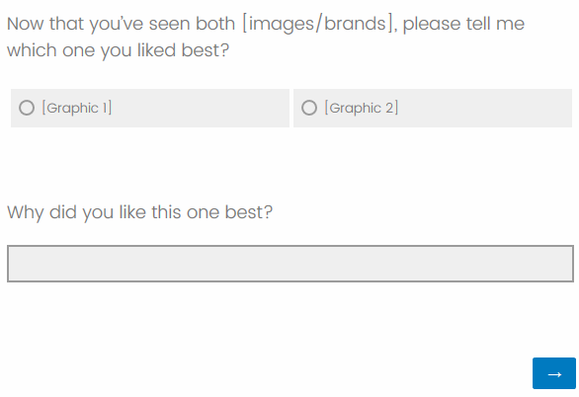

OMB No. 0920-0572
Expiration Date 08/31/2021

