Attachment 1 – Online Recruitment Flyer

Opinions of Hand Hygiene Health Communication Materials - Focus Group Discussion
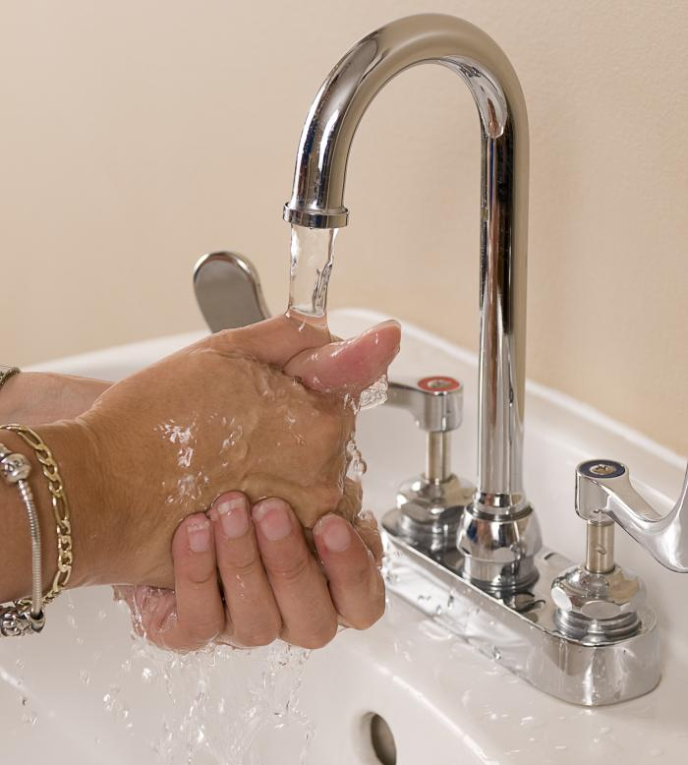
[CONSULTING COMPANY] is conducting two focus groups with adult men and women to learn about opinions of health communication materials promoting hand hygiene behavior. These in-person focus groups will take place in Atlanta, GA and will take about 60-minutes. To learn more about the focus groups, and to be screened for eligibility to participate, please click [link to online screening form]. If you have any questions about the focus groups, please contact [INSERT POINT OF CONTACT AT CONSULTING FIRM].

