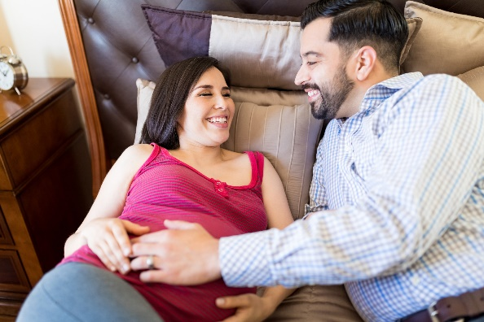
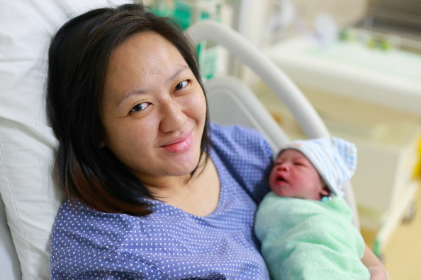

Share your thoughts on messaging about preventing pregnancy-related complications

The Centers for Disease Control and Prevention is holding focus groups with pregnant and postpartum women, as well as someone who supported them throughout their pregnancy and afterward (spouse, partner, family member, friend, doula). During the sessions, participants will share their opinions on messages related to potential complications of pregnancy.
These three-hour, in-person focus groups will take place in Atlanta, GA. Focus group members will receive a $75.00 cash gift card as a token of appreciation of their time.

To learn more about the focus groups and to see if you’re eligible to participate, please email [INSERT EMAIL] or call [INSERT PHONE NUMBER].

