Form Approved
OMB Control No.: 0920-0572
Expiration date: 8/31/2021

Sepsis Educational Effort – Moderator’s Guide
Healthcare Professionals – EMS Personnel

WELCOME, OVERVIEW, VERBAL CONSENT [5 MINUTES]
Hello and welcome, my name is ________ and I will be moderating tonight’s discussion. I work for ICF, a private research company that is contracted by the US Centers for Disease Control and Prevention (CDC). I first want to thank you for agreeing to participate – I appreciate your time and I am looking forward to our discussion.

I’d like to take a few minutes to tell you what you can expect from this discussion tonight.

We are conducting this project on behalf of the Centers for Disease Control and Prevention (or CDC) to better understand what information about sepsis is available to you as a healthcare professional and gather feedback on some messages and materials that have been developed for a CDC health communication initiative. Your insights are very important to us, and CDC will use your feedback to improve the materials you see today. Your time today is appreciated. We will have about 60 minutes for our discussion.

My role is simply to guide the discussion and keep us on track so that we finish on time. I did not create any of the messages or materials you will be seeing today, so I want to get your honest and frank opinions about them. You do not need to worry about offending me.
Before we begin, I want to point a few things out:
- Most importantly, there are no “right” or “wrong” answers to the questions I’m going to ask and absolutely no thoughts or feedback that should make you feel ashamed – we are just looking for your honesty. Please relax and enjoy the discussion.
- We are recording this discussion and members of my team will be observing and taking notes. This is to ensure that we are able to capture your thoughts and opinions as accurately as possible. Be assured that the information you provide today will not be tied specifically to you.
- Notes and recordings will be stored on a password-protected computer and only members of the project team will have access to that information. All notes and recordings will be destroyed once the project is complete.

Public reporting burden of this collection of information is estimated to average 5-60 minutes per response, including the time for reviewing instructions, searching existing data sources, gathering and maintaining the data needed, and completing and reviewing the collection of information. An agency may not conduct or sponsor, and a person is not required to respond to a collection of information unless it displays a currently valid OMB Control Number. Send comments regarding this burden estimate or any other aspect of this collection of information, including suggestions for reducing this burden to CDC/ATSDR Reports Clearance Officer, 1600 Clifton Road NE, MS D-74, Atlanta, Georgia 30333; ATTN: PRA 0920-0572
- Information learned from these discussions may be presented in documents or materials like reports, conference presentations or posters, or publications. The information may also be shared with other health departments and organizations working on sepsis to help assist with their efforts. Please know that the information included in any report or document will not contain your name or any other identifying information you share today.
- As a reminder, your participation in this discussion is completely voluntary. If at any time you are uncomfortable with my questions, you can choose not to answer. You may choose not to participate or to leave the discussion at any time. After the discussion, you will receive a token of appreciation for your time.

I know that was a lot of information. Do you have any questions before we get started?

Begin recording and ask:
We are now recording this session. I want to ask you again:
- Do you agree to participate in this interview?
- Do you agree to being recorded?

Alright, let’s get started.

SEPSIS KNOWLEDGE/PREFERRED SOURCE(S) FOR INFORMATION ON SEPSIS [10 MINUTES]
I’d now like to ask you a few specific questions about your knowledge and experience with sepsis and what resources to use to find information on sepsis.

  - What do you know about sepsis?
    - PROBE: What do you know about infections that can lead to sepsis?
  - Who do you think may be at risk for sepsis?
    - PROBE: How likely are you to encounter sepsis in your job? Why or why not?
  - What are the signs and symptoms you look for in patients that may indicate sepsis?
    - PROBE: Do you feel confident in your ability to recognize the signs and symptoms of sepsis?
    - PROBE: What challenges, if any, do you face in recognizing the signs and symptoms of sepsis?
  - What steps can you take if you suspect sepsis in your patient?
    - PROBE: What are potential barriers that may prevent your patient from receiving immediate treatment for sepsis?
[Moderator: If clarification is needed here, we want to understand what challenges may limit EMS personnel in their ability to get immediate treatment for the patient]
  - What resources, if any, do you refer to now or would you refer to in the future for more information on sepsis?
    - PROBE: Other healthcare providers in a different role than yours? On the job training? Websites? Media programs (TV, radio, podcast)? Professional organizations?
    - PROBE: Why do you use the sources you mentioned?
  - Have you ever received formal training on how to recognize sepsis?

MATERIAL TESTING [30 MINUTES]
Thank you so much for the information you’ve shared so far. Now, I’d like to share some materials with you to review and get your feedback.

EMS Card [15 MINUTES]
I’d like to share a card that has been developed specifically for EMS personnel like yourself. Please take 1-2 minutes to look over this material and then we can discuss.

  - What is your general reaction to this card?
  - Did you learn something new from this card? If so, what?
  - What information, if any, is confusing, unclear, or hard to understand? (HMTS 6d)
  - Is there anything else you want to know that this card doesn’t tell you? (HMTS 29d)
  - What do you think about the overall design?
    - PROBE: Pictures? Colors? Layout?
    - PROBE: Font too big? Too small? Too dense?
  - Is this information easy or difficult to read? (HMTS 16e)
  - What about this card, if anything, grabs your attention?
    - PROBE: Would you take time to read it? Why or why not?
  - How helpful is/would this card be to you or your EMS colleagues? Why?
  - Would you or your colleagues use this card? If so, how? Or why not?
    - PROBE: Are there other formats this information can be shared that would be more useful? (i.e. factsheet, brochure, video, webinar, etc.)
  - Any other comments you would like to make about this card before we move on to the next material? (HMTS 43e)
    - PROBE: Likes? Dislikes? Additional suggestions for improvement?

“Protect Your Patients from Sepsis” Infographic [15 MINUTES]
Next, I’d like to share an infographic with you. Please take 3-4 minutes to look over this material and then we can discuss.

  - What is your general reaction to this infographic?
  - Did you learn something new from this infographic? If so, what?
  - What information, if any, is confusing, unclear, or hard to understand? (HMTS 6d)
  - Is there anything else you want to know that this infographic doesn’t tell you? (HMTS 29d)
  - What do you think about the overall design?
    - PROBE: Pictures? Colors? Layout?
    - PROBE: Font too big? Too small? Too dense?
  - Is this information easy or difficult to read? (HMTS 16e)
  - What about this infographic, if anything, grabs your attention?
    - PROBE: Would you take time to read it? Why or why not?
  - How helpful is/would this infographic be to you or your EMS colleagues?
  - Would you or your colleagues use this infographic? If so, how? Or why not?
    - PROBE: Are there other formats this information could be shared that would be more useful? (i.e. factsheet, brochure, video, etc.)
  - Any other comments you would like to make about this infographic before we move on to the next material? (HMTS 43e)
    - PROBE: Likes? Dislikes? Additional suggestions for improvement?

INFORMATIONAL PREFERENCES & NEEDS [3 MINUTES]
Thanks so much for all of your helpful feedback. Now that you have seen a couple of materials in a variety of formats, I’d like to ask you a few more questions before we end the discussion.

  - From all of the materials you have reviewed, what information do you find most helpful in your role as an EMS personnel? (ex: Signs and symptoms? Who is at risk? Four types of infections? How to get ahead of sepsis?)
  - If you were going to participate in trainings on sepsis, what specific information would be of interest to you?
    - PROBE: How would you like to see these trainings presented? (i.e. webinars, modules, face-to-face, etc)
  - CDC currently has an educational campaign about sepsis. Have you seen/heard anything with the slogan “Get Ahead of Sepsis”?
    - PROBE: If yes, where have you seen or heard this slogan?
  - Have you ever seen this logo before?

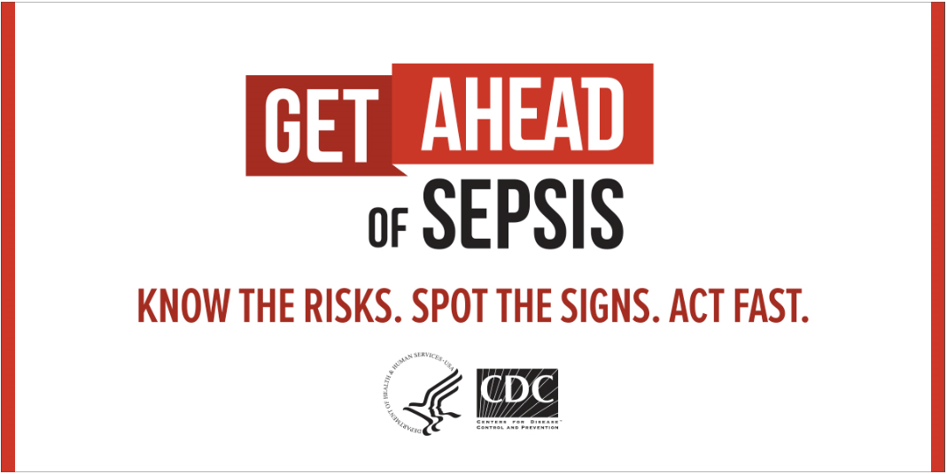

- PROBE: If yes, where have you seen this logo?

CLOSING [2.5 MINUTES]
This has been really great – thank you so much for sharing your thoughts and opinions. That brings me to the end of my questions. Are there any additional thoughts or comments that you think are important for us to consider that may have not already been discussed?

Let me check in with my team to see if there are any additional questions before I conclude the interview. I want to be respectful of your time.

Do you have any questions for me? If not, I will go ahead and conclude the discussion. Thanks so much again for your participation. You will receive a token of appreciation for your time at the mailing address you provided. Please feel free to visit the CDC’s website at www.cdc.gov/sepsis for more information on how to prevent infections that can lead to sepsis.

It’s been a pleasure talking with you. Have a good evening!

