FINAL – DHQP and NCEZID cleared

Antibiotic Use Educational Effort – Interviewer Guide

Healthcare Providers (HCPs) – Hospitalists

Welcome, rules, ice breaker/intro [2-3 minutes]
Thank you for taking the time to join us for this interview. My name is [INSERT NAME] and I work for ICF, a private firm, who is conducting research on behalf of the US Centers for Disease Control and Prevention, or CDC, who is sponsoring this health communication campaign. I want to take a few minutes to tell you what to expect from our conversation and go over the informed consent.
ICF is conducting this study on behalf of CDC to learn about antibiotic prescribing by hospitalists and to gather feedback on communication materials for CDC’s campaign to improve antibiotic use. This information will be used to improve the materials that you see.
Remember your participation is voluntary. That means you can stop us at any time and if you are uncomfortable with a question, or if you simply don’t have a response, it is fine to pass.
Our discussion should take about one hour. Your name and any identifiable information you may share during our discussion will not be included in our final report, so no responses will be linked to you directly. I don’t expect you to tell me anything that you would be uncomfortable sharing, but hope that you will be honest with your responses to the questions I ask.
Please speak up and speak clearly. We are audiotaping the discussion so that we can have an accurate record of the discussion. Also, we have observers from CDC and ICF listening and taking notes during our discussion today. We also have a technology support person to assist with any with any technical needs during our discussion.
Do you have any questions before we get started?
Begin recording and ask: We are now recording this session. I want to ask you again,
Do you agree to participate in this interview?
Do you consent to us recording your responses?

Understand providers’ perceived role in improving antibiotic prescribing and gathering information about participants preferred sources of information about antibiotic prescribing. [10 minutes]
Ok, great. Let’s get started. I’d like to start our conversation by hearing your thoughts on antibiotic prescribing and where you get information about it.
- Do you encounter any challenges with antibiotic prescribing in the hospital setting?
  - PROBE: [If yes] What are they?
  - PROBE: Are you reluctant to stop an antibiotic started by another clinician?
  - PROBE: Do you feel you have all the information you need when prescribing antibiotics at discharge?
- Do you think hospitalists or hospitals have a role to play in improving antibiotic prescribing?
  - PROBE: [If yes] What is that role?
  - PROBE: [If no] Why?
  - PROBE: Do you take any actions to improve prescribing?
  - PROBE: What actions does your hospital take to improve antibiotic prescribing?

Ok, let’s talk a little bit about where you get information about antibiotic prescribing.
- What resources, in general, do you refer to when prescribing antibiotics?
  - PROBE: What about hospital pharmacy & therapeutic (P&T) approved guidelines, such as for community-acquired pneumonia?
  - PROBE: What about pocketbooks, mobile apps or online educational resources (such as UpToDate)?
- What resources would be helpful for you to learn more about and implement recommended antibiotic prescribing practices in hospitals?
  - PROBE: What about webinars or educational trainings?
  - PROBE: What about mobile apps?
  - PROBE: What about websites?
  - PROBE: What about information in an electronic health record?
- Have you ever seen, heard, or read any TV, radio, newspaper, or online advertising about Be Antibiotics Aware?
  - PROBE: [If yes] Where have you seen or heard about Be Antibiotics Aware?
    - On TV?
    - On Social media?
    - Through e-mail?
    - On a website?

Gather feedback on CDC materials that can help to optimize antibiotic prescribing in hospitals - Test 5 Ways Hospitalists Can Be Antibiotics Aware poster [15 minutes]
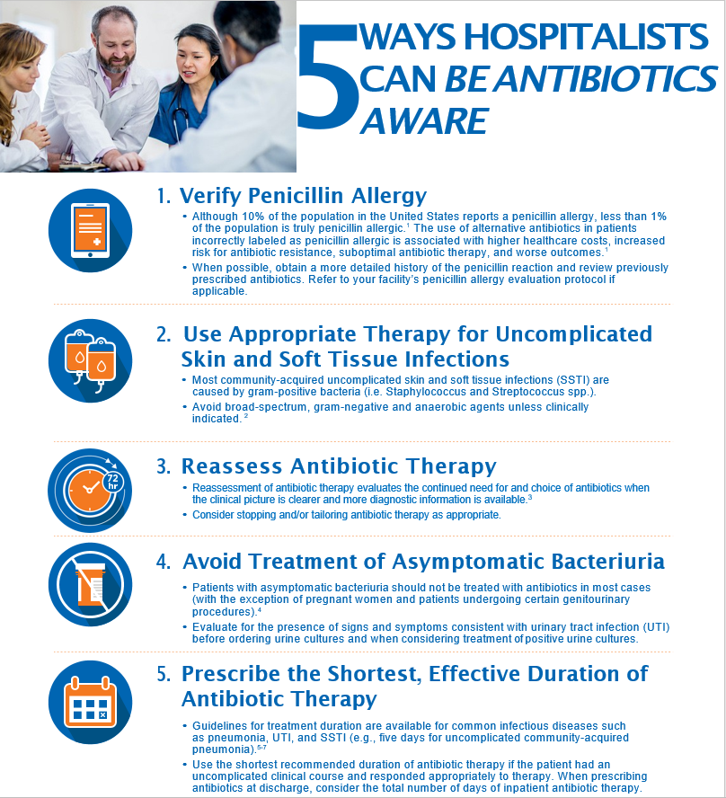
In the last few minutes, we discussed your thoughts around antibiotic prescribing. Now, let’s move on to our first material. Take a few minutes to read this and then we’ll discuss (give 3-4 minutes to read).

Let’s start with some questions about the content in this poster.
- What action(s) seem the easiest for you to perform in your clinical practice? Why?
- Which actions on this material are the most challenging to perform?
  - PROBE: Why?
  - PROBE: What are the barriers that would not allow you to perform this action(s)?
  - PROBE: What would make it easier for you to perform this action(s)?
- What do you think is the most important action in this material?
  - PROBE: Why?
- What do you like about this material?
  - PROBE: What about the length of this material?
- How could this poster be improved?
  - PROBE: Is there anything that is confusing or needs clarification?
  - PROBE: Is there anything you want to know that this material doesn’t tell you? (HMTS 6d)
- Would you use this poster?
  - PROBE: [For “No”] Why?
  - PROBE: [For “Yes”] How?
- Overall, if provided to hospitalists, how helpful do you think this poster is /would be for improving antibiotic prescribing in hospitals?
  - PROBE: [For any response] Why?

Now I have a few questions about the visual aspects of this piece.
- What do you think about the layout of information in this poster?
- Overall, how appealing is this material to you? (HMTS 7e)
- Would it catch your attention if you saw it somewhere? (HMTS 9e) Would you stop to read it?
- Where would you expect to find this material for you to use?
  - PROBE: What about from a professional society?
  - PROBE: What about on CDC’s website?

Gather feedback on CDC materials that can help to optimize antibiotic prescribing in hospitals - test hospitalist asymptomatic bacteriuria poster [15 minutes]
Ok, let’s move on to our second material. Take a few minutes to read this and then we’ll discuss (give 2-3 minutes to read).

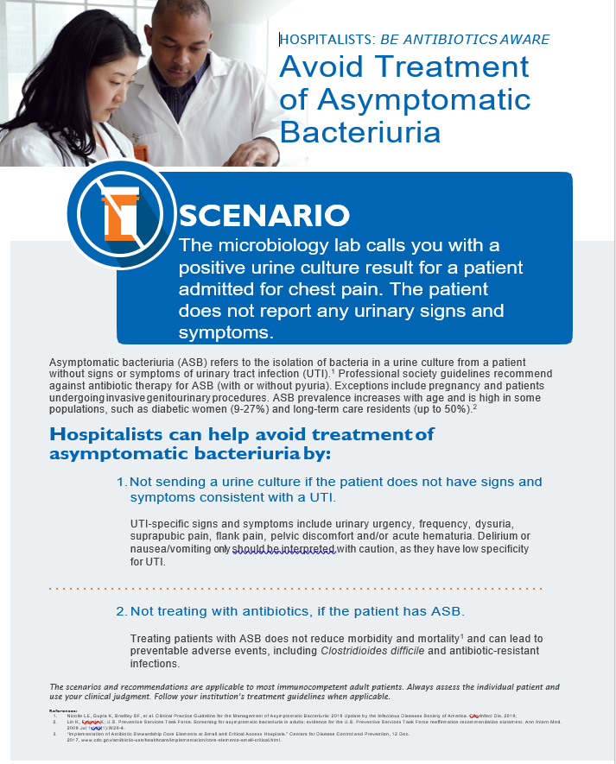
Let’s start with some questions about the content in this poster.
- What action(s) seem the easiest for you to perform in your clinical practice? Why?
- Which actions on this material are the most challenging to perform?
  - PROBE: Why?
  - PROBE: What are the barriers that would not allow you to perform this action(s)?
  - PROBE: What would make it easier for you to perform this action(s)?
- What do you think is the most important action in this material?
  - PROBE: Why?
- What do you like about this poster?
  - PROBE: What about the length of this material?
- How could this poster be improved?
  - PROBE: Is there anything that is confusing or needs clarification?
  - PROBE: Is there anything you want to know that this material doesn’t tell you? (HMTS 6d)
- Would you use this poster?
  - PROBE: [For “No”] Why?
  - PROBE: [For “Yes”] How?
- Overall, if provided to hospitalists, how helpful do you think this poster is /would be for improving antibiotic prescribing in hospitals?
  - PROBE: [For any response] Why?

Now I have a few questions about the visual aspects of this piece.
- What do you think about the layout of information in this poster?
- Overall, how appealing is this material to you? (HMTS 7e)
- Would it catch your attention if you saw it somewhere? (HMTS 9e) Would you stop to read it?
- Where would you expect to find this material for you to use?
  - PROBE: What about from a professional society?
  - PROBE: What about on CDC’s website?

Gather feedback on CDC materials that can help hospitalists optimize antibiotic prescribing - test antibiotic timeout at discharge messaging [15 minutes]
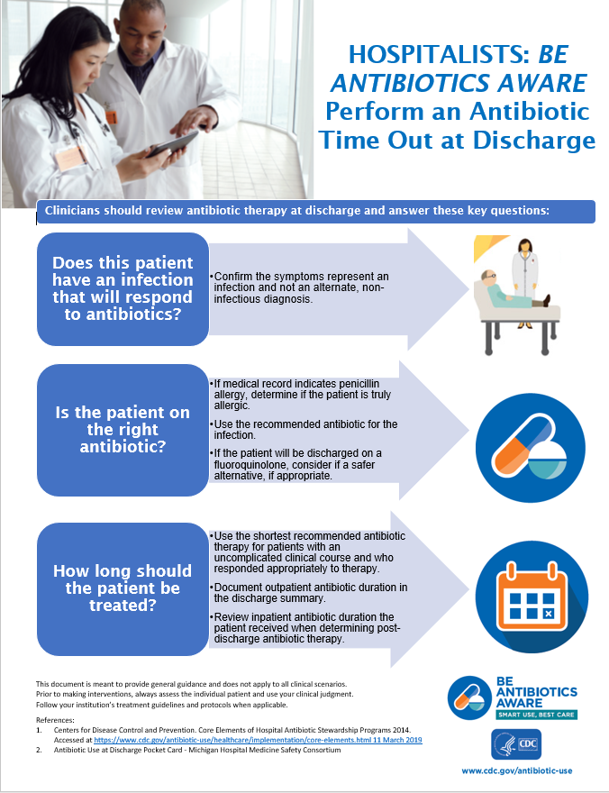
Here’s our last material. Please take a few minutes to read though it before I ask questions (give 4-5 minutes).
Let’s start with some questions about the content in this material.
- What action(s) seem the easiest for you to perform in your clinical practice? Why?
- Which actions on this material are the most challenging to perform?
  - PROBE: Why?
  - PROBE: What are the barriers that would not allow you to perform this action(s)?
  - PROBE: What would make it easier for you to perform this action(s)?
- What do you think is the most important action in this material?
  - PROBE: Why?
- What do you like about this material?
  - PROBE: What about the length?
- How could this material be improved?
  - PROBE: Is there anything that is confusing or needs clarification?
  - PROBE: Is there anything you want to know that this material doesn’t tell you? (HMTS 6d)
- Would you use this material?
  - PROBE: [For “No”] Why?
  - PROBE: [For “Yes”] How?
- Overall, if provided to hospitalists, how helpful do you think this material is / would be for improving antibiotic prescribing in hospitals?
  - PROBE: [For any response] Why?

Now I have a few questions about the visual aspects of this piece.
- What do you think about the layout of information in this flowsheet?
- Overall, how appealing is this material to you? (HMTS 7e)
- Would it catch your attention if you saw it somewhere? (HMTS 9e) Would you stop to read it?
- Where would you expect to find this material for you to use?
  - PROBE: What about from a professional society?
  - PROBE: What about on CDC’s website?

Closing [2-3 minutes]
Well, that’s the last of my questions. Do you have any comments or questions that you’d like to bring up before we end our discussion?
Thank you again for taking the time to participate in this discussion. Please visit www.cdc.gov/antibiotic-use for more information on appropriate antibiotic prescribing.
We sincerely appreciate and value your input!

