FINAL – DHQP and NCEZID cleared

Antibiotic Use Educational Effort – Interviewer Guide

Healthcare Provider (HCP) – Community Pharmacists

Welcome, rules, ice breaker/intro [2-3 minutes]

Thank you for taking the time to join us for this online interview. My name is [INSERT NAME] and I work for ICF, a private firm, who is conducting research on behalf of the US Centers for Disease Control and Prevention, or CDC, who is sponsoring this health communication campaign. I want to take a few minutes to tell you what to expect from our conversation and go over the informed consent.

ICF is conducting this study on behalf of CDC to learn about your thoughts about antibiotics and to gather feedback on communication materials for CDC’s campaign to improve antibiotic use. This information will be used to improve the materials that you see.

Remember your participation is voluntary. That means you can stop us at any time and if you are uncomfortable with a question, or if you simply don’t have a response, it is fine to pass.

Our discussion should take about one hour. Your name and any identifiable information you may share during our discussion will not be included in our final report, so no responses will be linked to you directly. I don’t expect you to tell me anything that you would be uncomfortable sharing, but hope that you will be honest with your responses to the questions I ask.

Please speak up and speak clearly. We are audiotaping the discussion so that we can have an accurate record of the discussion. Also, we have observers from CDC and ICF listening and taking notes during our discussion today. We also have a technology support person to assist with any with any technical needs during our discussion.

Do you have any questions before we get started?

Begin recording and ask:

We are now recording this session. I want to ask you again:
Do you agree to participate in this interview?
Do you consent to us recording your responses?

Understand providers’ perceived role in improving antibiotic use and gathering information about participants preferred sources of information about antibiotic prescribing. [10 minutes]
Ok, great. Let’s get started. I’d like to start our conversation by hearing your thoughts on antibiotic prescribing

- Do you think you, as a community pharmacist, play a role in improving antibiotic prescribing?
  - PROBE: [If yes] What is that role?
  - PROBE: [If no] Why?
  - PROBE: What actions do you or your pharmacy currently take to improve antibiotic prescribing?
- Do you encounter any challenges/barriers around improving antibiotic use? If so, what are they?
  - PROBE: What would make it easier for you to improve antibiotic use?
- What types of resources on antibiotic prescribing, in general, would be helpful for you?
  - PROBE: What about webinars or educational trainings?
  - PROBE: What about websites?
  - PROBE: What about posters to hang in your pharmacy and/or retail clinic (if applicable)?
- Have you ever seen, heard, or read any TV, radio, newspaper, or online advertising about Be Antibiotics Aware?
  - PROBE: [If yes] Where have you seen or hear about Be Antibiotics Aware?
    - On TV?
    - On Social media?
    - Through e-mail?
    - On a website?

Gather feedback on CDC materials to help pharmacists educate their patients on symptom relief. [15 minutes]
In the last few minutes, we discussed your thoughts around antibiotic prescribing. Now, let’s move on to our first material. Take a few minutes to read this and then we’ll discuss (give 2-3 minutes to read).

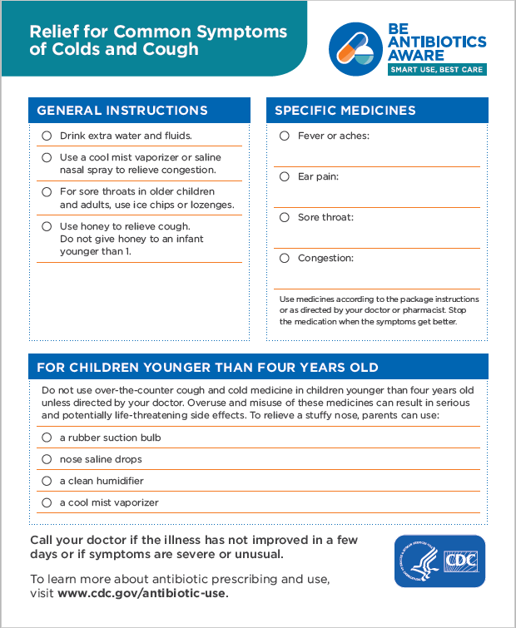
Let’s start with some questions about the content in this fact sheet.
- What’s your general reaction to the way this fact sheet looks? (HMTS 6e)
  - PROBE: What do you think about the layout of the information?
  - PROBE: What do you like about this fact sheet?
  - PROBE: How could this fact sheet be improved?
- Overall, how helpful do you think this fact sheet is in educating customers about symptom relief for cough and colds?
  - PROBE: [For any response] Why?
  - PROBE: Would you use this fact sheet when recommending OTC medications to a customer?
  - PROBE: Is there anything else that your customers ask you about symptom relief that isn’t covered on this fact sheet?
  - PROBE: Is there anything your customers should know about symptom relief that isn’t covered in this fact sheet?
- Are there any other types of materials or resources that you think would be helpful to educate customers about symptom relief?
  - PROBE: What about a poster that could be placed in your pharmacy and/or retail clinic (if applicable)?

Gather feedback on CDC materials for pharmacists to help their patients understand side effects of antibiotic use, in particular C. diff. [15 minutes]
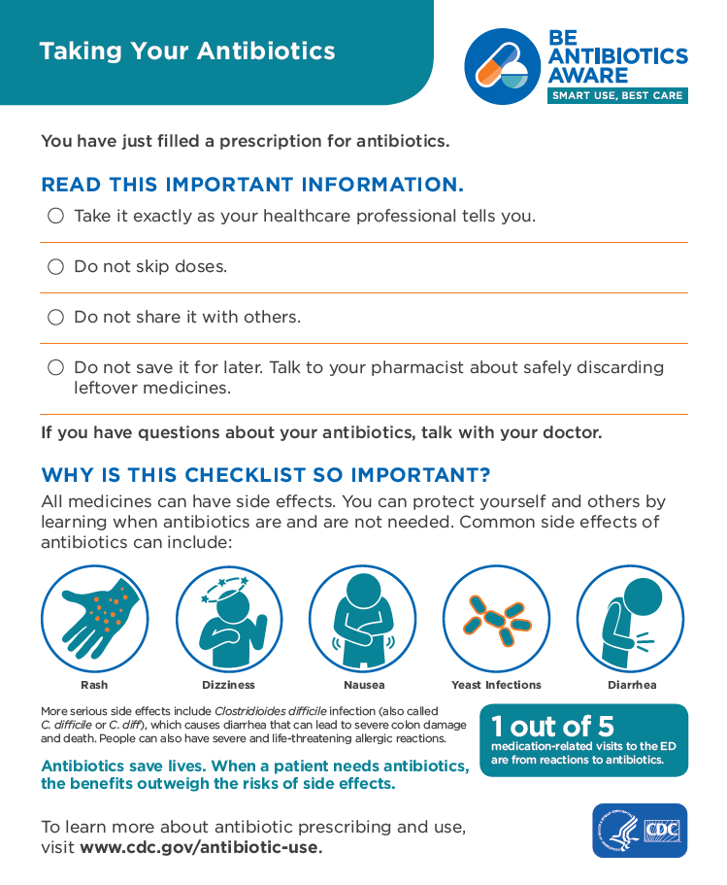
Ok, let’s move on to our second material. Take a few minutes to read this and then we’ll discuss (give 2-3 minutes to read).

- What’s your general reaction to the way this fact sheet looks? (HMTS 6e)
  - PROBE: What do you think about the layout of the information?
  - PROBE: What do you like about this fact sheet?
  - PROBE: How could this fact sheet be improved?
- Overall, how helpful do you think this fact sheet is in educating customers about appropriate antibiotic use?
  - PROBE: [For any response] Why?
  - PROBE: Would you use this fact sheet when giving a customer an antibiotic prescription? Why or why not?
  - PROBE: Is there anything else that your customers ask you about antibiotics that aren’t covered on this fact sheet?
  - PROBE: Is there anything your customers should know about antibiotics that aren’t covered in this fact sheet?
- Are there any other types of materials or resources that you think would be helpful to educate customers about taking antibiotics appropriately?
  - PROBE: What about a poster that could be placed in your pharmacy?

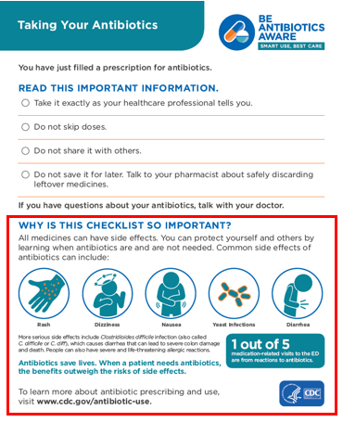
Let’s look specifically at the side effects section in this fact sheet.

- In a typical week, how often do you talk to your customers about possible side effects related to antibiotic use?
  - PROBE: How do you generally counsel your customers on antibiotic-related side effects?
    - PROBE: What side effects do you typically talk to them about?
    - PROBE: What about C. difficile infection?
- Do you think this section would help you educate your customers about possible antibiotic-related side effects?
  - PROBE: [For yes or no] Why?
  - PROBE: Is there any other information about antibiotic side effects that your customers ask you that isn’t covered in this section?
  - PROBE: Is there anything your customers should know about antibiotic use side effects that isn’t covered in this section?

Gather feedback on penicillin allergy poster to help pharmacists understand their role in identifying penicillin allergy. [15 minutes]
Now, let’s move on to our last material. Take a few minutes to read this and then we’ll discuss (give 3-4 minutes to read).
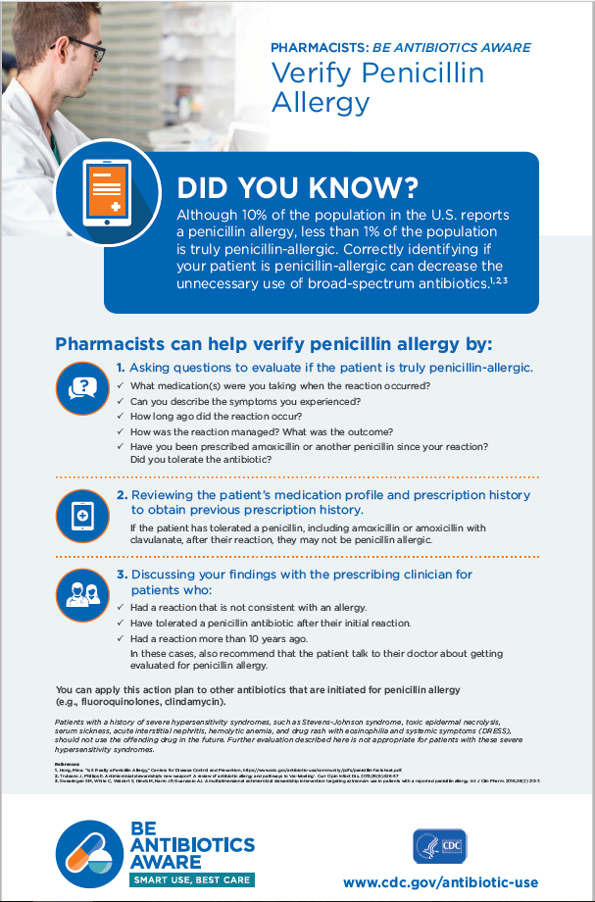
Let’s start with some questions about the content of this poster.

- What action(s) seem the easiest for you to perform in your pharmacy practice? Why?
- Which action(s) on this fact sheet are the most challenging to perform?
  - PROBE: Why?
  - PROBE: What are the barriers that would not allow you to perform this action(s)?
  - PROBE: What would make it easier to perform this action(s)?
- What do you think is the most important action in this poster?
  - PROBE: Why?
- What do you like about this poster?
- How could this poster be improved?
  - PROBE: Is there anything that is confusing or needs clarification?
  - PROBE: Is there anything you want to know that this poster doesn’t tell you? (HMTS 6d)
- Would you use this poster?
  - PROBE: [For either response] Why?
- Overall, if provided to pharmacists, how helpful do you think this poster is / would be for improving antibiotic prescribing?
  - PROBE: [For any response] Why?

Now I have a few questions about the visual aspects of this piece.
- What do you think about the layout of information in this poster?
- Overall, how appealing is this material to you? (HMTS 7e)
- Would it catch your attention if you saw it somewhere? (HMTS 9e) Would you stop to read it?
- Where would you expect to find this material for you to use?
  - PROBE: What about from a pharmacists’ professional society?
  - PROBE: What about on CDC’s website?

Closing [2-3 minutes]
Well, that’s the last of my questions. Do you have any comments or questions that you’d like to bring up before we end our discussion?

Thank you again for taking the time to participate in this discussion. Please visit www.cdc.gov/antibiotic-use for more information on appropriate antibiotic prescribing.

We sincerely appreciate and value your input!

