FINAL – DHQP and NCEZID cleared

Antibiotic Use Educational Effort – Interviewer Guide

Healthcare Providers (HCPs) – Nursing Home Advanced Practice Providers & Physicians

Welcome, Overview, and Rules [2-3 minutes]
Thank you for taking the time to join us for this interview. My name is _______ and I work for ICF, a private firm, who is conducting this research on behalf of the US Centers for Disease Control and Prevention, or CDC, who is sponsoring this health communication campaign. I want to take a few minutes to tell you what to expect from our conversation and go over the informed consent.
ICF is conducting this study on behalf of CDC to learn about antibiotic prescribing by advanced practice providers and physicians in nursing home settings, and to gather feedback on communication materials for CDC’s campaign to improve antibiotic use. This information will be used to improve the materials that you see.

Remember, your participation is voluntary. That means you can stop us at any time and if you are uncomfortable with a question, or if you simply don’t have a response, it is fine to pass.

Our discussion should take about one hour. Your name and any identifiable information you may share during our discussion will not be included in our final report, so no responses will be linked to you directly. I don’t expect you to tell me anything that you would be uncomfortable sharing, but hope that you will be honest with your responses to the questions I ask.

Please speak up and speak clearly. We are audiotaping the discussion so that we can have an accurate record of the discussion. We have observers from CDC and ICF listening and taking notes during our discussion today. We also have a technology support person to assist with any with any technical needs during our discussion.

Do you have any questions before we get started?

Begin recording and ask: We are now recording this session. I want to ask you again,
Do you agree to participate in this interview?
Do you consent to us recording your responses?

Understand providers’ perceived role in improving antibiotic prescribing and gathering information about participants preferred sources of information about antibiotic prescribing. [10 minutes]
Ok, great. Let’s get started. I’d like to start our conversation by hearing your thoughts on antibiotic prescribing and where you get information about it.

- In a normal week, how often do you prescribe antibiotics when you provide care to nursing home residents?
- Do you encounter any challenges with antibiotic prescribing in nursing homes? If so, what are they?
  - PROBE: In general, do you feel antibiotics are sometimes prescribed when they aren’t needed to nursing home residents?
    - PROBE: [If yes] what would you say are the most significant drivers of inappropriate antibiotic prescribing?
- Do you think clinicians in nursing homes have a role to play in improving antibiotic prescribing?
  - PROBE: [If yes] What is that role?
  - PROBE: [If no] Why?
  - PROBE: Do you take any actions to improve prescribing?
  - PROBE: What policies exist in your nursing home related to antibiotic prescribing?
  - PROBE: What policies do you think would be most effective in improving antibiotic use in your facility?

Ok, let’s talk a little bit about where you get information about antibiotic prescribing.
- What resources, in general, do you refer to when treating infections and prescribing antibiotics?
  - PROBE: What about mobile apps?
  - PROBE: What about UpToDate or other online resources or specific websites?
  - PROBE: What about resources from professional societies, such as the American Medical Director’s Association (AMDA), the Infectious Disease Society of America (IDSA), or others?
  - PROBE: What about information in the electronic health record?
- What training resources would be helpful for you to improve the treatment of infections and optimize antibiotic prescribing practices in nursing homes?
  - PROBE: What about workshops?
  - PROBE: How about lectures during yearly professional society conferences? Which conferences?
  - PROBE: What about webinars or educational videos?
    - PROBE: [If participant expresses interest in webinars or educational videos] What do you think is the ideal length of these webinars/videos?
- Have you ever seen, heard, or read any TV, radio, newspaper, or online advertising about Be Antibiotics Aware?
  - PROBE: [If yes] Where have you seen or heard about Be Antibiotics Aware?
  - On TV?
  - On Social media?
  - Through e-mail?
  - On a website?

Gather feedback on CDC materials that can help to optimize antibiotic prescribing in nursing homes - Test “5 Ways Nursing Home Clinicians can Be Antibiotics Aware” draft poster [15 minutes]
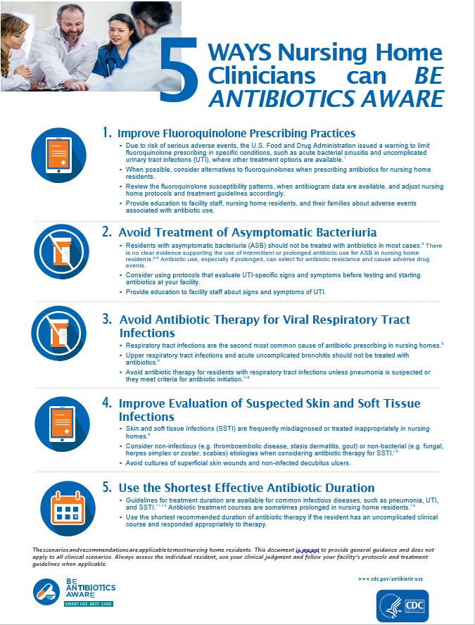
In the last few minutes, we discussed your thoughts around antibiotic prescribing. Now, let’s move on to our first material. Take a few minutes to read this and then we’ll discuss (give 3-5 minutes to read). Let’s start with some questions about the content in this material.
- What action(s) seem the easiest for you to implement in your clinical practice? Why?
- Which actions on this material are the most challenging to implement?
  - PROBE: Why?
  - PROBE: What are the barriers that would not allow you to perform this action(s)?
  - PROBE: What would make it easier for you to perform this action(s)?
- What do you think is the most important clinical scenario in this material?
  - PROBE: Why?
- What do you like about this material?
  - PROBE: What about the length of this material?
- How could this material be improved?
  - PROBE: Is there anything that is confusing or needs clarification?
  - PROBE: Is there another clinical scenario that you would like to see in this material?
    - PROBE: [If yes] What scenario(s)?
- Would you use this poster?
  - PROBE: [For “No”] Why?
  - PROBE: [For “Yes”] How?
- Would you like to see each of these clinical scenarios in its own, separate material with more information?
  - PROBE: [If yes] What is the best format to expand these clinical scenarios (i.e. short video, presentation slides, handouts)?
  - PROBE: [If no] Why?
- Do you find this material helpful?
  - PROBE: [For either response] Why?
  - PROBE: Who do you think would benefit most from reading this material?
- Overall, if provided to clinicians, how helpful do you think this material is /would be for improving antibiotic prescribing in nursing homes?
  - PROBE: [For any response] Why?

Now I have a few questions about the visual aspects of this piece.

- What do you think about the layout of information in this material?
- Overall, how appealing is this material to you? (HMTS 7e)
- Would it catch your attention if you saw it somewhere? (HMTS 9e) Would you stop to read it?
- Where would you expect to find this material for you to use?
  - PROBE: What about on CDC’s website?
  - PROBE: What about on a state health department’s website?
  - PROBE: What about from a professional society, like the American Medical Director’s Association (AMDA), the American Health Care Association (AHCA), or others?

Gather feedback on CDC materials that can help to optimize antibiotic prescribing in nursing homes - test Improve Communication with Residents and Families fact sheet [15 minutes]
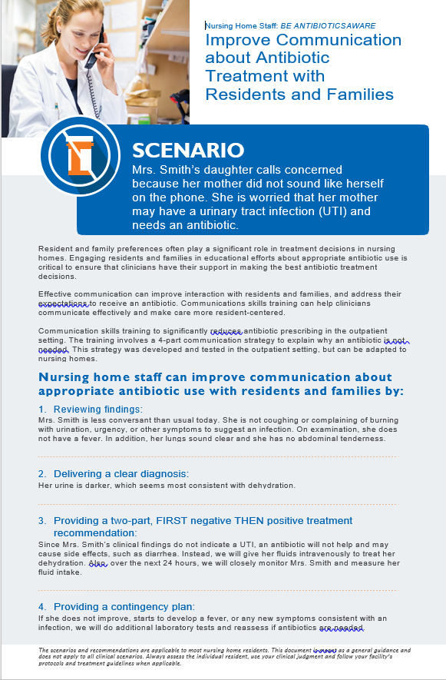
Ok, let’s move on to our second material. Take a few minutes to read this and then we’ll discuss (give 2-3 minutes to read).

Let’s start with some questions about the content in this material.
- What do you like about this material?
  - PROBE: What about the length of this material?
- How could this material be improved?
  - PROBE: Is there anything that is confusing or needs clarification?
  - PROBE: Is there anything else you would like to see included in this material?
  - PROBE: Do you think this information should be presented in a different format?
- PROBE: [If yes] What type of formats would you like to see (i.e. video, role playing)?
- PROBE: [If no] Why?
- Would you use this material?
  - PROBE: [For “No”] Why?
  - PROBE: [For “Yes”] How?
  - PROBE: Would you recommend it to others?
- Overall, if provided to clinicians, how helpful do you think this material is /would be in improving communication with residents and families about antibiotics?
  - PROBE: [For any response] Why?
  - PROBE: Do you think this material would help improve residents and their families’ satisfaction with care provided?
    - PROBE: [For either response] Why?
- Do you think communication skills training to improve antibiotic use would be helpful for you to facilitate communication with residents and their families?
  - PROBE: [For either response] Why?
- What other resources, if any, would help you in improving communication with residents and families?

Now I have a few questions about the visual aspects of this piece.

- What do you think about the layout of information in this material?
- Overall, how appealing is this material to you? (HMTS 7e)
- Where would you expect to find this material for you to use?
  - PROBE: What about on CDC’s website?
  - PROBE: What about on a state health department website?
  - PROBE: What about in publications or during yearly conferences from professional societies, like the American Medical Director’s Association (AMDA) or the American Health Care Association (AHCA)?

Gather feedback on Do You Need Antibiotics? brochure that can help NH APPs educate their patients about antibiotic use, focusing on adverse events of antibiotics. [15 minutes]
Here’s our last material. Please take a few minutes to read though it before I ask questions (give 4-5 minutes).
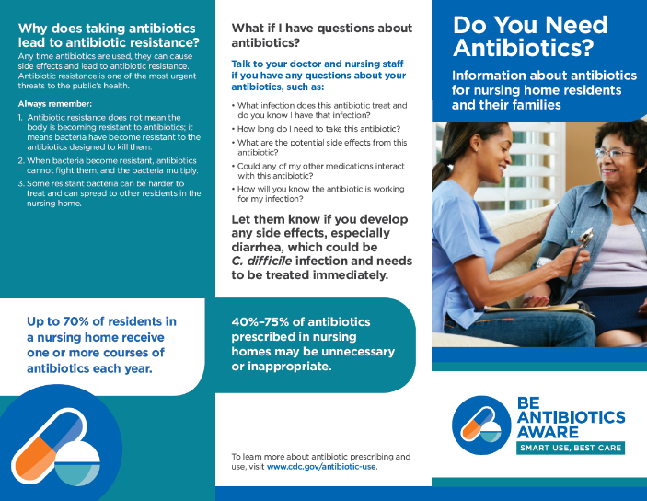
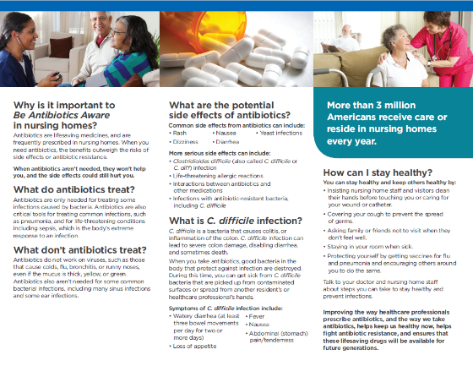

- What’s your general reaction to the way this brochure looks? (HMTS 6e)
  - PROBE: What do you think about the layout of the information?
  - PROBE: What do you like about this brochure?
  - PROBE: How could this brochure be improved?
- Overall, how helpful do you think this brochure is / would be in providing education for your residents and their families about appropriate antibiotic use?
  - PROBE: [For any response] Why?
  - PROBE: [For “Not helpful”] Would putting this information in a different format be more helpful to provide education to residents and families? If so, what format?
  - PROBE: Would you use this brochure to provide education for your residents and their families? Why or why not?
  - PROBE: Is there anything else that your residents and their families ask you about antibiotic use that isn’t covered in this brochure?
  - PROBE: Is there anything your residents and their families should know about antibiotic use that isn’t covered in this brochure?
- Are there any other types of materials or resources that you think would be helpful to educate residents and their families about appropriate antibiotic use?
  - PROBE: What about letters, short videos, presentations during resident council meetings or other meetings?

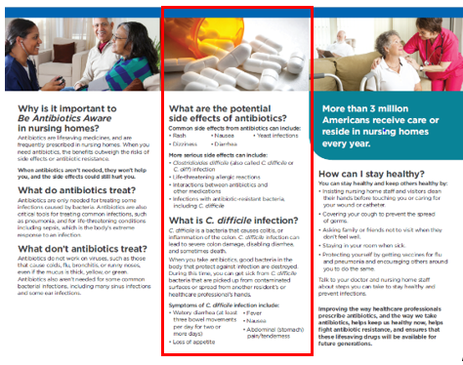
Let’s look specifically at the side effects section in this brochure

- In a typical week, how often do you talk to your residents and/or their families about possible side effects related to antibiotic use?
  - PROBE: How do you generally counsel residents/their families about antibiotic-related side effects?
- PROBE: What side effects do you typically talk to them about?
- PROBE: What about C. difficile infection?
- Do you think informing residents and their families about possible antibiotic-related side effects could reduce pressure to prescribe unnecessarily?
  - PROBE: [For either response] Why?
- Do you think this section would help you provide education to residents/their families about possible antibiotic-related side effects?
  - PROBE: [For yes or no] Why?
  - PROBE: Is there any other information about antibiotic side effects that residents/their families ask you that isn’t covered in this section?
  - PROBE: Is there anything residents/their families should know about antibiotic use side effects that isn’t covered in this section?
- Do you think another type of material with this information would be more helpful for residents and their families? If so, what type?

Closing [2-3 minutes]
Well, that’s the last of my questions. Do you have any comments or questions that you’d like to bring up before we end our discussion?

Thank you again for taking the time to participate in this discussion. Please visit www.cdc.gov/antibiotic-use for more information on appropriate antibiotic prescribing.

We sincerely appreciate and value your input!

