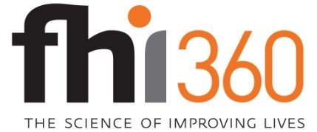

MESSAGE TESTING CARD SORT SURVEY FOR PEOPLE WITH DIABETES (PWD FOR PEOPLE WITH DIABETES WHO HAVE NOT HAD DSMES

September 19, 2019

To be included on the first page: Public reporting burden of this collection of information is estimated to average 10 minutes per response, including the time for reviewing instructions, searching existing data sources, gathering and maintaining the data needed, and completing and reviewing the collection of information. An agency may not conduct or sponsor, and a person is not required to respond to a collection of information unless it displays a currently valid OMB control number. Send comments regarding this burden estimate or any other aspect of this collection of information, including suggestions for reducing this burden to CDC/ATSDR Information Collection Review Office, 1600 Clifton Road NE, MS D-74, Atlanta, Georgia 30333; ATTN: PRA (0920-0572).

FOR PEOPLE WITH DIABETES WHO HAVE NOT HAD DSMES:
Introduction: Thank you for agreeing to participate. We are interested in how people with diabetes choose among different services to help them manage their conditions.
This survey asks you about diabetes self-management education and support services to which your health care provider may refer a person with diabetes. [INSERT PLAIN LANGUAGE DESCRIPTION HERE].

- Please read this description of diabetes self-management education and support services. (INSERT PLAIN LANGUAGE DESCRIPTION). Based on this description, which of the following words would describe what you think these services would be like? (Pick up 10 words)

(INSERT LIST OF POSITIVE WORDS, IN RANDOM ORDER).

- Based on this description, which of the following words would describe what the services would be like? (Pick up 10 words) {USE CLICK HERE TO READ DESCRIPTION AGAIN OPTION}

(INSERT LIST OF NEGATIVE WORDS, IN RANDOM ORDER).

- From the list of words below, please select up to 5 qualities that best describe what you would consider to be ideal diabetes self-management education and support services (services you would give a grade of A+). (SELECT NO MORE THAN 5)
[INSERT LIST OF POSITIVE WORDS; RANDOMIZE OPTIONS]

- Why did you choose each of these five qualities instead of the others? What’s important about them? [SHOW THE WORDS SELECTED IN Q1] [OPEN ENDED TEXT BOX]

- Thinking about these five qualities of ideal diabetes self-management education and support services, please rank them in order of importance to you, with 1 being the most important, 2 being the second most important, and so on.
(SHOW LIST THAT THEY CHOSE IN Q1 IN RANDOM ORDER; HAVE THEM RANK THE WORDS 1 TO 5)

