**ATTACHMENT 4**

**Prevention Research Centers Program**

**Web-based Data Collection System   
Screen Shots**

**(Note: The Table of Contents is provided for reviewers and is not a component of the web-based data collection system. Some screenshots contain test data for demonstration purposes.)**

Table of Contents

OMB Compliance Statement tab 4

Instructions tab 5

Support tab 6

Switch Year tab 7

Survey – Input: Partnerships 8

Survey – Input: Resources Provided 17

Survey – Activity: Center Projects 21

Survey – Activity: Other-funded Research Projects (ORP) 25

Survey – Output: Students Mentored 33

Survey – Output: Formal Training Programs (FTP) 37

Survey – Output: Practice & Research Tools 43

Survey – Impact: Systems & Environmental Strategies (PSE) 50

Survey – Impact: # of People Reached 56

Survey – Impact: Projects Found Effective 62

Survey – Impact: Projects Adopted Outside original study population 67

Survey – Additional Impacts 73

Cost Analysis – Participant Count/Duration 77

Cost Analysis – Labor 81

Cost Analysis – Materials & Consumables 85

Cost Analysis – Travel 89

Cost Analysis – Location 93

Cost Analysis – Cost to Participant (Indirect) 97

Products – Books & Book Chapters 101

Products – Journal Articles 106

Products – Presentations 112

# 

# OMB Compliance Statement tab

|  |
| --- |
| cid:image001.png@01D138D9.64FB3B20 |

# Instructions tab

|  |
| --- |
|  |

# Support tab

|  |  |
| --- | --- |
| Switch Year tab  |  | | --- | |  | |

# Survey – Input: Partnerships

|  |
| --- |
| **Partnerships Summary** |
|  |

|  |
| --- |
| **Partnership details – Partner tab** |
|  |

|  |
| --- |
| **Partnership details – Center Project Roles tab (if applicable)** |
|  |

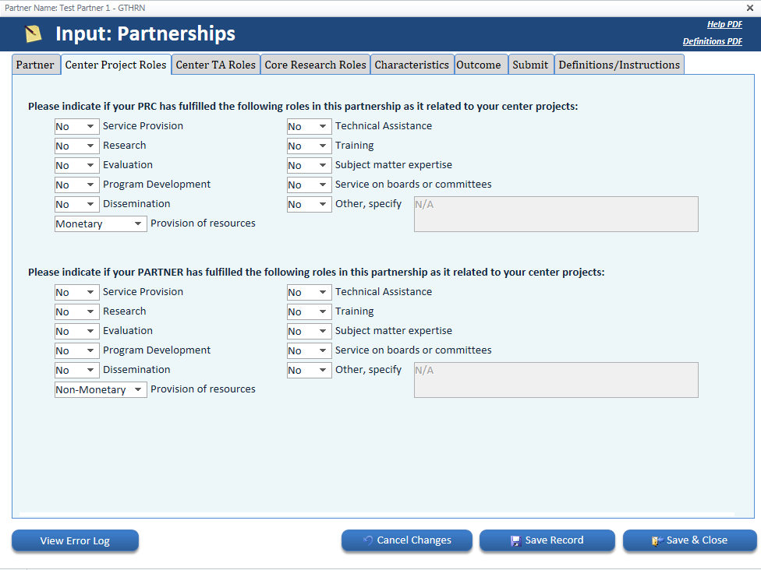

|  |
| --- |
| **Partnership details – Center TA Roles tab (if applicable)** |
|  |

|  |
| --- |
| **Partnership details – Core Research Roles tab (if applicable)** |
|  |

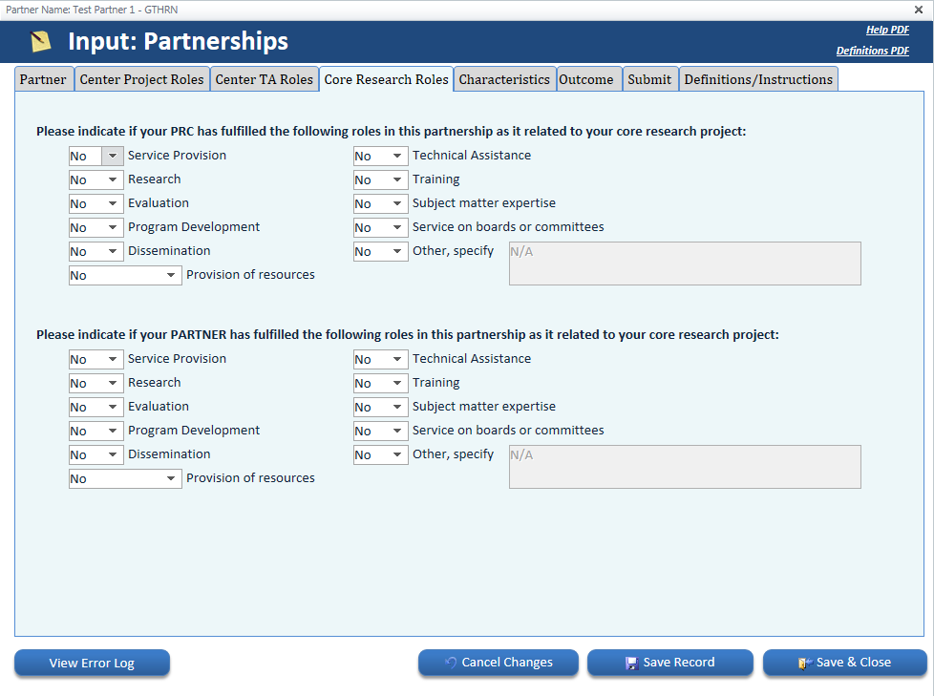

|  |
| --- |
| **Partnership details – Characteristics tab** |
|  |

|  |
| --- |
| **Partnership details – Outcome tab** |
|  |

|  |
| --- |
| **Partnership details – Submit tab** |
|  |

|  |
| --- |
| **Partnership details – Definitions/Instructions tab** |
|  |

# Survey – Input: Resources Provided

|  |
| --- |
| **Resources provided summary** |
|  |

|  |
| --- |
| **Resources provided details – Support Type tab** |
|  |

|  |
| --- |
| **Resources provided details – Submit tab** |
|  |

|  |
| --- |
| **Resources provided details – Definitions/Instructions tab** |
|  |

# Survey – Activity: Center Projects

|  |
| --- |
| **Center projects summary** |
|  |

|  |
| --- |
| **Center project details – Project tab** |
|  |

|  |
| --- |
| **Center project details – Submit tab** |
|  |

|  |
| --- |
| **Center project details – Definitions/Instructions tab** |
|  |

# Survey – Activity: Other-funded Research Projects (ORP)

|  |
| --- |
| **ORP summary** |
|  |

|  |
| --- |
| **ORP details – Project tab** |
|  |

|  |
| --- |
| **ORP details – Funding Sources tab** |
|  |

|  |
| --- |
| **ORP details – Health Topic tab** |
|  |

|  |
| --- |
| **ORP details – Characteristics tab** |
|  |

|  |
| --- |
| **ORP details – Involvement tab** |
|  |

|  |
| --- |
| **ORP details – Submit tab** |
|  |

|  |
| --- |
| **ORP details – Definitions/Instructions tab** |
|  |

# Survey – Output: Students Mentored

|  |
| --- |
| **Students mentored summary** |
|  |

|  |
| --- |
| **Students mentored details – Student Category tab** |
|  |

|  |
| --- |
| **Students mentored details – Submit tab** |
|  |

|  |
| --- |
| **Students mentored details – Definitions/Instructions tab** |
|  |

# Survey – Output: Formal Training Programs (FTP)

|  |
| --- |
| **FTP summary** |
|  |

|  |
| --- |
| **FTP details – Audience tab** |
|  |

**FTP details – Objective tab**

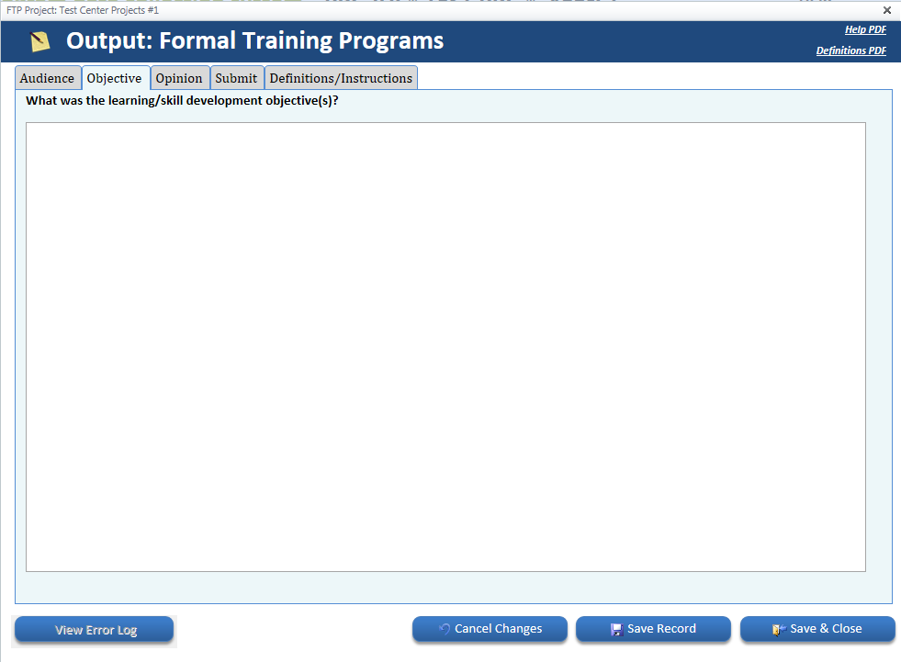

**FTP details – Opinion tab**

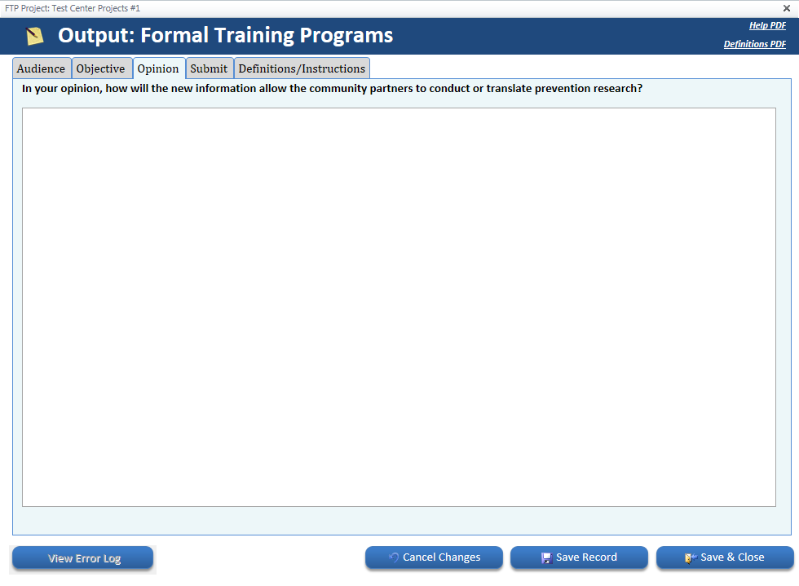

|  |
| --- |
| **FTP details – Submit tab** |
|  |

|  |
| --- |
| **FTP details – Definitions/Instructions tab** |
|  |

# Survey – Output: Practice & Research Tools

|  |
| --- |
| **Tools summary** |
|  |

|  |
| --- |
| **Tool details – Project tab** |
|  |

|  |
| --- |
| **Tool details – Tool Type tab** |
|  |

|  |
| --- |
| **Tool details – Dissemination tab** |
|  |

|  |
| --- |
| **Tool details – Partners tab** |
|  |

|  |
| --- |
| **Tool details – Submit tab** |
|  |

|  |
| --- |
| **Tool details – Definitions/Instructions tab** |
|  |

# Survey – Impact: Policy, Systems & Environmental Strategies (PSE)

|  |
| --- |
| **PSE summary** |
|  |

|  |
| --- |
| **PSE details – PSE Name tab** |

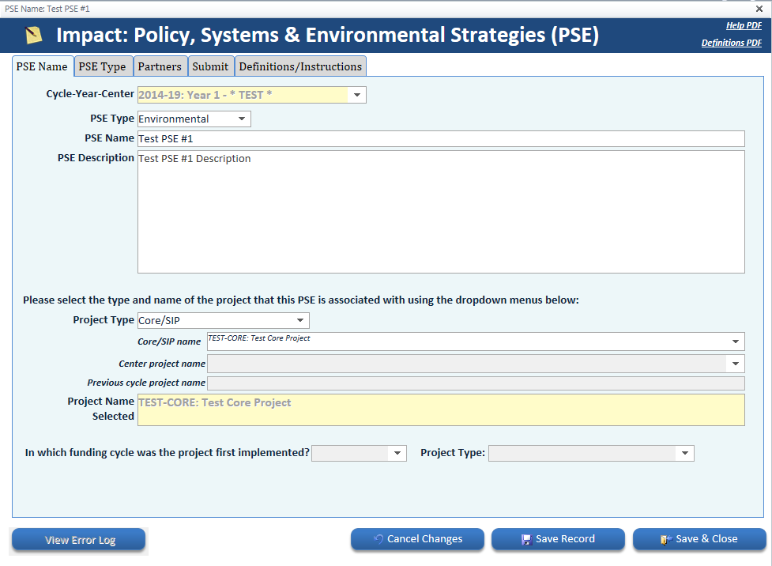

|  |
| --- |
| **PSE details – PSE Type tab** |

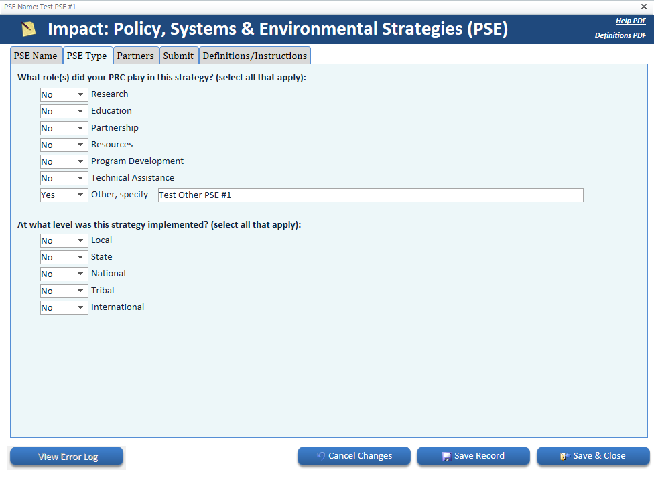

|  |
| --- |
| **PSE details – Partners tab** |

**PSE details – Submit tab**

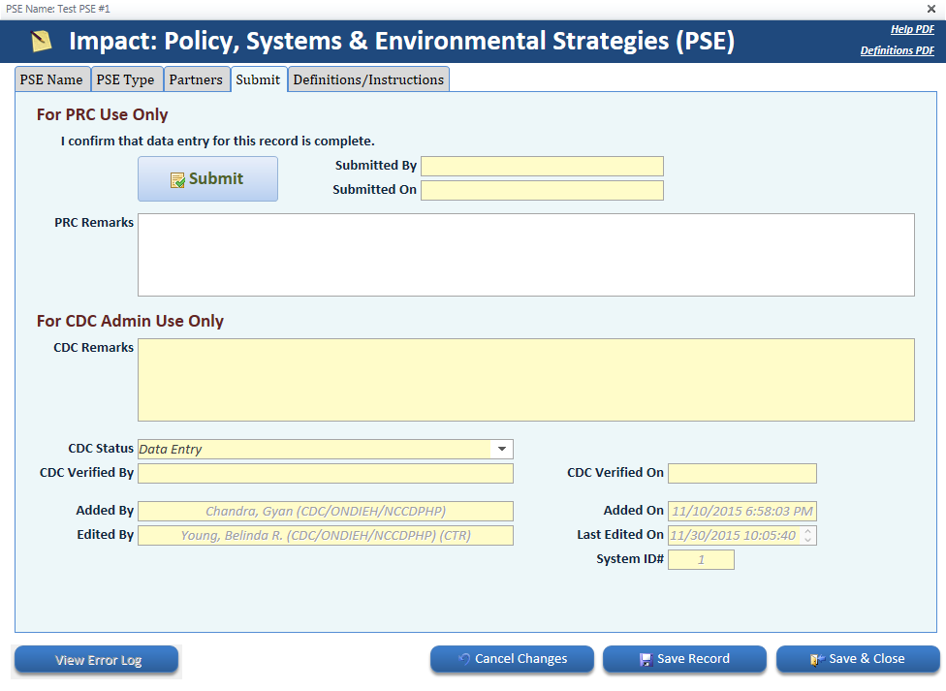

|  |
| --- |
| **PSE details – Definitions tab** |

# Survey – Impact: # of People Reached

|  |
| --- |
| **# of people reached summary** |
|  |

|  |
| --- |
| **# of people reached details – Project tab** |
|  |

|  |
| --- |
| **# of people reached details – Partners tab** |

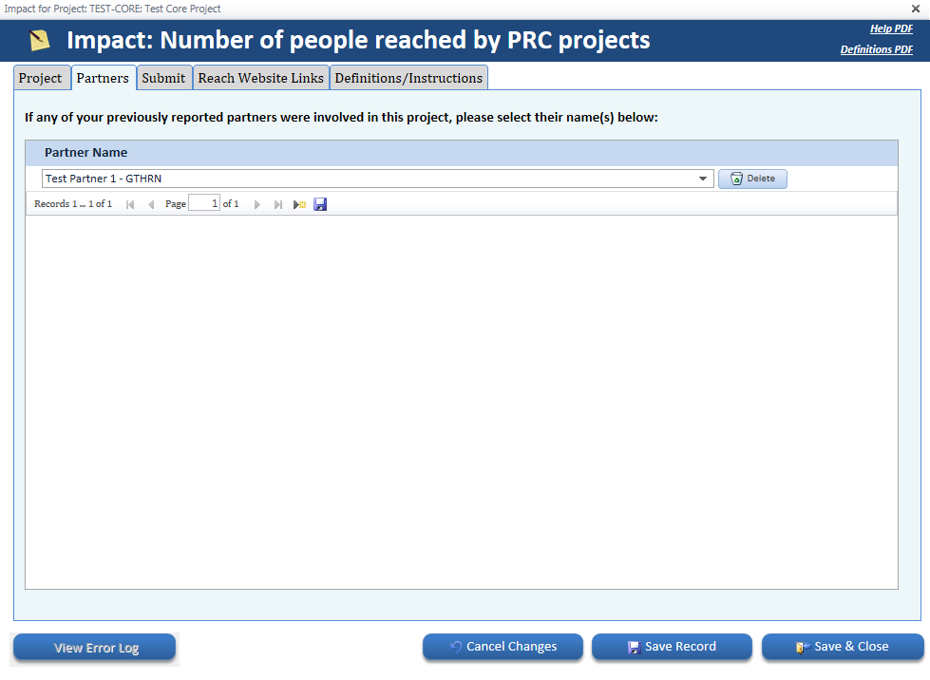

|  |
| --- |
| **# of people reached details – Submit tab** |
|  |

|  |
| --- |
| **# of people reached details – Reach Website Links tab** |
|  |

|  |
| --- |
| **# of people reached details – Definitions/Instructions tab** |
|  |

# Survey – Impact: Projects Found Effective

|  |
| --- |
| **Projects found effective summary** |
|  |

|  |
| --- |
| **Projects found effective details – Project tab** |
|  |

|  |
| --- |
| **Projects found effective details – Source/Level tab** |
|  |

|  |
| --- |
| **Projects found effective details – Submit tab** |
|  |

|  |
| --- |
| **Projects found effective details – Definitions/Instructions tab** |
|  |

# Survey – Impact: Projects Adopted Outside original study population

|  |
| --- |
| **Project adoption outside summary** |
|  |

|  |
| --- |
| **Project adoption outside details – Project tab** |
|  |

|  |
| --- |
| **Project adoption outside details – Organization Type tab** |
|  |

|  |
| --- |
| **Project adoption outside details – Organization Type pop-up details tab (if applicable)** |
|  |

|  |
| --- |
| **Project adoption outside details – Submit tab** |
|  |

|  |
| --- |
| **Project adoption outside details – Definitions/Instructions tab** |
|  |

# Survey – Additional Impacts

|  |
| --- |
| **Additional impacts summary** |
|  |

|  |
| --- |
| **Additional impacts details – Impact tab** |
|  |

|  |
| --- |
| **Additional impacts details – Submit tab** |
|  |

|  |
| --- |
| **Additional impacts details – Definitions/Instructions tab** |
|  |

# Cost Analysis – Participant Count/Duration

|  |
| --- |
| **Participant count/duration summary** |
|  |

|  |
| --- |
| **Participant count/duration details – Project tab** |
|  |

|  |
| --- |
| **Participant count/duration details – Submit tab** |
|  |

|  |
| --- |
| **Participant count/duration details – Definitions/Instructions tab** |
|  |

# Cost Analysis – Labor

|  |
| --- |
| **Labor summary** |
|  |

|  |
| --- |
| **Labor details – Labor tab** |
|  |

|  |
| --- |
| **Labor details – Submit tab** |
|  |

|  |
| --- |
| **Labor details – Definitions/Instructions tab** |
|  |

# Cost Analysis – Materials & Consumables

|  |
| --- |
| **Materials & Consumables summary** |
|  |

|  |
| --- |
| **Materials & Consumables details – Materials tab** |
|  |

|  |
| --- |
| **Materials & Consumables details – Submit tab** |
|  |

|  |
| --- |
| **Materials & Consumables details – Definitions/Instructions tab** |
|  |

# Cost Analysis – Travel

|  |
| --- |
| **Travel summary** |
|  |

|  |
| --- |
| **Travel details – Travel tab** |
|  |

|  |
| --- |
| **Travel details – Submit tab** |
|  |

|  |
| --- |
| **Travel details – Definitions/Instructions tab** |
|  |

# Cost Analysis – Location

|  |
| --- |
| **Location summary** |
|  |

|  |
| --- |
| **Location details – Location tab** |
|  |

|  |
| --- |
| **Location details – Submit tab** |
|  |

|  |
| --- |
| **Location details – Definitions/Instructions tab** |
|  |

# Cost Analysis – Cost to Participant (Indirect)

|  |
| --- |
| **Cost to Participant summary** |
|  |

|  |
| --- |
| **Cost to Participant details – Participant tab** |
|  |

|  |
| --- |
| **Cost to Participant details – Submit tab** |
|  |

|  |
| --- |
| **Cost to Participant details – Definitions/Instructions tab** |
|  |

# Products – Books & Book Chapters

|  |
| --- |
| **Books & book chapters summary** |
|  |

|  |
| --- |
| **Books & book chapters details – Book tab** |
|  |

|  |
| --- |
| **Books & book chapters details – Project Linking Data tab** |
|  |

|  |
| --- |
| **Books & book chapters details – Submit tab** |
|  |

|  |
| --- |
| **Books & book chapters details – Definitions/Instructions tab** |
|  |

# Products – Journal Articles

|  |
| --- |
| **Journal articles summary** |
|  |

|  |
| --- |
| **Journal article details – Journal tab** |
|  |

|  |
| --- |
| **Journal article details – PubMed View Abstract tab** |
|  |

|  |
| --- |
| **Journal article details – Project Linking Data tab** |
|  |

|  |
| --- |
| **Journal article details – Submit tab** |
|  |

|  |
| --- |
| **Journal article details – Definitions/Instructions tab** |
|  |

# Products – Presentations

|  |
| --- |
| **Presentation summary** |
|  |

|  |
| --- |
| **Presentation details – Presentation tab** |
|  |

|  |
| --- |
| **Presentation details – Project Linking Data tab** |
|  |

|  |
| --- |
| **Presentation details – Submit tab** |
|  |

|  |
| --- |
| **Presentation details – Definitions/Instructions tab** |
|  |