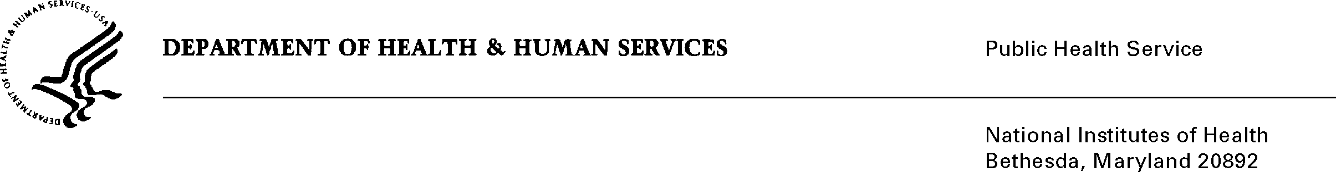
DATE: June 25, 2018

TO: Stephanie Mok
Office of Management and Budget (OMB)
Reports Clearance Officer, DHHS

FROM: Mikia P. Currie
Chief, Project Clearance Branch

SUBJECT: Change Request to a Currently Approved Form
(OMB # 0925-0361, Expiration Date 08/31/2019)

NIH is requesting non-substantive changes to the National Institutes of Health Loan Repayment Programs information collection approved under 0925-0361 which does not change the approved data collection, burden hours, or number of respondents. We are moving the Upload button for the Mentor Biosketch and an additional colleague (optional) to provide a single destination for Applicants to upload documents. Additionally, we are improving the process of identifying applicants’ research supervisors and primary mentors by including their organization and position title on the form.

Attachment A – Applicant Form (Colleague Information)

Your full consideration is appreciated.

