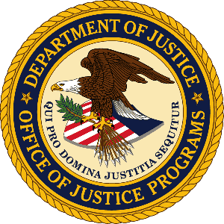

U.S. Department of Justice

Office of Justice Programs

Bureau of Justice Statistics

Washington, D.C. 20531

MEMORANDUM

To: Robert G. Sivinski
Office of Statistical and Science Policy
Office of Management and Budget

Through: Melody Braswell
Department Clearance Officer
Justice Management Division

Jeffrey H. Anderson, Ph.D.
Director
Bureau of Justice Statistics

Jeri M. Mulrow
Principal Deputy Director
Bureau of Justice Statistics

From: Jessica Stroop
Statistician, Project Manager
Bureau of Justice Statistics

Date: June 28, 2018

Re: Non-substantive change for the Bureau of Justice Statistics (BJS) National Survey of Youth in Custody (NSYC) program.

Purpose of the Memo

A clearance package was submitted to OMB for the NSYC-3 (#1121-0319) on August 15, 2017. OMB approved without change this previously approved collection on October 2, 2017 (Attachment 1). These approved activities support a collection mandated by Congress (Public Law 108-79; Attachment 2).

The NSYC gathers self-reported sexual assault data from juveniles in juvenile correctional facilities. State owned and operated facilities are eligible to be sampled in the NSYC along with private facilities that may be holding youth under state or local contract. Since private facilities may also be serving youth that are not under the custody of the state or local jurisdiction, the sample of youth drawn at private mixed facilities must have an indicator that determines their holding authority.

BJS is proposing adding a column to the Private/Contract facility roster form (Attachment 3) to collect whether the youth was placed by the state as a “yes” or “no” variable. The roster will also clarify this question by adding a statement asking the facility to determine the court ultimately responsible for placing the youth in the facility as a state or non-state level actor. This will help staff that may be unfamiliar the youth to verify the holding authoring before answering yes or no.
The inclusion of this information will be use to indicate the eligibility of the youth to be sampled in this NSYC.

Contact Information
Questions regarding any aspect of this project can be directed to:

Jessica Stroop
PREA Project Manager, Statistician
Bureau of Justice Statistics
U.S. Department of Justice
810 7th Street NW
Washington, DC 20531
Phone: 202-598-7610
Email: jessica.stroop@usdoj.gov

Attachment 1. OMB Approval (dated 10/2017) for the National Survey of Youth in Custody
Attachment 2. PREA Legislation
Attachment 3. Private/Contract facility roster form

