April 2, 2019

«Respondent_Title» «Respondent_First_Name» «Respondent_Last_Name»
«Company_Name»
«Respondent_Address»
«Respondent_City», «State2» «Respondent_Zip_Code»

Dear Mr. Smith:

The Bureau of Labor Statistics needs your assistance in measuring the rate of inflation in the U.S. economy. We collect the information for the Consumer Price Index (CPI) from a scientifically selected sample of rental housing units. As the only comprehensive measure of inflation at the household level, an accurate CPI is of critical importance to private industry, the public sector, as well as the general public for assessing the rate of inflation in the country.

Our research efforts have identified you as the probable owner for the following «Unit» in our sample. In the near future, our field representative will attempt to contact you via telephone or in person for the following «Address»:

- «Unit_Addresses»

This ongoing telephone survey provides important information on changes in housing costs. Our survey is brief and requests information on the current rent with some additional questions about utilities and services provided. The Bureau of Labor Statistics will use the information you provide for statistical purposes only. The information will be held in confidence to the full extent permitted by law in accordance with the Confidential Information Protection and Statistical Efficiency Act (44 U.S.C. 3572) and other applicable federal laws. Per the Federal Cybersecurity Enhancement Act of 2015, Federal information systems are protected from malicious activities through cybersecurity screening of transmitted data.

Our survey is interested in units that are rented to the general population. If you are the owner and currently reside in the unit mentioned above, please contact «CPI_User» at «Telephone_» so that we can remove your unit from the sample.

We have included additional information regarding the CPI Housing Survey for your review. We appreciate your assistance, and look forward to your participation in the CPI program.

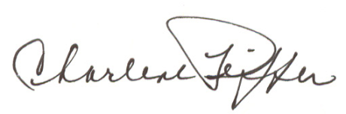
Sincerely yours,

Charlene Peiffer
Assistant Commissioner for Regional Operations
Bureau of Labor Statistics

