International Early Learning Study (IELS) 2018

Main Study

OMB# 1850-0936 v.5

Appendix A – B

Appendix A: Recruitment Materials, MyIELS

Appendix B: Sampling Materials, MyIELS, Consent, Nonresponse Follow-up, and Thank You Letters

National Center for Education Statistics (NCES)

U.S. Department of Education

Institute of Education Sciences

Washington, DC

June 2018

***Note****: All parent materials will also be provided in Spanish language. The Spanish versions of parent materials, as well as recruitment video scripts and links, and the full final MyIELS portal content will be provided to OMB as a change request in August 2018.*

Table of Contents

**Appendix A: Recruitment Materials, MyIELS**

State Recruitment Letter 5

IELS Study Brochure 6

School District Recruitment Letter 8

School Administrator Letter 10

Second Tier Incentive Letter for Pending Schools 12

Second Tier Incentive Letter for Refusing Schools 13

Second Tier Incentive Letter for Participating but Not Following-through Schools 14

FAQ for School Administrators 15

Gaining Cooperation Email Template Difficult to Reach Principal 17

Gaining Cooperation Email Template School Staff Considering Participation 19

Gaining Cooperation Email Template Follow-up to Address Concerns 21

Gaining Cooperation Email Template Follow-up after Cooperation Achieved 22

School Coordinator Responsibilities Fact Sheet 23

MyIELS.us Registration Email 26

MyIELS.us School View 23

Instructions for School Coordinators to E-file student list 40

FAQ for Teachers 42

Summer Email for School Coordinators 48

**Appendix B: Sampling Materials, Consent, Nonresponse Follow-up, and Thank You Letters**

School Coordinator Email Announcing E-Filing 50

School Coordinator Mailing 51

Pre-Assessment Call and Space Reminder Email for School Coordinators 52

Sample Setup of Assessment Room 53

School Coordinator Tracking Form Availability 54

First Consent and Participation Reminder Email for School Coordinators 55

Second Consent and Participation Reminder Email for School Coordinators 56

Final Participation Reminder Email for School Coordinators 57

Questionnaire Deadline Extension Email for School Coordinators 58

Teacher Questionnaire Invitation Email 59

MyIELS.us Teacher View 60

Notification Email for Parents 62

Study Introduction Letter for Teachers 63

Study Introduction Email for Teachers 65

Study Introduction Letter for Parents 67

Parent Consent Module of MyIELS 73

Notification Letter for Parents 76

Implicit Consent Letter for Parents 77

Implicit Consent Form for Parents 79

Explicit Consent Letter for Parents 80

Explicit Consent Form for Parents 82

Halloween Card for Teachers 83

Halloween Card for Parents 84

School Coordinator Tip Sheet for Questionnaire Follow-up 85

First Reminder Email for Teachers 87

Second Reminder Email for Teachers 88

Third Reminder Email for Teachers 89

Final Reminder Email for Teachers 90

Deadline Extension Email for Teachers 91

Explicit Consent Reminder Email for Parents 92

First Questionnaire Reminder Email for Parents 93

Second Questionnaire Reminder Email for Parents 94

Final Questionnaire Reminder Email for Parents 95

Questionnaire Deadline Extension Email for Parents 96

Notification Text Message for Parents 97

Explicit Consent Reminder Text Message for Parents 97

First Questionnaire Reminder Text Message for Parents 97

Second Questionnaire Reminder Text Message for Parents 97

Final Questionnaire Reminder Text Message for Parents 97

Questionnaire Deadline Extension Text Message for Parents 97

Thank You Letter Principal 98

Thank You Letter School Coordinator 99

The U.S. IELS Team 99

Thank You Email for School Coordinators 99

Thank You Letter Teachers 100

Thank You Email Teachers 100

Thank You Letter Parents 101

Thank You Email for Parents 101

Thank You Text Message for Parents 101

Results Now Available E-mail for Principals 102

Results Now Available E-mail for School Coordinators 102

Results Now Available E-mail for Teachers 102

Results Now Available E-mail for Parents 103

Appendix A

Except for school district and state IELS letters, all materials in this appendix will be used for

both public and private schools.

# State Recruitment Letter

# *Previously Approved – No Changes*

[Date]

[Title] [Name First] [Name Last]

[Title/Department]

[State]

[Address 1]

[Address 2]

[City], [State] [Zip code]

Dear [Title] [Name Last]:

I am writing to inform your district about an important new study: the **International Early Learning Study (IELS)**. This study of 5-year-olds will allow the U.S. to compare the skills and competencies of our children to their peers in other countries. Results from IELS will provide policymakers, educators, and parents/guardians with valuable information about the experiences that influence children’s early learning and their abilities as they begin school. I believe this is an extraordinary opportunity for us to learn more about children at this formative age.

The United States and other countries will conduct the study in the fall of 2018. *Some schools in your state have been randomly selected to participate in IELS, and I am writing to ask your agency to support the participation of those schools*.

IELS is sponsored by the Organization for Economic Cooperation and Development (OECD), an intergovernmental organization of industrialized countries. The study is conducted in the U.S. by the National Center for Education Statistics (NCES), part of the U.S. Department of Education, and is administered by Westat on behalf of NCES. The U.S. Office of Management and Budget (OMB) has approved the data collection under OMB #1850-0936. Study findings will not identify participating districts, schools, students, or individual staff. Please see the enclosed brochure for information about data confidentiality. While IELS is voluntary, your support of school participation in your state is invaluable so that the United States has a representative sample of schools across the country.

Within the next few weeks, a representative from Westat will contact sampled school districts and schools to discuss participating in the IELS main study. We are in contact with your state assessment director to try to ensure that we are not conflicting with other state efforts and that districts and schools understand how the IELS fits in with other data collections conducted by NCES. In the meantime, if you have questions about the study, please do not hesitate to call Mary Coleman at NCES at (202) 245-8382 or send an email to Mary.Coleman@ed.gov. You may also get more information by visiting the IELS website at https://nces.ed.gov/surveys/iels.

Thank you for your time and support.

Sincerely,

Peggy Carr, Ph.D.

Associate Commissioner, Assessments Division, NCES

cc: [State assessment coordinator name]

Enclosures

*The National Center for Education Statistics is authorized to conduct this study under the Education Sciences Reform Act of 2002 (ESRA 2002, 20 U.S.C. §9543). All of the information provided by school staff, students, and parents may be used only for statistical purposes and may not be disclosed, or used, in identifiable form for any other purpose except as required by law (20 U.S.C. §9573 and 6 U.S.C. §151). Individuals are never identified in any reports. All reported statistics refer to the U.S. as a whole or to national subgroups.*

# IELS Study Brochure

# *Previously Approved – No Changes*

IELS Study Brochure

* What do our children know and what can they do when they’re entering elementary school?
* What factors influence children’s early learning and development *before* they enter school?
* Are there lessons the U.S. can learn from other countries to improve early childhood education?

A new study gives us an extraordinary opportunity to learn more about children at this formative age. The International Early Learning Study (IELS) will provide important information about what 5-year-old children in different countries and learning environments know and can do as they enter elementary school. The study will give us new insights about children’s abilities in language and literacy, mathematics, self-regulation, and social emotional skills. It also collects information from educators and parents/guardians about children’s early childhood education and care experiences, home learning environments, and demographic characteristics to examine how these factors are related to children’s development.

**Why is this early learning study important?**

IELS will allow the U.S. to compare the skills and competencies of our children to their peers in other countries. Results from IELS will provide policymakers, educators, and parents/guardians with valuable information about the experiences that influence children’s early learning and their abilities as they begin school.

**Who develops and administers the study?**

IELS is coordinated by the Organization for Economic Cooperation and Development (OECD) and conducted in the U.S. by the National Center for Education Statistics (NCES) within the U.S. Department of Education. The study is developed through a collaborative process involving input from U.S. and international education experts to make sure the materials are appropriate for each country’s young children. The study is administered in the U.S. on behalf of NCES by Westat, a U.S. based research firm.

**Who participates in IELS?**

A nationally-representative sample of 5-year-olds enrolled in U.S. public and private schools participates in IELS, along with their peers in other countries. Parents/guardians and teachers of selected students are also asked to complete a questionnaire as part of the study. Participation in IELS is voluntary, yet critically valuable and important.

**What is involved for students?**

IELS is a play-based study conducted with tablets. Children will be asked to point to pictures, consider situations, and complete game-like tasks. They do not need to prepare in advance to participate in the study. The assessment is conducted one-on-one with trained staff who have experience working with children. The study is untimed and will be split across two days to minimize time away from regular classroom activity. Children will be allowed to take breaks as needed. In our experience, the study takes about 30 minutes each day and children enjoy participating.

**What is required of schools and teachers?**

School administrators are asked to agree to their students’ and teachers’ participation in the study, and to appoint a staff person who will help coordinate activities within the school. Teachers of students who participate in the study are asked to complete a brief survey about their professional background and the skills and abilities of those specific students. School staff will *not* be asked to administer the study. Trained IELS staff will facilitate the assessment and bring all required materials to the school.

**What role do parents have in the study?**

One parent or guardian of each student who participates in the study will be asked to complete a brief survey. The questionnaire asks demographic questions as well as questions about their child’s early learning environment, such as whether parents read to their child and whether the child participates in enrichment programs. It also asks questions about their child’s social skills and participation in child care.

**Will the names of participants and their responses be kept confidential?**

Results will not identify participating states, districts, schools, students, educators, or parents/guardians. All of the information provided by school staff, students, and parents may be used only for statistical purposes and may not be disclosed, or used, in identifiable form for any other purpose except as required by law (20 U.S.C. §9573 and 6 U.S.C. §151). Individuals are never identified in any reports. All reported statistics refer to the U.S. as a whole or to national subgroups. By law, every NCES employee as well as every NCES agent, such as contractors, has taken an oath and is subject to a jail term of up to 5 years, a fine of $250,000, or both if he or she willfully discloses ANY identifiable information about any study participant.

**Where can I find more information?**

Visit the IELS website at https://nces.ed.gov/surveys/iels.

For additional questions about IELS, contact the IELS U.S. home office at 1-855-299-1398 or email [IELSHelp@westat.com](mailto:IELSHelp@westat.com).

*The National Center for Education Statistics is authorized to conduct this study under the Education Sciences Reform Act of 2002 (ESRA 2002, 20 U.S.C. §9543).The U.S. Office of Management and Budget (OMB) has approved this data collection under OMB #1850-0936.*

# School District Recruitment Letter

# *Updated Since Previous Submission*

[Date]

[Title] [Name First] [Name Last], [Title/Department]

[School District]

[Address 1]

[City], [State] [Zip code]

Dear [Title] [Name Last]:

I am writing to inform your district about an important new study: the **International Early Learning Study (IELS)**. This study of 5-year-olds will allow the U.S. to compare the skills and competencies of our children to their peers in other countries. Results from IELS will provide policymakers, educators, and parents/guardians with valuable information about the experiences that influence children’s early learning and their abilities as they begin school. I believe this is an extraordinary opportunity for us to learn more about children at this formative age.

The U.S. and several other countries will participate in IELS in the fall of 2018. *Some schools in your district have been randomly selected to participate in the study, and I am writing to ask your district to support the participation of those schools*.

IELS is a play-based study that is given on tablets. It is conducted one-on-one with trained staff. The assessment is untimed and will be split across two days to minimize children’s time away from regular classroom activity. In our experience, the study takes about 30 minutes each day and children enjoy participating. Teachers of students selected for the study will be asked to complete a questionnaire, which includes questions about their professional background (about 3 minutes to complete) and the skills and abilities of the students selected for the study (about 5 minutes per child, with an average of 4 students per teacher). Parents will also be asked to complete a short survey.

We are asking you to encourage your school(s) to participate in IELS, which will take place this year in October and November. As a thank-you, each participating school in your district will receive $200 and each school’s IELS school coordinator (i.e., a school staff person designated to liaise with IELS staff) will also receive $200 to thank them for their time and effort. Selected teachers will receive $20 for completing part A of the questionnaire, plus an additional $7 per student questionnaire, and parents asked to complete the survey will receive $20. Each student who participates will receive a sticker or a pencil.

IELS is sponsored by the Organization for Economic Cooperation and Development (OECD), an intergovernmental organization of industrialized countries. The study is conducted in the U.S. by the National Center for Education Statistics (NCES), part of the U.S. Department of Education, and is administered by Westat on behalf of NCES. The U.S. Office of Management and Budget (OMB) has approved the data collection under OMB #1850-0936. Study findings will not identify participating districts, schools, students, or individual staff. Please see the enclosed FAQ for information about data confidentiality. While IELS is voluntary, your support of school participation in your district is invaluable so that the United States has a representative sample of schools across the country.

Within the next few days, a representative from Westat will contact the following school or schools in your district that have been selected for the study: [LIST SAMPLED SCHOOLS HERE…]. Please include the IELS assessment window (October to November 2018) on your district test calendar.

IELS is described in more detail in the enclosed materials. If you have any questions, please do not hesitate to call 1-855-299-1398 or send an email to IELSHelp@westat.com. You may also get more information about this study by contacting Mary Coleman at NCES at (202) 245-8382 or Mary Coleman@ed.gov, or by visiting the IELS website at https://nces.ed.gov/surveys/iels.

Thank you for your time and for supporting this important international education study.

Sincerely,

Peggy Carr, Ph.D.

Associate Commissioner, Assessments Division, NCES

Enclosures

*The National Center for Education Statistics is authorized to conduct this study under the Education Sciences Reform Act of 2002 (ESRA 2002, 20 U.S.C. §9543). All of the information provided by school staff, students, and parents may be used only for statistical purposes and may not be disclosed, or used, in identifiable form for any other purpose except as required by law (20 U.S.C. §9573 and 6 U.S.C. §151). Individuals are never identified in any reports. All reported statistics refer to the U.S. as a whole or to national subgroups.*

# School Administrator Letter

# *Updated Since Previous Submission*

Date]

[Title] [Name First] [Name Last], [Title/Department]

[School District]

[Address 1]

[City], [State] [Zip code]

Dear [Title] [Name Last]:

I am writing to inform your school about an important new study: the **International Early Learning Study (IELS)**. This study of 5-year-olds will allow the U.S. to compare the skills and competencies of our children to their peers in other countries. Results from IELS will provide policymakers, educators, and parents/guardians with valuable information about the experiences that influence children’s early learning and their abilities as they begin school. I believe this is an extraordinary opportunity for us to learn more about children at this formative age.

The U.S. and several other countries will participate in IELS in the fall of 2018. *Your school is one of 200 across the U.S. that has been selected to take part in the study between October and November of this year*.

IELS is a play-based study that is given on tablets. It is conducted one-on-one with trained staff. The assessment is untimed and will be split across two days to minimize children’s time away from regular classroom activity. In our experience, the study takes about 30 minutes each day and children enjoy participating. Teachers of students selected for the study will be asked to complete a questionnaire, which includes questions about their professional background (about 3 minutes to complete) and the skills and abilities of the students selected for the study (about 5 minutes per child, with an average of 4 students per teacher). Parents will also be asked to complete a short survey.

To thank you for participating, your school will receive $200. The individual you appoint as the IELS school coordinator (i.e., a school staff person designated to liaise with IELS staff) will also receive $200 as a thank you for their time and effort. Selected teachers will receive $20 for part A of the teacher questionnaire plus an additional $7 for each student questionnaire completed, and parents asked to complete the survey will receive $20. Each student who participates will receive a sticker or a pencil.

IELS is sponsored by the Organization for Economic Cooperation and Development (OECD), an intergovernmental organization of industrialized countries. The study is conducted in the U.S. by the National Center for Education Statistics (NCES), part of the U.S. Department of Education, and is administered by Westat on behalf of NCES. The U.S. Office of Management and Budget (OMB) has approved the data collection under OMB #1850-0936. Study findings will not identify participating districts, schools, students, or individual staff. Please see the enclosed FAQ for information about data confidentiality.

Within the next few days, a representative from Westat will contact you to discuss your participation. While the study is voluntary, we ask you to support participation in your school so that the U.S. has a representative sample of schools and we can ensure a fair and valid assessment for all U.S. 5-year-olds.

IELS is described in more detail in the enclosed materials. If you have any questions, please do not hesitate to call 1-855-299-1398 or send an email to IELSHelp@westat.com. You may also get more information about this study by contacting Mary Coleman at NCES at (202) 245-8382 or Mary.Coleman@ed.gov, or by visiting the IELS website at [https://www.MyIELS.us/](https://www.myiels.us/).

Thank you for your time and for supporting this important international education study.

Sincerely,

Peggy Carr, Ph.D.

Associate Commissioner, Assessments Division, NCES

Enclosures

*The National Center for Education Statistics is authorized to conduct this study under the Education Sciences Reform Act of 2002 (ESRA 2002, 20 U.S.C. §9543). All of the information provided by school staff, students, and parents may be used only for statistical purposes and may not be disclosed, or used, in identifiable form for any other purpose except as required by law (20 U.S.C. §9573 and 6 U.S.C. §151). Individuals are never identified in any reports. All reported statistics refer to the U.S. as a whole or to national subgroups.*

# Second Tier Incentive Letter for Pending Schools

# *New*

[Date]

[Title] [Name First] [Name Last], [Title/Department]

[School District]

[Address 1]

[City], [State] [Zip code]

Dear [Title] [Name Last]:

The International Early Learning Study (IELS) aims to provide U.S. educators, policymakers, and parents the opportunity to better understand the skills and competencies of our children at the beginning of primary school and how these compare with those of 5-year-olds in other countries. The study fills important gaps in international comparisons of education systems and helps countries understand how their early education and care systems prepare children for school. However, we will not be able to understand and compare the experience and skills of U.S. students without a sample of schools that represents the full spectrum of American students and teachers—and your school is an important part of such a sample.

As the IELS Project Director, conducting this study on behalf of the National Center for Education Statistics (NCES), I understand that you have not yet agreed to participate but I wish personally to ask you to consider participating because your school represents hundreds of schools across the country similar to yours (but those schools cannot participate because they were not sampled and do not meet the international sampling requirements for the study).

If you can help us secure a fully representative sample, we are offering an additional token of appreciation for your school’s time. If you participate, we will give your school $800. Your school’s IELS school coordinator (the school staff person designated to work with IELS staff) will receive $200 as a thank you for his or her time and effort. Selected teachers will receive $20 for completing part A of their questionnaire and an additional $7 for each student questionnaire they complete. Parents will receive $20 for completing their questionnaire.

The IELS data collection begins on October 15th and extends through December 7th, 2018. A representative of IELS at Westat will call you soon to discuss your decision. For additional information, please reach out to the IELS Help Desk at IELSHelp@westat.com or 1-855-299-1398. Furthermore, you may get more information about this study by contacting Mary Coleman at NCES at (202) 245-8382 or Mary Coleman@ed.gov, or by visiting the IELS website at https://nces.ed.gov/surveys/iels/.

Thank you for your time and consideration.

Sincerely,

Karen Tourangeau

Project Director, IELS in the United States

*The National Center for Education Statistics is authorized to conduct this study under the Education Sciences Reform Act of 2002 (ESRA 2002, 20 U.S.C. §9543). All of the information provided by school staff, students, and parents may be used only for statistical purposes and may not be disclosed, or used, in identifiable form for any other purpose except as required by law (20 U.S.C. §9573 and 6 U.S.C. §151). Individuals are never identified in any reports. All reported statistics refer to the U.S. as a whole or to national subgroups.*

# Second Tier Incentive Letter for Refusing Schools

# *New*

[Date]

[Title] [Name First] [Name Last], [Title/Department]

[School District]

[Address 1]

[City], [State] [Zip code]

Dear [Title] [Name Last]:

The International Early Learning Study (IELS) aims to provide U.S. educators, policymakers, and parents the opportunity to better understand the skills and competencies of our children at the beginning of primary school and how these compare with those of 5-year-olds in other countries. The study fills important gaps in international comparisons of education systems and helps countries understand how their early education and care systems prepare children for school. However, we will not be able to understand and compare the experience and skills of U.S. students without a sample of schools that represents the full spectrum of American students and teachers—and your school is an important part of such a sample.

As the IELS Project Director, conducting this study on behalf of the National Center for Education Statistics (NCES), I understand that you have not yet agreed to participate but I wish personally to ask you to reconsider participating because your school represents hundreds of schools across the country similar to yours (but those schools cannot participate because they were not sampled and do not meet the international sampling requirements for the study).

If you can help us secure a fully representative sample, we are offering an additional token of appreciation for your school’s time. If you participate, we will give your school $800. Your school’s IELS school coordinator (the school staff person designated to work with IELS staff) will receive $200 as a thank you for his or her time and effort. Selected teachers will receive $20 for completing part A of their questionnaire and an additional $7 for each student questionnaire they complete. Parents will receive $20 for completing their questionnaire.

The IELS data collection begins on October 15th and extends through December 7th, 2018. A representative of IELS at Westat will call you soon to discuss your decision. For additional information, please reach out to the IELS Help Desk at IELSHelp@westat.com or 1-855-299-1398. Furthermore, you may get more information about this study by contacting Mary Coleman at NCES at (202) 245-8382 or Mary Coleman@ed.gov, or by visiting the IELS website at https://nces.ed.gov/surveys/iels/.

Thank you for your time and consideration.

Sincerely,

Karen Tourangeau

Project Director, IELS in the United States

*The National Center for Education Statistics is authorized to conduct this study under the Education Sciences Reform Act of 2002 (ESRA 2002, 20 U.S.C. §9543). All of the information provided by school staff, students, and parents may be used only for statistical purposes and may not be disclosed, or used, in identifiable form for any other purpose except as required by law (20 U.S.C. §9573 and 6 U.S.C. §151). Individuals are never identified in any reports. All reported statistics refer to the U.S. as a whole or to national subgroups.*

# Second Tier Incentive Letter for Participating but Not Following-through Schools

# *New*

[Date]

[Title] [Name First] [Name Last], [Title/Department]

[School District]

[Address 1]

[City], [State] [Zip code]

Dear [Title] [Name Last]:

The International Early Learning Study (IELS) aims to provide U.S. educators, policymakers, and parents the opportunity to better understand the skills and competencies of our children at the beginning of primary school and how these compare with those of 5-year-olds in other countries. The study fills important gaps in international comparisons of education systems and helps countries understand how their early education and care systems prepare children for school. However, we will not be able to understand and compare the experience and skills of U.S. students without a sample of schools that represents the full spectrum of American students and teachers—and your school is an important part of such a sample.

As the IELS Project Director, conducting this study on behalf of the National Center for Education Statistics (NCES), I want to thank you for agreeing to participate in IELS. Unfortunately, we have not been able to confirm the IELS assessment date at your school and receive student lists for sampling. Your school represents hundreds of schools with a student body like yours. I hope that you can move forward with participation so that IELS can fully represent schools like yours.

To secure a fully representative sample, we are offering an additional token of appreciation for your school’s time. If you participate, **we will give your school $800**. Your school’s IELS school coordinator (the school staff person designated to work with IELS staff) will receive $200 as a thank you for his or her time and effort. Selected teachers will receive $20 for completing part A of their questionnaire and an additional $7 for each student questionnaire they complete. Parents will receive $20 for completing their questionnaire.

The IELS data collection begins on October 15th and extends through December 7th, 2018. A representative of IELS at Westat will call you soon to discuss your decision. For additional information, please reach out to the IELS Help Desk at IELSHelp@westat.com or 1-855-299-1398. Furthermore, you may get more information about this study by contacting Mary Coleman at NCES at (202) 245-8382 or Mary Coleman@ed.gov, or by visiting the IELS website at https://nces.ed.gov/surveys/iels/.

Thank you for your time and consideration.

Sincerely,

Karen Tourangeau

Project Director, IELS in the United States

*The National Center for Education Statistics is authorized to conduct this study under the Education Sciences Reform Act of 2002 (ESRA 2002, 20 U.S.C. §9543). All of the information provided by school staff, students, and parents may be used only for statistical purposes and may not be disclosed, or used, in identifiable form for any other purpose except as required by law (20 U.S.C. §9573 and 6 U.S.C. §151). Individuals are never identified in any reports. All reported statistics refer to the U.S. as a whole or to national subgroups.*

# FAQ for School Administrators

# *Updated Since Previous Submission*

International Early Learning Study

FREQUENTLY ASKED QUESTIONS

*Information for School Administrators*

**What is the International Early Learning Study (IELS)?**

IELS is an international study that provides important information about what 5-year-old children in different countries and learning environments know and can do as they enter elementary school. The study provides important information about children’s abilities in language and emergent literacy, mathematics and numeracy, self-regulation, and social emotional skills. It also collects information from educators and parents/guardians about children’s early childhood education and care experiences, home learning environments, and demographic characteristics to examine how various factors are related to children’s development. The U.S. Department of Education’s National Center for Education Statistics (NCES) facilitates our country’s participation in IELS.

**Why is IELS important?**

Results from IELS will provide policymakers, educators, and parents/guardians with valuable information about the experiences that influence children’s early learning and their abilities as they begin school. IELS will also allow the U.S. to compare the skills and competencies of our children to their peers in other countries.

**Why should my school and students participate in the study?**

Participants help IELS provide an accurate picture of what 5-year-olds in the U.S. know and can do. It is important that every selected school and student participate in the study because they represent many other schools and children like them across the country. Moreover, educators and parents/guardians contribute vital information about participating children’s skills and education experiences to provide insights into their learning and development.

**Are there incentives for participating schools?**

Yes. NCES will provide $200 to schools that participate in the study. NCES will also provide $200 to school coordinators who serve as the point of contact for each school.

**Why was my school selected for participation?**

Your school was selected as part of a nationally-representative sample of U.S. public and private schools. Approximately 3,000 students, from about 200 schools, will participate in the study across the country.

**Will all of our 5-year-old students be asked to participate?**

Up to 19 students will be randomly selected to take part in the study from each participating school. In very small schools, all 5-year-old students may be asked to participate. Students with disabilities and English Language Learners may be excused if a limited set of accommodations provided by IELS staff do not provide adequate support to enable their participation.

**When and where will the study be conducted?**

NCES will work with Westat, a research organization, to conduct the study in October and December 2018. The study will be conducted in participating schools. The assessment space needs to be able to accommodate the students and IELS staff.

**Who will be responsible for administering the study to students?**

Trained IELS staff will provide all required materials and conduct the study with students. Exceptions will be made for students with IEP accommodations who may require the assistance of school personnel (e.g., if a student works one-on-one with an aide).

**What is involved for students?**

IELS is a play-based study conducted with tablets. Children will be asked to point to pictures, consider situations, and complete game-like tasks. They do not need to prepare in advance. The assessment is conducted one-on-one with trained staff who have experience working with children. The study is untimed and will be split across two days to minimize time away from regular classroom activity. Children will be allowed to take breaks as necessary. The study takes about 30 minutes each day and children enjoy participating.

**What happens if a child refuses to participate?**

All participation is voluntary. Children can skip any question they do not want to answer. Any child who does not wish to work with IELS staff will not have to.

**What is involved for teachers and parents/guardians?**

Teachers of students selected for the study will be asked to complete a questionnaire, which includes questions about their professional background (about 3 minutes to complete) and the skills and abilities of the students selected for the study (about 5 minutes per child, with an average of 4 students per teacher). One parent/guardian of each participating student will also be asked to complete a brief questionnaire. Teachers will receive $20 for part A of their questionnaire and an additional $7 for each student questionnaire completed, and parents/guardians will receive $20 to thank them for their time and effort.

**Will the names of participants and their responses be kept confidential?**

Individual children’s performance will not be shared with teachers, the school, or the district in any way. Individual responses will be combined with those from other participants to produce summary statistics and reports. All of the information provided by school staff, students, and parents may be used only for statistical purposes and may not be disclosed, or used, in identifiable form for any other purpose except as required by law (20 U.S.C. §9573 and 6 U.S.C. §151). All field staff and other staff working on the study have signed an affidavit of non-disclosure where they swear to abide by this law. By law, every NCES employee as well as every NCES agent, such as contractors, has taken an oath and is subject to a jail term of up to 5 years, a fine of $250,000, or both if he or she willfully discloses ANY identifiable information about any study participant.

**Where can I find more information?**

For additional information, call the IELS information number, 1-855-299-1398, or send an email to IELSHelp@westat.com. You may also learn more about the study by visiting the IELS website at

http://nces.ed.gov/surveys/IELS.

# Gaining Cooperation Email Template Difficult to Reach Principal

# *Previously Approved – No Changes*

Dear [Principal Name]:

My name is [your name] and I have recently been trying to reach you to discuss a new, important study, the International Early Learning Study (IELS). Your [secretary, administrative assistant, receptionist] has been very gracious in receiving my calls and suggested I use email.

Below is a brief overview of IELS. [I spoke with (DISTRICT/DIOCESE SUPERINTENDENT NAME), superintendent of the (DISTRICT/DIOCESE NAME), about your school’s selection for IELS. (He/She) approved my contacting you directly.]

[CHOOSE APPROXIMATELY FIVE BULLETS FROM THE LIST BELOW.]

5-year-old students take a play-based assessment administered on tablets of Emerging Literacy, Emerging Numeracy, Empathy and Trust, and Self-Regulation;

IELS provides all materials, including tablets;

Local IELS staff administers the assessment;

IELS schedule consists of one hour of assessment time, with additional time built into the schedule for rapport building, practice sessions, and breaks;

Student and school names will not be published in any reports;

Teachers are not required to be present;

IELS staff have submitted to an FBI fingerprint clearance and signed a pledge of confidentiality;

Your school was selected by the National Center for Education Statistics (NCES) because of a variety of factors, including geographic location, religious orientation (if any), school size, and the makeup of the special school population you serve;

We NEED representation from all types of schools in the United States―public, Catholic, Amish, Christian, Jewish, and independent private schools;

There will be NO individual student assessment scores reported;

Your secretary, or a designee, can provide the demographics of the students and we will provide a sample parent letter for you to distribute to sampled students;

There is no cost involved―in fact, the school, the school coordinator, teachers, and the parents will all receive a monetary incentive for participation; and

Since INCLUSION is an important aspect of education today I hope you will not exclude [SCHOOL NAME] 5-year-old students from participating in this international program.

Please identify a convenient time when we can discuss your IELS participation. If you would rather appoint another staff member to serve as the contact, I would be glad to work with that person to make arrangements. Either way, please inform [SECRETARY NAME], and I will call (him/her) next [DAY OF WEEK] to set an appointment.

For more information about IELS, visit  [http://nces.ed.gov/surveys/IELS](http://nces.ed.gov/surveys/PISA) . If you have questions, please feel free to contact me.

Sincerely,

IELS Representative Telephone number Email address

# Gaining Cooperation Email Template School Staff Considering Participation

# *Previously Approved – No Changes*

Dear [Name]:

Thank you for taking your valuable time to speak with me today concerning (SCHOOL’S NAME) participation in IELS 2017. As you will be speaking with (your teachers, your board, etc.) about the assessment, I am including a brief overview of what the assessment involves as well as attaching some brochures for you to pass along. As we discussed, your staff’s time involvement is minimal, but their support is vital.

Key Information about IELS:

[CHOOSE APPROXIMATELY FIVE BULLETS FROM THE LIST BELOW.]

5-year-old students take a play-based assessment administered on tablets of Emerging Literacy, Emerging Numeracy, Empathy and Trust, and Self-Regulation;

IELS provides all materials, including tablets;

Local IELS staff administers the assessment;

IELS schedule consists of one hour of assessment time, with additional time built into the schedule for rapport building, practice sessions, and breaks;

Student and school names will not be published in any reports;

Teachers are not required to be present;

IELS staff have submitted to an FBI fingerprint clearance and signed a pledge of confidentiality;

Your school was selected by the National Center for Education Statistics (NCES) because of a variety of factors, including geographic location, religious orientation (if any), school size, and the makeup of the special school population you serve;

We NEED representation from all types of schools in the United States―public, Catholic, Amish, Christian, Jewish, and independent private schools;

There will be NO individual student assessment scores reported;

Your secretary, or a designee, can provide the demographics of the students and we will provide a sample parent letter for you to distribute to sampled students;

There is no cost involved―in fact, the school, the school coordinator, and the parents will all receive an incentive for participation;

Since INCLUSION is an important aspect of education today I hope you will not exclude [SCHOOL NAME] 5-year-old students from participating in this international program.

If you have questions or need additional information, please feel free to contact me. I will contact you on (INSERT DATE) to obtain the contact information for the person you designate to help with assessment arrangements.

For more information about IELS, visit <http://nces.ed.gov/surveys/IELS>.

Sincerely,

IELS Representative Telephone number Email address

# Gaining Cooperation Email Template Follow-up to Address Concerns

# *Previously Approved – No Changes*

Dear [Principal Name]:

Thank you so much for taking the time to speak with me today. I am writing to recap some of the details of our discussions today and to provide more information about [INSERT CONCERN]

IELS is an important study of international education and is a great opportunity for (School Name) to contribute to the interests of the broader educational community.

Please visit <http://nces.ed.gov/surveys/IELS> for more information, or contact me with any questions. I will telephone you again in a few days and look forward to working with you.

Sincerely,

IELS Representative Telephone number Email address

# Gaining Cooperation Email Template Follow-up after Cooperation Achieved

# *Previously Approved – No Changes*

Dear [Principal Name]:

Thank you for taking your valuable time to speak with me today concerning (SCHOOL’S NAME) participation in the IELS assessment. I am so pleased that your school will be representing thousands of similar schools across the nation. As we discussed, your staff’s time involvement is minimal, but their support is vital. To recap our discussions today:

I look forward to working with you and your staff. I will contact (SCHOOL COORDINATOR NAME) [INSERT DATE OR TIMEFRAME] to discuss the assessment and make preliminary arrangements. In the meantime, please feel free to contact me with questions, or logon to <http://nces.ed.gov/surveys/IELS> for more information about next steps.

Sincerely,

IELS Representative Telephone number Email address

# School Coordinator Responsibilities Fact Sheet

# *New*

2018 International Early Learning Study (IELS)

School Coordinator Responsibilities

*Overview*

As the School Coordinator, your efforts and support are crucial to the success of IELS. Please see the IELS School Coordinator Handbook for more information about how to complete the activities described below.

Thank you in advance for your help preparing for this important study!

*In late August−October, you will be responsible for:*

* **Preparing and submitting the student list to MyIELS.us.**

The student list, which should include all age-eligible students in the school (regardless of any special needs or language spoken) and their primary teacher’s information, is used to select the random sample of up to 19 students and their teachers who will participate in IELS. Please submit this list electronically; instructions are posted on the MyIELS.us website in the “Submit Student List” section. It is very important that the lists are prepared carefully and accurately.

* **Determining consent requirements and updating MyIELS.us.**

There are three basic types of consent used for IELS: notification, implicit consent, and explicit consent. The IELS team has developed an online consent module for collecting parent consent electronically and is also prepared to provide hard copy and customized consent materials as necessary. Please determine what type of consent is required for student participation in IELS in your school and how consent forms will be distributed to the parents of selected students; you will need to update MyIELS.us with the consent requirements.

*Leading up to the student assessment days, you will be responsible for:*

* **Receiving and updating student and teacher tracking forms.**

After your school’s sample of students is selected, you will receive an email when Child and Teacher Tracking Forms are available to download from MyIELS.us.

The Child Tracking Formallows you to note the completion of consent forms, parent questionnaires, and teacher questionnaires for each selected student, as well as any possible needs for student accommodations.

The Teacher Tracking Formallows you to monitor the completion of teacher questionnaires. Please check MyIELS.us regularly throughout the assessment period to determine which parents and teachers need prompting to complete their questionnaires.

* **Receiving and checking IELS School Coordinator packages.**

You will receive a FedEx package with the following hard-copy materials:

* Parent participation materials,
* Teacher participation materials, and
* A cover letter with a list of included materials.

The parent and teacher materials include informational fact sheets, instructions for completing questionnaires, reminder cards, and the monetary incentives for parents and teachers. Please ensure that there are parent and teacher envelopes for each selected student and that the materials in the parent and teacher envelopes are complete.

* **Notifying parents and teachers and distributing questionnaire information.**

You are responsible for distributing the parent and teacher envelopes that will be included in the School Coordinator packages. In the event that you determine students or teachers are not eligible to participate or a parent or teacher refuses to participate, be sure to update their status on both the tracking forms and MyIELS.us.

* **Encouraging consent and participation from parents and teachers and updating status on MyIELS.us.**

The success of the study relies on students, parents, and teachers. Please encourage them to participate and notify your Team Leader as soon as possible about any problems affecting participation in your school. You can check the completion of questionnaires on MyIELS.

It is also very important that you record consent information on the Child Tracking Forms and update MyIELS.us. The IELS Team Leader assigned to your school is trained to take consent very seriously and will follow up with you on consent progress during preassessment check-ins and on assessment day.

* **Participating in a preassessment call with your IELS Team Leader to plan the assessment days.**

The Team Leader assigned to your school will reach out to you to go over the status of the preliminary tasks, discuss student and teacher participation, and work with you to arrange assessment day logistics (such as arranging a room and determining where to park). The Team Leader can field any questions you may have about any of the IELS procedures.

* **Reserving space for the study administration.**

The assessment team will need two (2) consecutive days to assess all sampled students. Please reserve space for the IELS Team Leader and three IELS staff to conduct the study with students. The study can take place in one large room with separate tables or smaller rooms. The space should be well-lit, quiet, free of distractions, and have two chairs and a table for each member of the assessment team. The goal is to arrange a space that is comfortable and safe for participating children. Internet access is not required.

*On the student assessment days, you will be responsible for:*

* **Working with the Team Leader and providing support, as needed.**

Please plan to meet with the Team Leader at least 30 minutes before the first assessment session to walk through the plan for the day. Show the assessment location to the Team Leader and make sure that he/she is introduced to all relevant staff members and, if possible, to the students involved in the assessment. You should also make sure that the procedure for getting students to and from class is clear. As the School Coordinator, you are asked to assist the Team Leader and help resolve any unforeseen issues. If you are unable to meet with the Team Leader on the day of the assessment, please designate a deputy to take your place.

* **Debriefing with the Team Leader and returning completed paper questionnaires.**

After the assessment on each day, please plan to meet with the Team Leader for 5-10 minutes to debrief about the day’s assessments and return any questionnaires that are completed on paper by parents or teachers.

*After the student assessment days, you will be responsible for:*

* **Storing the tracking forms in the IELS Storage envelope until June 1, 2019.**

Please securely store the Child Tracking Form, Teacher Tracking Form, and Child Assessment Grid (Team Leader form) until June 1, 2019 in the red storage envelope provided by the Team Leader.

# MyIELS.us Registration Email

# *Updated Since Previous Submission*

Subject: Action Needed: Upcoming IELS Study in Your School

Dear <School Coordinator name>:

Welcome, and thank you again for agreeing to support the International Early Learning Study (IELS) in your school. Results from IELS will provide valuable information about what our country’s 5-year-old children know and can do as they enter elementary school. It will also allow the U.S. to compare the skills and abilities of our children to their peers in other countries.

We have attached to this email an overview of your responsibilities as a school coordinator. As a reminder, if allowable by your school district, you and your school will each receive $200 as a thank you for supporting the study.

To provide updates on IELS as well as steps for preparing for the study, we have developed a website called MyIELS (<https://www.MyIELS.us>). This is a secure site with content tailored to each individual school.

Below is your Registration ID. You will use this the first time you visit MyIELS to create your own username and password.

[**MyIELS**](https://www.MyIELS.us) **REGISTRATION ID:** **<INSERT REGISTRATION ID>**

If you need technical assistance at any time, please do not hesitate to contact the IELS help desk at 1-855-299-1398 or via email at IELSHelp@westat.com.

We look forward to working with you. We will be in touch again at the beginning of the 2018-2019 school year to prepare for the assessments.

Sincerely,

# The U.S. IELS Team

*Attachments*

Overview of School Coordinator Responsibilities

# MyIELS.us School View

***New***

**Intro Screen**

Welcome to IELS

Welcome and thank you for participating in the International Early Learning Study (IELS) 2018 field test!

The IELS 2018 field test assessments will occur between November 6 and December 15, 2017.

In IELS, each country or education system is represented by a sample of schools and students selected to reflect its population and educational contexts and provide valid estimates of student achievement.

This fall, a random sample of up to 19 students from your school who were born between November 1, 2012, and October 31, 2013 will be selected to be assessed. Each assessment will be administered by specially trained IELS staff.

There are a number of activities occurring before, during, and after the assessment. This website is designed to be your all-in-one resource throughout the entire process.

The “What You Need to Do” menu on the left is designed to guide the school coordinator through six different groups of tasks.

[Provide School Information](https://myielsdev.westat.com/ProvideSchoolInformation.aspx) - verify information about your school. This includes the school’s address and the estimated enrollment of students.

[Submit Student List](https://myielsdev.westat.com/SubmitStudentList.aspx) - submit a list of all age-eligible students (born between January 1, 2001, and December 31, 2001). IELS will use this list to draw a random sample of students to participate in the assessment.

[Prepare for Assessment](https://myielsdev.westat.com/PrepareforAssessment.aspx) - meet with your local IELS representative to prepare for the assessment. The school coordinator will complete paperwork, gain parent consent for students’ participation in IELS, and reserve school space for the staff to use during the visit.

[Assessment Day](https://myielsdev.westat.com/AssessmentDay.aspx) - IELS staff will administer the assessments, while the school coordinator will be responsible for making sure that participating students arrive promptly to designated assessment location(s).

[After the Assessment](https://myielsdev.westat.com/AftertheAssessment.aspx) - retain the IELS Storage Envelope in a secure place until a designated date.

The "What You Need to Know" menu stores informational materials. Clicking on the Documents link will take you to the IELS document catalog, and is also where you can download your list of selected students once sampling is complete. We’ve collected websites from NCEs and the OECD so you can be as informed as you would like about IELS.

What is IELS?

A new study gives us an extraordinary opportunity to learn more about children at this formative age. The International Early Learning Study (IELS) will provide important information about what 5-year-old children in different countries and learning environments know and can do as they enter elementary school. The study will give us new insights about children’s abilities in language and literacy, mathematics, self-regulation, and social emotional skills. It also collects information from educators and parents/guardians about children’s early childhood education and care experiences, home learning environments, and demographic characteristics to examine how these factors are related to children’s development.

IELS is sponsored by the Organization for Economic Cooperation and Development (OECD), an intergovernmental organization of industrialized countries. In the United States, IELS is managed and conducted by the National Center for Education Statistics (NCES) in the U.S. Department of Education.

For more specific information on the upcoming IELS 2018 field test data collection, please see the FAQs and study brochure with timeline linked below.

[IELS Brochure](javascript:__doPostBack('ctl00$MainContent$LoginView1$ucManagedDocumentList1$RepeaterList4$ctl01$LinkButtonViewile',''))

[IELS Facts for Parents](javascript:__doPostBack('ctl00$MainContent$LoginView1$ucManagedDocumentList1$RepeaterList4$ctl02$LinkButtonViewile',''))

[IELS Facts for School Administrators](javascript:__doPostBack('ctl00$MainContent$LoginView1$ucManagedDocumentList1$RepeaterList4$ctl03$LinkButtonViewile',''))

**Intro Screen Screenshot:**

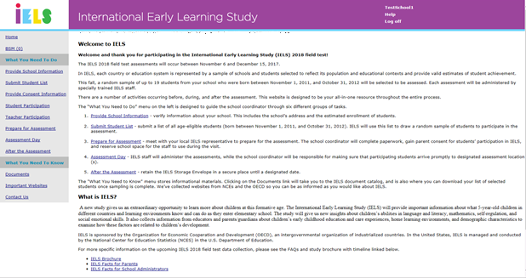

**Provide School Info Screen**

**Provide School Information**

|  |  |
| --- | --- |
| **School Name:** | **IELS School ID:** |
| **State:** | **District:** |
| **Assessment Date:** | **Submitted by:** |

Please review and complete the form below to ensure that IELS has the most up-to-date information about your school. Some fields are filled in already; please edit these if they are incorrect. The school coordinator information section is for the person at your school who is designated to work with IELS.

|  |  |
| --- | --- |
| **School Contact Information** | |
| Current | New |
| **School Name:** |  |
| **School Address 1:** |  |
| **School Address 2:** |  |
| **City:** |  |
| **State:** |  |
| **Zip Code:** |  |
| **School Website:** |  |
| **School Phone Number:** |  |
| **School Opens:** |  |
| **School Closes:** |  |

|  |  |
| --- | --- |
| **Principal Information** | |
| **Principal Prefix:** |  |
| **Principal Firstname:** |  |
| **Principal Lastname:** |  |
| **Principal Suffix:** |  |
| **Telephone Number:** **Ext:** | Ext: |
| **Email:** |  |

|  |  |
| --- | --- |
| **School Coordinator Information** | |
| **School Coordinator Prefix:** |  |
| **School Coordinator Firstname:** |  |
| **School Coordinator Lastname:** |  |
| **School Coordinator Suffix:** |  |
| **School Coordinator's Title:** |  |
| **Telephone:** **Ext:** | Ext: |
| **Fax:** |  |
| **Email:** |  |

|  |  |
| --- | --- |
| **School Characteristics** | |
| **First Day of School:** |  |
| **Year Round School:** |  |
| **Date school leaves for fall break:** |  |
| **Date school returns from fall break:** |  |

**Provide School Info Screen Screenshot:**

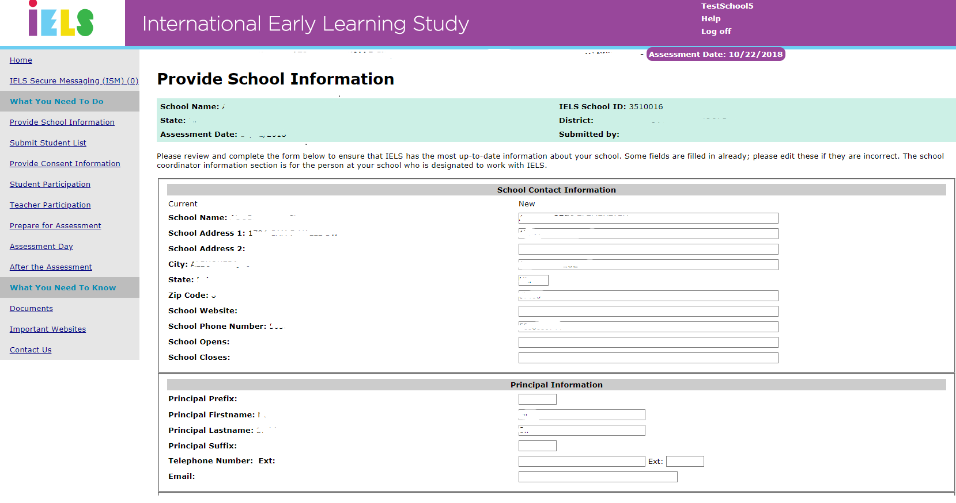

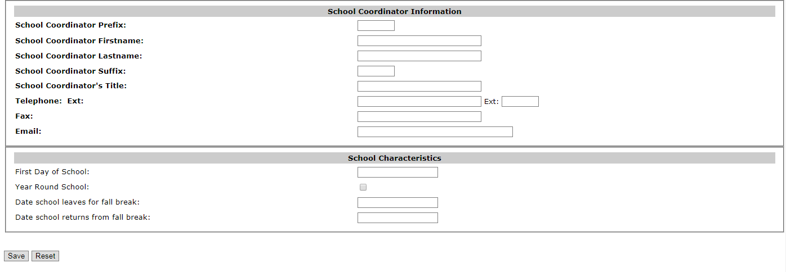

**Submit Student List Screen**

IELS collects a list of all students born between November 1, 2011 and October 31, 2012, along with their primary teacher, from your school in order to draw a random sample of students to participate in the assessment.

How to Submit Your Student List?

Student E-File Submission - Schools are able to submit student lists for sampling electronically through this website. Download the Excel Student E-File Template (below) and import the list of eligible students into the template for submission. The template contains all the necessary fields for sampling.

E-file you School’s Student List

It is preferred that you include column headers as the first row in your E-File (download template below). However, E-Files without column headers will be accepted. If you cannot submit your student data with this information in an Excel file, please call or email the IELS help desk at IELSHelp@westat.com or call 1-855-299-1398.

[IELS student efile template](javascript:__doPostBack('ctl00$MainContent$ucManagedDocumentList1$RepeaterList3$ctl01$LinkButtonViewile',''))

You list has been submitted successfully!

If you would like to modify or otherwise have problems with you list, please contact the IELS help desk at IELSHelp@westat.com or 1-855-299-1398

If you need help accessing this website, please contact the IELS help desk by phone between 8 a.m. and 8 p.m. Eastern Standard Time at 1-855-299-1398 or email [IELSHelp@westat.com](mailto:IELSHelp@westat.com).

**Submit Student List Screenshot:**

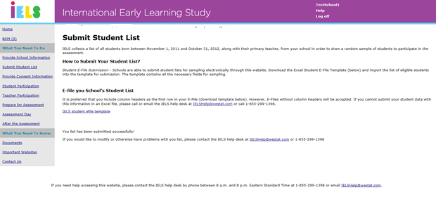

**Provide Consent Info Screen**

This page is designed to assist with the consent process. Use the drop-down boxes and tables below to enter the consent type, consent mode, and track parents responses. IELS has designed an online consent module that can collect parent consent online and the IELS team can perform electronic follow-up and make calls if you provide contact information.

Please select the consent type that is required for your school.

* Notification
* Explicit
* Implicit
* Other

Please indicate below if the district has additional consent requirements or materials, or would prefer to customize the IELS consent materials.

Please select the mode you will use to distribute and collect consent (online or hard-copy) and who you would like to distribute it (school or IELS home office). If you prefer to distribute the materials and choose ‘online’, you will be able to download and email parents the parent consent materials; if you choose ‘hard-copy’, we will mail you parent consent packets to distribute to each student’s parent or guardian after sampling is complete.

The table below is designed to track responses and collect statuses for both online and hard-copy consent. If you are not using the online method, the Consent Login and Consent Online columns will remain blank. Please update consent statuses on a regular basis. For more information please see the IELS School Coordinator Handbook, section ‘XX’

Column headers:

* + - Parent ID
    - Child ID
    - Child Name
    - Registered on MyIELS
    - Consent provided online
    - Consent provided on paper

Parent Contact Information

If you prefer the IELS home office to distribute the parent consent materials, please use the table below to provide contact information for parents. This information will not be used for any other purpose.

Column headers:

* + - Parent ID
    - Child ID
    - Child Name
    - Parent first name
    - Parent last name
    - Email
    - Phone
    - Address1
    - Address 2
    - City
    - State
    - Zip
* Consent information is final.

**Provide Consent Info Screen Screenshot:**

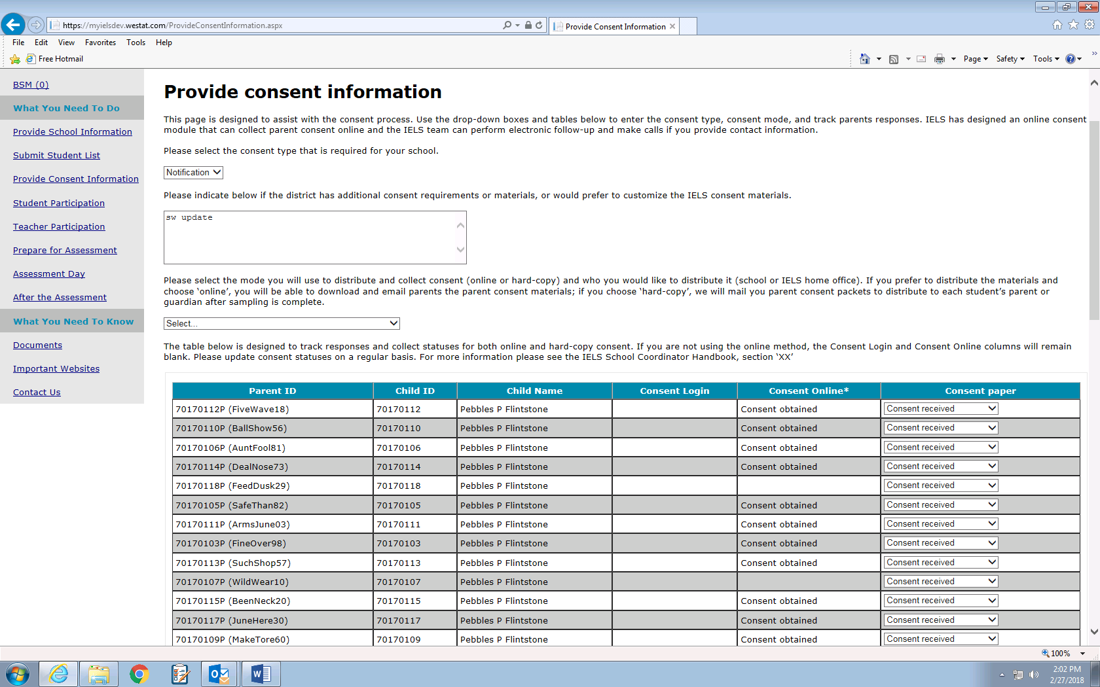

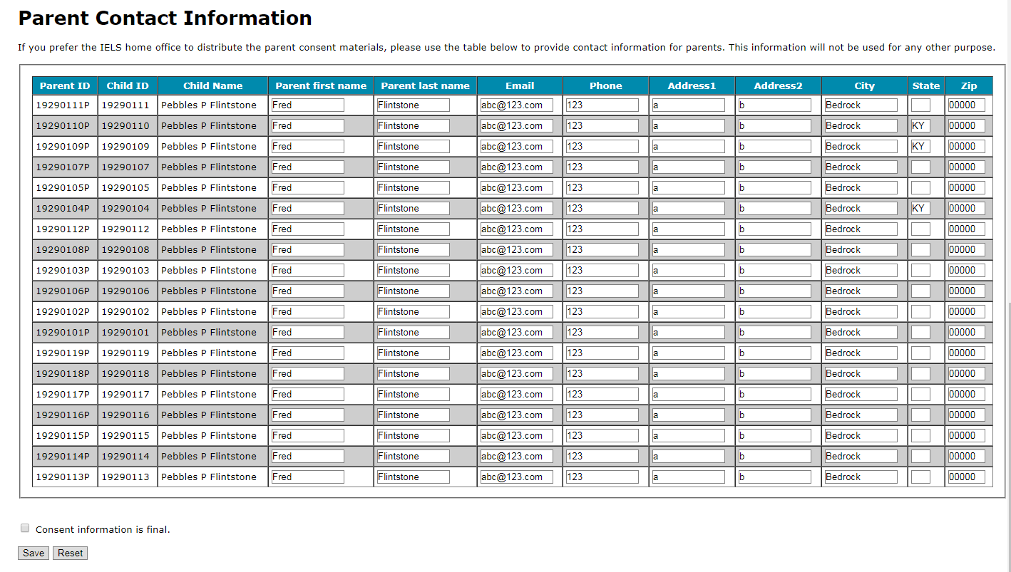

**Student Participation Screen**

Column headers:

* Child Name or Number
* Child ID
* Birthday
  + - MM
    - YYYY
* Gender
* Child Grade
* AM/PM/Both
* Child Primary Teacher
* Classroom
* Child no longer enrolled
* Special Education Needs
* Accommodations needed
* Exclusions
* Comments
* Consent obtained
* Questionnaire Return Status
  + - Section B Questionnaire
    - Parent Questionnaire

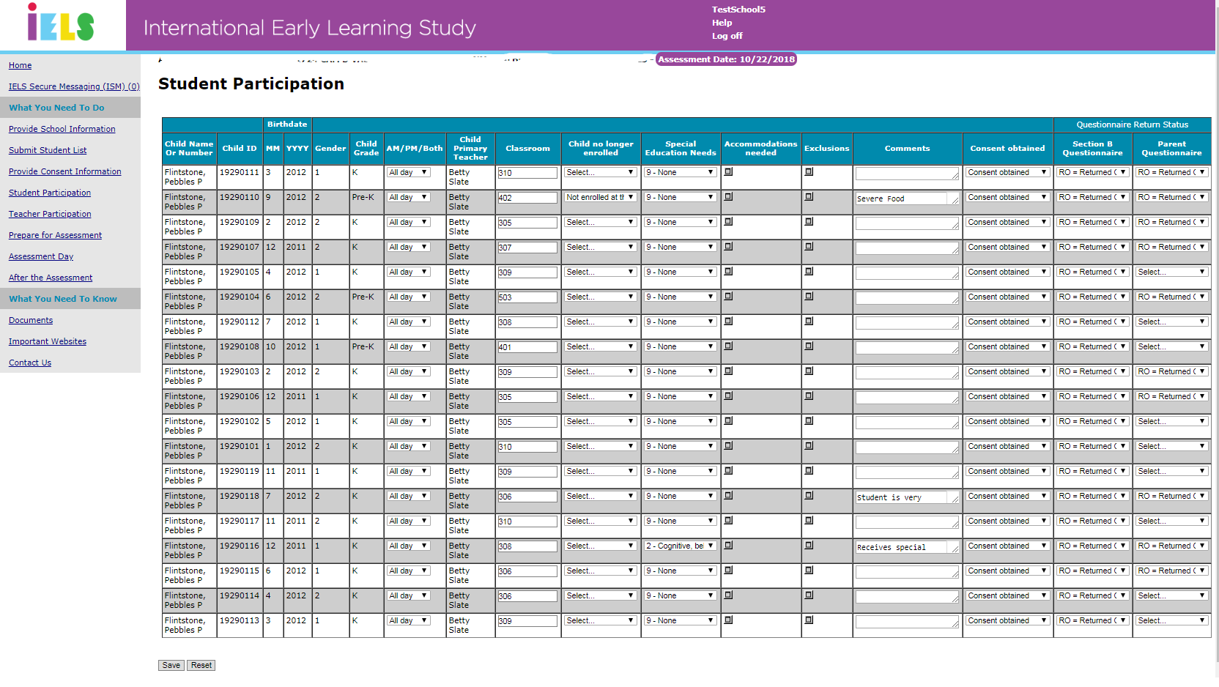**Student Participation Screenshot:**

**Teacher Participation Screen**

Use the table below to monitor and update teacher participation information.

You can print this form if you prefer to record the information on paper. Click on the Documents link on the left of this screen to navigate to a page to print the form. The IELS team is available to assist you with reminding teachers to complete their online questionnaires.

Column headers:

* + - ID
    - Staff Name
    - Part A Status (background questionnaire)
    - Participation code
    - Part B Number expected
    - Part B Number complete
    - Check Request date
    - Check FedEx#

**Teacher Participation Screen Screenshot:**

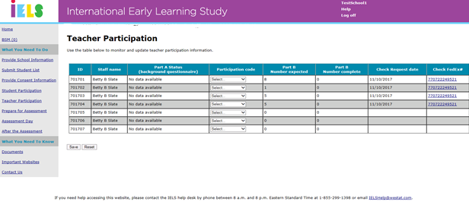

**Prepare for Assessment Day Screen**

To ensure a successful administration of IELS, it is important to make sure everyone involved in the assessment is informed and prepared. The tasks below will help you effectively prepare for IELS.

Informing your school’s administration and staff:

* Include IELS on the school calendar to avoid scheduling conflicts.
* Update the principal and other school staff on the assessment date and any arrangements that need to be made for assessment day.

Enlisting teacher support:

* Share informational materials from IELS at a faculty meeting.
* Place copies of IELS materials in your faculty lounge.
* Remind teachers to complete their online questionnaires.

Motivating parents to participate:

* Reach out to parents who have not provided consent to discuss the importance of the study and of returning the completed consent form prior to assessment day.

The Preassessment Call:

After students have been selected, your local IELS representative will contact you to set up a preassessment call (PAC). This call is aimed at helping prepare for the assessment and ensures everything will go smoothly and efficiently on assessment day.

Prior to the PAC:

* Download the list of selected students, called the Student Tracking Form, from the “Documents” section of this website.
* Review the Student Tracking Form to ensure all student demographic data are correct.
* Identify students who are withdrawn or ineligible.
* Identify students with special education needs (e.g., students with IEP or 504 plans and English language learners).
* Download the Teacher Tracking Form to identify the teachers selected to complete the Teacher Questionnaire.
* Distribute the teacher packs that will be mailed to you to each of the identified teachers and encourage them to complete the online questionnaire.
* Distribute the parent packs that will be mailed to you to the parents of the selected students so that they can provide consent and complete the online questionnaire.
* Identify space for assessment sessions to take place.

During the PAC the IELS representative will:

* Confirm parents/guardians of selected students have been notified.
* Discuss how to best follow-up to obtain missing parent consent.
* Confirm missing or corrected student demographic data.
* Confirm students that have withdrawn or are ineligible.
* Review the status of students identified as having special education needs (SEN), accommodations, and/or exclusions.
* Discuss incentives and distribution.
* Discuss the testing location(s).
* Collect and confirm assessment logistics information.

**Prepare for Assessment Day Screen Screenshot:**

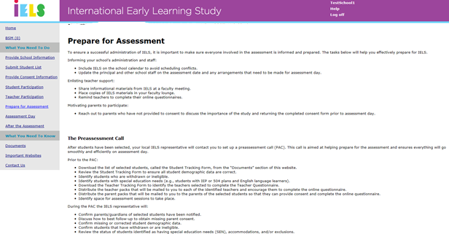

**Assessment Day Screen**

On assessment day, the IELS team will:

* Arrive at the school at least 1 hour before the assessment to set up and prepare.
* Meet with you regarding absent students and any last-minute completed consent forms.
* Confirm completion of Parent and Teacher Questionnaires.
* Administer the assessment.
* Conduct a short postassessment meeting.

As discussed during the preassessment call, you will need to ensure that parents and teachers have been notified of the assessment. Your assistance is also important to ensure that students attend the session(s).

Following the assessment, the IELS representative will meet with the school coordinator for a short meeting. There will also be some paperwork to finalize, which includes preparing copies of important documents to be left at the school.

As part of IELS's pledge of confidentiality, before departing, the IELS team with leave all documents with student names and identifying information at the school in the IELS Storage Envelope.

**Assessment Day Screen Screenshot:**

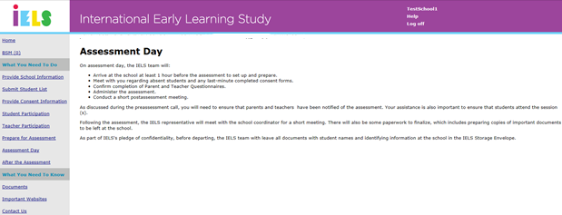

**After the Assessment Screen**

On behalf of IELS, we would like to extend a special thanks to the staff, parents, and students at your school. Your participation and support have made this data collection a success!

Your school should keep the contents of the IELS Storage Envelope until the date specified on the label, at which point they should be destroyed. The best way to destroy any sensitive IELS materials is to shred them.

IELS Scoring and Reporting

IELS scores the assessment data and links them to the background information collected from the staff and parent/guardian questionnaires to provide a more complete picture of early learning.

Exploring Education Policy Issues

NCES grants members of the education research community permission to use international education research data. To explore and analyze NCES international study data, visit the [International Data Explorer](https://myielsdev.westat.com/AftertheAssessment.aspx).

**After the Assessment Screen Screenshot:**

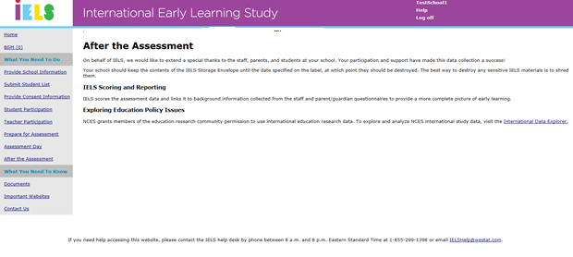

**Documents Screen**

Download your school's Student and Teacher Tracking Forms here: [Download SC1](javascript:__doPostBack('ctl00$MainContent$LinkButtonViewSC1',''))

SC PACK SHIP DATE:

SC PACK FEDEX#:

Important documents and letter templates for IELS 2018 and the IELS program in general can be found in the documents below

|  |  |
| --- | --- |
| File Name | Description |
| IELS Brochure | The IELS brochure provides information about IELS study goals, information for participating schools, and general study background. |
| IELS Facts for Parents | This document provides answers to common questions from parents of selected students such as what can their child expect on study day and what is involved for parents. |
| IELS Facts for School Administrators | IELS related information tailored to school administrators, presented in an FAQ format. |
| IELS student efile template | This excel file contains the column headers required for uploading student lists for sampling. |

**Documents Screen Screenshot:**

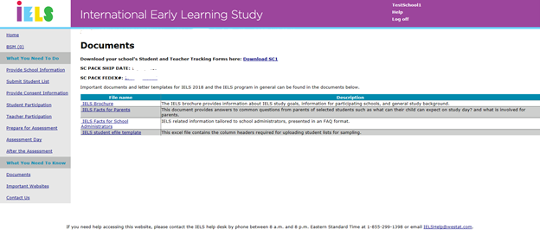

**Important Websites Screen**

More information about IELS can be accessed by clicking on the links below.

OECD IELS website: <http://www.oecd.org/edu/school/international-early-learning-and-child-well-being-study.htm>

NCES IELS website: <https://nces.ed.gov/surveys/iels/>

**Important Websites Screenshot:**

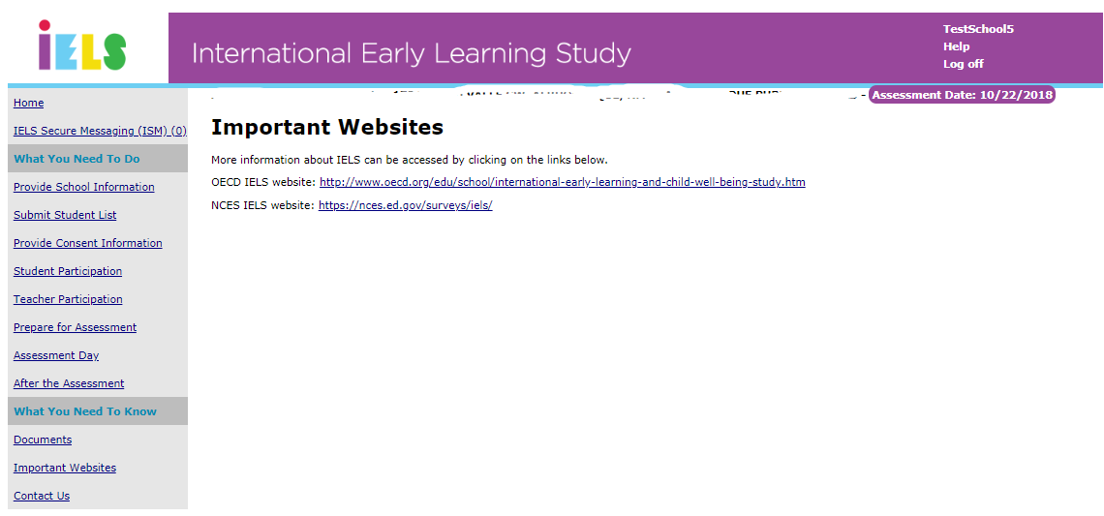

**Contact Us Screen**

Contact by Phone

You can contact Help Desk by phone between 9:00 am and 5:00 pm Eastern Standard Time at 1-855-299-1398 .

Contact by Email

You can contact Help Desk at [IELSHelp@westat.com](mailto:IELSHelp@westat.com).

**Contact Us Screenshot:**

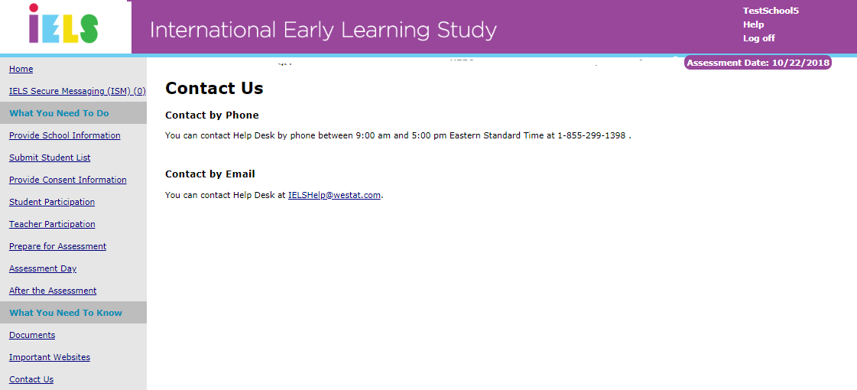

# Instructions for School Coordinators to E-file student lists

1. Prepare Electronic Student File (E-File)

Steps for preparing an Electronic Student File (E-File)

**Step 1: Identify ALL students at your school who meet the eligibility criteria**

Criteria for the IELS student eligibility are:

• Born between **Date and Date**.

NCES needs accurate information about all students at your school who meet the above criteria for IELS student eligibility. Include all students, even those students who typically may be excluded from other testing programs, such as students with IEPs or 504 plans (SD), English language learners (ELL), or students with limited English proficiency (LEP). A small number of these students may be unable to complete the IELS assessment. Do not include on your list students who are known to be withdrawn. All other eligible students **must** be added to your list of students.

**Step 2: List each of the eligible students along with their grade and demographic information (see** **Figure 1 below for an example)**

Using the electronic listing form template provided on the MyIELSUSA.com website (www.MyIELSUSA.com), list students in your school who are eligible for the IELS along with their demographic information.

• Student first name

• Student middle name (not required)

• Student last name

• Month of birth (M or MM; must be submitted in numeric format, not text)

• Year of birth (YYYY: 2012)

• Grade

• Sex (1 = Female; 2 = Male)

• Primary Teacher’s first name

• Primary Teacher’s last name

• Primary Teacher’s email address

**Figure 1**: **Example of Electronic Student File**

|  |  |  |  |  |  |  |  |  |  |
| --- | --- | --- | --- | --- | --- | --- | --- | --- | --- |
| **Student First Name** | **Student Middle Name** | **Student Last Name** | **Month of Birth** | **Year of Birth** | **Grade** | **Sex** | **Primary Teacher First Name** | **Primary Teacher Last Name** | **Primary Teacher Email Address** |
| Ted | Brian | Brooks | 5 | 2012 | K | 2 | Ann | Le | Le@bates.ed.com |
| Jeffrey |  | Jenkins | 3 | 2012 | K | 2 | Ann | Le | Le@bates.ed |
| Rose | Ann | Matthews | 9 | 2012 | K | 1 | Gert | Otter | Otter@bates.ed |
| Jennifer | Lynn | Trader | 4 | 2012 | K | 1 | Ann | Le | Le@bates.ed |
| José |  | Rodriguez | 5 | 2012 | K | 2 | Gert | Otter | Otter@bates |
| Roy | John | Zastrow | 8 | 2012 | K | 2 | Gert | Otter | Otter@bates |
| Sam |  | Walker | 3 | 2012 | K | 2 | Gert | Otter | Otter@bates |
| Julie |  | Walters | 6 | 2012 | K | 1 | Ann | Le | Le@bates.ed |

Submitting Your Electronic Student File

After you have created and saved your E-File, proceed to <https://www.MyIELS.us/>. Once you have logged in, click the “Submit Student List” link on the left side of the page. Then click the START E-FILE button at the bottom of the page.

**IMPORTANT! If at any point you have any difficulties with this process, please do not hesitate to contact the IELS Help Desk for assistance at 1-855-299-1398 or send an email to** [**IELSHelp@westat.com**](mailto:IELSHelp@westat.com)**.**

The National Center for Education Statistics is authorized to conduct this study under the Education Sciences Reform Act of 2002 (ESRA 2002, 20 U.S.C. §9543). All of the information you provide may only be used for statistical purposes and may not be disclosed, or used, in identifiable form for any other purpose except as required by law (20 U.S.C. §9573 and 6 U.S.C. §151). Individuals are never identified in any reports. All reported statistics refer to the U.S. as a whole or to national subgroups.

According to the Paperwork Reduction Act of 1995, no persons are required to respond to a collection of information unless such collection displays a valid OMB control number. The valid OMB control number for this voluntary survey is 1850-0936. The time required to complete this survey is estimated to average 30 minutes per response, including the time to review instructions, search existing data resources, gather the data needed, and complete and review the survey. If you have any comments concerning the accuracy of the time estimate, suggestions for improving this survey, or any comments or concerns regarding the status of your individual submission of this survey, please write to: International Early Learning Study (IELS), National Center for Education Statistics, Potomac Center Plaza, 550 12th Street, SW, Washington, DC 20202.

# FAQ for Teachers

# *Updated Since Previous Submission*

2018 International Early Learning Study

FREQUENTLY ASKED QUESTIONS

*Information for Teachers*

**What is the International Early Learning Study (IELS)?**

IELS is an international study that is conducted in the United States by the National Center for Education Statistics (NCES), part of the U.S. Department of Education. It will provide important information about:

* What 5-year-old children in different countries and learning environments know and can do as they enter elementary school;
* Children’s abilities in language and emergent literacy, mathematics and numeracy, self-regulation, and social emotional skills; and
* How home, childcare, and pre-school experiences are related to children’s skills as they enter school.

**Why is IELS important?**

IELS will allow the U.S. to compare the skills and competencies of our children to their peers in other countries. Results from IELS will provide educators, policymakers, and parents/guardians with valuable information about the experiences that influence children’s early learning and their abilities as they begin school. For example:

* Kindergarten teachers can gain a better understanding of children’s skills and abilities as they enter school, which can help them improve classroom activities.
* Educators and policymakers can use the results to make informed decisions about children’s early education.
* Parents/guardians can learn about activities they can do at home that may increase children’s knowledge and development.

**What is involved for students?**

IELS is a play-based study conducted with tablets. Children are asked to point to pictures, listen to stories, and complete game-like tasks. They do not need to prepare in advance, and they do not need to know how to read. In our experience, children enjoy participating in the study.

* The study will take place during school hours and in a room designated by the IELS School Coordinator, such as the library. It is untimed and will be split across two days. Children generally take about 30 minutes each day to complete the activities and can take breaks as necessary.
* Children will complete the study activities with an IELS team member who has experience working with children. School staff or teachers are welcome to observe.
* All participation is voluntary. Children can skip any question they do not want to answer. Any child who does not wish to work with IELS staff will not have to.

**What role do teachers have in IELS?**

Teachers of students selected for the study are asked to complete a questionnaire, which includes questions about their professional background (about three minutes to complete) and the skills and abilities of the students selected for the study (about five minutes per child, with an average of four students per teacher).

* The questionnaire is available online. You may also request a paper version, if you prefer.
* You can decide when and where to complete the questionnaire, within the timeframe of the study. You may exit the questionnaire at any point and return to it later.

Teacher participation ensures that IELS will be able to provide a more accurate picture of what our nation’s 5-year-olds know and can do. If allowed by school policy, teachers will be offered $20 for completing part A of the questionnaire, plus an additional $7 per student questionnaire. Schools will receive $200 for participation.

**Do teachers need to help administer the assessments?**

No. Trained IELS staff from Westat will administer the study on behalf of NCES. Exceptions will be made for students with IEP accommodations that may require the assistance of school personnel (e.g., if a student works one-on-one with an aide).

**What is involved for parents?**

One parent or guardian of each student who participates in the study is asked to complete a 30-minute questionnaire. The questionnaire asks about the child’s early childhood education and care experiences, home learning environments, and demographic characteristics.

**Why should students, teachers, and parents participate in the study?**

Participants help IELS provide an accurate picture of what 5-year-olds in the U.S. know and can do. It is important that every selected school and student participate in the study because they represent many other schools and children like them across the country. Teachers and parents/guardians contribute vital information about participating children’s skills and education experiences to provide insights on the relationship between children’s early learning experiences and their skills as they enter school.

**What will happen with the collected data?**

IELS is not designed to produce results for individual children. Results will be combined to describe the nation’s 5-year-olds and will not identify participating districts, schools, students, teachers, or parents/guardians. Individual responses will be combined with those from other participants to produce summary statistics and reports.

**How are schools and students selected for participation?**

The U.S. Department of Education identified a sample of about 200 public and private schools to represent the nation. Within each school, up to 19 children were randomly chosen to participate. Approximately 3,000 5-year-olds will take part in the study across the U.S.

**Will the names of participants and their responses be kept confidential?**

All of the information provided by teachers, students, and parents may be used only for statistical purposes and may not be disclosed, or used, in identifiable form for any other purpose except as required by law (20 U.S.C. §9573 and 6 U.S.C. §151). All field staff and other staff working on the study have signed an affidavit of non-disclosure where they swear to abide by this law. By law, every NCES employee as well as every NCES agent, such as contractors, has taken an oath and is subject to a jail term of up to 5 years, a fine of $250,000, or both if he or she willfully discloses ANY identifiable information about any study participant.

**Where can I find more information?**

For additional information, call the IELS information number, 1-855-299-1398, or send an email to IELSHelp@westat.com. You may also learn more about the study by visiting the IELS website at <http://nces.ed.gov/surveys/IELS>.

# Summer Email for School Coordinators

# *Previously Approved*

Subject line: Upcoming IELS Study in Your School

Dear {name}:

Thank you again for agreeing to take part in the important new study, the International Early Learning Study (IELS). This study of 5-year-olds will allow the U.S. to compare the skills and competencies of our children to their peers in other countries.

We enjoyed speaking with you this past winter and are looking forward to visiting your school on {assessment date} to complete the planned assessments. If for any reason that date no longer works for your school, please contact us at 1-855-299-1398 or IELSHelp@westat.com.

This fall, a Westat representative will call you to discuss sampling all of the 5-year-olds and their teachers in your school so that we can randomly select the 19 children we will ask to participate. We will also discuss the most efficient method of contacting parents and gaining consent for their child’s participation, working with teachers who were identified during sampling to invite them to the study and to complete their online surveys, and assessment logistics. To thank you for your help, you will receive $100 after sampling is complete and an additional $100 at the end of the study.

In the meantime, if you would like to learn more about the study, please visit [https://www.MyIELS.us/](https://www.myiels.us/). If you have forgotten your username and/or password, information is on the site to have them resent to you. You can also call the IELS support line for this information.

Thank you and have a wonderful rest of your summer,

The IELS Project Staff

*The National Center for Education Statistics is authorized to conduct this study under the Education Sciences Reform Act of 2002 (ESRA 2002, 20 U.S.C. §9543). All of the information provided by school staff, students, and parents may be used only for statistical purposes and may not be disclosed, or used, in identifiable form for any other purpose except as required by law (20 U.S.C. §9573 and 6 U.S.C. §151). Individuals are never identified in any reports. All reported statistics refer to the U.S. as a whole or to national subgroups.*

# 

Appendix B

All materials in this appendix will be used for both public and private schools.

# School Coordinator Email Announcing E-Filing

# *Updated Since Previous Submission*

Subject: Time to Submit IELS Student Lists

Dear <School Coordinator name>:

Thank you for your support for the International Early Learning Study (IELS) at your school!

In order to randomly select students for IELS, we need a list of all eligible students at your school. Detailed instructions about how to submit your lists are included in the attached document, “IELS E-Filing Instructions.” Be sure to include all students who meet the birth-date criteria regardless of any special needs or language spoken; the sample of up to 19 students will be taken from the full list.

The deadline for student list submission is **[Month] [Day], 2018**. Please upload your school’s lists as soon as possible so that sampled students, their teachers, and their parents/guardians can be notified about the study well in advance.

Please also begin to determine the consent requirements for your school. There are three basic types of consent used for IELS: notification, implicit consent, and explicit consent. More information about the consent options can be found in the School Coordinator Handbook, which is also available on the MyIELS website.

If you have any questions about the instructions, please contact the IELS help desk at IELSHelp@westat.com or by calling 1-855-299-1398. The e-filing instructions are also posted on the [IELS website](https://www.MyIELS.us/).

Sincerely,

# The U.S. IELS Team

*Attachments*

IELS E-Filing Instructions

School Coordinator Handbook

# School Coordinator Mailing

# *Updated Since Previous Submission*

Subject: IELS—Parent/Teacher Notification

Dear <School Coordinator name>:

Thank you again for agreeing to serve as the school coordinator for the International Early Learning Study (IELS).

By now you should have received your school coordinator package via FedEx containing parent and teacher materials for distribution. If you have not received your package, please let us know as soon as possible by contacting the IELS help desk at IELSHelp@westat.com or by calling 1-855-299-1398.

The package includes participation envelopes for parents and teachers, Halloween-themed questionnaire reminder cards, along with a cover letter for you with a list of the included materials. The parent and teacher envelopes include information about participation and providing consent; instructions for completing questionnaires; and the monetary incentives for parents and teachers.

After you ensure that there are parent and teacher envelopes for each selected student and that the materials in the parent and teacher envelopes are complete, please:

* Notify parents and teachers that they will be receiving them (draft emails are attached for you to use),
* Distribute the envelopes to the selected parents and teachers, and
* Encourage them to participate by using the strategies outlined in the attached tip sheet.

**The success of the study relies on the participation of students, parents, and teachers.** Please notify your IELS Team Leader as soon as possible about any problems affecting participation in your school. The Team Leaders will be happy to assist you in following-up with parents and teachers about the completion of the questionnaires.

If you have any questions about the instructions, please contact the IELS help desk at IELSHelp@westat.com or by calling 1-855-299-1398. The e-filing instructions are also posted on the [MyIELS site](https://www.MyIELS.us/).

Sincerely,

# Karen Tourangeau

# IELS Project Director

*Attachments*

Notification Email for Parents

Study Introduction Email for Teachers

Tips for Encouraging Participation

# Pre-Assessment Call and Space Reminder Email for School Coordinators

# *New*

Subject: IELS Reminder: Reserve space and talk with your Team Leader

Dear <School Coordinator name>:

The IELS assessment days will be here before we know it! If you haven’t done so already, please reserve space for the IELS Team Leader and three IELS assessors to conduct the study with participating students.

When arranging for a space for the study, remember that the ideal location for the assessments is one large room like the gymnasium, the music room during off-hours, the library or media center, or any other similar space where several assessments could be conducted simultaneously. The space should be well-lit, quiet, free of distractions, and have two chairs and a table for each member of the assessment team. The goal is to arrange a space that is comfortable and safe for participating children.

A sample setup of an assessment room is attached for your reference.

Your IELS Team Leader will soon be reaching out to you to arrange assessment day logistics. He/she will be able to answer any questions you have about the assessment space, encouraging participation from parents and students, or using [MyIELS](https://www.MyIELS.us/).

As always, if you have any questions in the meantime, please contact the IELS help desk at IELSHelp@westat.com or by calling 1-855-299-1398.

Sincerely,

# The U.S. IELS Team

*Attachments*

Sample setup of assessment room

### Sample Setup of Assessment Room

Tablet

Child

Assessor

Observer

Door

Child

Tablet

Assessor

### School Coordinator Tracking Form Availability

### *New*

Subject: IELS—Child and Teacher Tracking Forms Now Available

Dear <School Coordinator name>:

Thank you very much for submitting your student lists for IELS. Your school’s sample of students has been selected, and the Child and Teacher Tracking Forms are now available for you to download at [MyIELS.us](https://www.MyIELS.us/).

The Child Tracking Form allows you to note the completion of consent forms, parent questionnaires, and teacher questionnaires for each selected student, as well as any possible needs for student accommodations. The Teacher Tracking Form allows you to monitor the completion of teacher questionnaires. The deadline for questionnaire completion is **November 30, 2018.**

We will soon be sending you a package via FedEx that includes materials for you to notify parents and teachers about their students’ participation.

**If you have not yet entered information into** [**MyIELS**](https://www.MyIELS.us/) **about consent requirements for your school, please do so as soon as possible.**

If you have any questions about the instructions, please contact the IELS help desk at IELSHelp@westat.com or by calling 1-855-299-1398.

Sincerely,

# The U.S. IELS Team

# First Consent and Participation Reminder Email for School Coordinators

# *New*

Subject: IELS—Consent and Participation Reminder

Dear <School Coordinator name>:

Thank you for all you are doing to make IELS a success! We truly appreciate your support.

We wanted to send a friendly reminder to check on the status of consent forms and questionnaire completion by parents and teachers, and to update [MyIELS](https://www.MyIELS.us/) as appropriate. Teachers and parents contribute critical information for IELS to be able to report on children’s skills and education experiences as they enter school.

If parents and teachers still need to complete their questionnaires, please send them a reminder email. We have attached drafts for you to customize as needed. Text message drafts are also available for parents.

The deadline for completing the questionnaires is **Friday, November 30, 2018.**

You can also consider hosting information sessions for parents and teachers to review the study details and answer their questions. [MyIELS](https://www.MyIELS.us/) has PowerPoint presentations for both groups that can be used for this purpose.

Please notify your Team Leader as soon as possible about any problems affecting participation in your school.

If you have any questions, please contact the IELS help desk at IELSHelp@westat.com or by calling 1-855-299-1398.

Sincerely,

# The U.S. IELS Team

*Attachments*

Parent Consent Reminder Emails and Text Messages for Parents

Questionnaire Reminder Emails and Text Messages for Parents

Questionnaire Reminder Emails for Teachers

Tips for Encouraging Participation

# Second Consent and Participation Reminder Email for School Coordinators

# *New*

Subject: IELS—Consent and Participation Reminder

Dear <School Coordinator name>:

As the IELS student assessment days draw closer, we wanted to remind you to check on the status of consent forms and questionnaire completion by parents and teachers, and to update [MyIELS](https://www.MyIELS.us/) as appropriate. The success of the study relies on you, students, parents, and teachers! Thank you for all you are doing to support the program.

The deadline for completing the questionnaires is **Friday, November 30, 2018.**

If parents and teachers still need to complete their questionnaires, please send them a reminder email. We have attached drafts for you to customize as needed. Text message drafts are also available for parents.

You can also share the IELS Halloween card with parents and teachers as an extra reminder to log on to the portal and complete the questionnaire. The Halloween cards were sent in the School Coordinator package by FedEx.

Please notify your IELS Team Leader as soon as possible about any problems affecting participation in your school.

If you have any questions, please contact the IELS help desk at IELSHelp@westat.com or by calling 1-855-299-1398.

Thank you again for all your hard work!

Sincerely,

# The U.S. IELS Team

*Attachments*

Questionnaire Reminder Emails and Text Messages for Parents

Questionnaire Reminder Emails for Teachers

Tips for Encouraging Participation

# Final Participation Reminder Email for School Coordinators

# *New*

Subject: IELS—One Last Questionnaire Reminder

Dear <School Coordinator name>:

Thank you for all you did to make the IELS student assessment days possible!

This is the final reminder to check on the completion of the parent and teacher questionnaires. If parents and teachers still need to complete their questionnaires, please remind them that the deadline is **Friday, November 30, 2018.** Draft emails and text messages are attached for you to use and customize as appropriate.

If you have any questions, please contact the IELS help desk at IELSHelp@westat.com or by calling 1-855-299-1398.

Thank you!

Sincerely,

# The U.S. IELS Team

*Attachments*

Questionnaire Reminder Emails and Text Messages for Parents

Questionnaire Reminder Emails for Teachers

Tips for Encouraging Participation

# 

# Questionnaire Deadline Extension Email for School Coordinators

# *New*

Subject: IELS questionnaire deadline extended until <insert date>!

Dear <School Coordinator name>:

To ensure we can collect all the key information for the International Early Learning Study (IELS), the questionnaire deadline for parents and teachers is being extended until **December 7, 2018.**

Please send any parents or teachers who have not completed their questionnaires an email or text message to let them know about the extension and the importance of participation.Draft emails and text messages are attached for you to use and customize as appropriate. As you know, their input is critical for ensuring we can provide valuable results!

If you have any questions, please contact the IELS help desk at IELSHelp@westat.com or by calling 1-855-299-1398.

Thank you!

Sincerely,

# The U.S. IELS Team

*Attachments*

Deadline Extension Email and Text Message for Parents

Deadline Extension Email for Teachers

# Teacher Questionnaire Invitation Email

# *Updated Since Previous Submission*

Dear «Name»:

Your school is one of about 200 schools across the United States that has accepted an invitation from NCES to participate in the IELS 2018 main study. You’ve been sampled to participate by completing an online teacher questionnaire about your teacher training and education, your views on teaching, and information about some of the students you teach. If you have any questions about how you were selected for this survey, please contact your IELS school coordinator, «SC_FNAME» «SC_LNAME».

The questionnaire takes on average 3 minutes per teacher background questionnaire plus 5 minutes per student for student information questionnaire to complete, with an average of 4 students per teacher. This information, combined with data from students, and their parents/legal guardians helps to provide a more complete understanding of early childhood education and contexts for learning.

Your school coordinator should have given you informational materials about the study, along with a check for $20 for completing part A of the questionnaire, plus an additional $7 per student questionnaire you are asked to complete, if allowed by your school’s policy. Use the provided link and unique account information below to complete your questionnaire.

Link: [<URL](https://portal.mypisa.us/TeacherQuestionnaire) TBD>   
Username**: «TeachID»**  
Password: **«TEACHPWD»**

IELS is conducted in the United States by the National Center for Education Statistics (NCES) in the U.S. Department of Education and is administered by Westat, headquartered in Rockville, Maryland, on behalf of NCES. The U.S. Office of Management and Budget (OMB) has approved the data collection under OMB #1850-0936.

If you have any questions, please do not hesitate to call 1-855-299-1398 or send an email to IELSHelp@westat.com.

Thank you for your time and for supporting this important international study.

Sincerely,

The U.S. IELS Team

*The National Center for Education Statistics is authorized to conduct this study under the Education Sciences Reform Act of 2002 (ESRA 2002, 20 U.S.C. §9543). All of the information you provide may be used only for statistical purposes and may not be disclosed, or used, in identifiable form for any other purpose except as required by law (20 U.S.C. §9573 and 6 U.S.C. §151). Individuals are never identified in any reports. All reported statistics refer to the U.S. as a whole or to national subgroups.*

# MyIELS.us Teacher View

***New***

**Login Screen**

Welcome to the IELS online teacher portal!

This is a restricted-use website that contains information on the Program for International Early Learning Study (IELS). This website provides teachers of IELS students access to an online module and the teacher survey.

The National Center for Education Statistics is authorized to conduct this study under the Education Sciences Reform Act of 2002 (ESRA 2002, 20 U.S.C. §9543). All of the information you provide may only be used for statistical purposes and may not be disclosed, or used, in identifiable form for any other purpose except as required by law (20 U.S.C. §9573 and 6 U.S.C. §151). Individuals are never identified in any reports. All reported statistics refer to the U.S. as a whole or to national subgroups.

According to the Paperwork Reduction Act of 1995, no persons are required to respond to a collection of information unless such collection displays a valid OMB control number. The valid OMB control number for this voluntary survey is 1850-0936. The time required to complete this survey is estimated to average 30 minutes per response, including the time to review instructions, search existing data resources, gather the data needed, and complete and review the survey. If you have any comments concerning the accuracy of the time estimate, suggestions for improving this survey, or any comments or concerns regarding the status of your individual submission of this survey, please write to: International Early Learning Study (IELS), National Center for Education Statistics, Potomac Center Plaza, 550 12th Street, SW, Washington, DC 20202

OMB No. 1850-0936, Approval Expires 04/30/2020

**

**Notice: You are accessing a U.S. Government information system.**

This warning banner provides privacy and security notices consistent with applicable federal laws, directives, and other federal guidance for accessing this Government system, which includes all devices/storage media attached to this system. This system is provided for Government-authorized use only. Unauthorized or improper use of this system is prohibited and may result in disciplinary action and/or civil and criminal penalties.

**Login Screen Screenshot:**

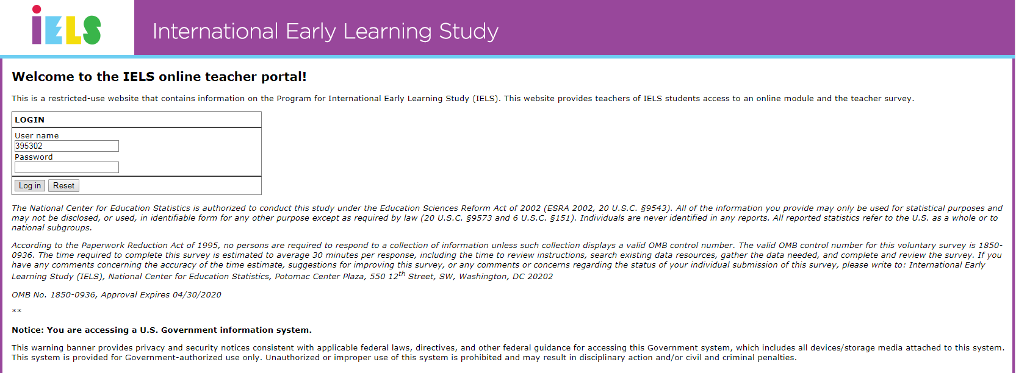

**Teacher portal**

Betty B Slate, welcome to the IELS online teacher portal!

Teacher questionnaire:

The teacher questionnaire is an essential part of IELS. Your input provides context and valuable data for understanding the landscape of early childhood education. Click the link and use the login and password below to access the parent questionnaire for your child.

Status: Started

First Accessed: 5/7/2018 3:01:02 PM

Last Accessed: 6/26/2018 8:23:26 AM

Completed: 100%

Column headers:

* + - Child ID
    - Child Name
    - Student Qx Status
    - % Complete
    - First Accessed
    - Last Accessed
    - Total Logins
    - Survey

**Teacher Portal Screenshot:**

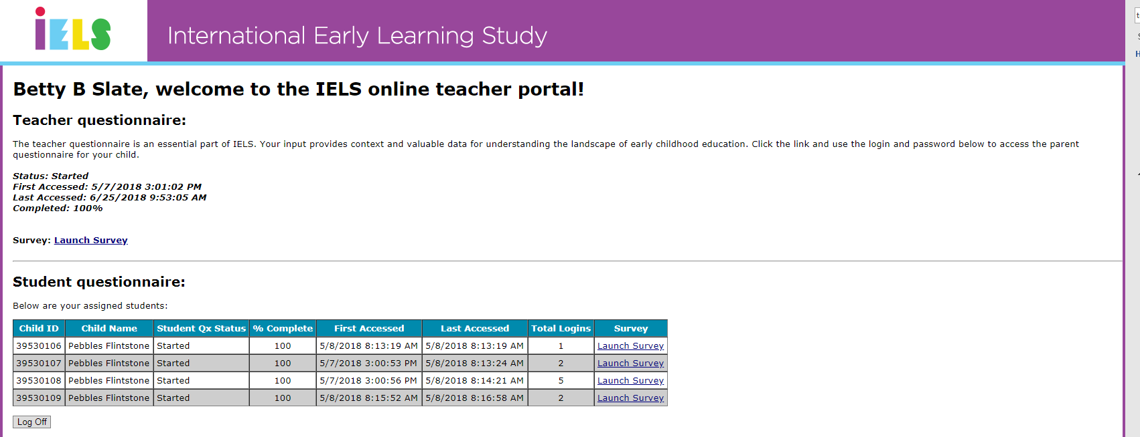

# Notification Email for Parents

# *New*

Subject: Important materials being sent home with your child

Dear <parent/guardian name>:

Our school has been selected to participate in the U.S. Department of Education’s International Early Learning Study (IELS). Results from the study will provide parents/guardians, teachers, and policymakers with valuable information that can be used to improve children’s education and experiences in the first five years of life

A small group of our kindergartners, including your child, have been randomly chosen to participate in the study. Parents are also asked to complete a 30-minute questionnaire to provide a more complete picture of their child’s learning and development.

I will be sending an IELS information packet home with your child this week. Please watch for it. You can also learn more about the study here: <http://nces.ed.gov/surveys/IELS>.

The study is voluntary, but I encourage you to participate. Our school receives $200 for participating and a $20 cash card is included in the information packet to thank you for your time and effort. It will be activated when you complete the parent questionnaire.

Please let me know if you have any questions.

Sincerely,

<School Coordinator name>

# Study Introduction Letter for Teachers

# *New*

# *Spanish version forthcoming.*

SCHOOL LETTERHEAD

Dear <Teacher name>:

Our school is one of about 200 schools across the United States that has been selected to participate in the 2018 International Early Learning Study, or IELS. Results from IELS will provide valuable information about what our country’s 5-year-old children know and can do as they enter elementary school. It will also allow the U.S. to compare the skills and abilities of our children to their peers in other countries.

IELS is conducted by the U.S. Department of Education’s National Center for Education Statistics (NCES). The study will take place during the week of <insert date>.

* Some of your students have been selected to participate in IELS as part of the random sample of 5-year-olds across the nation. The study will be split across two days and children take about 30 minutes each day to complete the activities.
* As the teacher of participating students, you are asked to complete brief questionnaires about their skills and abilities as well as provide information about your teacher training and education. A check is included to thank you for completing the questionnaires for your selected students.
* Parents are also asked to complete a questionnaire for each participating student. Together, these questionnaires provide important contextual data on children’s early learning environments.
* Our school will receive $200 for participating in the study!

I encourage you to support this effort. IELS is voluntary, but participation is critically important for the study to be successful. Please see the enclosed FAQ for more information.

Please use the link below to complete your questionnaires by **November 30, 2018.**

Website: <http://MyIELS.us>

* To complete the questionnaire about your teacher training and education (Part A), please use the unique account information below.
  + Username:<TeacherID>
  + Password: <Password>
* To complete the questionnaire for each of your selected students (Part B), please use the unique account information I have included with the roster of your selected students.
  + **You have <insert number of Part B not-started>/<Insert total number of assigned Part B> Part B questionnaires to complete.**

NCES is working with Westat, a research organization, to conduct the study. If you have any questions, please do not hesitate to call 1-855-299-1398 or send an email to IELSHelp@westat.com. You may also learn more about the study by visiting the IELS website at <http://nces.ed.gov/surveys/IELS>.

Thank you for your time and for supporting this important education study.

Sincerely,

<School Coordinator name>

Enclosures:

Frequently Asked Questions for Teachers

Roster of Selected Students

Incentive Check

*The National Center for Education Statistics is authorized to conduct this study under the Education Sciences Reform Act of 2002 (ESRA 2002, 20 U.S.C. §9543). All of the information you provide may be used only for statistical purposes and may not be disclosed, or used, in identifiable form for any other purpose except as required by law (20 U.S.C. §9573 and 6 U.S.C. §151). Individuals are never identified in any reports. All reported statistics refer to the U.S. as a whole or to national subgroups.*

# Study Introduction Email for Teachers

# *New*

Subject: Participation requested! Hard copy materials forthcoming.

Dear <teacher name>:

Our school is one of about 200 schools across the United States that has been selected to participate in the 2018 International Early Learning Study, or IELS. Results from IELS will provide valuable information about what our country’s 5-year-old children know and can do as they enter elementary school. It will also allow the U.S. to compare the skills and abilities of our children to their peers in other countries.

IELS is conducted by the U.S. Department of Education’s National Center for Education Statistics (NCES). The study will take place during the week of <insert date>.

Below are the key things you need to know about the study. I will also provide you with an information packet soon.

* Some of your students have been selected to participate in IELS as part of the random sample of 5-year-olds across the nation. The study will be split across two days and children take about 30 minutes each day to complete the activities.
* As the teacher of participating students, you are asked to complete brief questionnaires about their skills and abilities as well as provide information about your teacher training and education. **You will receive a check to thank you for completing your questionnaires.**
* Parents are also asked to complete a questionnaire for each participating student. Together, these questionnaires provide important contextual data on children’s early learning environments.
* Our school will receive $200 for participating in the study!

I encourage you to support this effort. IELS is voluntary, but participation is critically important for the study to be successful. Please see the attached FAQ for more information.

Please use the link below to complete your questionnaires by **November 30, 2018.**

Website: <http://MyIELS.us>

* To complete the questionnaire about your teacher training and education (Part A), please use the unique account information below.
  + Username**:** <TeacherID>
  + Password: <Password>
* To complete the questionnaire for each of your selected students (Part B), please use the unique account information I have attached with the roster of your selected students.
  + **You have <insert number of Part B not-started>/<Insert total number of assigned Part B> Part B questionnaires to complete.**

NCES is working with Westat, a research organization, to conduct the study. If you have any questions, please do not hesitate to call 1-855-299-1398 or send an email to IELSHelp@westat.com. You may also learn more about the study by visiting the IELS website at <http://nces.ed.gov/surveys/IELS>.

Thank you for your time and for supporting this important education study.

Sincerely,

<School coordinator name>

*The National Center for Education Statistics is authorized to conduct this study under the Education Sciences Reform Act of 2002 (ESRA 2002, 20 U.S.C. §9543). All of the information you provide may be used only for statistical purposes and may not be disclosed, or used, in identifiable form for any other purpose except as required by law (20 U.S.C. §9573 and 6 U.S.C. §151). Individuals are never identified in any reports. All reported statistics refer to the U.S. as a whole or to national subgroups.*

# Study Introduction Letter for Parents

# *Updated Since Previous Submission*

# *Spanish version forthcoming.*

SCHOOL LETTERHEAD

Dear <parent/guardian name>:

Our school has been selected to participate in the 2018 International Early Learning Study, or IELS. Results from IELS will provide valuable information that can be used to improve children’s education and experiences in the first five years of life. It will also allow the U.S. to compare the skills and abilities of our children to their peers in other countries.

IELS is being conducted by the U.S. Department of Education’s National Center for Education Statistics (NCES). The study will take place during the week of <insert date>.

* Your child has been selected to participate in IELS as part of the random sample of 5-year-olds across the nation. The study will be split across two days and children take about 30 minutes each day to complete the activities.
* As a parent or guardian of a participating student, you are asked to complete a 30-minute questionnaire. A $20 cash card is included in this mailing to thank you for your time. It will be activated when you complete the questionnaire.
* Teachers are asked to complete a 5-minute questionnaire for each participating student.
* Our school will receive $200 for participating in the study!

I encourage you to support this effort. IELS is voluntary, but participation is critically important for the study to be successful. Please see the enclosed FAQ for more information.

If you agree to your child’s participation, please also complete the parent questionnaire by November 30, 2018. Use the link and login information below to provide consent and access and complete the questionnaire:

* Website: <http://MyIELS.us>
* Username: <ParentID>
* Initial password: <Password>

You may also go directly to the parent questionnaire here: <Link to be provided>

NCES is working with Westat, a research organization, to conduct the study. If you have any questions, please do not hesitate to call 1-855-299-1398 or send an email to [IELSHelp@westat.com](mailto:IELSHelp@westat.com). You may also learn more about the study by visiting the IELS website at <http://nces.ed.gov/surveys/IELS>.

Thank you for taking the time to consider your child’s participation in this important study.

Sincerely,

<School Coordinator name>

Enclosures:

Consent Form

Frequently Asked Questions for Parents and Guardians

$20 Cash Card

*The National Center for Education Statistics is authorized to conduct this study under the Education Sciences Reform Act of 2002 (ESRA 2002, 20 U.S.C. §9543). All of the information you provide may be used only for statistical purposes and may not be disclosed, or used, in identifiable form for any other purpose except as required by law (20 U.S.C. §9573 and 6 U.S.C. §151). Individuals are never identified in any reports. All reported statistics refer to the U.S. as a whole or to national subgroups.*

**FAQ for Parents**

***Updated Since Previous*** *Submission*

# *Spanish version forthcoming.*

2018 International Early Learning Study

FREQUENTLY ASKED QUESTIONS

*Information for Parents and Guardians*

**What is the International Early Learning Study (IELS)?**

IELS is an international study that is conducted in the United States by the National Center for Education Statistics (NCES), part of the U.S. Department of Education. It will provide important information about:

* What our country’s 5-year-old children know and can do as they enter elementary school;
* How home and pre-school experiences are related to children’s skills as they enter school; and
* How U.S. students and their experiences compare to their peers in other countries.

**Why is IELS important?**

Results from IELS will provide valuable information that can be used to improve children’s education and experiences in the first five years of life. These early years can set the stage for future success in and outside of school. For example:

* Parents/guardians can learn about activities they can do at home that may increase children’s knowledge and development.
* Kindergarten teachers can gain a better understanding of children’s skills and abilities as they enter school, which can help them improve classroom activities.
* Educators and policymakers can use the results to make informed decisions about children’s early education.

**What is involved for students?**

IELS is a play-based study conducted with tablets. Children are asked to point to pictures, listen to stories, and complete game-like tasks. They do not need to prepare in advance, and they do not need to know how to read. In our experience, children enjoy participating in the study.

* The study will take place during school hours and in a room designated by the IELS School Coordinator, such as the library. It is untimed and will be split across two days. Children generally take about 30 minutes each day to complete the activities and can take breaks as necessary.
* Children will complete the study activities with an IELS team member who has experience working with children. School staff or teachers are welcome to observe.

**What is involved for parents?**

One parent or guardian of each student who participates in the study is asked to complete a 30-minute questionnaire. Parent participation in IELS is critically important for the study to be able to report on the relationship between children’s early learning experiences and their skills as they enter school.

* The questionnaire asks for demographic information and about the child’s early childhood education experiences. It also asks questions about the child’s social skills and participation in child care.
* The questionnaire is available online. You may request a paper version, if you prefer. Spanish versions of the questionnaire are also available.
* You can decide when and where to complete the questionnaire, within the timeframe of the study. You may exit the questionnaire at any point and return to it later.
* You may skip questions you do not want to answer.

Parent participation ensures that IELS will be able to provide valuable, actionable results. You will receive $20 to thank you for your time and effort.

**BACK PAGE**

**Why should my child and I participate in the study?**

It is important that every selected child participates in IELS because they represent many other children like them across the country. Parents contribute vital information about children’s early educational experiences to provide a more complete picture of their learning and development. The child’s teacher will also complete a short questionnaire to provide a full picture of a child’s skills and experiences.

Schools that participate in IELS will be offered $200 and parents/guardians who complete the questionnaire will receive $20.

**What results will be reported?**

IELS results will include information about:

* 5-year-olds’ abilities in language and literacy, mathematics, self-regulation, and social emotional skills; and
* The relationship between these skills and children’s early learning experiences.

IELS is not designed to produce results for individual children. Results will be combined to describe the nation’s 5-year-olds.

The information provided by individual children and parents or guardians will not be shared with teachers, schools, or the district. Individuals and schools will not be identified in any reported data.

**How did my child and their school get selected for IELS?**

The U.S. Department of Education identified a sample of about 200 public and private schools to represent the nation in the study. Schools were chosen at random to ensure racial/ethnic and socioeconomic diversity, as well as representation from schools in rural, suburban, and urban areas.

Within each school, up to 19 students were randomly chosen to participate. Approximately 3,000 5-year-olds will participate in IELS across the country.

**What happens if my child refuses to participate?**

All participation is voluntary. Children can skip any question they do not want to answer. Any child who does not wish to work with IELS staff will not have to. Children can take breaks whenever they would like during the assessment.

**My child has a disability. Can he/she still participate?**

Students with disabilities and English Language Learners may be offered a limited set of accommodations to participate in IELS. If those accommodations provide adequate support, they may participate.

**Will the names of participants and their responses be kept confidential?**

All of the information provided by teachers, students, and parents may be used only for statistical purposes and may not be disclosed, or used, in an identifiable form for any other purpose except as required by law (20 U.S.C. §9573 and 6 U.S.C. §151). All field staff and other staff working on the study have signed an affidavit of non-disclosure in which they swear to abide by this law. By law, every NCES employee as well as every NCES agent, such as contractors, has taken an oath and is subject to a jail term of up to 5 years, a fine of $250,000, or both if he or she willfully discloses ANY identifiable information about any study participant.

**Who do I contact for information about the IELS?**

For additional information, call the IELS information number, 1-855-299-1398, or send an email to IELSHelp@westat.com. You may also learn more about the study by visiting the IELS website at

<http://nces.ed.gov/surveys/IELS>.

**Reward Card Mock Up for Parents**

***New***

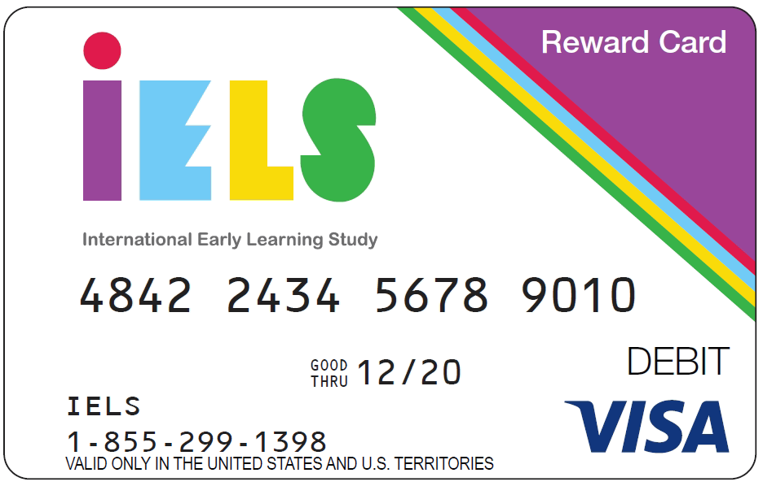

# Parent Consent Module of MyIELS

# *Updated Since Previous Submission*

# *Spanish version forthcoming.*

# Page 1:

# Welcome to the IELS parent consent and questionnaire portal!

# [Para Español haga clic aqui](javascript:__doPostBack('ctl00$MainContent$LinkButtonChangeTo_EN',''))

This website contains links for you to:

* Learn more about the study
* Provide permission for your child to participate in the study
* If desired, provide your contact information to receive study updates
* Complete the parent interview, and
* Register your Visa gift card so it can be activated and used.

The assessment dates in your child’s school are: <to be provided>

IELS is a play-based study conducted with tablets. Children are asked to point to pictures, listen to stories, and complete game-like tasks. They do not need to prepare in advance, and they do not need to know how to read. In our experience, children enjoy participating in the study and are happy about the experience.

[IF SCHOOL HAS EXPLICIT CONSENT:

**Consent Form**

We need your permission before we can include your child in the study. Please check one of the boxes below and then enter your name and click on the Submit button. Without your permission, we will be unable to include your child in IELS.

**PLEASE CHECK ONE:**

Yes, I give permission for my child to participate in IELS.

No, I do not give permission for my child to participate in IELS.

# Enter your name: _________

# Note that even if you choose for your child not to participate, we still want to hear from you. Please click the Submit button below to continue to the parent interview.

**More Information**

To learn more about the study, click on the links below.

Short video to see the assessment in action [LINK TO VIDEO]

Frequently Asked Questions [LINK TO FAQs]

Study brochure [LINK TO BROCHURE]

# 

Submit

[IF SCHOOL HAS IMPLICIT CONSENT OR NOTIFICATION:

**More Information**

To learn more about the study, click on the links below.

Short video to see the assessment in action [LINK TO VIDEO]

Frequently Asked Questions [LINK TO FAQs]

Study brochure [LINK TO BROCHURE]

Next

If you do not want your child to participate in the IELS activities, please let us know by entering your name below.

# Enter your name: _________

# Note that even if you choose for your child not to participate, we still want to hear from you. Please click the Next button above to continue to the parent interview.]

**Pop-up Box (only shown if condition below is met—otherwise continue to page 2)**

IF PARENT DID NOT GIVE CONSENT:

We notice you did not provide permission for your child to participate in the IELS activities. Click on the “Return” button if you meant to provide your permission. You will be taken back to the previous screen. If you do not wish to provide this permission, click the “OK” button below to continue.

# Page 2:

# Update Contact Information

Please update or complete the contact information below. We will use it to send you study reminders and updates when they are available. **This information will not be shared or used for any other purpose.**

If the information on file is correct, please check the box below and then click the “Update Information” button.

If you do not want to provide updated information, click the button, “No thanks, proceed to questionnaire.”

|  |  |
| --- | --- |
| **Contact Information** | |
| Information on file | Updates |
| **First Name:** |  |
| **Last Name:** |  |
| **Email Address:** | Please confirm your email by entering it again |
| **Phone number:** |  |
| **Address 1:** |  |
| **Address 2:** |  |
| **City:** |  |
| **State:** |  |
| **Zip Code:** |  |

 Click this box if the information on file is correct.

 

# Page 3:

# Parent questionnaire

The parent questionnaire is an essential part of IELS. Your input ensures that the study will be able to provide valuable, actionable results that can be used to improve children’s education and experiences in the first five years of life.

Click the link and use the login and password below to access the parent questionnaire for your child. At the completion of the survey, you will be asked to enter information from the Visa gift card so that it can be activated and used.  
  
URL: <https://myiels.us/survey>   
Login: <to be provided>  
Password: <to be provided>

Survey Status: NOT STARTED/STARTED/COMPLETE

IF COMPLETE, DO NOT SHOW THE URL/LOGIN/PASSWORD—JUST GRAY OUT OR LEAVE BLANK]

Visa Gift card status: ACTIVATED/NOT ACTIVATED

**More Information**

To learn more about the study, click on the links below.

Short video to see the assessment in action [LINK TO VIDEO]

Frequently Asked Questions [LINK TO FAQs]

Study brochure [LINK TO BROCHURE]

# Notification Letter for Parents

# *Updated Since Previous Submission*

# *Spanish version forthcoming.*

SCHOOL LETTERHEAD

Dear Parent or Guardian,

I am writing to inform you about an exciting study that our school will participate in this fall. This study is called the International Early Learning Study, or IELS. It will allow the U.S. to compare the skills and competencies of our children to their peers in other countries. Results from IELS will provide policymakers, educators, and parents/guardians with valuable information about the experiences that influence children’s early learning and their abilities as they begin school.

The U.S. Department of Education’s National Center for Education Statistics (NCES) has asked our school to take part in IELS. Some of our 5-year-olds, including your child, have been randomly chosen to participate. IELS is voluntary, but participation is important to ensure we get an accurate picture of what 5-year-olds in the U.S. can do.

IELS is a play-based study that is given on tablets. It is conducted one-on-one with trained staff. The assessment is untimed and will be split across two days to minimize time away from regular classroom activity. In our experience, the study takes about 30 minutes each day and children enjoy participating.

I encourage you to support this effort by agreeing to have your child take part. One parent or guardian of each student who participates will be asked to complete a brief survey. Enclosed is information about how to complete the survey, along with a $20 cash card to thank you for completing the survey.

The information provided by students and parents or guardians will not be shared with teachers, our school, or the district. Individuals and schools will not be identified in any reported data. NCES is authorized to conduct this study under the Education Sciences Reform Act of 2002 (ESRA 2002, 20 U.S.C. §9543). All of the information provided by you and your child may be used only for statistical purposes and may not be disclosed, or used, in identifiable form for any other purpose except as required by law (20 U.S.C. §9573 and 6 U.S.C. §151).

NCES will work with Westat, a research organization, to conduct the study in the U.S. between October and November 2018. The enclosed fact sheet provides additional information about IELS and explains what is involved for each child selected to participate in the study. If you have any questions, please do not hesitate to call 1-855-299-1398 or send an email to IELSHelp@westat.com. You may also get more information about this study by visiting the IELS website at [https://www.MyIELS.us/](https://www.myiels.us/).

Thank you for taking the time to consider your child’s participation in this important study.

Sincerely,

Enclosures:

Study Brochure

Facts for Parents about the IELS Main Study

$20 cash card

# Implicit Consent Letter for Parents

# *Updated Since Previous Submission*

# *Spanish version forthcoming.*

SCHOOL LETTERHEAD

Dear Parent or Guardian,

Our school has been selected to participate in the 2018 International Early Learning Study, or IELS. Results from IELS will provide valuable information that can be used to improve children’s education and experiences in the first five years of life. It will also allow the U.S. to compare the skills and abilities of our children to their peers in other countries.

IELS is being conducted by the U.S. Department of Education’s National Center for Education Statistics (NCES). The study will take place during the week of <insert date>.

* Your child has been selected to participate in IELS as part of the random sample of 5-year-olds across the nation. The study will be split across two days and children take about 30 minutes each day to complete the activities.
* As a parent or guardian of a participating student, you are asked to complete a 30-minute questionnaire. A $20 cash card is included in this mailing to thank you for your time. It will be activated when you complete the questionnaire.
* Teachers are asked to complete a 5-minute questionnaire about each participating student.
* Our school will receive $200 for participating in the study!

I encourage you to support this effort. IELS is voluntary, but participation is critically important for the study to be successful. Please see the enclosed FAQ for more information.

If you do not want your child to participate in the IELS activities, please let us know by completing the attached consent form and returning it to the school.

If you agree to your child’s participation, please also complete the parent questionnaire by November 30, 2018. Use the link and login information below to learn more about the study and complete the parent questionnaire:

* Website: <http://MyIELS.us>
* Username: <ParentID>
* Initial password: <Password>

You may also go directly to the parent questionnaire here: <Link to be provided>

NCES is working with Westat, a research organization, to conduct the study. If you have any questions, please do not hesitate to call 1-855-299-1398 or send an email to IELSHelp@westat.com. You may also learn more about the study by visiting the IELS website at <http://nces.ed.gov/surveys/IELS>.

Thank you for taking the time to consider your child’s participation in this important study.

Sincerely,

<Insert School Coordinator Signature>

Enclosures:

Consent Form

Frequently Asked Questions for Parents and Guardians

$20 Cash Card

*The National Center for Education Statistics is authorized to conduct this study under the Education Sciences Reform Act of 2002 (ESRA 2002, 20 U.S.C. §9543). All of the information you provide may be used only for statistical purposes and may not be disclosed, or used, in identifiable form for any other purpose except as required by law (20 U.S.C. §9573 and 6 U.S.C. §151). Individuals are never identified in any reports. All reported statistics refer to the U.S. as a whole or to national subgroups.*

# Implicit Consent Form for Parents

# *Updated Since Previous Submission*

# *Spanish version forthcoming.*

SCHOOL LETTERHEAD

**International Early Learning Study (IELS)**

**Parent/Guardian Consent Form**

Your 5-year-old has been asked to participate in the International Early Learning Study (IELS). The study is being administered by Westat on behalf of the U.S. Department of Education’s National Center for Education Statistics (NCES).

The study will be split across two days and children will take about 30 minutes each day to complete the activities. Your child will complete the study activities with an IELS team member who has experience working with children. School staff or teachers are welcome to observe.

If you have any questions, please refer to the enclosed materials and do not hesitate to call 1-855-299-1398 or send an email to [IELSHelp@westat.com](mailto:IELSHelp@westat.com).

**If you grant permission for your child to participate in IELS, you do not need to return this form.**

**If you do not give permission for your child to participate in IELS, please check the box below, and sign and return this form to your child’s school as soon as possible.**

No, I do not give permission for my child to participate in IELS.

____________________________________________

(Signature of parent or guardian)

Date of signature: _______/_______/____________

PLEASE PRINT (Information for school office purpose only):

**Student name: _____________________________________________**

School name: ______________________________________________

Parent name: __________________________

Parent telephone: _________________________________________

Parent email: ______________________________________________

FOR OFFICE USE ONLY:

Student ID: ________________________________________________

# Explicit Consent Letter for Parents

# *Updated Since Previous Submission*

# *Spanish version forthcoming.*

SCHOOL LETTERHEAD

Dear Parent or Guardian,

Our school has been selected to participate in the 2018 International Early Learning Study, or IELS. Results from IELS will provide valuable information that can be used to improve children’s education and experiences in the first five years of life. It will also allow the U.S. to compare the skills and abilities of our children to their peers in other countries.

IELS is being conducted by the U.S. Department of Education’s National Center for Education Statistics (NCES). The study will take place during the week of <insert date>.

* Your child has been selected to participate in IELS as part of the random sample of 5-year-olds across the nation. The study will be split across two days and children take about 30 minutes each day to complete the activities.
* As a parent or guardian of a participating student, you are asked to complete a 30-minute questionnaire. A $20 cash card is included in this mailing to thank you for your time. It will be activated when you complete the questionnaire.
* Teachers are asked to complete a 5-minute questionnaire about each participating student.
* Our school will receive $200 for participating in the study!

I encourage you to support this effort. IELS is voluntary, but participation is critically important for the study to be successful. Please see the enclosed FAQ for more information.

We must have your written consent before we can allow your child to participate in IELS. Please complete the attached form and return it to the school, or provide consent online, using the credentials below.

If you agree to your child’s participation, please also complete the parent questionnaire by November 30, 2018. Use the link and login information below to learn more about the study, provide consent for your child to participate, and complete the parent questionnaire:

* Website: <http://MyIELS.us>
* Username: <ParentID>
* Initial password: <Password>

You may also go directly to the parent questionnaire here: <Link to be provided>

NCES is working with Westat, a research organization, to conduct the study. If you have any questions, please do not hesitate to call 1-855-299-1398 or send an email to IELSHelp@westat.com. You may also learn more about the study by visiting the IELS website at <http://nces.ed.gov/surveys/IELS>.

Thank you for taking the time to consider your child’s participation in this important study.

Sincerely,

<Insert School Coordinator Signature>

Enclosures:

Consent Form

Frequently Asked Questions for Parents and Guardians

$20 Cash Card

*The National Center for Education Statistics is authorized to conduct this study under the Education Sciences Reform Act of 2002 (ESRA 2002, 20 U.S.C. §9543). All of the information you provide may be used only for statistical purposes and may not be disclosed, or used, in identifiable form for any other purpose except as required by law (20 U.S.C. §9573 and 6 U.S.C. §151). Individuals are never identified in any reports. All reported statistics refer to the U.S. as a whole or to national subgroups.*

# Explicit Consent Form for Parents

# *Updated Since Previous Submission*

# *Spanish version forthcoming.*

SCHOOL LETTERHEAD

**International Early Learning Study (IELS)**

**Parent/Guardian Consent Form**

Your 5-year-old has been asked to participate in the International Early Learning Study (IELS). The study is being administered by Westat on behalf of the U.S. Department of Education’s National Center for Education Statistics (NCES).

The study will be split across two days and children will take about 30 minutes each day to complete the activities. Your child will complete the study activities with an IELS team member who has experience working with children. School staff or teachers are welcome to observe.

If you have any questions, please refer to the enclosed materials and do not hesitate to call 1-855-299-1398 or send an email to IELSHelp@westat.com.

**PLEASE CHECK ONE:**

Yes, I give permission for my child to participate in IELS.

No, I do not give permission for my child to participate in IELS.

I have read this permission form and understand what my child and I are being asked to do.

**PLEASE SIGN YOUR NAME BELOW:**

____________________________________________

(Signature of parent or guardian)

Date of signature: _______/_______/____________

PLEASE PRINT (Information for school office purpose only):

**Student name: _____________________________________________**

School name: ______________________________________________

Parent name: ______________________________________________

Parent telephone: _________________________________________

Parent email: ______________________________________________

FOR OFFICE USE ONLY:

Student ID: ________________________________________________

# Halloween Card for Teachers

# *New*

**Cover**

Halloween-Themed with IELS Logo

**Interior Text**

**I**nsects, **E**lephants, **L**ions, **S**heep? No, it’s the **I**nternational **E**arly **L**earning **S**tudy!

Halloween gives kids an opportunity for fun inside and outside of the classroom. Your participation in IELS gives us an opportunity to better understand how we can set our students up for success now and in the future. Please remember to take a moment to support their participation in IELS on behalf of the U.S. Department of Education.

This is a friendly reminder that the teacher questionnaire is due by November 30, 2018. Your notification letter and email have directions for how to complete the survey.

Thanks, and Happy Halloween!

<School Coordinator name>

# Halloween Card for Parents

# *New*

**Cover Graphic**

Halloween-themed with IELS Logo

**Interior Text**

**I**nsects, **E**lephants, **L**ions, **S**heep? No, it’s the **I**nternational **E**arly **L**earning **S**tudy!

After your child’s night of costumes and trick-or-treating, please remember to take a moment to support their participation in IELS on behalf of the U.S. Department of Education.

This is a friendly reminder that the parent questionnaire is due by November 30, 2018. Your information packet includes directions about how to complete the questionnaire. Thanks, and Happy Halloween!

# School Coordinator Tip Sheet for Questionnaire Follow-up

# *New*

2018 International Early Learning Study

Encouraging Participation

*Tips for School Coordinators*

The following suggestions are helpful ideas for how you can encourage participation and ensure a successful study administration in your school. Remember, results from the International Early Learning Study (IELS) will provide valuable information that can be used to improve children’s education and experiences in the first five years of life. The success of the study relies on the participation of students, parents, and teachers.

* It is important that every selected child participates in IELS because they represent many other children like them across the country.
* Teachers provide additional information about the knowledge and skills of participating children that provides a more complete picture of what our nation’s 5-year-old children know and can do.
* Parents contribute vital information about children’s home, early care, and pre-school experiences, which helps the program report how those experiences are related to children’s skills as they enter school.

**Notify** selected students’ parents and teachers about the study before you distribute their participation envelopes. Providing advanced notice increases the likelihood that parents and teachers will pay attention to the printed materials.

**Provide** additional information to parents and teachers using the PowerPoint presentations that are available on MyIELS. Consider hosting informational sessions during a scheduled staff meeting or parent night.

**Remind** parents and teachers about the deadline for completing their questionnaires on a regular basis using the provided email, text message, and/or printed reminders. Email reminders are especially helpful because parents and teachers can immediately access MyIELS or the online questionnaire.

**Support** parents and teachers by answering questions, as appropriate, about the content of the questionnaires. Consider offering a time and space for parents to complete the questionnaires at your school and/or meeting with them if they have any questions during the process.

**Emphasize** the importance of the study and their contribution to it when communicating with parents and teachers. Talking points are provided on the back of this document.

**Remember** that the IELS team is here to help! If you have any questions, please contact your IELS Team Leader, call the IELS help desk at 1-855-299-1398, or send an email to IELSHelp@westat.com.

BACK PAGE

**Talking Points for Parents**

* It is important that every selected child participates in IELS because they represent many other children like them across the country. Together, the participating children will demonstrate what 5-year-old children in the United States know and can do as they begin elementary school.
* IELS will provide you and other parents with valuable information about activities you can do at home that may increase children’s knowledge and development.
* By completing the questionnaire, you will help the study provide results about the relationship between children’s early learning experiences and their skills as they enter school.
* It is important to be honest and accurate to ensure IELS can provide valuable, actionable results.
* Our principal, teachers, and staff can gain a better understanding of children’s skills and abilities as they enter school, which can help us improve classroom activities and better meet their needs.
* Educators and policymakers can use the results for the U.S. and other countries to make informed decisions about how to improve early childhood education for future generations.
* It will only take you 30 minutes to complete the parent questionnaire, and you will receive $20 to thank you for your time and effort!

**Talking Points for Teachers**

* IELS results can help you, our staff, and our principal gain a better understanding of children’s skills and abilities as they enter school, which can help us improve classroom activities and better meet their needs.
* By completing the questionnaire, you help ensure that IELS can provide a more complete picture of what our country’s 5-year-old children know and can do as they enter school.
* Educators and policymakers can use the results for the U.S. and other countries to make informed decisions about how to improve early childhood education for future generations.
* It will take less than 30 minutes for you to complete all of your questionnaires.
* To thank you for your time and effort, you will receive $20 for part A of the teacher questionnaire, and an additional $7 for each questionnaire you are asked to complete for participating students (if allowed by school policy).

# First Reminder Email for Teachers

# *Updated Since Previous Submission*

Subject: Reminder to complete your IELS questionnaire!

Dear <Teacher name>:

I am reaching out to remind you that you and some of your students have been selected to participate in the International Early Learning Study (IELS). As a teacher, your participation is critically important for IELS to be able to report on what our country’s 5-year-old children know and can do as they enter elementary school.

Please log onto the website and complete the questionnaires before November 30, 2018.

Website: <http://MyIELS.us>

* To complete the questionnaire about your teacher training and education (Part A), please use the unique account information below.
  + Username:<TeacherID>
  + Password: <Password>
* To complete the questionnaire for each selected student you teach (Part B), please use the unique account information I have attached with the roster of your selected students.
  + **You have <insert number of Part B not-started>/<Insert total number of assigned Part B> Part B questionnaires to complete.**

For any questions, please email [IELSHelp@westat.com](mailto:IELSHelp@westat.com) or contact the IELS information number at 1-855-299-1398. For additional information about IELS, visit <http://nces.ed.gov/surveys/IELS>.

You can also reach out to me if you have any questions about your or your students’ participation. If your students’ parents ask you about the study, please encourage them to participate and direct them to me for any questions.

Thank you again!

Sincerely,

<School Coordinator name>

# Second Reminder Email for Teachers

# *Updated Since Previous Submission*

Subject: Don’t miss out on your IELS incentives!

Dear <Teacher name>:

I appreciate your willingness to participate in the International Early Learning Study (IELS)! We look forward to learning more about what our country’s youngest students know and can do—and the factors that may impact their skills and abilities—as they enter elementary school.

As a reminder, the deadline to complete your surveys for participating students is **Friday, November 30, 2018**. Please log on to the IELS website to complete them if you have not done so already. Don’t forget that you received $20 + an additional $7 incentive for each survey you have been asked to complete.

Website: <http://MyIELS.us>

* To complete the questionnaire about your teacher training and education (Part A), please use the unique account information below.
  + Username**:** <TeacherID>
  + Password: <Password>
* To complete the questionnaire for each selected student you teach (Part B), please use the unique account information I have attached with the roster of your selected students.
  + **You have <insert number of Part B not-started>/<Insert total number of assigned Part B> Part B questionnaires to complete.**

For any questions, please email [IELSHelp@westat.com](mailto:IELSHelp@westat.com) or contact the IELS information number at 1-855-299-1398. For additional information about IELS, visit <http://nces.ed.gov/surveys/IELS>.

You can also reach out to me if you have any questions about your or your students’ participation. If your students’ parents ask you about the study, please encourage them to participate and direct them to me for any questions.

Thank you again!

Sincerely,

<School Coordinator name>

# Third Reminder Email for Teachers

# *Updated Since Previous Submission*

Subject: IELS teacher questionnaire – due Friday!

Dear <Teacher name>:

Thanks again for participating in the International Early Learning Study (IELS)!

I know you are very busy, but I wanted to remind you that the deadline for completing your surveys is **Friday, November 30, 2018.** If you could find time to complete them it would go a long way toward helping the study provide valuable information for teachers, administrators, parents, and policymakers.

I can request a hard-copy questionnaire and pre-paid return envelope if you’ve had difficulties completing the questionnaire online. If you would like to complete the questionnaire on paper, please let me know as soon as possible.

Website: <http://MyIELS.us>

* To complete the questionnaire about your teacher training and education (Part A), please use the unique account information below.
  + Username**:** <TeacherID>
  + Password: <Password>
* To complete the questionnaire for each of your selected students (Part B), please use the unique account information I have included with the roster of your selected students.
  + **You have <insert number of Part B not-started>/<Insert total number of assigned Part B> Part B questionnaires to complete.**

For any questions, please email [IELSHelp@westat.com](mailto:IELSHelp@westat.com) or contact the IELS information number at 1-855-299-1398. For additional information about IELS, visit <http://nces.ed.gov/surveys/IELS>.

You can also reach out to me if you have any questions about your or your students’ participation. If your students’ parents ask you about the study, please encourage them to participate and direct them to me for any questions.

Sincerely,

<School Coordinator name>

# Final Reminder Email for Teachers

# *Updated Since Previous Submission*

Subject: Due tomorrow: IELS Teacher Questionnaire

Dear <Teacher name>:

The deadline for completing your International Early Learning Study (IELS) questionnaires is **tomorrow, November 30, 2018.** Don’t let this to opportunity to inform our work pass you by!

Website: <http://MyIELS.us>

* To complete the questionnaire about your teacher training and education (Part A), please use the unique account information below.
  + Username**:** <TeacherID>
  + Password: <Password>
* To complete the questionnaire for each of your selected students (Part B), please use the unique account information I have included with the roster of your selected students.
  + **You have <insert number of Part B not-started>/<Insert total number of assigned Part B> Part B questionnaires to complete.**

For any questions, please email [IELSHelp@westat.com](mailto:IELSHelp@westat.com) or contact the IELS information number at 1-855-299-1398. For additional information about IELS, visit <http://nces.ed.gov/surveys/IELS>.

You can also reach out to me if you have any questions about your or your students’ participation. If your students’ parents ask you about the study, please encourage them to participate and direct them to me for any questions.

Sincerely,

<School Coordinator name>

# Deadline Extension Email for Teachers

# *Updated Since Previous Submission*

Subject: IELS questionnaire deadline extended till <insert date>!

Dear <Teacher name>:

We are making every effort to collect information for the International Early Learning Study (IELS) so the teacher survey deadline is being extended until **November 7, 2018**. I encourage you to go online and complete the questionnaires as soon as possible. The IELS team is really counting on your participation!

Website: <http://MyIELS.us>

* To complete the questionnaire about your teacher training and education (Part A), please use the unique account information below.
  + Username**:** <TeacherID>
  + Password: <Password>
* To complete the questionnaire for each of your selected students (Part B), please use the unique account information I have included with the roster of your selected students.
  + **You have <insert number of Part B not-started>/<Insert total number of assigned Part B> Part B questionnaires to complete.**

For any questions, please email [IELSHelp@westat.com](mailto:IELSHelp@westat.com) or contact the IELS information number at 1-855-299-1398. For additional information about IELS, visit <http://nces.ed.gov/surveys/IELS>.

You can also reach out to me if you have any questions. Thank you in advance for taking the time to complete the questionnaires!

Sincerely,

<School Coordinator name>

# Explicit Consent Reminder Email for Parents

***New***

Subject: IELS Consent Form

Dear <parent/guardian name>:

Thank you for reviewing the materials I sent home about the International Early Learning Study (IELS). Please don’t forget to fill out the consent form for your child to participate in IELS by <Insert Date>.

It is important that every selected child participates in IELS to ensure we get an accurate picture of what 5-year-olds in the U.S. can do.

If you agree to your child’s participation, please also complete the parent questionnaire by November 30, 2018. Use the link and login information below to provide consent and complete the questionnaire:

Website: <URL>

Username: <ParentID>

Initial password: <Password>

You may also go directly to the parent questionnaire here: <Link to be provided>

For any questions, please email [IELSHelp@westat.com](mailto:IELSHelp@westat.com) or contact the IELS information number at 1-855-299-1398. For additional information about IELS, visit <http://nces.ed.gov/surveys/IELS>.

You can also reach out to me if you have any questions about the study activities for you or your child.

Thank you again!

Sincerely,

<School Coordinator name>

# First Questionnaire Reminder Email for Parents

# *Updated Since Previous Submission*

Subject: Reminder to complete your IELS questionnaire!

Dear <parent/guardian name>:

Thank you for agreeing to take part in the International Early Learning Study (IELS). I am reaching out to remind you to log onto the website and complete the parent questionnaire. Please do so before November 30, 2018.

As a parent, your participation is critically important for IELS to be able to report on the relationships between early learning experiences and children’s skills as they enter school.

Use the link and login information below to access and complete the questionnaire:

Website: <URL>

Username: <ParentID>

Initial password: <Password>

You may also go directly to the parent questionnaire here: <Link to be provided>

For any questions, please email [IELSHelp@westat.com](mailto:IELSHelp@westat.com) or contact the IELS information number at 1-855-299-1398. For additional information about IELS, visit <http://nces.ed.gov/surveys/IELS>.

You can also reach out to me if you have any questions about the study activities for you or your child.

Thank you again!

Sincerely,

<School Coordinator name>

# Second Questionnaire Reminder Email for Parents

# *Updated Since Previous Submission*

Subject: Don’t miss out on your $20!

Dear <parent/guardian name>:

I appreciate your family’s participation in the International Early Learning Study (IELS)! We look forward to learning more about what our country’s youngest students know and can do as they enter school so we can better meet their needs.

As a reminder, the deadline to complete your parent questionnaire is November 30, 2018. Please log on to the IELS website to complete the parent questionnaire if you have not done so already. Don’t forget that your $20 cash card will be activated when you finish!

Use the link and login information below to access and complete the questionnaire:

Website: <URL>

Username: <ParentID>

Initial password: <Password>

You may also go directly to the parent questionnaire here: <Link to be provided>

For any questions, please email [IELSHelp@westat.com](mailto:IELSHelp@westat.com) or contact the IELS information number at 1-855-299-1398. For additional information about IELS, visit [<http://nces.ed.gov/surveys/IELS>](https://www.MyIELS.us/).

You can also reach out to me if you have any questions about the study activities for you or your child.

Thank you again!

Sincerely,

<School Coordinator name>

# Final Questionnaire Reminder Email for Parents

# *Updated Since Previous Submission*

Subject: IELS parent questionnaire – due tomorrow!

Dear <parent/guardian name>:

Thanks again for participating in the International Early Learning Study (IELS)!

I know you are very busy, but I wanted to remind you that the deadline for completing your parent questionnaire is **tomorrow, November 30.** If you could find time to complete the questionnaire it would go a long way toward helping the study provide valuable information for parents, schools, and policymakers.

To complete the questionnaire, follow the link below and use your unique login information:

Website: <URL>

Username: <ParentID>

Initial password: <Password>

You may also go directly to the parent questionnaire here: <Link to be provided>

For any questions, please email [IELSHelp@westat.com](mailto:IELSHelp@westat.com) or contact the IELS information number at 1-855-299-1398. For additional information about IELS, visit [<http://nces.ed.gov/surveys/IELS>](https://www.MyIELS.us/).

You can also reach out to me if you have any questions about the study activities for you or your child.

Sincerely,

<School Coordinator name>

# Questionnaire Deadline Extension Email for Parents

# *Updated Since Previous Submission*

Subject: IELS parent questionnaire deadline extended to <insert date>!

Dear <parent/guardian name>:

We are making every effort to collect information for the International Early Learning Study (IELS) so the parent questionnaire deadline has been extended until December 7, 2018. The IELS team is really counting on your participation!

As a reminder, your $20 cash card will be activated after you complete the questionnaire to thank you for your participation.

To complete the questionnaire, follow the link below and use your unique login information:

Website: <URL>

Username: <ParentID>

Initial password: <Password>

You may also go directly to the parent questionnaire here: <Link to be provided>

Don’t let this opportunity to help shape education for future generations pass you by.

For any questions, please email [IELSHelp@westat.com](mailto:IELSHelp@westat.com) or contact the IELS information number at 1-855-299-1398. For additional information about IELS, visit <http://nces.ed.gov/surveys/IELS>.

You can also reach out to me if you have any questions.

Sincerely,

<School Coordinator name>

# Notification Text Message for Parents

# *New*

Hello! You and your child have been selected to participate in the U.S. Department of Education’s International Early Learning Study (IELS). An information packet will be sent home with your child this week. Please watch for it and let us know if you have any questions.

# Explicit Consent Reminder Text Message for Parents

# *New*

Please don’t forget to fill out the consent form for your child to participate in the International Early Learning Study (IELS) by <Insert Date>. It is included in the information packet that was sent home from <School Coordinator name>. Please let us know if you have any questions.

# First Questionnaire Reminder Text Message for Parents

# *New*

Thank you for agreeing to take part in the International Early Learning Study (IELS). Your child will partake in the study on <Insert Date>. Please don’t forget to complete the parent questionnaire before November 30, 2018. Your information packet and email from <School Coordinator name> have directions. Thanks!

# Second Questionnaire Reminder Text Message for Parents

# *New*

Hello! Don’t miss out on your $20 for participating in the International Early Learning Study (IELS). The deadline to complete your questionnaire is November 30. Your information packet and email from <School Coordinator name> have directions. Please let us know if you have any questions.

# Final Questionnaire Reminder Text Message for Parents

# *New*

We know you are very busy, but we want to remind you that the deadline for completing your International Early Learning Study (IELS) questionnaire is tomorrow, November 30, 2018. Please contact <School Coordinator name> if you have any questions.

# Questionnaire Deadline Extension Text Message for Parents

# *New*

We are making every effort to collect information for the International Early Learning Study (IELS) so the parent questionnaire deadline has been extended until December 7, 2018. Please contact <School Coordinator name> if you have any questions. Thank you!

# Thank You Letter Principal

# *Updated Since Previous Submission*

Dear {name},

Thank you for participating in the International Early Learning Study (IELS). Enclosed is a check for <$200/$800> as a token of our appreciation for your school’s participation in this important study of American education.

The study has been very successful because of the cooperation and participation of the children, parents, schools, school administrators, and teachers. You can find further information about the study at our website at https://nces.ed.gov/surveys/iels.

Thank you again for your support of IELS. If you have any questions or concerns please contact the IELS support line at 1-855-299-1398 or IELSHelp@westat.com.

The IELS Project Staff

# Thank You Letter School Coordinator

# *Updated Since Previous Submission*

Dear <School Coordinator name>:

Thank you so very much for all your help in coordinating the International Early Learning Study (IELS) in your school. We truly couldn’t have done it without you! Enclosed is a check for $100 to thank you for your time and effort in the second half of the study.

The IELS report is tentatively scheduled to be released in <month, year to be provided>. We look forward to seeing our country’s results and hope you do too.

Thank you again for your support of IELS. If you have any questions or concerns, please contact the IELS help desk at 1-855-299-1398 or [IELSHelp@westat.com](mailto:IELSHelp@westat.com).

Sincerely,

# The U.S. IELS Team

# Thank You Email for School Coordinators

# *New*

Dear <School Coordinator name>:

Thank you so very much for all your help in coordinating the International Early Learning Study (IELS) in your school. We truly couldn’t have done it without you! Please watch for a check in your mail to thank you for your time and effort in the second half of the study.

We hope you will send our thanks to the participating parents and students. Draft letters, emails, and text messages are attached for you to customize and send as you see fit.

The IELS report is tentatively scheduled to be released in <month, year to be provided>. We look forward to seeing our country’s results and hope you do too.

Thank you again for your support of IELS. If you have any questions or concerns, please contact the IELS help desk at 1-855-299-1398 or [IELSHelp@westat.com](mailto:IELSHelp@westat.com).

Sincerely,

The IELS USA Team

*Attachments*

Thank You Letter, Email, and Text Message for Parents

Thank You Letter and Email for Teachers

# Thank You Letter Teachers

# *Updated Since Previous Submission*

SCHOOL LETTERHEAD

Dear <Teacher name>:

On behalf of our school, the U.S. Department of Education, and—most importantly—our students, I want to thank you for participating in the International Early Learning Study (IELS). I eagerly await our country’s results and to work with you to consider how we can better support incoming kindergarteners at our school.

As a reminder, you can find further information about the study at <https://nces.ed.gov/surveys/iels>. If you have any questions or concerns, please contact the IELS support line at 1-855-299-1398 or email [IELSHelp@westat.com](mailto:IELSHelp@westat.com).

Thank you again for your support of this important study!

Sincerely,

<Principal or School Coordinator name>

# Thank You Email Teachers

# *New*

Subject: Thank you for participating in IELS!

Dear <Teacher name>:

On behalf of our school, the U.S. Department of Education, and—most importantly—our students, I want to thank you for participating in the International Early Learning Study (IELS). I eagerly await our country’s results and to work with you to consider how we can better support incoming kindergarteners at our school.

As a reminder, you can find further information about the study at <https://nces.ed.gov/surveys/iels>. If you have any questions or concerns, please contact the IELS support line at 1-855-299-1398 or email [IELSHelp@westat.com](mailto:IELSHelp@westat.com).

Thank you again for your support of this important study!

Sincerely,

<Principal or School Coordinator name>

# Thank You Letter Parents

# *Updated Since Previous Submission*

SCHOOL LETTERHEAD

Dear <Parent/Guardian name>:

On behalf of our school, the U.S. Department of Education, and—most importantly—our students, I want to thank you and your child for participating in the International Early Learning Study (IELS). We eagerly await the results and consider how we can use the national findings to better support incoming kindergarteners at our school. I hope you and other parents will find the results helpful, too.

As a reminder, you can find further information about the study at <https://nces.ed.gov/surveys/iels>. If you have any questions or concerns, please contact the IELS support line at 1-855-299-1398 or email [IELSHelp@westat.com](mailto:IELSHelp@westat.com).

Thank you again for your support of this important study!

Sincerely,

<Principal or School Coordinator name>

# Thank You Email for Parents

# *New*

Subject: Thank you for participating in IELS!

Dear <Parent/Guardian name>:

On behalf of our school, the U.S. Department of Education, and—most importantly—our students, I want to thank you and your child for participating in the International Early Learning Study (IELS). We eagerly await the results and consider how we can use the national findings to better support incoming kindergarteners at our school. I hope you and other parents will find the results helpful too.

As a reminder, you can find further information about the study at <https://nces.ed.gov/surveys/iels>. If you have any questions or concerns, please contact the IELS support line at 1-855-299-1398 or email [IELSHelp@westat.com](mailto:IELSHelp@westat.com).

Thank you again for your support of this important study!

Sincerely,

<Principal or School Coordinator name>

# Thank You Text Message for Parents

# *New*

On behalf of our school, the U.S. Department of Education, and—most importantly—our students, Thank you for participating in the International Early Learning Study (IELS). We look forward to seeing the results and hope you do, too!

# Results Now Available E-mail for Principals

# *New*

Subject: Now Available: IELS Results!

Dear <Principal name>:

Results are now available for the 2018 International Early Learning Study (IELS)! Learn about what our nation’s 5-year-olds know and can do, what their educational experiences are before they enter school, and how they compare to their peers in other countries.

You can find the report here: <link to be provided>

Thank you again for making this study a success. We couldn’t have done it without help from you and your students, parents, and staff.

Sincerely,

# The U.S. IELS Team

# Results Now Available E-mail for School Coordinators

# *New*

Subject: Now Available: IELS Results!

Dear <School Coordinator name>:

Results are now available for the 2018 International Early Learning Study (IELS)! Learn about what our nation’s 5-year-olds know and can do, what their educational experiences are before they enter school, and how they compare to their peers in other countries.

You can find the report here: <link to be provided>

Thank you again for making this study a success. We couldn’t have done it without your help.

Sincerely,

# The U.S. IELS Team

# Results Now Available E-mail for Teachers

# *New*

Subject: Now Available: IELS Results!

Dear <Teacher name>:

Results are now available for the 2018 International Early Learning Study (IELS)! Learn about what our nation’s 5-year-olds know and can do, what their educational experiences are before they enter school, and how they compare to their peers in other countries.

You can find the report here: <link to be provided>

Thank you again for participating in the study and helping it to be successful!

Sincerely,

# The U.S. IELS Team

# Results Now Available E-mail for Parents

# *New*

Subject: Results Now Available for the International Early Learning Study!

Dear <Parent/Guardian name>:

Results are now available for the 2018 International Early Learning Study (IELS)! Learn about what our nation’s 5-year-olds know and can do, how their home and pre-school experiences relate to those skills, and how they compare to their peers in other countries.

You can find the report here: <link to be provided>

Thank you again for participating in the study and helping it to be successful!

Sincerely,

The U.S. IELS Team