Evaluation of Heavy Vehicle Crash Warning Interfaces

Research Plan Summary

Introduction

Rear end crashes for combination-unit trucks account for 18.2 percent of all heavy-truck crashes (daSilva et al., 2009). Recent research suggests that forward collision warning (FCW) systems for heavy vehicles (HVs) can reduce rear end crashes when combined with responsive systems such as crash mitigation braking (Battelle, 2007; Fitch et al., 2009; Hickman & Hanowski, 2011; Houser et al., 2009; Najm et al., 2011; Sayer, 2011). However, these studies were based on early field operational test (FOT) data that assessed the effectiveness of a single, early-generation warning system that was subject to problems such as nuisance alarms as well as unreliable object detection performance.
Evaluating crash warning interfaces (CWI) performance requires examination of multiple aspects, such as: driver response characteristics and design of displays and controls, operating in the influence of the roadway and traffic environment, and the performance of sensor and data-processing components of the system. In support of creating more effective CWIs, this project seeks to examine some of the issues surrounding the visual interfaces provided in CWIs and help inform CWI design and implementation. To achieve these goals, a multistep process has been followed. This has included a review of new literature, review of existing guidelines, identification of research needs, creation of research questions following these research needs, as well as the design and conduct of experimental research in support of the identified research needs.

Research Questions

The overall goal of this project is to examine visual interfaces in CWIs and help inform their design and implementations for improved effectiveness, especially for nighttime conditions. Although multiple research needs were identified in the process of reviewing the literature, the research needs that were selected to develop as research questions for the present study are those that: 1) support the goal of improving the design of HV crash warning interfaces (HV-CWIs), and 2) are able to be accomplished within the confines of the study.

Research Questions
Research Question 1. Is there a benefit or disbenefit, in terms of braking reaction time to an FCW, to providing drivers a visual imminent collision warning (ICW) display in nighttime or other low-light conditions?
Research Question 2. Is there a benefit or disbenefit, in terms of braking reaction time to an FCW, to providing drivers a visual ICW display that is delayed in timing with respect to the activation of an auditory alert?
Research Question 3. Based on the findings of Research Questions 1 and 2, is there a benefit or disbenefit in terms of braking reaction time when these conditions are applied to a lane departure warning (LDW)?

Experimental Approach
Three experiments will be used to address these three research questions. The first two experiments will be conducted using a Class-8 truck with 53’ foot trailer, while the third experiment will be conducted with VTTI’s commercial truck simulator. A description of each experiment follows.

Human Performance Testing

Overview
This section presents an overview of the human performance testing that will occur in this study. Three experiments will be performed as part of this study. First will be an evaluation of the visual alert in a nighttime setting using a Class-8 truck-trailer combination. This will focus on the effects of distraction created by the luminance of the visual alert on driver performance during an ICW. The second experiment will be an evaluation of delayed activation of a visual alert on driver performance during an ICW in a Class-8 truck-trailer combination. The third experiment will be an examination of the aspects from the first two evaluations implemented into a lane departure warning. This will be conducted in VTT’s commercial truck simulator.

Experiment 1. Nighttime Visual Alert Evaluation

Overview
The purpose of this experiment is to examine the effect of the luminance of visual alerts on reaction time to an imminent crash warning alert. The findings of this study will inform CWI design as to the benefit (or lack thereof) of the luminance levels during the presentation of a crash warning alert.

Participants
A total of 20 participants will be tested in Experiment 1. Participants must have a valid Class-A CDL (without an air brakes restriction (K) or automatic transmission restriction) and a current DOT medical card. Participants will not be recruited based on age; however, Federal regulations require individuals to be age 21 or greater in order to qualify and obtain an interstate CDL, so no participants under the age of 21 will be included as participants in this experiment. Participants will also not be recruited based on gender. However, the Institutional Review Board requires that, during screening, any female that is pregnant is requested to meet with their physician to ensure they are medically fit to participate and a sign a waiver form.
Further requirements to serve as a participant include either being currently or recently employed (defined as within the past 6 months) in truck operations as a driver, not having a DOT-reportable incident within the past year, and having never participated in a study at VTTI that involves a surprise event.
While participants will have a valid DOT medical card, additional vision acuity and color testing along with a basic hearing test will be administered upon arrival to VTTI to ensure they meet the minimum requirements set forth in the DOT regulations.
Note that this number of participants was set by an a priori power analysis. This power analysis indicated the number of participants needed to reach a set power and detect a difference (if there is one). However, this number indicates the number of complete participants; the actual number of participants needed may be larger due to data loss, participant withdrawal/attrition, participant non-compliance, and other factors that could lead to a participant’s data being unusable.
A limited number of VTTI employees who hold a valid CDL will be used for initial (pilot) testing. The data from these participants will not be used for analysis; instead, these participants’ data will be used to refine the testing and data analysis procedures as needed.

Materials

2007 Freightliner Cascadia
The class-8 truck for use in this study is a 2007 Freightliner Cascadia (Figure 2; Figure 3). The Freightliner Cascadia has a wheelbase of approximately 6.1 m with an approximate tare weight of 5,443 kg. The truck is equipped with an Eaton-Fuller 10-speed non-synchronized manual transmission, electronic stability control (ESC), traction control, anti-lock brakes (ABS), and super-single tires on the rear drive axles. This vehicle is similar in design and operation to most class-8 trucks in CMV operations today.

Utility Trailer
The trailer for use in this study is a 2007 Utility 4000D-X trailer with a tare weight of 5,960 kg. The trailer is a 16.15 m (53 ft.) long dry van that is equipped with ABS and will be used in an empty configuration. This trailer is similar in design and operation to most over-the-road dry van trailers in use today.
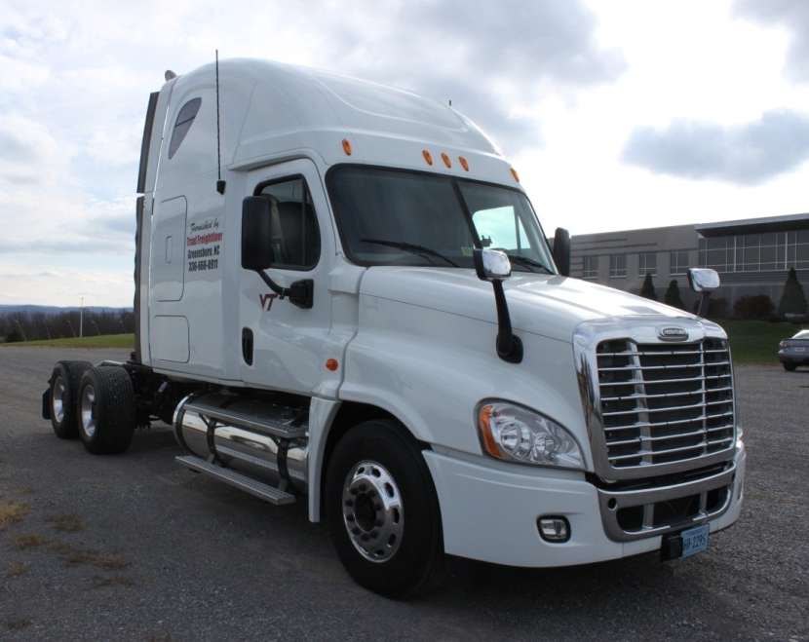
Figure 2. Freightliner Cascadia
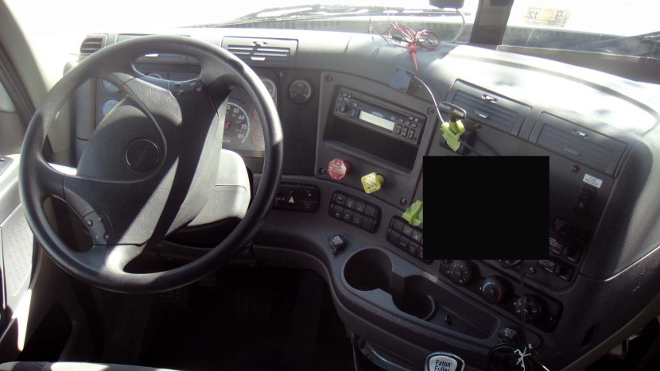
Figure 3. Freightliner Cascadia Driver’s Area

Data Acquisition System
A VTTI data acquisition system (DAS) is installed in the experimental truck in order to collect a number of vehicle variables, including: speed, engine RPM, throttle and brake position, following distance, and time-to-contact. The DAS also has the capability to record multiple channels of time-synchronized video. These video views for this experiment include a view of the forward roadway, a wide angle of the driver’s face, a wide angle over-the-shoulder view of the driver, the driver’s foot well (oriented towards the pedals), and a view of the visual display that generates to collision warning alert (Figure 4). The DAS is unobtrusive and does not interfere with the driver. The data and video are recorded and encrypted on a removable hard drive contained within the DAS.

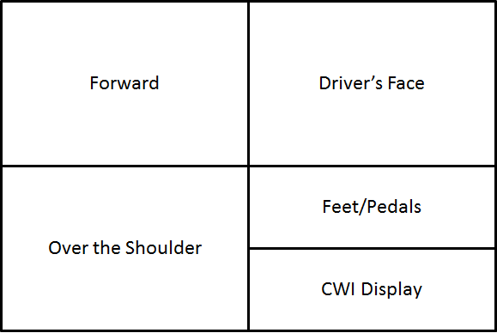
Figure 4. Video Layout as Recorded by the DAS

Collision Warning System
The collision warning system for this experimentis a single-stage alert system that provides an ICW alert when triggered. The system provides an auditory and visual alert. Triggering of the ICW alert is experimentally controlled via the DAS and associated instrumentation. Both the visual alert and auditory alert trigger simultaneously.
The ICW visual alert is displayed on a Samsung Galaxy Player 4.0 (Model YP-G1CWY/XAA) color display mounted on the instrument panel of the vehicle (Figure 18). This area was chosen to represent the location of an integrated display that many suppliers and manufacturers are in the process of implementing. The display location is based on existing guidelines (COMSIS Corporation, 1996; Campbell et al. 2007) suggesting a position within 15° of the driver’s line of sight and should, upon activation, direct the driver’s attention to the forward roadway. The icon used as the display alert is based on existing CWI guidelines (Campbell et al., 2007; see Figure 5).
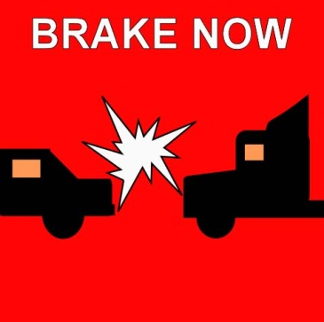
Figure 5. ICW Visual Alert for Experiment 1.
The auditory alert is played through external speakers located on the dash of the vehicle. The auditory alert and volume is based on existing CWI guidelines (Campbell et al. 2007) and is a replication of CAMP sound 8 (Kiefer, LeBlanc, Palmer, Salinger, Deering, & Shulman, 1999). Sound level readings were taken with the vehicle in the test area at the test speed (72 km/h) in the gear participants will be asked to use (9th gear). When the vehicle reached a steady state (i.e., no additional throttle manipulations were required to maintain the vehicle speed in the test area), maximum-value (using the maximum hold setting) sound pressure readings were obtained by holding the measurement wand of a Sper Scientific detachable probe sound meter (model 840012) in the area directly adjacent to the driver’s right ear. This provides a sound pressure measure in the probable area of the driver’s ear. These measurements are summarized in Table 1. The auditory alert is displayed at a level 15 dB greater than ambient and background music levels.
Table 1. Sound Pressure Readings from Test Vehicle
Measurement Point | Sound Pressure Level (dbA)
Ambient Noise Level | 69
Music | 72
Music and Alert | 87

Experimental Scenario
The experimental scenarios occur on the VTTI test track, which is a 3.5 km section of two-lane highway constructed to relevant Federal and state Department of Transportation (DOT) standards. For these scenarios, only the participant vehicle and relevant confederate vehicles are present on the test track.
Two different scenarios are tested in Experiment 1. These scenarios assess the effect of distraction created by the visual alert in a nighttime setting. Music acts as the secondary cabin sounds for the experiment. Based on the results of prior research examining the effects of different music on driving performance (Brodsky, 2002), a song with a medium paced tempo was selected (Café Amore by Spyro Gyra). The same song is played across both test scenarios for all participants. Scenario 1 triggers the ICW while scenario 2 acts as the baseline with no alert being generated. Table 2 provides the participant breakdown for this experiment.
Table 2. Test Matrix for Experiment 1
Scenario | Venue | n | Starting Conditions |  |  |  | Secondary Audio | Condition
 |  |  | SV Speed (mph) | LV Speed (mph) | Range (m) | SV Decel (g)
1 | Track | 10 | 45 | 45 | 160 | .60 | Music | FCW
2 | Track | 10 | 45 | 45 | 160 | .60 | Music | No Alert

Design
This is a between subjects design with a single exposure surprise event. Each of the scenarios consists of four test trials. The first test trial is designed to have the participant become comfortable driving the vehicle on the test track. The subject vehicle will be the only vehicle on the test track for this trial. Test trials 2, 3, and 4 introduce the participant to a lead vehicle and side vehicle (left adjacent lane) and have the participant perform an in-vehicle secondary task such as a radio task. Based on the result of naturalistic examinations of CMV operator distraction (Olson, Hanowski, Hickman, & Bocanegra, 2009), three secondary in-vehicle tasks were selected. The same four test trials are used in both experiments within this study. The surprise event occurs only in the fourth test trial and consists of a 0.60g braking maneuver by the lead vehicle while the participant is performing a task that requires eyes of the road. The lead vehicle braking event will result in ICW activation at a 3.0 s TTC.
Baseline scenarios are conducted by having the participant perform the same secondary task as performed in the fourth test trial, only with no ICW presented. The lead vehicle driver will perform a lane exit to the adjacent lane at 1.0 s TTC, as they would in the presence of a participant non-response to the ICW.

Procedure
Following participant greeting, the information sheet, and the vision and hearing screening, participants are given an orientation to the Class 8 truck they will be driving on the test track. During the participant greeting, participants are not informed as to the true nature of the experiment until after their exposure to the surprise event. Once the vehicle orientation is complete the participant is instructed to proceed to the test track for instructions prior to beginning testing. Participants receive instructions prior to the start of each test trial. For test trials 2 through 4 (involving a secondary in-vehicle task), participants are given time to practice a similar task prior to driving.
For the first test trial, participants drive the length of the test track at 72 km/h (45 mph) with no other vehicles present and will not perform any secondary in-vehicle task.
For the second test trial, participants are introduced to a lead vehicle. The lead vehicle will be traveling at 72 km/h. The participant is instructed to drive the length of the test track traveling at 72 km/h while maintaining a 4.0 s following distance behind the lead vehicle. During this test trial the participant is asked to perform a secondary in-vehicle task of adjusting the radio station by changing the band of the radio from AM to FM and using the manual tune buttons to find station 105.3 MHz. Upon completion of this test trial, the participant is instructed to park and receive instructions prior to the next test trial.
Test trial 3 includes both the lead vehicle and side vehicle. The side vehicle travels in the left adjacent lane and remains at a position approximately adjacent to the driver’s side window of the subject vehicle. The participant is instructed to travel at 72 km/h while maintaining a 4.0 s following distance behind the lead vehicle. During the test trial the participants perform a map reading task of finding the two interstate highways that cross in Butte, Montana using a trucker atlas (an atlas designed specifically for heavy-/large-vehicle drivers). Upon completion of this test trial, the participant is instructed to park and receive instructions prior to the next test trial.
Test trial 4 includes both the lead vehicle and side vehicle. The side vehicle travels in the left adjacent lane and remains at a position approximately adjacent to the driver’s side window of the subject vehicle. The participant is instructed to travel at 72 km/h while maintaining a 4.0 s following distance behind the lead vehicle. During the test trial the participants perform a reach for object task involving reaching for a single red pen located in a group of various colored pens held in the floor moor-mounted cup holder. During the this task when the participant’s eyes are off of the road the in-vehicle experimenter signals (using a radio system the participant is unaware of) the lead vehicle to perform a 0.60 g braking maneuver from 72 km/h to 32 km/h and to maintain this speed until signaled again by the in-vehicle experimenter. Once the TTC between the lead and participant vehicle reaches 3.0 s, the ICW is triggered. As a safety precaution, the researcher is monitoring the participant and will cue the participant to brake and the lead vehicle to make an evasive maneuver (using the radio system) once TTC reaches 1.0 s if the participant does not react to the alert. Baseline scenarios are conducted by having the participant perform the same secondary task as performed in the fourth test trial, only with no ICW presented. In baseline scenarios, the lead vehicle driver will perform a lane exit to the adjacent lane at 1.0 s TTC.
After completion of this task and braking maneuver, the researcher instructs the participant to stop the vehicle and proceed with the informed consent process. Ample time is provided for the participant to fully understand what just took place, why deception was used, and to ensure all questions are answered. Following completion of this consenting process the participant is instructed to proceed to the gate of the test track, exit the track, and park the vehicle. A debriefing questionnaire will be completed followed by compensation for the participant’s time.

Measures and Analysis
The primary measure of interest is brake reaction time to the ICW alert. Both the timing of the participant’s foot lifting from the accelerator and first depression of the brake pedal are measured via video analysis. The second measure of interest is the participant’s first reaction to the ICW alert (i.e., did they look forward or look to the visual alert first). For the purposes of this study, only trials where the participant has not begun to release the throttle or apply the brake at the time of the alert issuance will be analyzed. Participant’s subjective feedback on task performance is also assessed via questionnaire.

Experiment 2. Delayed Visual Warning System Evaluation

Overview
The purpose of this experiment is to examine the effect of delaying the visual alert with respect to the auditory alert on reaction time to an ICW alert. Processing visual information takes time, therefore presenting a crash warning message in a delayed manner could potentially reduce potential distraction issues and lead to greater performance of the human-machine system. The findings of this study will inform whether a delayed visual ICW alert with respect to an auditory alert activation is beneficial or not.

Participants
A total of 20 participants will be tested in Experiment 2. The screening and eligibility requirements will be identical as in Experiment 1, described above.

Materials

Vehicle
A 2007 Freightliner Cascadia pulling a 2007 Utility 4000D-X 53’ dry van trailer (described in Experiment 1, above) is used for this experiment. The vehicle configuration is identical to the configuration in Experiment 1.

Data Acquisition System
The DAS configuration and installation from Experiment 1 will be used for Experiment 2. No modifications to the DAS are needed.

Collision Warning System
The same experimental collision warning system developed for Experiment 1 is used for this experiment. The collision warning system triggers an auditory alert (same as used in Experiment 1) and a delayed visual alert (same visual icon used in Experiment 1).

Experimental Scenarios
All experimental scenarios occur on the VTTI test track, as described in Experiment 1. For these scenarios, only the participant vehicle and relevant confederate vehicles are present on the test track.
Three different scenarios are be used for this experiment, with each participant experiencing only one scenario. These scenarios assess the effect of delayed display activation on reaction time to an imminent crash warning alert. Scenario 1 is the delayed visual activation condition conducted in a daytime setting and scenario 2 is the delayed visual activation condition conducted in a nighttime setting. Scenario 3 has no delay in visual alert activation. Note that data collected under Experiment 1 is being used to populate the no delay condition (Scenario 3).

Table 3. Test Matrix for Experiment 2
Scenario | Venue | N | Starting Conditions |  |  |  | Visual Display
 |  |  | SV Speed (mph) | LV Speed (mph) | Range (m) | SV Decel (g)
1 | Track | 10 | 45 | 45 | 160 | .60 | Daytime
2 | Track | 10 | 45 | 45 | 160 | .60 | Nighttime
3 | Track | 10* | 45 | 45 | 160 | .60 | No delay
Note. Asterisk (*) indicates data for a cell is obtained from Experiment 1.

Design
The same experimental design as used in Experiment 1 is applied to Experiment 2. As in Experiment 1, the surprise event occurs only in the fourth test trial and consists of a 0.60g braking maneuver by the lead vehicle while the participant is performing a task that requires eyes of the road. This is the only test trial that will produce the ICW.

Procedure
The procedures for this experiment will be identical as in Experiment 1.

Measures and Analysis
The primary measure of interest will be braking reaction time to the ICW based on delayed visual display activation. Both the timing of the participant’s foot lifting from the accelerator and first depression of the brake pedal will be measured. The visual area of interest will be measured using the DAS video recording to determine if the participant looks at the visual display and, if so, for how long. For the purposes of this study, only trials where the participant has not begun to release the throttle or apply the brake at the time of the alert issuance will be analyzed. Participant’s subjective feedback on task performance will also be assessed via questionnaire.

Experiment 3. Evaluation of Conditions with a Lane Departure Warning

Overview
This experiment will serve as a measure of the benefits (or lack thereof), in terms of brake reaction time, when evaluated in a LDW system. The findings of this study will demonstrate the potential benefits the design of CWS.

Participants
A total of 20 participants will be tested in Experiment 3. Screening and eligibility requirements will be identical as in Experiments 1 and 2.

Materials

Vehicle
VTTI’s commercial truck simulator will be employed for this experiment. The commercial truck simulator is a FAAC, Inc., model TT-2000-V7 driving simulator (Figure 6). This simulator provides a 225° seamless (borderless screens) forward field of view with five forward visual channels.

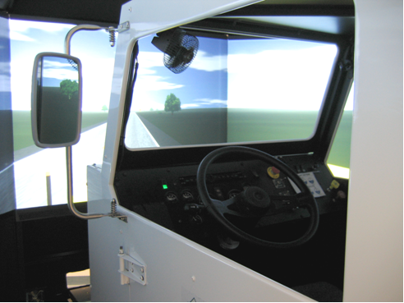
Figure 6. Photo. The TT-2000-V7 Driving Simulator
Two rear visual channels provide views through the use of real mirrors.

Data Acquisition System
The DAS installation identical to the equipment used in Experiments 1 and 2 will be used for this experiment. No modifications to the DAS will be needed and the same video views will be recorded.

Collision Warning System
The findings Experiment 2 will guide the CWS to be utilized in Experiment 3. If the results from Experiment 2 indicate significantly quicker driver reaction times when the visual alert is delayed, then Experiment 3 will also utilize a delayed visual alert. However, if no statistical significance is found, the Experiment 3 will utilize the visual alert with no delay as this is the configuration vehicle manufacturers currently implement.

Experimental Scenarios
The experimental scenarios occur on the VTTI commercial truck simulator. Only the participant vehicle and research experimenter will be present in the simulator room.
Two different scenarios will be tested in this experiment. Scenario 1 will consist of the baseline condition (ie.e., no alert) and scenario 2 with consist of ICW alert.
Table 4. Test Matrix for Experiment 3
Scenario | Vehicle | Venue | n | Starting Conditions |  |  |  | Warning
 |  |  |  | SV Speed (mph) | LV Speed (mph) | Range (m) | SV Decel (g)
1 | Truck | Track | 10 | 45 | N/A | N/A | N/A | No alert
2 | Truck | Track | 10 | 45 | N/A | N/A | N/A | ICW alert

Design
This is a between subjects design with a single exposure; however, the experimental design does have some differences from that used in Experiment 1 and Experiment 2. Being that Experiment 3 is assessing an LDW system in a simulator, a comprehensive driving route has been developed to assess lane departures. This route includes straight sections of roadway, moderate curves, and sharp curves. Both baseline participants and participant receiving the ICW alert will drive the same route.

Procedure
All participants will drive VTTI’s standard simulator orientation driving route to become accustomed to the commercial truck simulator. Once the orientation route has been completed, participants will be given a five minute break before beginning the test route. Participants will be instructed to follow the posted speed limit signs and all traffic laws. The experimenter sits behind the truck cab and provides driving route instructions. No other instructions are provided to the driver. The same music as used in Experiment 1 and Experiment 2 will be played again in Experiment 3 to act as the secondary cabin noise.

Measures and Analysis
The primary measure of interest will be reaction time to the ICW alert based as compared to the baseline condition of no alert. Both the timing of the participant’s foot lifting from the accelerator, first depression of the brake pedal, and steering wheel movement will be measured. Participant’s subjective feedback on task performance will also be assessed via questionnaire. The results of this experiment will be inform the guidelines and help shape the regulatory process for CWIs.

Expected Findings
The findings of these experiments will inform CWI design relating to the perceived luminance levels of a visual alert icon in a nighttime (Experiment 1), inform CWI design as to the benefit (or lack thereof) of delaying the visual alert with respect to the auditory alert, and demonstrate the potential benefits (or lack thereof) for applications in a lane departure warning system (Experiment 3).
As stated earlier, this project seeks to inform CWI design and implementation. This is being done in support of creating more effective CWIs. The findings of this course of research, while not able to address the entirety of the remaining research needs for CWI design, will support the design of more effective alerts.

