Dear (name):

NASA, where the first “A” stands for aeronautics, will be flying a supersonic jet offshore near Galveston this November as part of an aviation-related research program, and we are inviting you to join our test team. Seriously! The enclosed $2, which is yours to keep, no strings attached, is our way of thanking you just for reading this letter.
Here are the details: During the two-week period, our F/A-18 research jet pictured below will be flying faster than the speed of sound over the Gulf of Mexico and doing so in a way that residents of Galveston will hear what we call a “sonic thump.” This muffled sound is very different from the sonic booms you have heard about – or may actually have heard – in the past. In fact, you may not even hear the sonic thumps at all. And that’s where you can help NASA.

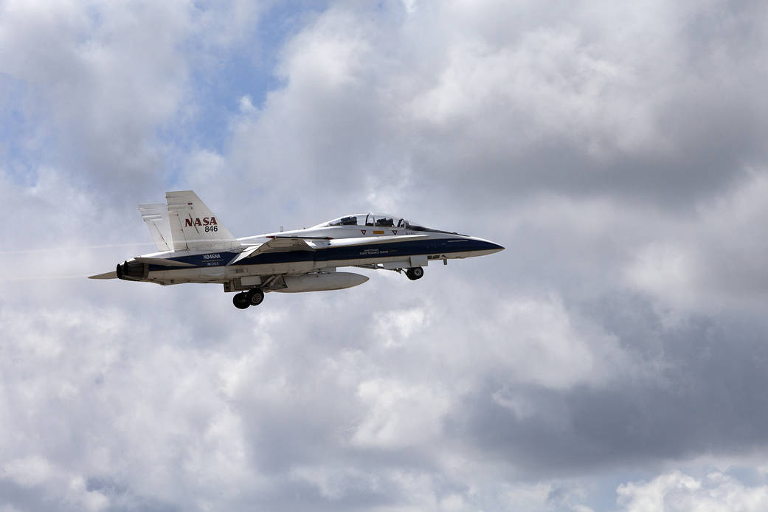
NASA F/A-18 Research Aircraft

If you volunteer, your job will be to go about your normal daily activities. When a sonic thump occurs, we want you to provide information about your location and your perception of the sound. You’ll do this by filling out a simple survey that you can access online with any computer or device you have handy. You’ll get the specific instructions after officially signing up, but we assure you filling out the survey is easy and will only take a minute or two each time you have something to report. There will be a maximum of 8 sonic thumps per day, all during the daytime.

In some cases, volunteers will be sent text messages reminding them to listen for the sound and be sure their phone or device’s location settings are turned on. This will help us pinpoint with greater accuracy who is hearing what and where they are relative to a set of audio sensors that will be strategically placed around town in locations your local authorities have approved. So, if you volunteer and wonder why we need your phone number, that’s why.

While the whole survey process is set up to be easy and take very little of your time, we also know we’re asking for time out of your busy days. So if you choose to volunteer, in addition to our sincere thanks, you will be paid $25 per week for the two weeks of the survey, for a total of $50. If after the flights begin, you choose to stop participating – which you are free to do at any time -- your payment will be pro-rated for the time you actually helped us.

Most importantly, if you are interested in volunteering, we encourage you to sign up right away at the website below and tell us a little bit about yourself. Like any statistical survey, only a limited number of the entire population are selected to participate, and in our case, it’s first come, first served. Once we have enough volunteers, the registration webpage will be closed. The website is run by Penn State University, who is helping NASA manage the survey.

Ethical review of this research study was provided by the NASA Institutional Review Board. If you have any questions regarding your rights as a research subject, how to volunteer or exactly what is expected of you, feel free to email the investigators at QSF18@nasa.gov. If you would like to participate in the survey but do not have internet access, please contact NASA at (757) 864-3186.

To learn more about this research project and register as a volunteer participant, visit this website:

http://src.survey.psu.edu/qsf18/

