(Front of Post Card. Post Card printed in Publisher.)
Penn State University
Survey Research Center
105 The 330 Building
University Park, PA 16802

Name
Address
City, State, Zip

(Back of Post Card.)

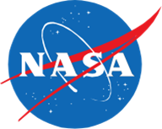

Dear (name)
A short while ago we mailed you a letter asking if you would volunteer for a NASA sponsored study about the sounds of supersonic flight. As a reminder, you will be compensated $50 for your participation in the two-week project ($25 per week you participate). If you have already responded, thank you! If you have not yet responded, you can still volunteer to participate. For more information and to enroll and complete the background survey, please visit:

http://src.survey.psu.edu/qsf18

Thank you for your willingness to participate in this research study!

