Daily Summary
Note: The survey will not be openly available online. Each participant will receive a unique link so that only those who are enrolled can complete the surveys.
Table of Contents
Daily Summary 1
Date of response with inquiry if sonic thump was heard on that date 2
Daily annoyance and startle summary 3
Time periods at or near home on that date 3
Inquire if heard thump while at home 4
Annoyance and startle summary at home 4
Time periods at or near work 5
Inquire if heard thump while at work 5
Annoyance and startle summary at work 6
Additional comments 6
End of Daily Summary Thank You 7

Date of response with inquiry if sonic thump was heard on that date

Daily annoyance and startle summary

Time periods at or near home/work on that date and other comments
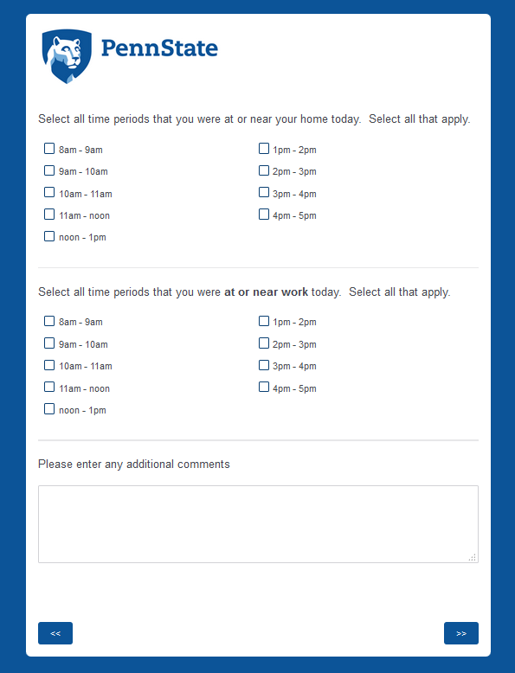

End of Daily Summary Thank You

