QSF18 Introductory and Background Surveys, and Reminder Confirmation
Table of Contents
QSF18 Introductory and Background Surveys, and Reminder Confirmation 1
Introductory page, implied informed consent and eligibility 1
Implied consent 2
Eligibility to participate 3
Background Survey 6
Social and demographics questions 8
Education 8
Self-assessment of hearing ability 9
House construction and home noise environment 10
Attitudes and experience with neighborhood noises 11
Length of time in current home; Single Event and Daily Summary instructions 12
End of Background Survey Thank You 13
Enrollment Reminder Message 13
Receipt of Reminder Confirmation 13
Reminder Confirmation Thank You 14

Introductory page, implied informed consent and eligibility
The QSF 18 survey link is: http://src.survey.psu.edu/qsf18/
QSF 18 Introductory page is shown at the top of the screen. Links to surveys are provided at bottom. The links will not be on the introductory page, as each participant will be sent a unique personal access link. All surveys are timed stamped, both start and finish.
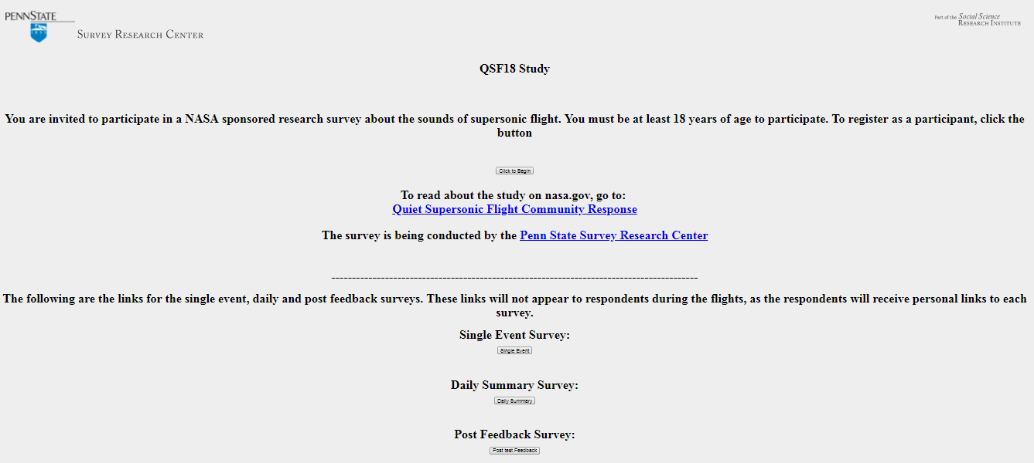
Hit Click to Begin.

Implied consent

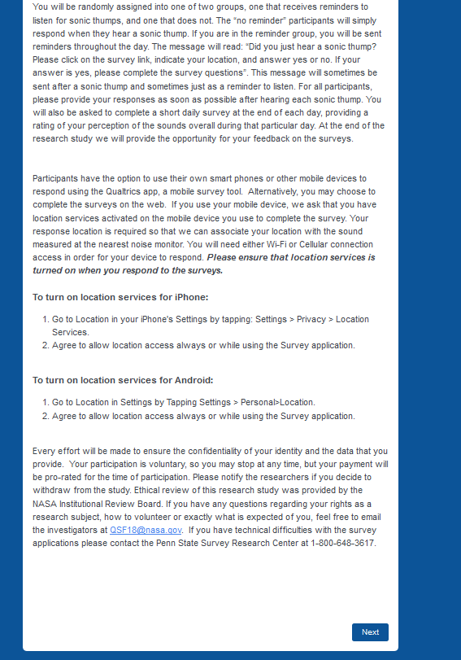

Eligibility to participate
Willing to participate:
If answer to willing to participate is No:
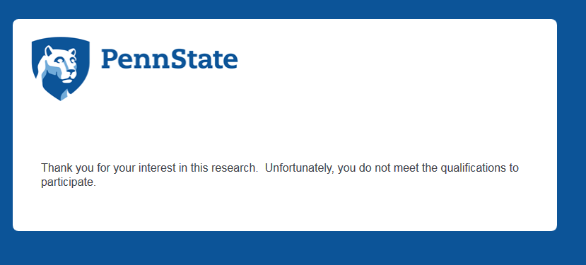
If answer to willing to participate is Yes, inquire about prior media exposure:
If answer to prior media exposure to test is No, inquire about age:
If answer to prior media exposure to test is Yes:
Inquire about media sources and age:
If answer to 18 years of age or older is No:
If answer to 18 years of age or older is Yes:
If answer is to 18 years of age is Yes, inquire about locations:
If locations answer is No:
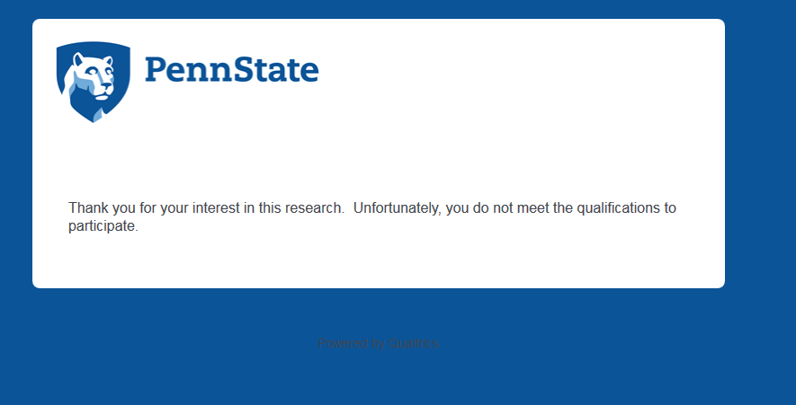
If locations answer is Yes:

END of Informed Consent and Participation Eligibility Questions. Begin with Background Survey.

Background Survey
New Survey. No back button to eligibility questions.
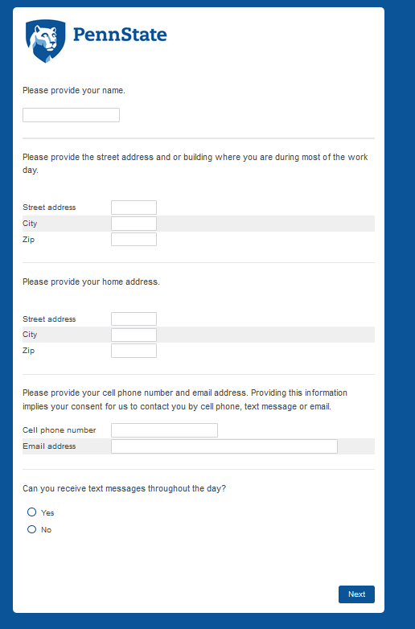
You must provide cell phone or email to proceed.

Social and demographics questions
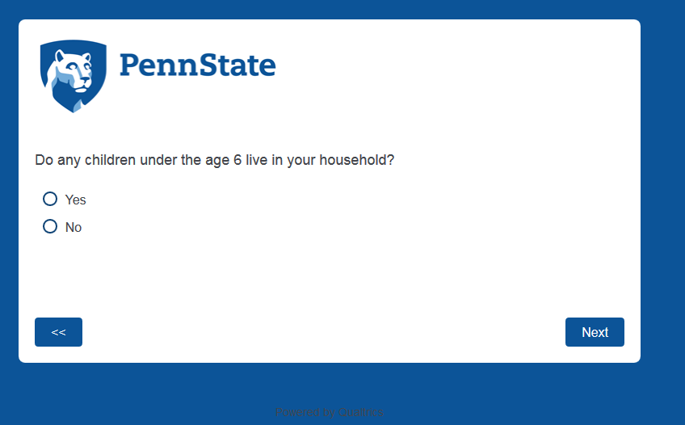
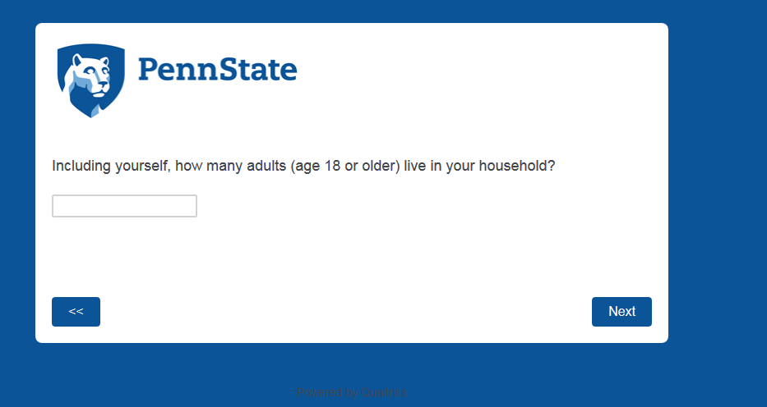

Education

Self-assessment of hearing ability
If hearing ability is diminished, inquire about hearing aids.
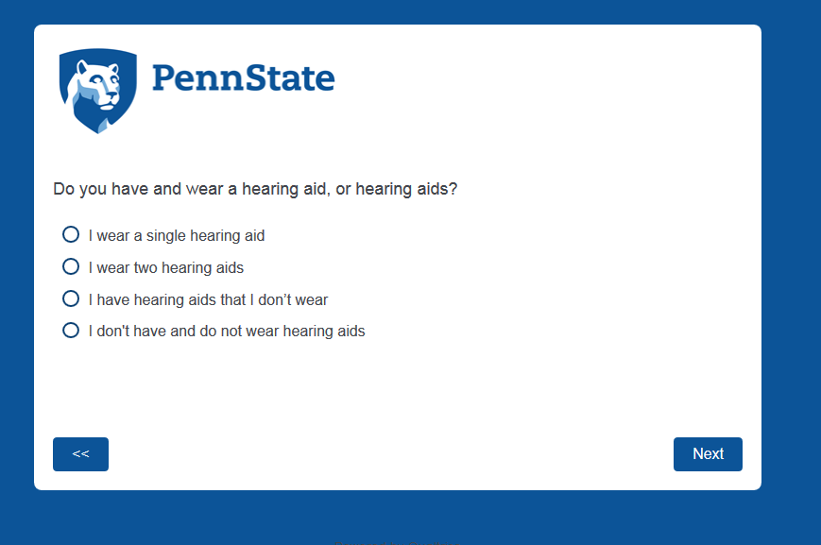

If hearing ability is normal, proceed with House construction questions.

House construction and home noise environment
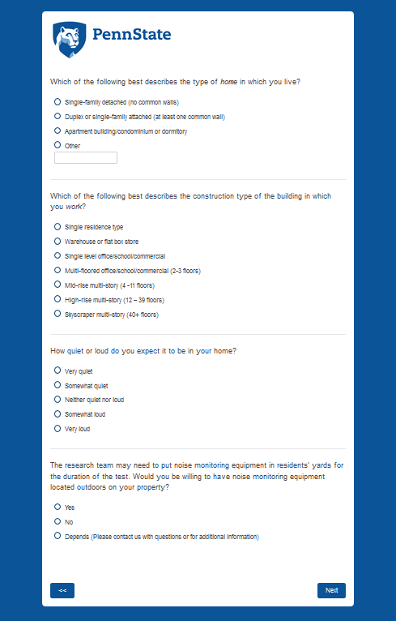

Attitudes and experience with neighborhood noises

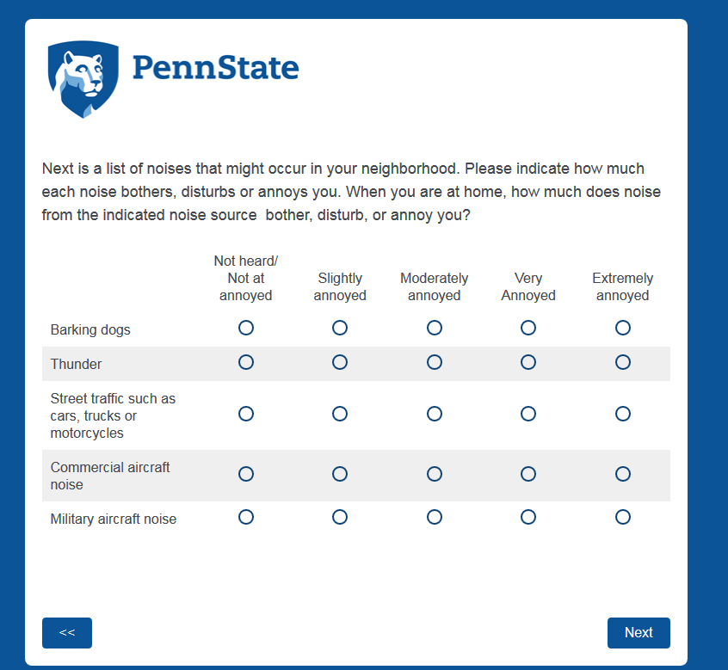

Length of time in current home; Single Event and Daily Summary instructions

End of Background Survey Thank You

Enrollment Reminder Message
Qualtrics will generate a unique link for each respondent. The reminder message will read: You recently volunteered for a NASA sponsored study. You are in the reminder message group, so please click the link to verify: (Qualtrics generated small link).

Receipt of Reminder Confirmation

Reminder Confirmation Thank You

