# QSF18 Post Test Feedback

Table of Contents

QSF18 Post Test Feedback 1

Ease of understanding and completing surveys 2

Clarity of Daily Summary 3

Ease of using Geo-location 4

Helpfulness of Text Notifications 5

End of Survey Thank You 5

## Ease of understanding and completing surveys

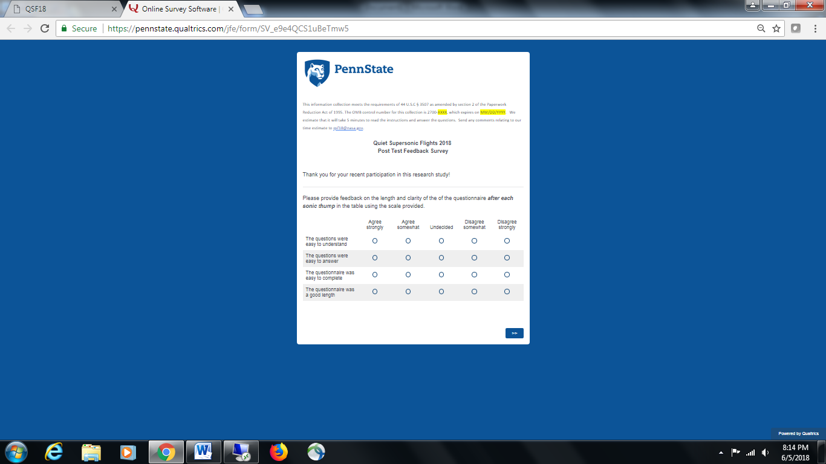

## Clarity of Daily Summary

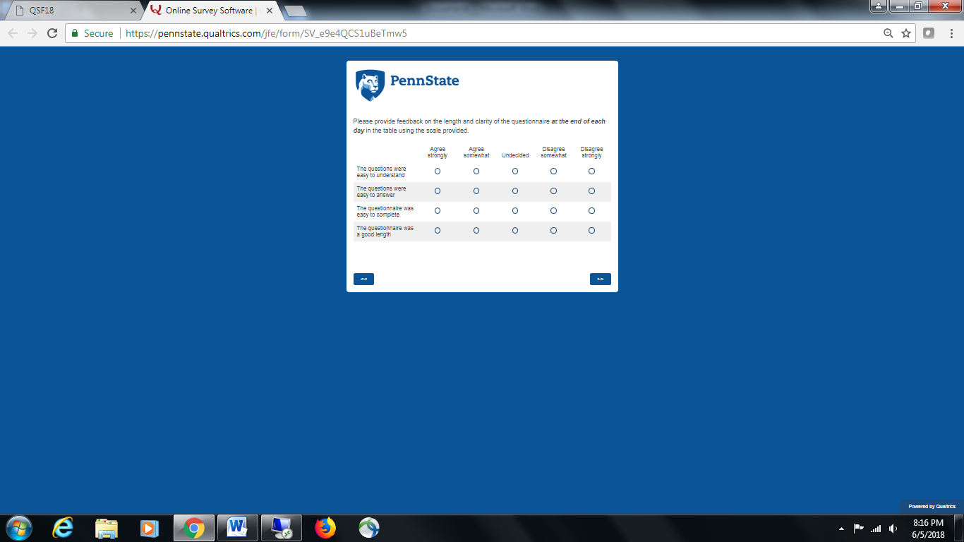

## Ease of using Geo-location

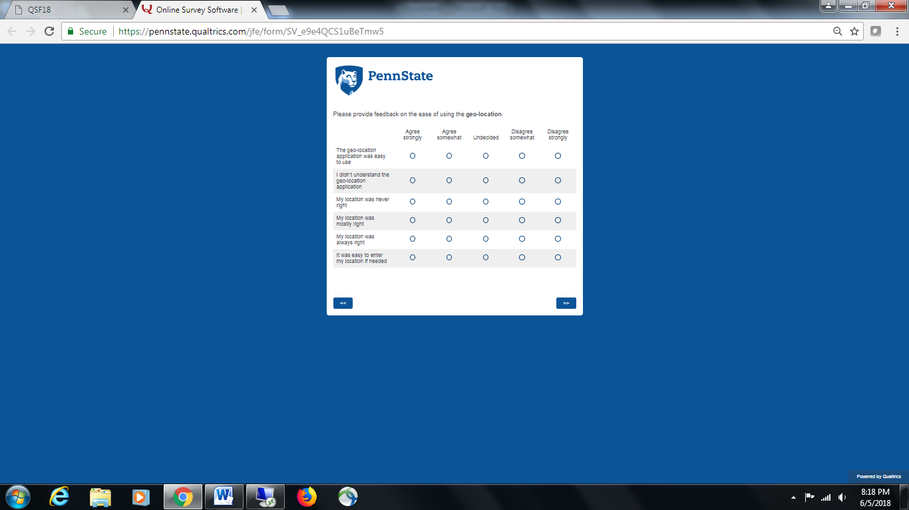

## Helpfulness of Reminders

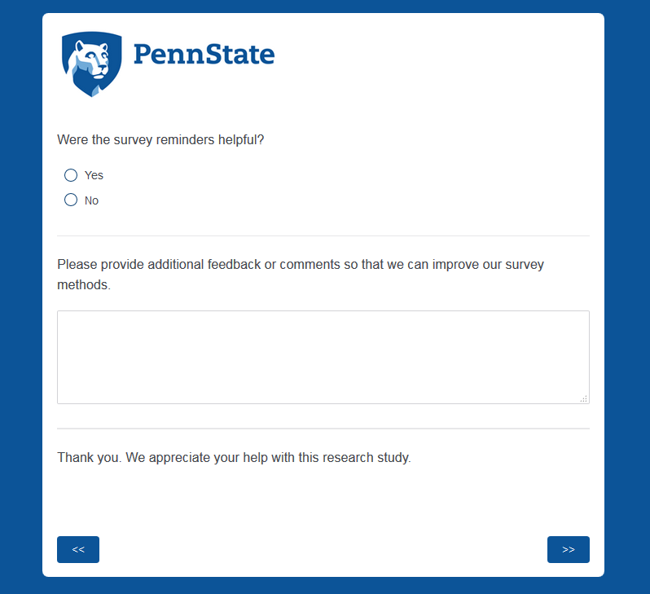

## End of Survey Thank You

