QSF18 Single Event
Note: The survey will not be openly available online. Each participant will receive a unique link so that only those who are enrolled can complete the surveys. All surveys are timed stamped, both start and finish.
Table of Contents
QSF18 Single Event 1
Location verification with sonic thump inquiry 2
Date and time of sonic thump 5
Annoyance and perceptual response questions 6
Vibration and startle questions 7
Windows open or closed 7
Additional comments 8
End of Single Event Thank You 8

Location verification with sonic thump inquiry
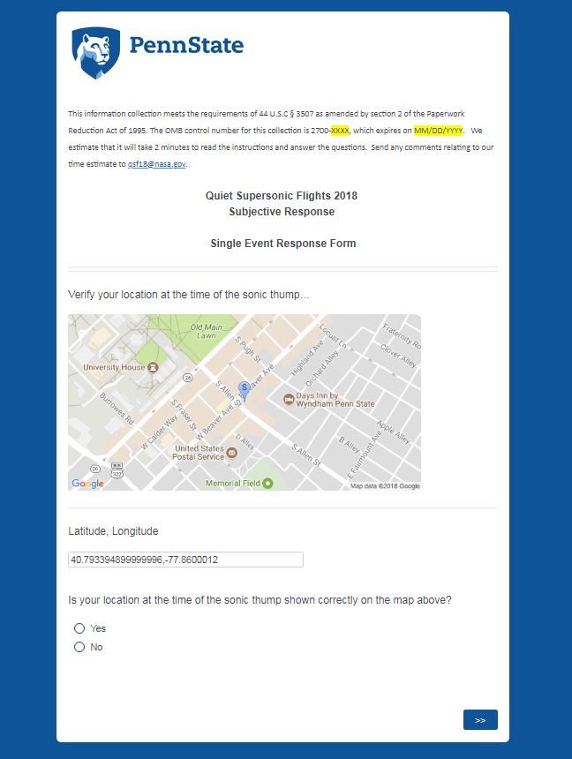
If verification of location is No, obtain address. Then inquire if participants heard a sonic thump.
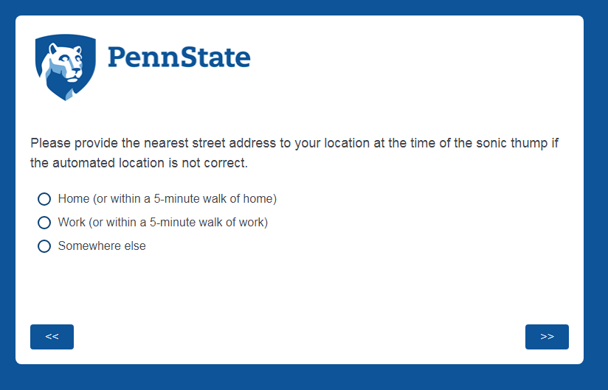
Somewhere else selected:
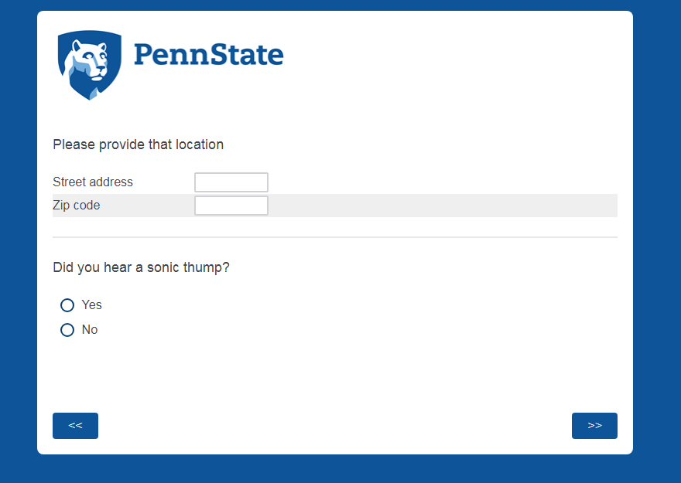

If No sonic thump heard, thank respondent and record response.
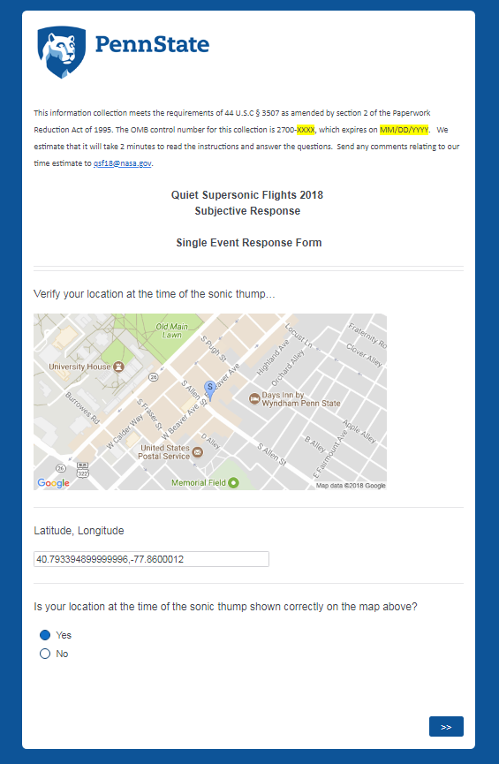

If location is verified, inquire if heard sonic thump.
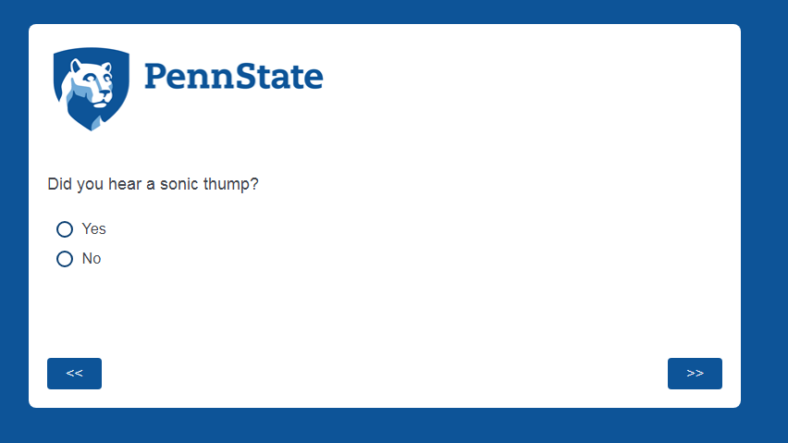

Date and time of sonic thump

Annoyance and perceptual response questions

Vibration and startle questions

Windows open or closed

Additional comments

End of Single Event Thank You

