Support Statement for Information Collection Requirements

Waveforms Sonic Boom Perception and Response Risk Reduction (WSPRRR) Program

Form names and numbers:
OMB Control Number: -xxxx

OMB 83I states: A Supporting Statement, including the text of the notice to the public required by 5 CFR 1320.5(a)(i)(iv) and its actual or estimated date of publication in the Federal Register, must accompany each request for approval of a collection of information. The Supporting Statement must be prepared in the format described below, and must contain the information specified in Section A below. If an item is not applicable, provide a brief explanation. When Item 17 of the OMB Form 83-I is checked "Yes", Section B of the Supporting Statement must be completed. OMB reserves the right to require the submission of additional information with respect to any request for approval.

Part A. Justification
1. Need for the Information Collection: Explain the circumstances that make the collection of information necessary. Identify any legal or administrative requirements that necessitate the collection. Attach a copy of the appropriate section of each statute and regulation mandating or authorizing the collection of information.
Supersonic flight over land is currently restricted in the U.S. and many countries because sonic boom noise disturbs people on the ground and can potentially damage private property. NASA has developed a method for generating low level sonic boom noise similar to that anticipated for quiet supersonic flight. As sufficient research is assembled, there is potential for a change in federal and international policy.
The Waveforms Sonic Boom Perception and Response Risk Reduction (WSPRRR) test will utilize a specialized maneuver developed by NASA using an existing F-18 research aircraft to correlate human annoyance response with low level sonic boom noise in a community setting. This effort is designed to evaluate remote aircraft basing and operations, community engagement, sonic boom measurements, and community annoyance surveys. The effort will improve research methods for future community-scale response testing using a purpose-built, low boom flight demonstration aircraft (LBFD).

NASA supported two prior risk reduction field tests to evaluate data collection methods for low boom community response at Edwards Air Force Base (EAFB) in November 2011(see ref. 1&2). The findings from both studies are not readily generalizable to a larger population, as the residents at EAFB are accustomed to hearing full level sonic booms on a routine basis.
2. Use of this Information: Indicate how, by whom, and for what purpose the information is to be used. Except for a new collection, indicate the actual use the agency has made of the information received from the current collection.
The outcomes from this F-18 low boom community noise test will provide guidance for the development of the future LBFD tests by developing methods for noise measurement, dose estimation techniques, and the validation of survey methods. The research will assess acceptability of low level sonic boom noise, with the premise that the variables influencing acceptability are stimulus factors, situational factors, and psychosocial factors. Analysis of the data gathered will provide understanding of the association of various noise metrics with the annoyance response. The findings will be published in technical reports that will be available to interested users, such as government officials, aircraft designers, and other researchers. The field test design is modeled after a similar community test conducted on annoyance response from blast military training noise (Pater, 2007) which was sponsored by the Strategic Environmental Research and Development Program under OMB Approval No. 0710-0015.
The low boom is a new noise source. Past sonic boom research evaluated full scale booms, with levels that were approximately 1 psf or greater. The low booms are anticipated to be much lower in level, approximately 0.2 to 0.6 psf.
Single event ratings and cumulative daily ratings are needed to compare to federal policy and other research assessments of aviation noise annoyance. Currently FAA quantifies aircraft noise exposure using the Day-Night Average Sound Level (DNL), which is a cumulative, 24-hour equivalent sound level based on annual aircraft operations. Both single event and daily cumulative noise levels and survey responses are being gathered, to provide a comprehensive dose response data set. The low boom noise from overland supersonic operations will affect a much larger percent of the population than the noise from the takeoff and landing operations at airports. The proposed effort is aimed at providing answers to the following questions:

- At what single event and/or cumulative daily level (threshold) of low boom noise does a community become annoyed?
- What percentage of people are annoyed at a given level of low boom noise?
- What percentage of booms go unnoticed for a given noise level?
- How much does annoyance change with a change (either an increase or decrease) in the number of low boom noise events for the same cumulative level?
- How are categorical attributes such as vibration, rattle and startle related to the annoyance response?
The survey includes automated geo-location to analyze the annoyance response data at the time of the boom to estimate the noise dose. The responses to the survey questions will provide data to assist in interpreting the results of the dose-response models.
- Use of Information Technology: Describe whether, and to what extent, the collection of information involves the use of automated, electronic, mechanical, or other technological collection techniques or other forms of information technology, e.g., permitting electronic submission of responses, and the basis for the decision for adopting this means of collection. Also describe any consideration of using information technology to reduce burden.
Information Technology is implemented by using both smart phone and web- based surveys for the modes of response, text messages to prompt responses and the use of GPS to identify the respondents’ location. The survey instruments will be mobile enabled web surveys programmed into The Pennsylvania State University Survey Research Center’s (SRC) Qualtrics survey platform. Qualtrics is a mobile enabled web based survey software platform that provides the latitude and longitude position of a GPS-enabled device. The SRC has also implemented a prototype front-end mapping application that provides a visual map and allows the respondent to provide a location if the automated system is not accurate. All data collected using the mobile enabled web surveys will include time stamps and automated approximate geographic coordinates.
Prior low boom noise research (NASA/CR-2014-218180) compared paper, web and smart-phone based interviews to assess residents’ annoyance response. The smart phone had a 45% response rate, paper had 58% and web had 50% for an aggregate response rate of 51% across all modes. The smart phone and web based response modes were chosen for this test because response rates were similar and they provide ease of access for the respondent and facilitate implementation.
Participants will be asked to rate their perception of the low booms each time they notice a sonic boom event, and to provide a daily summary of their low boom perceptions. The respondent will provide consent to have location services enabled on their device and to allow their location to be retrieved and sent through the mobile survey.
The use of technology reduces participant response burden as they are afforded the opportunity to use their privately owned, readily available device. The technology also reduces burden to the research team as it provides an automated method to gather and tabulate data.
4. Efforts to Identify Duplication: Describe efforts to identify duplication. Show specifically why any similar information already available cannot be used or modified for use for the purposes described in Item 2 above.
The proposed research is the first flight test of this new noise source over a “non-acclimated” community to gather data to correlate human annoyance with low level sonic boom noise. Previous tests of low level booms have been conducted to evaluate data collection methods over an “acclimated” community of residents accustomed to hearing full booms. The acoustics literature on full booms and similar impulsive noises were studied extensively. Relevant references are provided at the end of Section B.
5. Burden on Small Business: If the collection of information impacts small businesses or other small entities (Item 5 of OMB Form 83-I), describe any methods used to minimize burden.
Collection of this information does not have a significant impact on small businesses.
6. Consequences of Not Collecting the Information: Describe the consequence to Federal program or policy activities if the collection is not conducted or is conducted less frequently, as well as any technical or legal obstacles to reducing burden.
This information is not scheduled to be collected by any other agency or program. This information collection is a risk reduction measure to allow NASA to refine techniques to assess and predict human response to low boom noise. Non-collection of this data places additional risk on future dose-response tests with the LBFD.
7. Special Circumstances: Explain any special circumstances that would cause an information collection to be conducted in a manner:
Low booms are a new noise source. Previous full scale booms were approximately 1 psf or more, and sounded like fireworks. The low boom sounds more like distant thunder. It is anticipated that the flight design for the noise dose schedule will include 7 days of flights over a 10-day test period, allowing for days with no booms due to weather, flight circumstances or simply as ‘rest’ days. The number of booms per day will vary throughout the test, with a typical range of 0 to 6 booms per day, and a potential for 8 booms maximum per day.
8. Consultation and Public Comments: If applicable, provide a copy and identify the date and page number of publication in the Federal Register of the agency's notice, required by 5 CFR 1320.8(d), soliciting comments on the information collection prior to submission to OMB. Summarize public comments received in response to that notice and describe actions taken by the agency in response to these comments. Specifically address comments received on cost and hour burden.
The 60-day and 30-day Federal Register notice were published for comments. The 60-day Federal Register Notice xx-xxx was published on mm/dd/2017, FRN Vol xx, page xxxxx.
The 30-day Federal Register Notice was published on mm/dd/2017, FRN Vol xx, page xxxxx.
- Payments to Respondents: Explain any decision to provide any payment or gift to respondents, other than remuneration of contractors or grantees.
The Baseline Survey Recruitment Mailing includes a printed survey, a cover letter, a business reply envelope and a $2 token incentive sent to all potential recruits. At the end of each week in which participants maintain full participation, they will be compensated $25. The total compensation per respondent who completes the surveys every day for two weeks is $52.
The use of a token is recommended in the Tailored Design Method (Dillman, Smyth and Christian, 2009) recruiting strategy which utilizing a targeted Address Based Sampling (ABS) approach. A small pre-incentive of $2 can increase response rates by 10 to 15%.
- Assurance of Confidentiality: Describe any assurance of confidentiality provided to respondents and the basis for the assurance in statute, regulation, or agency policy.
The survey will conform to the practices as approved by the Institutional Review Board at The Pennsylvania State University and NASA Langley Research Center. Each survey respondent will be told that their responses are voluntary and their identities will not be associated with their responses. As such, their responses are treated as confidential. All individuals who participate, will be assigned a unique identification number that will be associated with their survey responses. The participants name, email, cell phone number and address will be used for test communications and determination of noise dose. The contact information will be destroyed within a reasonable period after the completion of the field test.
All subjective data sources will be merged into a single data set that will allow for detailed analysis. All personally identifiable information will be removed from the data and will only be linked by case ID
11. Sensitive Questions: Provide additional justification for any questions of a sensitive nature, such as sexual behavior and attitudes, religious beliefs, and other matters that are commonly considered private. This justification should include the reasons why the agency considers the questions necessary, the specific uses to be made of the information, the explanation to be given to persons from whom the information is requested, and any steps to be taken to obtain their consent.
There are no questions of a sensitive nature in any of the information collection protocols.
12. Respondent Burden Hours and Labor Costs: Provide estimates of the hour burden of the collection of information.
The following sections (A –E) are addressed in the Tables provided below.
- ANNUAL BURDEN HOURS:

The maximum total burden across respondents over the 2 week test is 2000 hours, assuming 500 respondents and 4 hours per respondent. See supporting tables below.
- NUMBER OF RESPONDENTS:

See discussion on sample size based on noise exposure in Part B.

C. RESPONSES PER RESPONDENT:

D. AVERAGE BURDEN PER RESPONSE:

E. FREQUENCY OF RESPONSES:

Total Cost Burden of Responses per Respondent
Survey Instrument | Time per respondent  (minutes) | Frequency of response  (#/day) | Frequency of response over test  (#days/test) | Total time per respondent  (minutes) | Total across all 500 respondents, minutes  (hours)
Background | 15 |  | 1 | 15 | 7500  (125)
Single Event | 2 | 10 (max) | 10 (max) | 200 | 100,000 (1666.66)
Daily Summary | 2 | 1 | 10 (max) | 20 | 10,000  (166.66)
Post Test | 5 |  | 1 | 5 | 2,500  (41.67)
Total |  |  |  | 240 | 120,000  (2,000)

Annualized Cost to Respondent
Survey Instrument | Total across all 500 respondents, minutes  (hours) | Hourly wage rate  $7.25 | Respondent Cost
Background | 7500  (125) | $7.25 | $906.25
Single Event | 100,000  (1666.66) | $7.25 | $12083.29
Daily Summary | 10,000  (166.66) | $7.25 | $1208.29
Post Test | 2,500  (41.67) | $7.25 | $302.11
Total | 120,000  (2,000) | $7.25 | $14500.00
13. Estimates of Cost Burden to the Respondent for Collection of Information: Provide an estimate for the total annual cost burden to respondents or record keepers resulting from the collection of information. (Do not include the cost of any hour burden shown in Items 12 and 14).
No additional cost burden will be imposed on respondents aside from the labor cost of the burden hours shown above.
14. Cost to the Federal Government: Provide estimates of annualized costs to the Federal government.
The annual costs of Federal employees for monitoring the contract are estimated to be $90,000, or 0.5 FTE. This estimate includes time spent by the Technical Monitor, as well as the contracting officer and other NASA employees who participate in technical interchange meetings and reviews.
The contractor team is currently funded at $1,593,634 total over a 3 year period for planning, executing and analysis of the data from the community tests.
NASA is concurrently supporting the flight team for this test. This includes daily ground and flight support for 3 F-18 flights per day over the course of a 2-week test. The NASA field team will be at the remote field location over a 3 week period. The estimated cost to NASA for this portion of the research support is $900,000 including aircraft flight costs (research and deployment), civil servant/NASA contractor labor and travel for about 19 days.
15. Changes in Burden: Explain the reasons for any program changes or adjustments reported in Items 13 or 14 of the OMB Form 83-I.
This is a new information collection. No change in the burden is anticipated.
16. Publication of Results: For collections of information whose results will be published, outline plans for tabulation and publication. Address any complex analytical techniques that will be used. Provide the time schedule for the entire project, including beginning and ending dates of the collection of information, completion of report, publication dates, and other actions.
A comprehensive report to NASA is planned upon completion of the research and will be published as a NASA Contractor Report (CR) freely available on the NASA Technical Reports Server. Findings will be published in peer-reviewed journals and may be presented at appropriate conferences and published in professional refereed journals.
17. If seeking approval to not display the expiration date for OMB approval of the information collection, explain the reasons that display would be inappropriate.
Not applicable. This research will display the expiration date for OMB approval of this information collection on the background survey/consent document.
18. Explain each exception to the certification statement identified in Item 19, "Certification for Paperwork Reduction Act Submissions," of OMB Form 83-I.
Not applicable. There are no exceptions to the certification statement.

Part B. Collections of Information Employing Statistical Methods
Noise metrics will be calculated for each single boom event and for daily cumulative noise exposure. The variables that influence the annoyance response are the noise stimulus factors, situational factors, and psychosocial factors.
The Steven’s Mark VII calculation, PLdB, derives the perceived level of loudness (Stevens, 1972). It is a single number rating for outdoor sonic boom level that correlates with human assessment of loudness. The PLdB metric implemented here for sonic booms is an approximation of Steven’s Mark VII Perceived Level and is calculated using a time constant of 70 msec (Shepherd and Sullivan, 1991).
1. Potential respondent universe
The PSU Survey Research Center is obtaining the potential sample using address based sample (ABS) from Survey Sampling International (SSI). Typically, Zip Codes are used to define a survey community, but smaller geographies can be used. The target population is residents exposed to low booms created by the F-18 dive maneuver, whether they are at home or away from home. The sampling frame consists of all residences within predicted sonic boom noise contours (Page and Downs, 2017) using PCBoom6 (Page et al., 2010). Actual sonic boom levels will be obtained via acoustic measurements during the community response test. The target community will be divided into geometric grid cells under the boom footprint and census definitions (i.e., census tracts, block groups or blocks) may be used for greater geographic precision.
2. Procedures for the Collection of Information
- Statistical methodologies for stratification and sample selection
The research plan is to sample from the population utilizing a targeted ABS approach towards a goal of reaching 500 respondents to complete the pre-survey and participate in the single-event and End of Day/End of Night surveys. The recruiting strategy utilizes a Tailored Design Method (Dillman, Smyth and Christian, 2009) approach to reach 2000 homes in the targeted area. A complete enumeration of households will be conducted within the calculated boom footprint area across the community, from which a random sample of households will be selected for recruitment using Address Based Sampling. In areas with sufficient population density, a systematic random sample will be selected by determining a random starting point on the enumerated list of available households and using a sampling interval. The interval will be based on the ratio of required respondents to the total number of available households in that area. For each household recruited, we will ask for the person over 18 years of age with the most recent birthday to identify the resident that would participate. The contact interview ensures that respondents both live and work within the expected sonic boom footprint area.
- Sample size
To evaluate the sample size required, we mimic the analysis outlined in "Research Methods for Understanding Aircraft Noise Annoyances and Sleep Disturbance", released by the NAS in 2014. As such, data simulation of varying sample sizes evaluates the effect of the sample size on both precision of our estimation of important model parameters and, similarly, the power to detect significant model parameters, varying the significance of parameters under investigation. Informed guesses for the many required inputs to the simulation are obtained from the 2011 WSPR study (Page et al, 2012) and a recent 2018 study of NASA Armstrong Flight Research Center (AFRC) personnel response to sonic booms conducted in 2017. Data from these events was utilized to assess:
- reasonable response rates for participants,
- reasonable values for quantities governing the dose-response relationship,
- reasonable annoyance response profiles.
A review of data from these two studies indicate that response rate can vary from ~7% to 45% on average. These studies differ from the planned community response test as follows:
- The participants were at home during WSPR 2011 or at work during the recent 2018 study of AFRC personnel. During the community response test the participants are expected to be freely mobile and busy with work/life events which may affect their response rate.
- During WSPR 2011 and the recent 2018 AFRC study, all participants were residents or employees on Edwards Air Force Base that were familiar with sonic booms and motivated to support each of the studies. One of the major objectives of the planned community response test is to engage a “non-acclimated” population in an area where sonic booms do not normally occur. We anticipate this population to provide a different response rate than what was observed during the previous studies.
- During WSPR 2011 and the recent 2018 AFRC study, the participants were exposed to some sonic booms which were louder than what is planned for the community response test. The community response test will employ sonic booms of the level anticipated to be delivered by the LBFD aircraft.
Given these differences several values were explored for average response rate in the range of what was observed during the previous studies. A conservative value of 7% was selected to ensure adequate capture of data to support statistical analysis of the current effort. This approach provides conservative estimates of statistical power and precision in the case that the response rates are higher. The WSPR 2011 effort presented boom levels comparable to the current proposed effort, and exhibited a slope of approximately 0.06 for the PL metric. Therefore, slopes from 0 (no relationship) to 0.03 are explored as a conservative estimate.
Using each sample size, and true value of the slope under investigation, we simulate 100 datasets as described above to assess whether a non-zero slope is detected and the degree of accuracy of the estimated slope (Figure 1). According to Figure 1b, there exists power to detect a relationship half as large as in WSPR 2011 (slope of .03 vs. .06) with a sample size of 300 (i.e. 300 total participants would detect this nearly 100% of the time, according to simulations). However, we expect far less annoyance due to low boom noise, and conservatively note that to achieve 80% power in detecting a relationship that is roughly 75% smaller (~.015), we need between 400-500 participants in total.
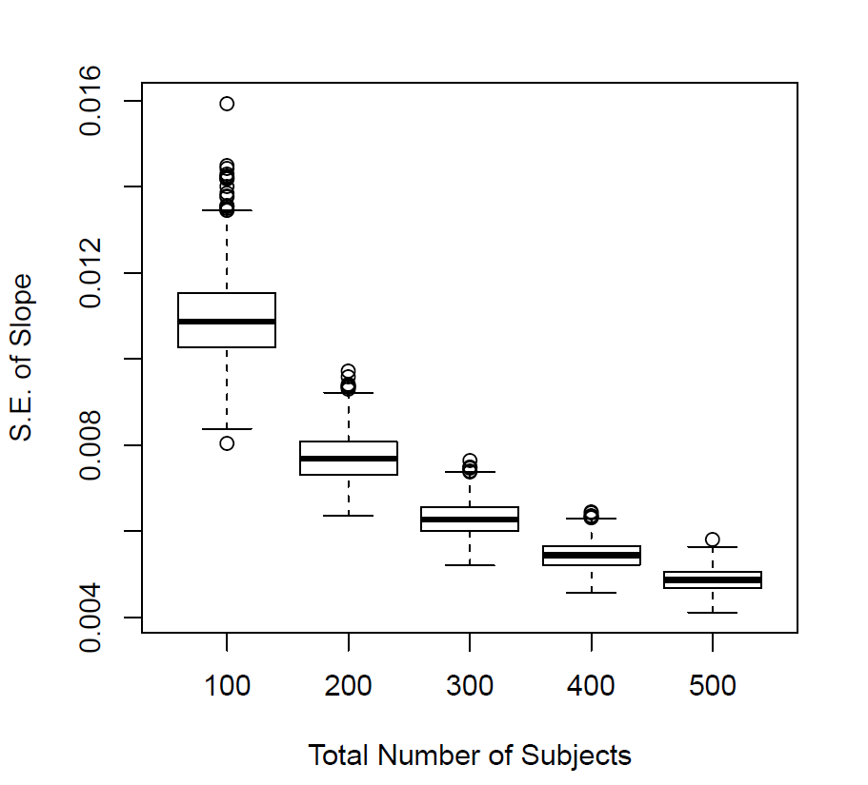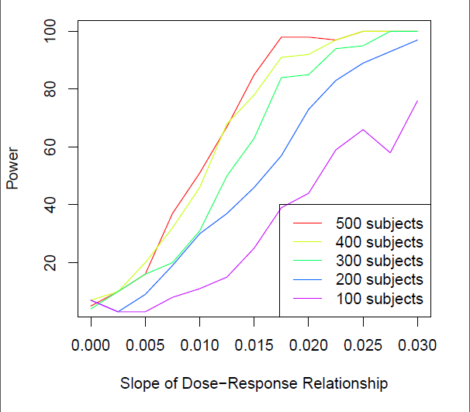
Figure 1a (Left): Precision for Slope with average 7% response rate. Figure 1b (Right): Power to Detect Various Slopes of Dose-Response Relationship as a Function of Sample Size for an average response rate of 7%

- Estimation Procedures and Analysis Model

The focus of the intended survey is annoyance response, thus single event annoyance will be rated after each boom event and a daily summary will provide a cumulative measure of annoyance.
The proposed research model is a multi-variable analysis model. Data will determine the components of the dose-response model of annoyance. The annoyance response is a function of non-noise co-variables, noise effects, and random effects, as outlined in the form: Y = XB + B_{M}Met + ZA + E, where:
Y is the annoyance response to be modeled, which is a function of:

Non-noise co-variables:
X is a matrix of covariates that interact with the annoyance response
B is a px1 vector of coefficients to be estimated

The non-noise co-variables include respondent factors such as demographics, attitudes, or household composition.

Noise effects:
B_{M} is a coefficient indicating the effect of the objective measure of noise
Met is a vector of the objective measures of noise

The noise effects include noise factors such as the noise level or number of booms in a day.

Random effects:
Z is a nxk matrix of random effects (e.g. respondent)
A is a kx1 vector of random variables
E is a nx1 vector of estimation errors

The random effects include individual variables such as health, or community wide effects such as stormy weather.
Y is the annoyance response (single events or daily summary) that is being modeled. The proposed analysis model is a random intercepts and/or random slopes model for the annoyance response and associated attributes. This can be treated as a generalized linear mixed model that could be fit in software such as the Statistical Analysis System (SAS).

- Degree of accuracy needed for the purpose described in the justification
As discussed in the sample size section above, the 2011 WSPR study would indicate that a maximum standard error for the slope of .06 would be acceptable. For our conservative order of magnitude reduction line of thinking, a maximum standard error for the slope of .0075 would be acceptable.

- Unusual problems requiring specialized sampling procedures, and
We are conducting a noise dose response test. The households included for sampling will be within the calculated boom footprint area across the community, rather than from the community at large.

- Any use of periodic (less frequent than annual) data collection cycles to reduce burden.
The community noise impact data that will be gathered is for a new noise source. It is anticipated that the flight design for the noise dose schedule will include 7 days of flights over a 10 day test period. See A7.

3. Maximization of Response Rates, Non-response, and Reliability
To maximize response rate, the survey instruments are accessible by web or smart phone to facilitate ease of access and to be more respondent-friendly.
The initial Background survey mailing includes an introductory letter that includes information on how to complete the survey on-line, a printed copy of the survey, a business reply envelope, and a token $2 incentive. Additionally, incentive compensation of $25 per week encourages continued participation throughout the two-week survey period.
Text messages will be used to encourage the completion of Background Survey, Single-Event surveys, and the Daily Summary Survey. A link to the survey will be embedded within the text messages.
4. Tests of Procedures or Methods
This noise research assesses community annoyance and response associated with low level sonic boom noise. Respondents’ home and work addresses will be gathered at the time of their recruitment and noise levels will be measured by an array of distributed monitors throughout the community. These data are used to estimate respondents’ single event exposure from noise levels measured at the closest noise monitor to their location. As we receive responses to single events, the time of response brackets the noise exposure for that individual event. For cumulative daily exposure, respondents will indicate whether they were at home or work for the morning, afternoon, and/or the entire day. These data, along with individual event geo-location data, allows for a determination of respondents’ daily cumulative noise exposure.
These procedures and implementation methods for information collection will follow generally accepted social science research standards. A test of methods for was undertaken in the 2011 WSPR program (NASA/CR-2014-218180). An additional risk reduction assessment was conducted in May 2017 at NASA Armstrong Flight Research Center (APS Report 3494-420 REV, APS Report 3494-419-4-REV).
5. Statistical Consultation and Information Analysis

Standards and guidelines published by the International Commission on the Biological Effects of Noise (ICBEN) have been reviewed to develop survey questionnaire wording (Fields, 2001).

PSU Survey Research Center will gather and tabulate the data for analysis. Gaugler Consulting will conduct statistical analyses. In addition, our team contains several individuals with well-recognized expertise in noise and dose-response research who will contribute to the interpretation of the findings. The team includes researchers from APS, Eagle Aeronautics, Gulfstream Aerospace, Penn State University, Volpe National Transportation System Center, US DOT, KBR Wyle, and Gaugler Consulting.

PSU contact:  Kathleen Hodgdon  Applied Research Laboratory, The Pennsylvania State University  814-865-2447 | Statistical Analysis:  Dr. Trent Gaugler  Gaugler and Associates  610-330-5328
References
CHABA (1996). Fidell, S. (editor), “Community Response to High-Energy Impulsive Sounds: An Assessment of the Field since 1981,” Committee on Hearing, Bioacoustics and Biomechanics, National Research Council, Wash. D.C., National Academy Press.
Fields, J.M. (1997). ‘‘Reactions of Residents to Long-term Sonic Boom Noise Environments,’’ NASA Contractor Report 201704, 1–157.
Cohen, J. “A Power Primer.” Psychological Bulletin, July 1992: 112, 1.
Dillman, Don A., Smyth, Jolene D., Christian, Leah Melani. 2009. Internet, Mail and Mixed-Mode Surveys: The Tailored Design Method, 3rd edition. John Wiley: Hoboken, NJ.
Fidell, S., Mestre, V., Schomer, P., Berry B., Gjestland, T., Vallet, M., and Reid, T. A first-principles model for estimating the prevalence of annoyance with aircraft exposure. J. Acoust. Soc. Am. 130, 791-806 (2011).
Fidell, S. et.al, The “Pilot Test of a Novel Method for Assessing Community Response to Low-Amplitude Sonic Booms” NASA/CR-2012-217767
Fields, J.M., R.G. De Jong, T. Gjestland, I.H. Flindell, R.F.S Job, S. Kurra, P. Lercher, M. Vallet, T. Yano, R. Guski, U. Felsheur-Suhr, and R. Schumer (2001). “Standardized General Purpose Noise Reaction Questions for Community Noise Surveys: Research and a Recommendation.” Journal of Sound and Vibration 242:641-679.
Groothuis-Oudshoorn C.G.M. & Miedema H.M.E. Multilevel grouped regression for analyzing self-reported health in relation to environmental factors: the model and its application. Biom. J. 2006, 48 (1) 67-82.
Hodgdon, Kathleen K.; Page, Juliet. “Low amplitude sonic boom noise exposure and social survey design.” The Journal of the Acoustical Society of America vol. 133 issue 5 May 2013. p. 3368-3368. DOI: 10.1121/1.4805768. ISSN: 0001-4966.
Hodgdon, Kathleen K.; Page, Juliet; Gaugler, Trent; Phillips, Daisy; Shumway, Durland; Rosenberger, James. “Statistical analysis of community response to low amplitude sonic boom noise.” The Journal of the Acoustical Society of America vol. 133 issue 5 May 2013. p. 3369-3369. DOI: 10.1121/1.4805772. ISSN: 0001-4966.
Hodgdon, Kathleen K., Robert P. Hunte, Juliet A. Page, Robert A. Cowart, Domenic J. Maglieri, Kevin A. Bradley, Trent A. Gaugler, “Armstrong Flight Research Center Waveforms and Sonic boom Perception and Response Risk Reduction (WSPRRR) Test Plan” , APS Report 3494-420 REV, Submitted to NASA for publication January 2017.
Hunte, Robert P., Kathleen K. Hodgdon, Juliet A. Page, Robert A. Cowart, Domenic J. Maglieri, Kevin A. Bradley, Trent A. Gaugler, “ NASA Low Boom Flight Demonstrator Community Response Pre-Test Armstrong Flight Research Center May 8-12, 2017, APS Report 3494-419-4-REV, Submitted to NASA for publication May 2017.
ISO 1996-1:2016 Acoustics -- Description, measurement and assessment of environmental noise -- Part 1: Basic quantities and assessment procedures.
International Standards Organization 2003. ISO 15666: 2003, “Acoustics – Assessment of noise annoyance by means of social and socio-acoustic surveys”.
Krecker, P., Koenig, C., Page, J., Hodgdon, K., Cowart, R., “Using Mobile Devices to Measure Subjective Responses to Low Boom Noise: A Comparison with Web and Paper” Prepared for the 37th Annual Conference of the Midwest Association for Public Opinion Research, November, 1, 2012.
Maglieri, Domenic J., Percy J. Bobbitt, Kenneth J. Plotkin, Kevin P. Shepherd, Peter G. Coen, David M. Richwine, 2014. Sonic Boom, Six Decades of Research, NASA/SP-2014-622, NASA Langley Research Center, Va.
Messer, Benjamin L. & Don A. Dillman. 2011. “Surveying the general public over the Internet using addressed-based sampling and mail contact procedures.” Public Opinion Quarterly, 75(3):429-57.
Nykaza, Edward T; Hodgdon, Kathleen K.; Gaugler, Trent; Krecker, Peg; Luz, George A., “On the relationship between blast noise complaints and community annoyance” The Journal of the Acoustical Society of America, Volume 133, issue 5 (May 2013), p. 2690-2698. DOI: 10.1121/1.4795781. ISSN: 0001-4966.
Nykaza, E. T. ; Valente, D. ; Swift, S H ; Danielson, B.; Krecker, P ; Hodgdon, Kathleen; Gaugler, Trent; “ An Investigation of Community Attitudes Toward Blast Noise. General Community Survey, Study Site 1”, Apr 2012 DTIC ADA561222.
Page, J.A, Downs, R. 2017. “Sonic boom weather analysis of the F-18 low boom dive maneuver”, J. Acoust Soc. Am, Paper 2pNSb8, 173rd Meeting of the Acoustic Society of America, June.
Page, Juliet A., Kathleen K. Hodgdon, Robert P. Hunte, Robert A. Cowart, Domenic J. Maglieri, Kevin A. Bradley, Trent A. Gaugler, “NASA Low Boom Flight Demonstrator Conceptual Test Plan for Community Response Testing - Risk Identification and Proposed Risk Mitigation Activities (Revision A)” APS Report 3494-001-RPT-024RA, Submitted to NASA for publication, May 2016.
Page, J.A., Hobbs, C.M., Plotkin, K.J., 2013. “Waveform and Sonicboom Perception and Response (WSPR) Program: Low Amplitude Sonic Booms over Small and Large Communities”, Proceedings of Meetings on Acoustics, Vol. 19, 040042.
Page, J.A., Hodgdon, K.K., Hobbs, C., Wilmer, C., Krecker, P., Cowart, R., Gaugler, T., Shumway, D., Rosenberger, J., Phillips, D. (2012). “Waveforms and Sonic Boom Perception and Response (WSPR) Program Final Report, Low-Boom Community Response Program Pilot Test Design, Execution and Analysis,” Wyle Research Report WR 12-15, NASA Contractor Report-2014-218180, March 2014.
Page, J.A., Plotkin, K.J., and Wilmer, C., “PCBoom Version 6.6 Technical Reference and User Manual”, NASA Contract No. NNL10AB94T, Wyle Research Report WR 10-10, December 2010.
Pater, L., E. Nykaza, K. Hodgdon, A. Atchley, R. Baumgartner, P. Rathbun, and G. Luz. (2007). “An Investigation of Community Attitudes toward Blast Noise.” Technical Report ERDC/CERL SR-07-24. Champaign, IL: Army Construction Engineering Research Laboratory (available at www.cecer.army.mil).
Schultz, T. (1978). “Synthesis of social surveys on noise annoyance,” Journal of the Acoustical Society of America 64, 29.
Shepherd, K.P., and Sullivan, B.M. (1991). “A Loudness Calculation Procedure Applied to Shaped Sonic Booms”, NASA Technical Paper TP-3134.
Stevens, S.S. (1972). “Perceived Level of Noise by Mark VII and Decibels (E)”, J. Acoustical Soc. Am., 51(2) (Part 2), 575-601.
National Academies of Sciences, Engineering, and Medicine. 2014. Research Methods for Understanding Aircraft Noise Annoyances and Sleep Disturbance. Washington, DC: The National Academies Press. https://doi.org/10.17226/22352.

