Survey of Veterans in the
Program of Comprehensive Assistance for Family Caregivers (PCAFC)

PAPER WORK REDUCTION ACT INFORMATION: This information is collected according to the clearance requirements of section 3507 of the Paper Work Reduction Act of 1995. No persons are required to respond to a collection of information unless it displays a valid Office of Management and Budget (OMB) control number. The valid OMB control number for this information collection is 2900-xxxx. The time required to complete this information collection is estimated to average 15 minutes per response, including the time to review instructions, search existing data resources, gather the data needed, and complete and review the information collection. The information requested on this survey will be used to help VA improve the caregiver support program. A response to this survey is voluntary, and failure to respond will not have any impact on your entitlement to benefits.

VETERANS HEALTH ADMINISTRATION

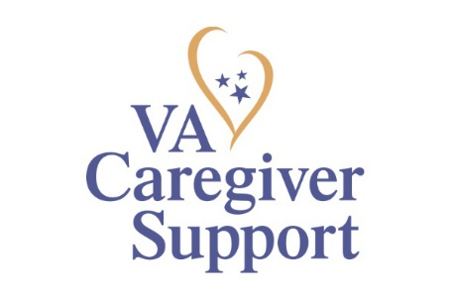 VETERAN SURVEY
Welcome to the Veteran Survey for the Department of Veterans Affairs (VA) Program of Comprehensive Assistance for Family Caregivers (PCAFC).
(The program is also known as the “Caregiver Support Program”, “VA Stipend Program” or “Family Caregiver Program”).

This survey is confidential. VA will protect your identity and answers to the fullest extent allowed under law. We will combine your answers with other people who take this survey. As such, VA staff will not know any of your individual answers. Also, we will not release any of your information to the general public in a way that can be traced back to you.

The survey asks about Veteran awareness, use, and satisfaction with the Program of Comprehensive Assistance for Family Caregivers (PCAFC). Even if you are not currently in PCAFC your feedback is important. This survey takes about 15 minutes to complete, depending on your experience in the program.

We want to hear about your personal experiences with the program. Your participation in this study is voluntary, but we hope you will choose to participate. No matter if you participate or not, your VA benefits or other benefits to which you are entitled will not be affected.

Questions or concerns? Call the Survey Information Line toll free at 1-888-203-1288 Monday through Friday, 8:00 a.m. until 8:00 p.m. Eastern time, or send an email to support@VHASurvey.org. In accordance with the Paperwork Reduction Act of 1995, comments concerning the burden estimate of the collection and any suggestions for reducing the burden may also be e-mailed to support@VHASurvey.org .

For questions about healthcare services at the VA please contact the Health Resource Center toll free at 1-877-222-VETS (8387) Monday through Friday, 8:00 a.m. until 8:00 p.m. Eastern time.

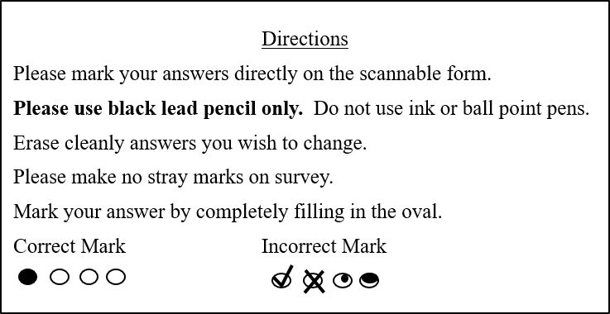
SECTION A: Program of Comprehensive Assistance for Family Caregivers (PCAFC) Participation Status
Q1. Are you currently enrolled in PCAFC?
- Yes (PLEASE GO TO Q1a)
- No (PLEASE GO TO Q1b)

Q1a. How long have you been in PCAFC? Please select one response.
- Less than 3 months
- 3-6 months
- 7-12 months
- 13-18 months
- 19-23 months
- 2-3 years
- 4-5 years
- More than 5 years

Q1b. How long were you in PCAFC? Please select one response.
- Less than 3 months
- 3-6 months
- 7-12 months
- 13-18 months
- 19-23 months
- 2-3 years
- 4-5 years
- More than 5 years

SECTION B: Caregiver Support Coordinator
Every VA medical center has at least one Caregiver Support Coordinator. This person may have helped you with the PCAFC application process or assisted in referring you to additional resources and services. This person serves as a point of contact for your local VA medical center Caregiver Support Programs.

Q2. As a Veteran, how helpful was it to have a Caregiver Support Coordinator as a designated person you could contact for assistance?
- Not helpful at all (PLEASE GO TO Q2a)
- Not very helpful (PLEASE GO TO Q2a)
- Neutral (PLEASE GO TO Q3)
- Helpful (PLEASE GO TO Q3)
- Very helpful (PLEASE GO TO Q3)
- Was not aware of the Caregiver Support Coordinator (PLEASE GO TO Q3)

Q2a. Which of the following explains why the Caregiver Support Coordinator was not helpful? Select all that apply.
- The Caregiver Support Coordinator was not responsive to my requests
- The Caregiver Support Coordinator did not follow-up with me
- The Caregiver Support Coordinator did not clearly communicate with me
- The Caregiver Support Coordinator could not provide the information I needed
- The Caregiver Support Coordinator was not familiar with my specific health needs
- Other, specify_________________

Q3. How well were you updated by the VA on your application status during the application process?
- Not at all
- Not very well
- Neutral
- Well
- Very well
- Don’t remember

Q4. How well did the Caregiver Support Coordinator explain the following responsibilities to you as a Veteran entering PCAFC?
Veteran Responsibility | Not at All | Not Very Well | Neutral | Well | Very Well
How well did the Caregiver Support Coordinator explain your overall responsibility to:
a. Put in writing to the VA if you decide to change or revoke your Primary or Secondary Family Caregiver.
b. Follow your local VA medical facility’s policies for sharing your health information with your Caregiver(s).
c. Tell the Caregiver Support Coordinator if you receive care from non-VA providers that is not authorized by VA.
d. Work with your Caregiver and primary care team toward your highest possible level of independence.
e. Be physically present and participate during home visits.
How well did the Caregiver Support Coordinator explain your responsibility to promptly inform the primary care team, Primary Family Caregiver and Caregiver Support Coordinator:
f. If there are any changes in your physical or mental health condition.
g. If you or your Caregiver is admitted to a hospital, long term care facility, rehabilitation facility, or residential treatment program, or become incarcerated.
h. If your address changes.
i. If your Caregiver’s address, telephone number or other contact information changes.

SECTION C: PCAFC Staff Support

Q5. How often have you had issues because of lack of communication or miscommunication between PCAFC staff and your VA health care providers?
- Never
- Rarely
- Sometimes
- Most of the time
- Always

Q6. How often do/did you feel that you were treated with respect by the PCAFC team?
- Never
- Rarely
- Sometimes
- Most of the time
- Always

Q7. Did PCAFC staff tell you about VA resources to help you and your Caregiver?
- Yes
- No

Q8. Did the PCAFC staff tell you about community resources to help you and your Caregiver?
- Yes
- No

Q9. To what extent does/did your participation in PCAFC help you maintain or improve your quality of life?
- No help at all
- Very little help
- Some help
- A lot of help

Q10. To what extent does/did your Caregiver’s participation in PCAFC help you maintain or improve your quality of life?
- No help at all
- Very little help
- Some help
- A lot of help

Q11. Which of the following explains why you might recommend PCAFC to other post 9/11 Veterans in need of Caregiver assistance? Select all that apply.

  - The financial support (e.g., stipend, travel reimbursement, etc.) enables/enabled my Caregiver to continue with the level of care I need
  - CHAMPVA, the Civilian Health and Medical Program of the Department of Veteran’s Affairs, is/was a big help to my Caregiver
  - My Caregiver Support Coordinator was very helpful
  - The program’s educational support to my Caregiver has improved the quality of care he/she provided to me
  - The program has enhanced my Caregiver’s support system as he/she cares for me
  - It allows my Caregiver to advocate for my care at the VA
  - My health has improved as a direct result of the program
  - Other, please specify_________________

Q12. Which of the following explains why you might not recommend PCAFC to other post 9/11 Veterans in need of Caregiver assistance? Select all that apply.

- The application decision process was too lengthy
- The clinical appeals process was confusing
  - My Caregiver Support Coordinator was not helpful
  - The education services provided to the Caregivers were not helpful
  - There was a lack of follow-up services
  - There was a lack of personalized communications (e.g., phone calls, in-person meetings, etc.)
- Poor customer service from VA staff
- There was a lack of useful information about the program
- My VA doctors had no knowledge about PCAFC and did not understand the role my Caregiver has supporting my health care needs
  - Other, please specify_________________

Q13. Overall, how satisfied are/were you with PCAFC?
- Very dissatisfied
- Dissatisfied
- Neutral
- Satisfied
- Very satisfied

Q14. In the space below, please provide any additional information about your experiences with the PCAFC, suggestions for additional support, or possible improvements. Your feedback will aid VA’s understanding of Veteran satisfaction and overall experience with PCAFC. Please note that your responses will not be linked to your identity.

THANK YOU FOR COMPLETING THE SURVEY.

