Additions to the On-Line Member Enrollment Form Used by Grantee Programs to Enroll Members in an AmeriCorps Program

Two check boxes have been added where program staff certify they have performed the required sex offender and criminal history checks on potential members being enrolled as AmeriCorps members.

SAMPLE SCREEN

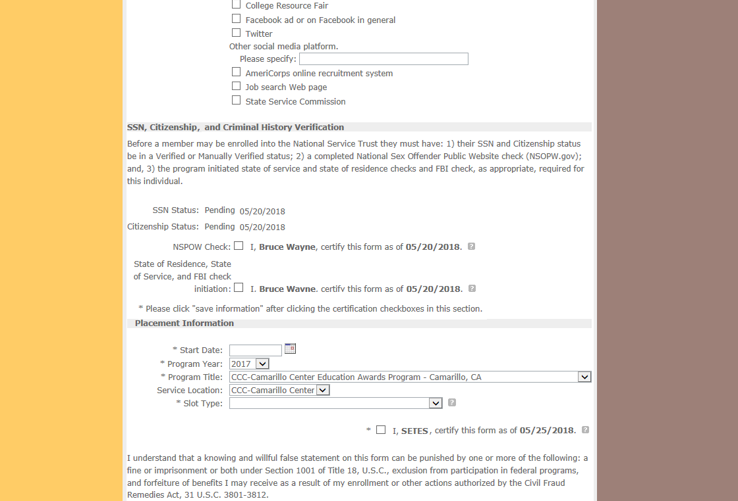
I certify that I have conducted, reviewed, and adjudicated the results of a nationwide NSOPW.gov check (with all jurisdictions on NSOPW.gov reporting) for this individual.
I certify that I have initiated the state of service and state of residence checks and FBI check, as appropriate, required for this individual.

