MINK PRICE SURVEY- 2018

OMB No. 0535-0212
Approval Expires: 11/30/2019
Project Code: 197 SMetaKey: 2597
 |  |  |  | 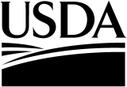 | United States  Department of  Agriculture
 |  |  | 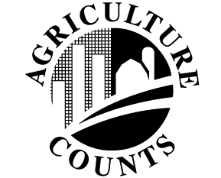 |  | NATIONAL  AGRICULTURAL  STATISTICS  SERVICE

USDA/NASS
National Operations Division
9700 Page Avenue, Suite 400
St. Louis, MO 63132-1547
Phone: 1-888-424-7828
FAX: 1-855-415-3687
e-mail: nass@nass.usda.gov
The information you provide will be used for statistical purposes only. Your response will be kept confidential and any person who willfully discloses ANY identifiable information about you or your operation is subject to a jail term, a fine, or both. This survey is conducted in accordance with the Confidential Information Protection provisions of Title V, Subtitle A, Public Law 107-347 and other applicable Federal laws. For more information on how we protect your information please visit: https://www.nass.usda.gov/confidentiality. Response to this survey is voluntary.
According to the Paperwork Reduction Act of 1995, an agency may not conduct or sponsor, and a person is not required to respond to, a collection of information unless it displays a valid OMB control number. The valid OMB number is 0535-0212. The time required to complete this information collection is estimated to average 30 minutes per response, including the time for reviewing instructions, searching existing data sources, gathering and maintaining the data needed, and completing and reviewing the collection of information.

Please report sales and price for United States farm raised mink only.

 | Number of Pelts Sold  (produced from prior year listed) |  | Market Price  of Pelts Sold  (produced from prior year listed)
Color Class | 2017 | 2018 | 2017 | 2018
Black
Demi/Wild
Pastel
Sapphire
Blue Iris
Mahogany
Pearl
Lavender
Palomino
Violet
White
Misc. & Unclassified
Total

Please return the completed table by fax to (855) 593-5469 by June 15, 2018. If you have any questions or comments please contact Suzanne Avilla at (202) 720-4028.

