System: Web-Based Supply Chain Management (WBSCM)
Form: Domestic Order Form (Direct Ship)
Screenshot as of: 8/15/13

Screenshot #1: Domestic Order Entry Form (Product Selection)
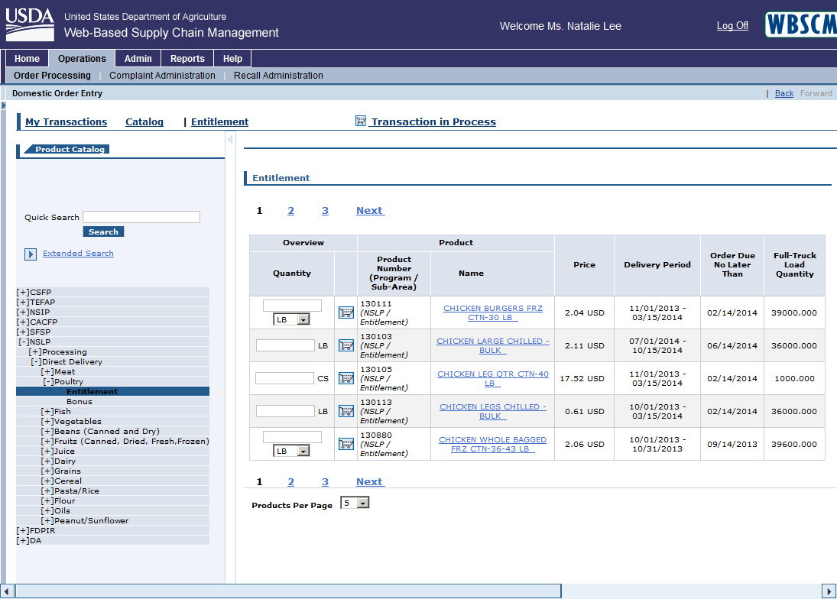

Screenshot #2: Domestic Order Entry Form (Delivery Date & Quantity Selection)
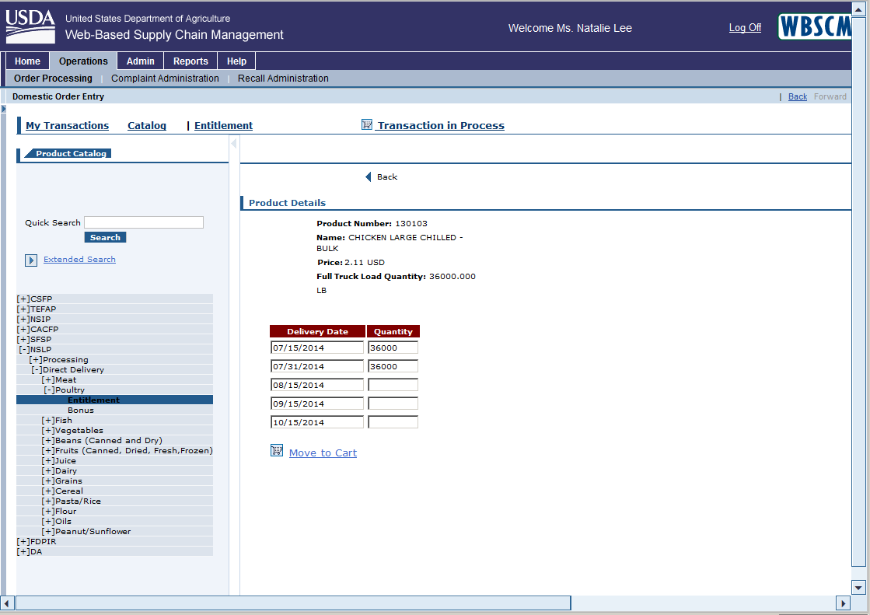

Screenshot #3: Domestic Order Entry Form (Shopping Cart View)
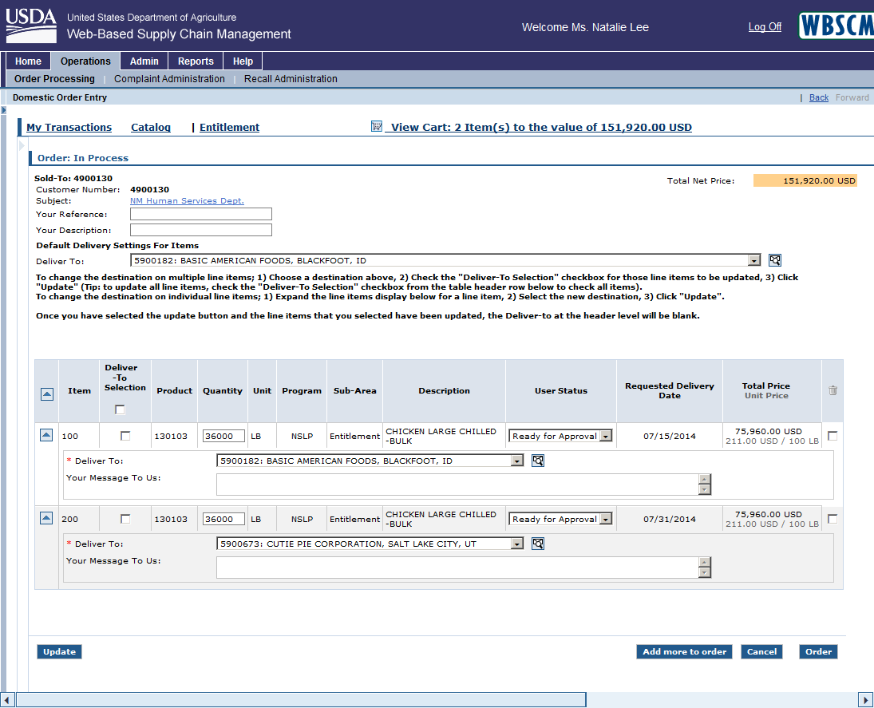
*Click the “Deliver To” dropdown box to select/change the ship-to destination
*Click the “Order” button to submit the requisition order to the SDA for approval

