System: Web-Based Supply Chain Management (WBSCM)
Form: Consolidated Requisition (Sales Order) Form
Screenshot as of: 8/15/13

Screenshot #1: Consolidated Requisition (Sales Order) Form
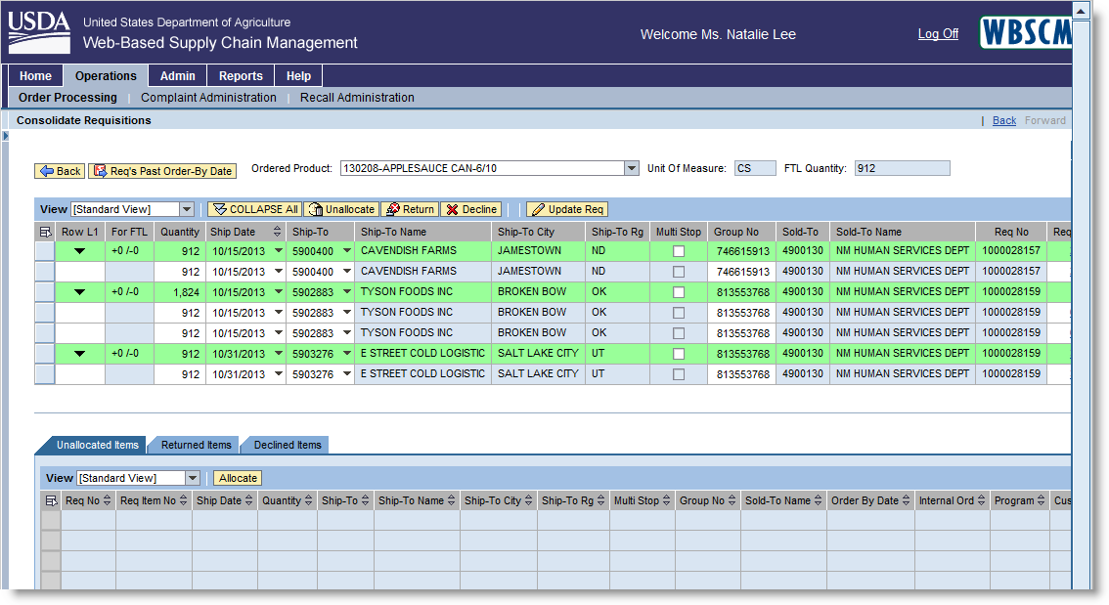
*State Distributing Agency Order Manager may unallocate, return, or decline a sales requisition by clicking the appropriate button on the consolidation screen.

Screenshot #2: Consolidated Requisition (Sales Order) Form – Submit for Sales Order Creation Button
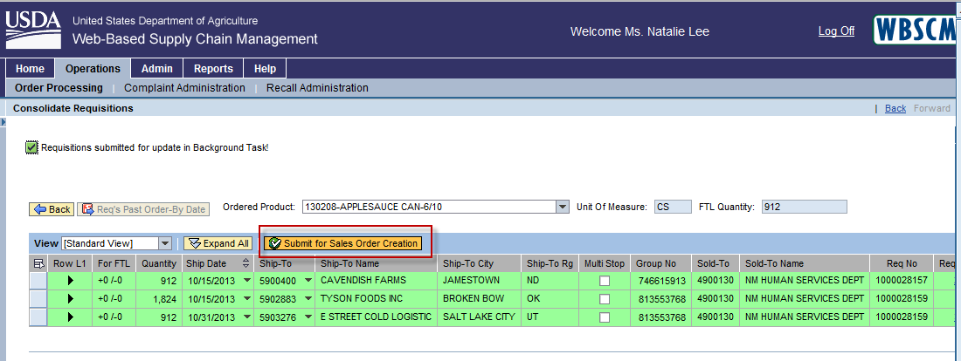
*By clicking the “Submit for Sales Order Creation” button, the requisition orders are submitted for Sales Order creation and are routed to FNS for approval.

