System: Web-Based Supply Chain Management (WBSCM)
Form: Shipment Receipt Form
Screenshot as of: 8/15/13

Screenshot #1: Shipment Receipt Form
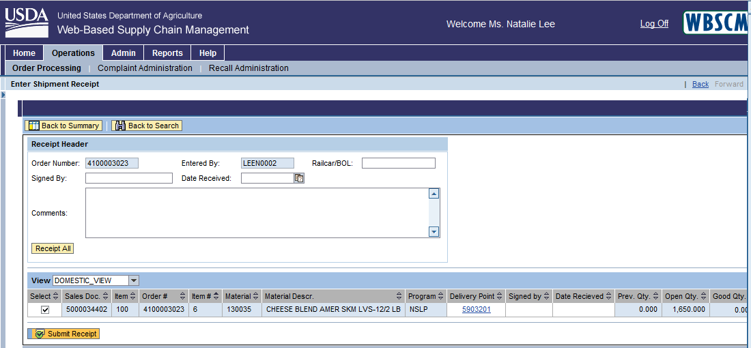

Screenshot #2: Shipment Receipt Form (continuation of columns)
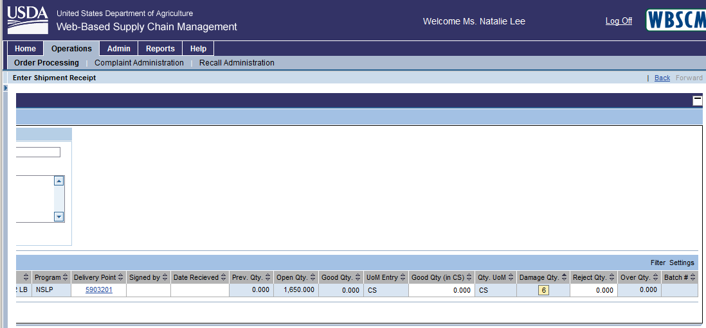

Screenshot #3: Shipment Receipt Form - Damage Quantity Details
